Q1.

(a) First and second generation languages are known as low-level languages.
What is meant by the term low-level language?
___________________________________________________________________
___________________________________________________________________
(1)
(b) Programs written using a high-level language are easier to maintain and understand than programs written in a low-level language.
Describe two ways in which high-level languages can make this possible.
___________________________________________________________________
___________________________________________________________________
___________________________________________________________________
___________________________________________________________________
___________________________________________________________________
___________________________________________________________________
(2)
(c) A student new to programming has heard that some languages are compiled and others are interpreted, and that compilers and interpreters are both known as types of translator.
Describe to this student:
• the role of a translator
• the differences between a compiler and an interpreter
• a situation where you would use a compiler
• a situation where you would use an interpreter.
In your answer, you will be assessed on your ability to use good English and to organise your answer clearly in complete sentences, using specialist vocabulary where appropriate.
Use the space provided to write your answer to this question
___________________________________________________________________
___________________________________________________________________
___________________________________________________________________
___________________________________________________________________
___________________________________________________________________
___________________________________________________________________
___________________________________________________________________
___________________________________________________________________
___________________________________________________________________
___________________________________________________________________
(6)
(Total 9 marks)
Q2.

The diagram below shows the classifications of various types of software used on a computer system and some examples of these types.
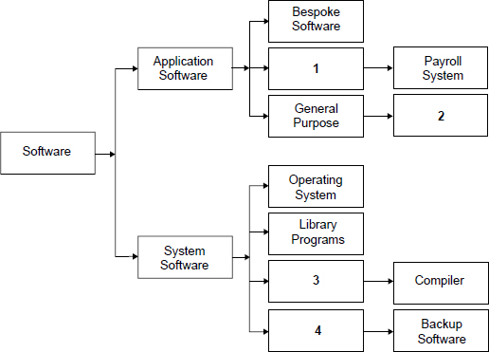
(a) Complete the diagram by suggesting labels for the boxes numbered 1 to 4 in the diagram.
1. _________________________________________________________________
2. _________________________________________________________________
3. _________________________________________________________________
4. _________________________________________________________________
(4)
(b) (i) Machine code is the first generation of programming language.
What is the second generation of programming language?
______________________________________________________________
(1)
(ii) A program written in a second generation programming language has been loaded into a computer. In this form it cannot be directly executed on this computer.
What has to be done to make an executable form of the program, which can be directly executed by this computer, and what would be used, typically, to do this?
______________________________________________________________
______________________________________________________________
______________________________________________________________
(2)
(iii) A programmer then finds that when the executable form of the program is transferred unaltered to another computer, the program does not run and an error message is displayed.
Why might the executable form of the program not be able to run on this computer?
______________________________________________________________
______________________________________________________________
(1)
(Total 8 marks)
Q3.
Describe what thin-client computing is and explain two reasons why a thin-client system might be chosen in preference to a thick-client system.
_______________________________________________________________________
_______________________________________________________________________
_______________________________________________________________________
_______________________________________________________________________
_______________________________________________________________________
_______________________________________________________________________
_______________________________________________________________________
_______________________________________________________________________
_______________________________________________________________________
(Total 3 marks)
Q4.
A computer system consists of hardware and software.
(a) What is meant by hardware?
___________________________________________________________________
___________________________________________________________________
(1)
(b) What is meant by software?
___________________________________________________________________
___________________________________________________________________
(1)
(Total 2 marks)
Q5.
Describe two differences between machine code and assembly language.
_______________________________________________________________________
_______________________________________________________________________
_______________________________________________________________________
_______________________________________________________________________
(Total 2 marks)
Q6.

(a) Some of the components of a computer system are:
Memory:
main memory 1
Peripherals:
keyboard 2
monitor 3
hard disk drive 4
I/O Ports:
keyboard controller 5
disk controller 6
VDU controller 7
In the diagram, name the components by writing the number into the appropriate box.
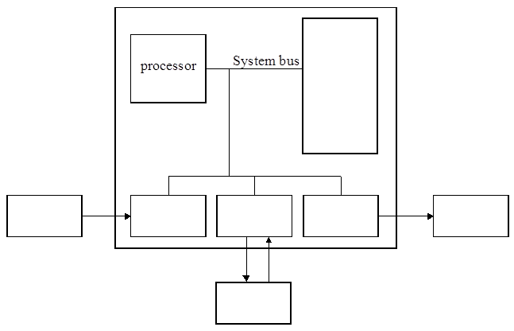
(4)
(b) The above computer system uses the stored program concept. Explain this term.
___________________________________________________________________
___________________________________________________________________
___________________________________________________________________
___________________________________________________________________
(2)
(c) Many computer systems and printers have both serial and parallel ports. Data can be sent to a printer from either port. What is meant by:
(i) serial transmission of data; ________________________________________
______________________________________________________________
(1)
(ii) parallel transmission of data. _______________________________________
______________________________________________________________
(1)
(d) (i) When could parallel data transmission be used?
______________________________________________________________
(1)
(ii) Justify the answer you have given in (d) (i). ___________________________
______________________________________________________________
(1)
(e) Asynchronous data transmission is a method of data transmission in which a character is sent as soon as it becomes available, for example when a key is pressed on the keyboard. In this situation, what is the reason in having the start and stop bits?
___________________________________________________________________
___________________________________________________________________
___________________________________________________________________
___________________________________________________________________
(2)
(Total 12 marks)

