
Roman Depth Study
Section B: Ruling Roman Britain, AD 43–c.128
REVISION GUIDE
A Level Ancient History
OCR (H407)
NAME

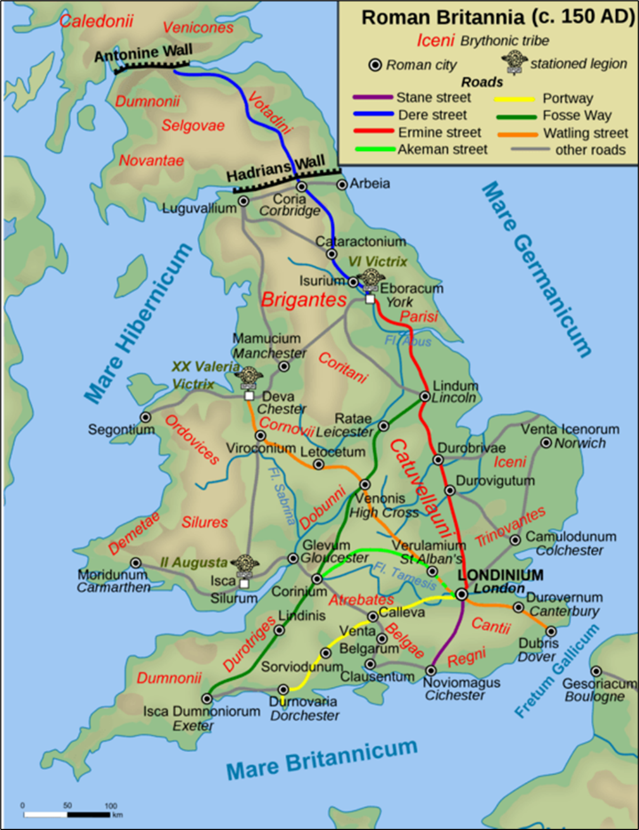

Roman Depth Study – Ruling Roman Britain AD 43 – c.128
TOPIC |  | CONTENT | Revised
1 | Roman Military Policy towards Britain: Conquest and Expansion | - Julius Caesar’s invasions in 55/54 BC – what kind of relations did Rome and Britain have prior to the invasion  - Causes and events of the invasion of AD 43  - The Governors and what military policy was like under them.  - The governorship of Agricola and his portrayal by Tacitus
2 | Frontier Policy: Consolidation and Retrenchment AD 85 – c.128 | - The nature of the sources covering this topic  - Frontier policy after Agricola  - Reasons for retrenchment by Domition and Trajan  - Stanegate road system  - Hadrian’s Wall – why and how was it built – features and functions
3 | Resistance to Roman Rule | - Resistance to the intitial Roman invasion in AD 43  - Case Study 1: Caratacus  - Case Study 2: Boudicca  - Case Study 3: Cartimandua and Venutis  - Case Study 4: Calgacus  - The portrayal of resistance figures in the sources – Tacitus’ creation of the ‘noble savage’
4 | Roman Control | - Romanisation  - The role and personnel of Governor of Britain  - The different roles of the Roman army in Britain  - The importance of auxiliaries  - Client kingdoms and the reasons for British collaboration  - The army’s role in building and patrolling Hadrian’s wall.
5 | Effects of Roman rule | - Economic exploitation during the Claudian period;  - Changes to agricultural production;  - Trade and infrastructure, with particular reference to roads;  - the impact of the Roman Army on the British economy;  - Urbanisation: reasons for the development of towns; the different types of towns (coloniae, civitates, municipia, vici) and their functions; the development of towns as economic centres during the 1st century AD; leisure and public facilities provided by towns;  - towns as agents of Romanisation; the emergence of a Romanised elite;  - The importance of Fishbourne Palace and its reflection of new cultural tastes and attitudes; the extent of Romanisation

Topic 1 – Check you know
- Julius Caesar’s invasions in 55/54 BC

- Which two years saw the invasion of Britannia by Julius Caesar?
55/54BC
- When Caesar campaigned in Britain who did he side with and who was he against?

- What did Caesar say about the Druids?

- Strabo wrote that” the Celts are war mad”. What made their weapons quite formidable?

- What products were being sold by the Romans into Southern Britannia long before the conquest?

- Causes and events of the invasion of AD 43

- Explain the background to Claudius’ invasion – Julius Caesar’s invasions and relations with the tribes before AD 43

- What did Pomponius Mela say that might make it seem there were economic advantages in taking Britannia?
Britain held rich soils and materials like Iron and Silver.
- Claudius’ invasion – Causes
POLITICAL: He had been decreed triumphal ornaments by the senate, but he didn’t believe he was worthy of this, so he needed to gain a triumph by invading.
DIVISION AMONG THE TRIBES: Verica’s exile led to division among the tribes
ECONOMIC MOTIVES: fertile land, “a land not yet discovered at the edge of the world”, rich in materials.

- Claudius’ invasion –What caused the mutiny among Roman soldiers and what impact did this mutiny have?

- Impact of Aulus Plautius and Vespasian
-Vespasian was seen as more detrimental to the invasion as he captured 20 cities.
- What made Britons vulnerable to Roman attack?

- Factors influencing Roman military policy towards Britain and moves to expand the province and establish a frontier

- Discuss why the Romans were so successful at defeating the Britons during the early conquest period.

The governorship of Agricola and his portrayal by Tacitus
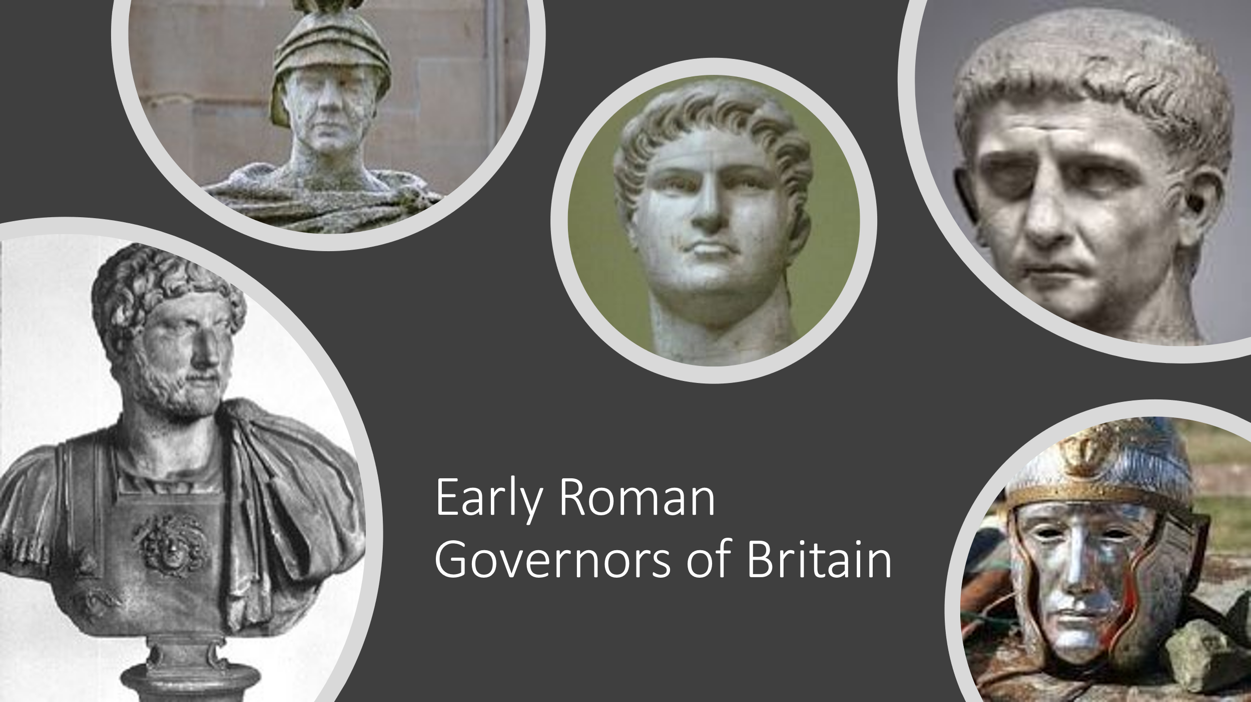
- Roman policy and governors AD 43-84 – Consolidation and Expansion – how effective were the policies of the first Roman governors?

- What were Roman governors expected to achieve when managing the province of Britannia?

- Who achieved this best?

- What do the gravestones tell you about the campaign that resulted in the conquest of Britannia? Mention at least two examples.

- The year of four emperors and how this impacted on the conquest of Britain

- The governorship of Agricola – how significant are his achievements.

- Which future emperor did Agricola fight for in his first time in Britannia?

Key Sources – Tacitus, Annals and Tacitus Agricola, Dio, Roman History, Josephus, Jewish War , Pomponius Mela Roman History ,Suetonius, Twelve Emperors, Arch of Claudius, Aureus of Claudius, Bronze coin of Cunobelinus, Stater of Verica, Tombstones (of Gaius Saufeius, M Petronius, Dannicus Sex, Valerius Genialis, Rufus Sita)

Explain the following words

Fosse Way, The Trinovantes, The Atrebates, The Catuvellauni, The Iceni, The Brigantes, Silures, Hubris, Guerilla Warfare, Mons Graupius, Legion,

Topic 2 – Consolidation and Retrenchment
- The nature of the sources covering this topic

- What kinds of sources do we rely on to cover much of our knowledge of Roman Britain and why?

- When does Trajan take over as Emperor ?

- What does the location and building material of Trajan’s fortifications in Britain reveal about Roman policy at this time?

- What do we learn from this commemorative stone?
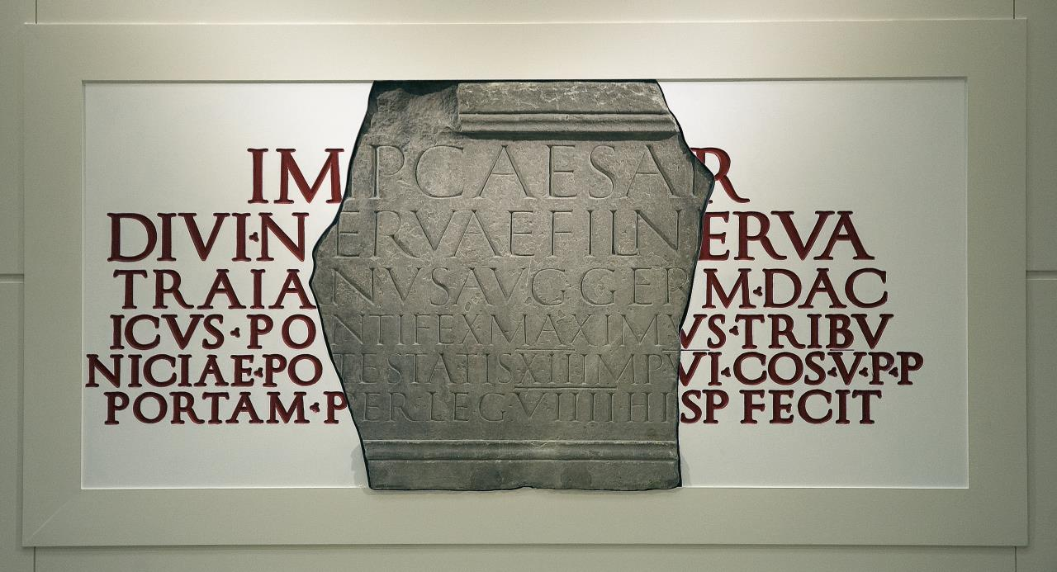
Commemorative Tablet From York, AD 107-8

- What is the Scriptores Historiae Augustae (SHA) and how useful is it for telling us about why Hadrian’s wall was built?

- What is Milecastle 38 and why is it important?

- What do we learn from the remains at Inchtuthil?

- What do we infer from the sestertius of Hadrian dated AD119?

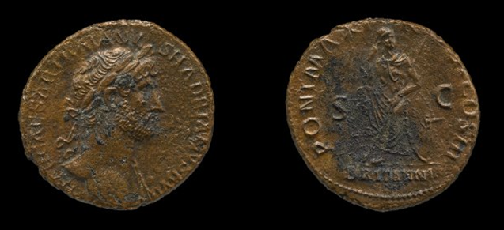

- What kind of sources are the Vindolanda tablets? When do they date from and why are they so useful?

- Frontier policy after Agricola

- The withdrawal of Roman control from Caledonia – what caused it?

- How consistent was Roman policy AD 84-98?

- How do we know that policy was changing?

- Reasons for Domitian’s retrenchment after Agricola’s governorship.

- What strategy was the barracks at Inchtuthil meant to be the centre of?

- Stanegate road

- What was the Stanegate road established and what was it used for?
47AD,
- When does this seem to have happened?

- Which forts were deliberately destroyed before the Romans moved down there?

- What kind of settlement was Vindolanda and which auxiliary cohorts were based there?

- What are auxiliaries?

- What do you deduce from the fact that Trajan kept legionaries in the south and west and sent auxiliaries to this northern border?

- Hadrian moved the sixth legion to this northern border in 122. Why do you think he may have done that?

- What is the evidence for this?

- Hadrian’s Wall – why and how was it built
- Hadrian’s Wall – Where is it and what are the reasons it might have been built? There are at least 4 possible reasons.
(i)

(ii)

(iii)

(iv)

- Hadrian’s Wall – Design and features – explain its structure.
- A milecastle

- Fort

- Vicus

- Vallum

- Hadrian’s Wall – When was it built and what is it mainly consisting of?

- What are the reasons that people think Hadrian found Britain quite troublesome when he first succeeded to the throne?

Key Sources – Tacitus, Histories and Tacitus Agricola, ,Suetonius, Twelve Emperors, SHA (Scriptores Historiae Augustae) Hadrian Altars to Neptune and Oceanus, Caerlon stone of Traja, Commemorative tablet from York, Halton Chesters dedication slab, Inchtuthil fort, Milecastle 38 building inscription, Sestertius of Hadrian, Vindolanda fort, Vindolanda tablet: invitation to a birthday party, Vindolanda tablet: military strength report.

Explain the following words

Inchtuthil, Milecastle, turret, Whinsill, Vallum, Vicus, Auxiliary, Parthians, Antonine Wall

Topic 3 – Resistance to Roman Rule
- Resistance to the initial Roman invasion in AD 43

- What was a Client kingdom and give an example of one.

- What was Maiden Castle in Dorset? What does it demonstrate about how the Britons fought?

- Why did the Iceni rebel first in 47 AD? What does this tell you about the new governor Scapula and his methods of control?

- What methods did the Britons use to fight off Roman domination?

- Case Study 1: Caratacus

- What kind of leader was Caratacus?

- Which tribe helped him after he escaped from the Battle of the Medway?

- What happened at the battle of Caer Caradoc?

- What was the purpose of Caratacus’ trial in Rome and why do you think Claudius was so merciful?

- What is the speech saying about Tacitus and about Roman perception of tribe leaders?

- Case Study 2: Boudicca

- Why did the Trinovantes fight along side the Iceni under Boudicca?

- What are the differences between Tacitus and Dio on the causes of the rebellion?
Tacitus description of the causes | Dio description of the causes
Evaluation of this evidence – who is Tacitus, how reliable is his knowledge, what is his perspective and should we trust him? | Evaluation of this evidence, Who is Dio? How reliable is his knowledge, what is his perspective and should we trust him?

- Why was Paulinus not responding more quickly to the rebellion? Where was he and what was he doing?

- Why did Colchester fall so easily?

- Who was Decianus Cato and what did he contribute to causing the troubles in Britannia? (3 things)

(i)

(ii)

(iii)

- Dio and Tacitus both describe Boudica as dying at the battle of Watling Street. Do you think they have good reason and which do you find more reliable?

- A freedman called Polyclitus came over to see what was going on after the Battle of Watling Street. What did he report back to Nero and how did this change policy in governing the country of Britannia?

- Case Study 3: Cartimandua and Venutis

- Why did the Romans decide to suspend the client kingdom status of Brigantia?

- How does Tacitus describe Cartimandua?

- What do we learn about the potential disadvantages of a client kingdom from this example?

- Why did Venutius oppose Cartimandua so bitterly?

- Which Roman governor crushes the trouble in Brigantia and what does he do to run this area efficiently?

- Case Study 4: Calgacus

- Who was Calgacus?

- Why is his speech so famous and what do we learn about what Tacitus thought of brave barbarians?

- Whereabouts is it likely that the Battle of Mons Graupius took place?

- Which two groups of auxiliaries led the attack against the Caledonians?

- Summarise in your own words why the Romans were victorious in the battle of Mons Graupius?

- The portrayal of resistance figures in the sources – Tacitus’ creation of the ‘noble savage’
- Why do you think ancient writers such as Tacitus and Dio include speeches in their works of history? What are they trying to achieve by doing this?

- How threatening was opposition to Roman rule in Britannia?

Key Sources Tacitus Annals, Tacitus Agricola, Dio Roman History, Suetonius Nero, Arch of Claudius
Explain the following words: Client Kingdom, Verulamium, Noble Savage, Procurator, Testudo, reconnoitring, consolidation

Topic 4 – Roman Control
- Administration

- What is the difference in responsibility between a Governor and a Procurator? Explain their duties and mention some examples.

- Why do you think Aulus Platorious was chosen to be a governor of Britannia under Hadrian. Look at the grave inscription (page 3 booklet 4).

- What were the methods of Romanisation described in “Agricola” by Tacitus.

- Why was Romanisation such an effective method of control?

- The role and personnel of Governor of Britain

- Which British governors were chosen because of their Military experience and which are responsible for the greatest amount of expansion?

- What was the most important tax in Britain? What other commodities were taxed?

- Who was Aulus Platorius and what did he do that was significant in Britain?

- How far do you think the criticisms of Decianus Catus are in the ancient sources?

- What was a speculator?

- The different roles of the Roman army in Britain

- What made a legion and why was it such an effective fighting force?

- What were the main functions that the roman army performed in addition to fighting?
(i)

(ii)

(iii)

(iv)

- What contribution did Auxiliaries make to conquering Britain?

- What was the Classis Britannica?

- Describe what you have found out about 3 auxiliaries in Britannia from gravestones in your booklet.
(i)

(ii)

(iii)

- Name at least three famous Roman Roads and explain why they were built and some of the fundamentals that made them so good.

- Client Kingdoms
- What were the advantages of a Client Kingdom to Rome?

- Why might a British tribe choose to become a Client Kingdom?

- Why do we know there were several tribes who were happy to become subject to Rome immediately after Claudius conquered the country? What benefit could there have been to them?

- Who was Cogidubnus and where did he live?

Prescribed Source – Chichester Dedication Slab, second half of first century AD
“To Neptune and Minerva, for the welfare of the Divine House by the authority of Tiberius Claudius Togidubnus, great king of Britain, the guild of smiths and those therein gave this temple from their own resources, Pudens, son of Pudentinus, presenting the site.
- How is this archaeological source evidence of Cogidubnus’ pro-Roman behaviour (clue – think about what he was dedicated it to)?

Key Sources – Tacitus, Annals and Tacitus Agricola, ,Suetonius, Twelve Emperors, Nero in particular, also Dio Roman History, Arch of Claudius, Patorius Statue inscription, Tombstone of Julius Classicianus, Tombstone of a speculator, Tombstone of Auxiliary standard bearer, Benwell Classiss Britannica inscription, Silchester Baths plan

Explain the following words: Client kingdom, Noble savage, Procurator, speculators, Beneficiarii, Legionaries, conturbunium, Centurion, Cohort, Auxiliary, Legate, Military Tribune

Topic 5 – The effects of Roman Rule
- Why was Romanisation so important to the running of the Roman Empire?

- How do we know that Rome and Britain traded and had valuable contacts before Rome invaded?

- When Strabo produced his “Geography” in the reign of Augustus what did he feel would be the advantages of taking Britannia?

- How useful is Strabo’s information about Britannia?

- Where did the Romans begin to extract lead and silver and how do we have evidence of this?

- We have seen that urbanisation is the basic element in Romanisation of new territory. TExplain the four categories of urban settlement that the Romans established:

- Vici

- Coloniae

- Municipia

- Civitates

- For the towns to survive and flourish there had to be a secure economic base. What are the benefits of the Roman road system?

- What were the advantages of a universal stable currency?

- How do we know that Camulodunum was an important trade centre with Rome before the invasion?

- All major Roman cities were laid out on regular lines, though the colonies were likely to adhere more closely to the standard Roman grid plan not least because they were often, as in the cases of Gloucester and Lincoln on the sites oflegionary bases handed over for civilian use when the army moved on. The individual blocks of the grid were known as insulae (islands) and in all urban settlemetns the central insula was occupied by the forum. Describe a typical forum.

- Bath houses fulfilled a vital public function where business and commerce could take place. The bathers would move from room to room. Normally you would go through the following in a sequence however large or small the baths. Please explain what went on in each room.

- The apodyterium?

- The frigidarium?

- The tepidarium?

- The Caldarium

Some baths had a Laconicum and a Palaestra. What are these?

- For these baths to flourish it was necessary to provide adequate water supplies and in the case of the coloniae the citizens were provided with elaborate covered and pressured aqueducts that drove water uphill through concreate sheathed pipes. Lincoln was an example of this and it is also unusual in Britain because it has a grid of underground sewers. How did most cities at this time deal with their foul or storm waters?
- Why did the Veterans in Camulodunum contribute to the provocation that caused the Boudican rebellion?

- Obviously the new towns needed feeding and agriculture needed to increase production to feed those who lived in towns. How did the Romans revolutionise agriculture in Britain?

- Explain what luxuries could be found in a large Roman villa such as Fishbourne?

- To what extent had Britannia been Romanised by AD 128?

Key Sources – Tacitus, Annals and Tacitus Agricola, ,Suetonius, Twelve Emperors, Pomponius Mela, Caesar, Gallic Wars, Strabo Geographica, Stater of Cunobelinus, Mendip Lead Pig, Site of Colchester (with its Temple of Claudius, Basilica, forum, baths and theatre. Verulamian Forum inscription (79/81 AD) Wroxeter Forum dedication (129 – 130 AD). Fishbourne Palace. Plan of Silchester Baths. Vindolanda Tablet 185 use and role of road network (Dere Street and Stanegate)

Explain the following words: Hill fort, Oppida, Vici, coloniae, Municipia, Civitates, Forum, Basilica, Macellum, Subsistence Farming, Hypocaust, frigidarium, tepidarium, caldarium, laconicum, palaestra, apodyterium

Sample essay from 2019 exam
How far does the evidence help us understand the aims of the Romans in their construction of Hadrian’s Wall?
You must use and analyse the ancient sources you have studied as well as your own knowledge to support your answer. [36 marks.}
The evidence overall helps us to see many of the functions of Hadrian’s wall, which overall gives a fairly accurate reason as to why the Romans built it from how it is used. There is very little written evidence about Hadrian’s wall, and the only written description of the wall comes from a 7th century monk, Bede. Physical evidence points towards the wall being an instrument for the Romans to use to control the frontier in Britain.
The first evidence on this front is covered by the Scriptoriae Historia Augustae, a comprehensive history of Rome written in the 4th century. It claims that “the Britons could not be kept under Roman control” and that many provinces in the empire were also revolting, such as Armenia and Libya. Various physical evidence also supports the ideas that the Britons were in revolt, as an As of Hadrian pictured with Britannia set on a rock depicts ‘victory in Britain’. There would be no victories to be had unless they had revolted, which shows that Rome at least needed new measures to assure the security of the province. The aim of Hadrian’s work perhaps was to control the province and stop more revolts.
Furthermore by Hadrian’s reign, three new fortresses, York, Carleon and Chester were built to house the three legions in Britain of the time. As one can see from the stone construction as part can still be seen of all three today, these fortresses were built to serve a more permanent function, securing three corners of the province.
Another key feature of understanding what Rome built Hadrian’s Wall to achieve is seen through the retrenchment policies after Agricola’s governorship. Inchtuthill, a fortress abandoned north of the River Tay in Scotland, can be found with unused nails and parts of the fortresses which have been incomplete. This is because there was a withdrawal from Scotland between 84AD-110AD after Rome had “conquered the whole island” according to Tacitus’ Histories. Two smaller forts, Newsteads and Dalswinton also had been abandoned, but this time burnt to the ground (as can be seen from geo-physical surveys of the site). The Romans it seems, had a change in policy from expansion to consolidation. This may be attributed to as early as Domitian’s reign, as Tacitus mentions that Agricola was recalled (his father in law). While Tacitus links this weakly to jealousy, his comment that the empire was in economic recession was probably the more likely reason. Thus it seems Hadrian’s Wall was perhaps built as part of consolidating the Empire and creating a safer border. The Rhone also went through a similar process with a string of forts on the frontier, so it is probably part of an overall policy.
Furthermore, the construction of the work itself comes to a similar conclusion. The SHA is the only source available that actually describes why the wall was built. It says rather crudely that it was built to separate the barbarians from the Romans. This interpretation claims that the Romans aimed to create a complete separation of the other nations, which is unlikely as the wall itself had 80 mile castles, all fitted with gates. What is a more likely interpretation is that it meant a clear separation of territory – Rome and Caledonia which seems more likely as the Romans wouldn’t have built 80 gates to stop people coming in. What is more likely is that Romans allowed requested passage but not unauthorised access. Furthermore, the aim of the wall had perhaps changed by 128, as the forts such as Newsteads were built astride, rather than below the wall, with three north gates suggesting Romans want to scout north, not separate the countries.
South of the wall is also important to look at. The South mound, south of the vallum and military way shows that the area around the wall was clearly sectioned off. Parts of the vallum can be seen today, which shows that the vallum itself clearly sections off a zone north of it. This suggests that the Romans aimed to build a controlled military zone, rather than a single frontier. The Fosse way, which is a mile below the wall also connects forts together, showing that the infrastructure focused around keeping the Frontier well supplied. A receipt was found at Vindolanda supporting this, listing various foodstuffs that had been transported from York as luxury goods.
In conclusion, the aims of the Romans in their construction of Hadrian’s wall was to improve safety by constructing a controlled, regulated military zone that was used to ensure that revolts did not happen, which the evidence most, supports this claim. In addition, the Romans, rebuilding the East half in stone, perhaps wanted this controlled area to be a permanent feature, also showing that the Romans aimed to build a strong frontier for their empire too, with Britain as its most northerly area. The idea that it was used to separate is not strictly true either, as 80 gates and forts built astride the wall show a more complete aim of the wall than just separation.

Exam Board comments
31/36 (level 6: an excellent range of sources, analysed and evaluated, a convincing explanation, a very good range of knowledge, detailed and relevant; focus on the question , with a sustained structure, relevant and supported.)
The response establishes a sound and clearly knowledgeable approach to the issue and the limitations of the evidence (L^). It is an example of how dealing well with some of the relevant material can gain higher levels even where not all aspects are covered.
The initial focus of the explanation is detailed and precise, and sets the issue in the context of the Empire at the time, again giving the impression of a clear understanding of the historical context (L6). The coin is detailed and relevant, in a concise and clearly stated manner. It leads to a convincing and thorough analysis of the evidence so far (AO3/2 L6). The response has been precise and to the point. The material and narrative is coherent.
The use of evidence of the state of Britain places the wall in context with reference to the fortresses – again succinctly and clearly focused on the issues AO1 L5/6)
The development of the argument that this was about consolidation is fully and thoroughly supported by the account of the retrenchment from Scotland (detail of Inchtuthill) and the destruction of further forts (AO2/3). To this is added reference to limited literary evidence, as well as activity elsewhere (although this might have been more detailed) AO3/2/1 L5/6).
The use of SHA is both detailed and critical. The comparison of evidence (SHA and Milecastles) provides a very good explanation and a convincing analysis at this point (AO2), although more detail of the Milecastles would have developed this more thoroughly. There is now an error with the reference to Newsteads (AO1/3 which is a fort north of the wall not astride it. The point is valid (AO2), despite the error but unsubstantiated as it stands (AO2/1L5).
The discussion of the Vallum is a little unclear since it mentions both north and south. The reference to the Fosse Way is again unclear at this point. The Vindolanda tablet could have been a little more integrated into the discussion as evidence for the overall strategy (AO3 L5). There seems to be some lack of careful reasoning in this section where the judgements have been underdeveloped although still showing a very good knowledge and understanding (AO2 L5).
The response has covered the most of the available evidence well, although not consistently detailed for higher Level 6. The conclusion is supported by much of the narrative and provides some excellent and reasoned judgments. There is fully relevant material and there is a sustained structure to the argument (L6). There is largely a convincing and at times excellent explanation, but this is not always consistent (L5/6); the knowledge and understanding are clearly level 6; while not every aspect of the issue has been covered, what is dealt with has been both precise and at times sophisticated in its understanding not only of the specific material but also of the wider context.

36 mark essay
How reliable are the portrayals of the leaders in the sources?

To cover the range of evidence and establish how reliable it is, it is worth considering it from the differing perspectives. Some portrayals are definitely affected by Roman prejudice, as for example the description of the female leaders which Tacitus strongly disapproves of. Some of the evidence takes on typical literary devices, such as the main battles described all have the leaders making inspirational speeches before hand, which it is unlikely anyone took down or even understood. They are more likely reflecting the assumptions of what motivated these fighters as understood by the Roman writers. Some of these leaders are clearly “worthy foe” – men such as Caratacus who puts up a valiant resistance at the very beginning and continues to defend Britannia against the Roman invaders until he is betrayed by Cartimandua. There is much that is plausible about the portrayal of his fight and his portrayal as a worthy foe – just from the fact that he was rewarded with the leadership of a tribe he did not come from when forced to flee after the defeat of the Catuvellauni at the Battle of the Medway. The other worthy foe is possible entirely fictitious – Calgacus – as his existence is not corroborated, though the fight in Caledonia is supported by archaeological evidence. Finally there is some discussion of leaders who are pro-Roman and who explain why the Romans have such easy access into Britainnia, such as Verica who invites them in , or Togidumnus of the Regni who is a loyal supporter.

The female leaders are both initially in tribes that submit to Claudius according to the triumphal arch in Rome, which refers to the eleven tribes that submit without a fight. Cartimandua is leader of the Brigantes in the far north, and her behaviour is described contemptuously by Tacitus. He describes her as an adulterous, traitor who hands over the worthy foe, Caratacus to her nation’s enemies. What does support this is that Caratacus did flee to the Brigantes and was indeed handed over to face trial in Rome. It is also evident that she and her co-leader Venutius fall out badly and Venutius leads the party that is hostile and fighting Rome, but Tacitus assumes Venutius is husband to Cartimandua because he also leads the tribe and there is no British perspective on how the tribe was set out. Tacitus takes a traditional Roman perspective on women. They should be quiet and obedient wives, and his dislike of strong women is manifest when in “Annals” he says that “Cartimandua with some cunning captured Venutius’ brother and relations. The enemy were infuriated at this, and were further provoked by the disgrace of being subject to a female ruler”. Tacitus talks about Cartimandua betraying Caratacus through “treachery” and describes her as having “passion “and a “savage temper” and attests that she “supported the adulterer” all of which implies she is treacherous, adulterous, savage and wholly unpleasant. His perspective is not only affected however, by the fact that she is a powerful woman, he will have known that when his father in law was succeeding Cerialis, there had been a hard and bloody battle to settle the Brigantes because the Romans had to keep propping up her rule in the civil war against the anti-Roman members of her tribe led by Venutius. The evidence that civil war among the Brigantes had to be suppressed by the Romans is supported by the fact that there are tombstones and that a row of forts on the Stanegate are built up presumably to keep order in this area. The arrival of the second legion sent over by Vespasian to settle these troubles is evidenced by gravestones such as that of Titus Velerius Pudens and forst that get built in the late 70s AD in Chester, York Wroxeter and Caerlon. The fact that Cartimandua’s pro Roman sympathies are unsuccessful are supported and show that Tacitus, while hostile, has some reliable information to share.

The attitude of Tacitus to Boudicca in his account of her rebellion in “Annals” is also interesting because he explains why she was provoked. Her tribe, the Iceni had also been a client kingdom and that when her husband Prasutagus died he tried to protect her by leaving half the kingdom to Nero. Instead, the greedy and stupid procurator Decianus Cato, stationed in London, seized the entire kingdom. Tacitus describes horrific provocation, such as the beating of Boudicca and the raping of her daughters. This is not supported by Dio who dwells more on the bad behaviour of local veterans and the imposition of heavy and unjust taxes which were used to build an enormous temple to Claudius. Remains of the temple have been found which corroborate the existence of this massive Roman eyesore and would explain why the Trinovantes join with the Iceni to rebel. The violence of the rebellion is supported by a reference to it in Suetonius, “Nero” where he mentions that two Roman cities are burnt down and this has also been corroborated by a layer of ash found by archaeologists under Colchester – with hidden Roman jewelry and some burnt Roman foodstuffs. It is Dio, in his “Roman History” who describes the physical appearance of Boudicca and that is probably not reliable as there are no earlier accounts of what she looked like – his description of a tall woman with waist length red hair and a strident voice is very much as a fiction writer would describe a warrior queen. However, it is not impossible given that many Celts did have red hair and as a warrior leader she must have been tall and able to command. Both Dio and Tacitus describe Boudicca as dying before the end of the battle of Watling Street and Tacitus suggests she took poison whereas Dio just says she died. Actually the probability is that she would have been injured in battle and while it is plausible that she would rather kill herself than get taken by the Romans, she might also simply have died gloriously of her wounds. The Roman writers do not give her credit for that and this could just reflect their prejudices. The women leaders probably therefore do not get a reliable presentation from Roman historians.

The leaders whose fight against the Romans could earn them the description of being “worthy foe” get more sympathetic treatment. That quite possibly makes it less reliable. It is without question true that it took the Romans eight years to capture Caratacus and it would have been true that when he was handed over and taken to Rome, there would have been recent witnesses who would know if Tacitus was lying when he explained the speech that won Caratacus his freedom. This make this event seem reliable, but it has to be said that the many speeches Tacitus reports in his “Annals”, first Caratacus at Caer Caradoc, then Boudicca at Watling Street, and the inspiring speech made by Calgacus are all likely to have been invented by him. They follow a literary tradition whereby a brave leader would make an inspiring speech before a battle, and many of the criticisms made of the Romans reflect the opinions Tacitus states about the way modern Romans (of his time) were behaving. This does make the speeches interesting as they reflect persuasive judgements about Rome of the day, but they are not reliable evidence of what the British leaders actually said. Calgacus may not even have existed. While there is evidence that Agricola had indeed led his legions up into Scotland and we have evidence from the fort of Inchtuthil to support this, there is no secure knowledge of where the battle of Mons Graupius was and the name Calgacus is not certain as it means something like blade or prickly and could just be a title. The idea that he was a splendid leader would be unreliable, as the battle is recorded in “Agricola” the book, that Tacitus wrote about his father in law, and it was more likely that he would want his father his law to be recorded as defeating someone worthwhile than that they actually were. This makes the evidence seriously flawed. We do see that Agricola went up in to Scotland, from the fort of Inchtuthil, but the fact is that after 83 AD the Romans seem to withdraw from Caledonia so if the success was quite as flawless as Tacitus describes this is somewhat surprising and it can be said that the evidence here is not reliable.

The final area of leadership that we hear and can consider are the pro-Roman leaders such as Verica and Tiberius Togidumnus of the Regni. These do not interest Tacitus or Dio very much so our main evidence for them is passing references, or inscriptions and the magnificent palace of Fishbourne. These do show that there were genuinely leaders who helped and supported the Roman invasion and the physical evidence that supports this is clearly reliable.

So in conclusion the evidence about the leaders is flawed and there is little that can be wholly depended upon for establishing a certain picture. But the general outline of resistance and a long term fight before the Romans could secure their new province is supported not only by the writers, but also by the physical archaeological evidence. There are certain areas which clearly suffer from hostile prejudices of the ancient Roman writers, such giving full credit to the warrior qualities of the female leaders, and the speeches, but the general outline of a long and vigorous resistance is supported by the tombstones, and the many forts which were established, particularly in the north in the Brigantes area. So the sources are somewhat reliable.

H407/23 – Question 4
Sources
1. Obverse: VIR(ICA) split by vine-leaf
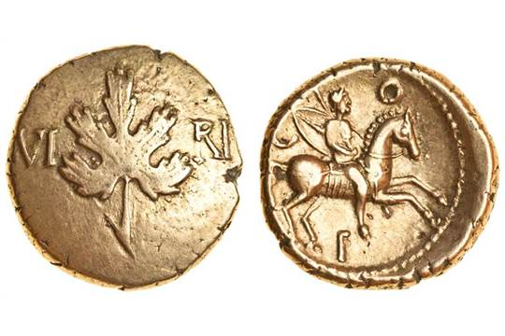
Reverse: Horseman; Below: C(OMMI) F(ILIVS)
Gold Stater of Verica Coin date: c. AD 20–40

2.Obverse: Ear of corn. CA MV (LODVNVM),
Reverse: Horse. Below: CUNO(BELINVS).
Gold Stater of Cunobelin(us) Coin date: AD 20–40

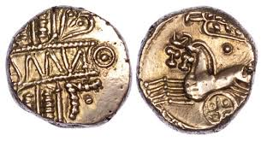

3.Aulus Plautius, a senator of great reputation, led an expedition to Britain. This was because a certain Berikos [Verica], who had been driven out of the island as a result of civil war, persuaded Claudius to send a force there.
Cassius Dio, Roman History 60.19.1

4. He undertook only one expedition, and that a modest one. The Senate had decreed him triumphal ornaments, but he regarded this as beneath his dignity as emperor. He sought the honour of a real triumph, and chose Britain as the best field in which to seek this, for no one had attempted an invasion since the time of Julius Caesar and the island at this time was in turmoil because certain refugees had not been returned to the island.
Suetonius, Claudius, 17.1–2 5 4.
How useful are these sources for our understanding as to why Claudius invaded Britain in AD43 [12} Bullet point your answer – you can use the better examples to help.

Example 1
The two numismatic sources are very helpful in understanding the reason for Claudius invasion for many reasons. Firstly, the ‘Gold Stater of Verica’ shows that there was wealth on the island due to the fact that they could afford to make their coins out of very expensive materials. This is true as British mines produced metals, including iron, tin, silver and gold. This would have attracted Claudius greatly to the island as it was an opportunity for him to bring wealth to Rome and would make him more popular with all classes which was something he greatly lacked at the time due to his reputation. This is further confirmed by the ‘Ear of corn’ and the horses which again shows the great wealth of the island. Secondly, the fact that there are two different people on the Gold Slater shows that there was great rivalry between tribes making it a perfect place for Claudius to invade due to its lack of unison. Furthermore, the lack of unison was great for Claudius as if they had united they could have been a great threat to Rome.
The third source is also useful in helping us understand the reason for the invasion. This is because it talks about the fact that Verica was exiled from the island which was a major reason why Claudius chose to invade in the first place. This is because the exile represented the growing power and threat of the anti- Roman Catuvallauni who threatened Roman influence in Britain which would have most likely resulted in the loss of trade. This would have given Claudius a great reason to invade as not only where they an enemy of the state but also threatened the Roman economy which was something that Claudius could not afford to happen to him so early in his career. However, this source also lacks reliability as it is unlikely that Claudius would have decided to invade a whole country and risk so much just because someone asked him to. This makes us think if there were possibly other more concrete reasons for the invasion rather than the economical status of Rome.
The last source shows us a key reason for the invasion of Rome – to prove to his people that he was better than what his reputation set him to be. This is because he was physically disabled which had made him a questionable ruler amongst his people and meant he hadn’t yet received the respect he desired. Therefore, his invasion of Britain if successful would have gained him public recognition from the Romans as it would show them that he was better than Caesar as he could achieve what Julius had tried to do 12 years before but failed. This is very true as the invasion is viewed by some as a PR campaign instead of it being something that Claudius was truly passionate about and a reason to make Rome a better place. However, this source could be deemed unreliable as Suetonius was certainly critical towards Claudius which could make the source biased and unreliable.
All four sources are very helpful in understanding why Claudius invaded Britain as it shows multiple different reasons for his decision and gives us a better insight into why he made the choices he did. However, the sources don’t suggest other key reasons for the invasion such as to avoid an over concentration of troops and his motivation which was surely dominated by his own personal desire.

Example 2
Claudius decided to send Aulus Plautius to Britain to lead an expedition after Verica had been driven out. This supports the belief that there were problems between the tribes hence why Verica had fled to Rome. The first source implies that there was a lot of wealth in Britain and that they were civilised because they will have used this wealth trading with one another. The coin found has writing on it which shows that the tribes in Britain were skilled with metal, this goes against Claudius’ idea of the Britons being barbaric and implies that he had a good reason to invade.
The second source also has links to the wealth that Britain had. It mentions a gold stater of Verica. This suggests that gold was being mined from the hills which is another strong reason for Claudius to invade, as the wealth achieved would benefit the Roman army.
The fact that Verica goes to Claudius for help and gold coins are found all around the tribes indicates that there is a lot to gain from the invasion financially. The second coin found shows a horse on the back which indicates the chariot warfare that the tribes specialized in. The ‘ear of corn’ links to the wealth being from natural resources which would have tempted Claudius into going ahead with the invasion.
The sources shown are helpful for understanding reasons why Claudius invaded as they show the wealth that the tribes possessed. Furthermore they state that Verica went to Claudius for help which supports the belief that there was conflict between tribes.

Example 3
Numismatic evidence is very useful in telling us the attitudes of various people. The first coin features a vine-life which was a common symbol within Roman culture and both coins contain Latin writing. This shows that the users of these coins had a pro-Roman outlook, which would mean they may be compliant to Roman occupation thus making it an easy invasion and victory for Claudius. Archaeological evidence also backs up that in some cases relations were good between some British tribes and the Romans; these include amphorae found in Britain, show that even before the conquest there was trade between them across the channel. On top of this, both coins are made of gold meaning Britain was rich in minerals. This is further supported on the second coin where there is an ear of corn boasting the natural resources the Britons had too. These two coins are useful as they give indications as to what might have influenced Claudius to invade Britain.
The source by Dio Cassius says that King Verica who had been driven out of the island had appealed to Claudius and persuaded him to send a force there. This may have been propaganda justifying Roman invasion of Britain, but it could be a genuine reason for the conquest because fighting between tribes could damage trade agreements so the conquest could be a protection method of trade as well as alliances between Romans and significant British figures. This source is useful because it gives a direct reason for the Roman invasion; aiding an ally and maintaining relations. However it doesn’t mention Claudius’ personal motivations for invasion which in my opinion are the most significant ones because there would have been tribal conflict before the Claudius’ invasion, during the rule of other emperors but only Julius Caesar had chosen to invade.
Suetonius says that the expedition was a “modest” one which suggests that the conquest wasn’t supposed to be that difficult so the Romans may have done it because it would look like a big achievement with only minimal casualties or effort. The invasion of Britain would be seen as a significant achievement because only Julius Caesar had attempted it before and had not been completely successful so if Claudius was successful he would look even greater that Julius Caesar. We are also told that Claudius wanted the “honour of a real triumph” because he as an emperor was not well respected or liked and wanted a military success to compensate for his defects. Finally he says that the “island was in turmoil because certain refugees had not been returned to the island”, supporting the detail contained within the Dio Cassius passage. This source is very useful for understanding why the Romans invaded because it gives a more likely explanation for the Roman conquest - glory for Claudius.
As a group I think this collection of sources are useful because they are all very different; by two different writers and two different coins, thus offering a variety of evidence that puts forward several different explanations as to why the Roman’s invaded Britain in AD 43.

Examiner Commentary
Example 1 The analysis of the coins shows understanding of the relevant issues concerning wealth and possible conflict between tribes; there might have been support for these conclusions to emphasise the usefulness of the coins from either Strabo or Caesar regarding mineral wealth. The discussion of source 3 is again considered and quite thoroughly but does not support the view of ‘Roman economy’ being threatened. Linking this with the elements of Roman influence on the coins might again have made the argument more substantiated. The discussion of source 4 is less successful in terms of the detail used, again not picking up the issue of ‘turmoil’ and linking it to the point made in paragraph 1 over the coins. The limitations of the sources is highlighted but not developed with reference to the evidence for the other reasons. The very general attempts at evaluation are not developed in terms of assessing usefulness nor are the contexts in which they are produced. Level 5 = 9/12
Example 2 There is an error on the second source which states that it mentions Verica; the response generalises rather than notes specific points – ‘coins are found all around the tribes’ is not supported here or in general with coins. There seems to be no reference to source 4 specifically named. Source 3 is implied in paragraph 3 but is not specifically used. The only motive developed is wealth with a brief mention of conflict. There is no obvious evaluation and limited support for the points made from the sources. The sources are described rather than analysed consistently and at times it is basic. Contexts are not developed. Level 2 = 4/12
Example 3 The discussion of the coins is precise and detailed with a clear understanding of the contexts and some reference to evidence outside the sources set on the specimen paper. This allows the discussion to develop the usefulness by comparison and contrast. There is analysis to place the Dio source in context and assess its usefulness and limitations; trade agreements are not supported here but the discussion shows a detailed and developed understanding of the situation in Britain (links might have been made with the coins). The discussion of Suetonius is both detailed and accurate in its use of the passage and a depth of understanding regarding the situation of Claudius (which might have been supported by other parts of Suetonius or Dio). The judgement of usefulness is well-developed. There is no clear evaluation of the sources to assess their reliability and therefore their usefulness from that viewpoint. High Level 5 = 10/12

Sources – Topic 1: Roman Military Policy: Conquest and Expansion 43-84 CE
Topic | Sources and content
Relationship before 43 CE | - Gallic Wars – Caesar’s invasions and diplomatic ties.  - Bronze Coin of Cunobelinus (43 CE) – existence of King of Catavellauni/Britain  - Dio – Berikos (Verica) driven out of Britain and request aid from Claudius.
Reasons for Conquest | - Dio – Verica request assistance, soldiers resistance to expedition,  - Gold State of Verica (15-40 CE) – possible confirms diplomatic ties with Rome  - Suetonius – Claudius’ legitimacy and triumph after conquest.  - Aureus/Arch of Claudius (46-7, 51 CE) – shows importance for legitimacy through propaganda  - Tacitus – extension of the Pomerium (also Cippus inscription).  - Claudius to the Athletes (46 CE) – shows prestige of conquest  - Pomponius Mela, De Situ Orbis (c. 40 CE) – economic benefits of Britain
Invasion and Plautius 43-47 CE | - Dio – account of invasion, Medway and Thames, Captures Colchester, submission of tribes, Claudius’s triumph  - Arch of Claudius (51 CE) – submission of ’11 British Kings’.  - Suetonius – expansion with Vespasian campaigning South  - Tombstones of Saufeius, Petronius, Dannicus, Genialis and Sita – 3 pronged expansion to Fosse Way.
Successive Governors 47-77 CE | - Tacitus, Annals – Caratacus and Silures, Scapula’s campaign & death, Verianus campaigns against Silures, Suetonius in Mona, Boudiccan Revolt (and Dio), Turpilianus consolidation,  - Tacitus, Agricola – Mutiny of Caelius, Bolanus’ consolidation, Cerialis in Brigantia, Frontinus subdues Silures  - Tacitus, Histories – Mutiny of Caelius, loss of 14th Legion, Cartimandua and Venutius,  - Josephus – increase to 4 legions again  - Tombstone of Pudens (71-74 CE) – Second Legion in Lincoln (so Ninth in Brigantia).  - Tombstone of Celer (78-87 CE) – re-organisation to Chester and York for campaigns.
Agricola 77-84 CE | - Tacitus, Agricola – Situation/actions on arrival, conquest of Wales, Campaign in Caledonia – use of Navy, Briton counter/attack on 9th Legion, Mons Graupius, left province secure.  - Chester Lead Pipe (XX CE) – Fortress built in Chester to hold Wales.  - Inchtuthil Fort – fortress built to hold the area.

Sources – Topic 2: Roman Military Policy: Consolidation and Retrenchment 84-130 CE
Topic | Sources and content
Retrenchment - Changes to Frontier policy | - Inchtuthil Fort – Occupation of Forth-Tay Frontier,  - Tacitus, Histories – Britannia conquered and let go, Dacian War.  - Suetonius – retreat because of economic reasons with Domitian’s building and pay increases & Dacian War.  - Caerleon Stone (100 CE) – shows retreat to Stanegate with fortress built in stone in York.
The Stanegate Road System | - Vindolanda Tablet 2.291 (c.100 CE) - birthday invitation of Severa shows stability.  - Vindolanda Tablet 2.154 (c. 90s CE) – military strength report show stability as not full strength.  - Vindolanda Fort – Auxiliary fort on new frontier.
Hadrian’s Wall | - SHA – unrest on Hadrian’s accession, Hadrian’s building of wall, military/defensive purpose, features of wall.  - Tombstone on Sabinus (119 CE) – shows increased military numbers at this time.  - As of Hadrian (119 CE), Sestertius (134 CE) – both celebrate Hadrian’s British campaign on accession.  - Altars to Neptune and Oceanus (early 120s CE) - XII legion’s role in building the wall.  - Milecastle 38 inscription (122-6 CE) – evidence of fortifications and legions role in building.  - Vindolanda – no initial need for forts as on Stanegate, auxiliaries manning the frontier.  - Hadrian’s Wall – features of the wall: broad/narrow gauge, vallum, milecastles/turrets.  - Halton Chesters dedication slab (122-5 CE) – fortifications built into the wall in early 120s.  - Great Chesters inscription (128 CE) – forts built less ‘offensively;.  - Jarrow Fragment

Sources – Topic 3: Resistance to Roman Rule
Topic | Sources and content
Nature and effectiveness, and early resistance | - Dio – Claudian invasion, Medway and Thames, Togodubnus’ death, further expansion to Fosse Way, chariots.  - Suetonius – evidence of successful campaigning in the South (Vespasian).  - Gold stater of Verica (15-40 CE) – lack of unity e.g. those allied to Rome.  - Gallic Wars – military description of Britons e.g. chariots.  - Tacitus, Annals – military differences e.g. Watling Street, Guerrilla tactics e.g. Silures, First Iceni revolt 47 CE
Caratacus | - Dio – Caratacus and Catavellauni at Medway and Thames.  - Tacitus, Annals – Caratacus flees to Siluria, leadership of confederacy, last stand – speech, topography and battle, Escape to Brigantia and capture, speech to Claudius in Rome, Silures continue without Caratacus, Guerrilla tactics, subdued by Scapula and Gallus, First dispute between Cartimandua and Venutius.
Boudiccan Revolt 61 CE | - Dio – Economic causes, Boudicca as leader of confederacy, sacking of Colchester and atrocities, speech before battle, Boudicca dies of an illness.  - Tacitus, Annals – Suetonius campaigns in Wales, causes – Iceni and Trinovates, sacking of Colchester, defeats 9th legion and sack of London/St. Albans, Speech before battle, Watling Street and defeat, Boudicca poisons herself, Suetonius’ reaction to revolt, Classicianus arrives and has Suetonius Paulinus removed.  - Suetonius – damage to cities.
Cartimandua and Venutius | - Tacitus, Histories – Divide and factions in Brigantes, dispute with Venutius, expulsion of Cartimandua and Roman support.  - Tacitus, Agricola – Cerialis and resumption of expansion with Brigantia campaign.  - Tombstone of Pudens – resumption of expansion IX Legion in York.
Calgacus | - Tacitus, Agricola – speeches before battle from both, battle deployments, Battle of Mons Graupius – differing tactics, roman discipline and use of auxiliaries.  - Inchtuthil Fort – possibly shows want to hold area/campaign further.

Sources – Topic 4: Roman Control
Topic | Sources and content
Role of Governor and Procurator | - Inscription from state of Nepos (125 CE) – career and background of a governor.  - Tacitus, Agricola – his views on the role: positive about conquest and expansion, critical of consolidation, background of Agricola, problems on arrival: army and administration, initial raiding,  - Tacitus, Annals – influence of Procurator (Classicianus).  - Dio – role with taxation and some military (Catus and Boudican revolt).  - Tombstone of Classicianus (60-61 CE) – proof of identity and existence of procurator.  - Tombstone of Celsus (1st C CE) – existence and location of speculatos.  - Tombstone of Secundus (61 CE) – existence and location of beneficiaries.
Role of the Army | - Tombstone of Facilius (43-9 CE) – existence and location of legionary.  - Tacitus, Annals – role in Romanisation as veterans at colonia  - Milecastle 38, Halton Chesters and Altars of Neptune & Oceanus – role in construction and infrastructure.  - Tombstone of Sdapeze (1st C CE) and Vindolanda tablet on cavalry (97-102/3 CE), Fort of Vindolanda – use of auxiliaries see also battles from Dio, Annals and Agricola.  - Benwell classis Britannica inscription (122-5 CE) – Prescence of fleet in Britain ‘British fleet’ (see also Agricola) and role in building Hadrian’s Wall.
Co-Operation and Client Kingdoms | - Tacitus, Annals – Iceni as allies  - Dio, stater of Verica and Arch of Claudius – submission of tribes diplomatically.  - Tacitus, Agricola – Regni as allies and use in Romanisation.  - Chichester Dedication Slab (50-100 CE) – Cogidubnus of Regni as ally (Rex) and role in Romanisation.  - Tacitus, Histories – Cartimandua as ally and mutual benefit e.g. Roman aid in dispute.  - Silchester Baths (1st C CE) – early Roman support and benefits of Romanisation.

Sources – Topic 5: Effects of Roman Rule and Romanisation
Topic | Sources and content
Economic Value of Britannia | - Pomponius Mela – Economic value and resources, also social assessment of Britons.  - Caesar, Gallic Wars – agriculture and mineral resources.  - Strabo, Geographica – lack of economic value, discusses economic produce  - Tacitus, Agricola – agriculture and different crops, minerals and pearls.  - Stater of Cunobelinus (20-40 CE) – possible indication of wheat as important crop.  - Mendip Lead Pig (c. 49 CE) – mineral wealth of Britain.
Colchester and Romanisation | - Stater of Cunobelinus (20-40 CE) – Colchester (Camulodunum) as capital of Catavellauni.  - Tacitus, Annals – founding of colonia at Colchester, destruction on Boudiccan revolt, use in romanisation.  - Site of Colchester – Temple of Claudius, Basilica and forum, baths, theatre,  - Samian Ware – indication of lifestyle of Romans.
Romanisation | - Tacitus, Annals – limitations of Romanisation (veterans and Boudiccan revolt) – see other resistance to rule.  - Suetonius – suppression of British values abolition of Druidism.  - Tacitus, Agricola 21 – Tacitus views on Romanisation: methods and purpose and benefits.  - Colchester – e.g. of romanisation: religion (see also Bath and Carrawbugh), civic buildings and entertainment.  - Verulamium Forum inscription (79/81 CE), Wroxeter Forum dedication (129-30 CE) – Civic buildings.  - Fishbourne Palace – Romanisation of British Elite.  - Silchester Baths – example of amenities of a Roman settlement.  - Vindolanda Tablet 185 – use and role of road network (Dere St. and Stanegate).
Impact on Agriculture | - Caesar, Gallic Wars – Pre-Roman Agriculture  - Mela, Strabo, Agricola and Stater of Cunobelinus – economic value of Britain for agriculture.  - Tacitus, Agricola – demand and existence of grain levy.  - Vindolanda Tablet 185 – use of roads and increasing demand to forts/urban areas.
Fishbourne Palace | - Tacitus, Agricola and Chichester dedication slab – Cogidumnus as ‘King’ and Roman ally, occupied under Nero  - Fishbourne Place – example of Romanised elite, construction, gardens, baths, decorations and mosaics, use, hypocaust,

Learners must be prepared to answer commentary questions on plans or reconstructions of the archaeological sites listed below.
- Guy de la Bedoyere, Roman Britain: A New History, (ISBN-13: 978-0500291146) Fishbourne Palace reconstruction (p.200)
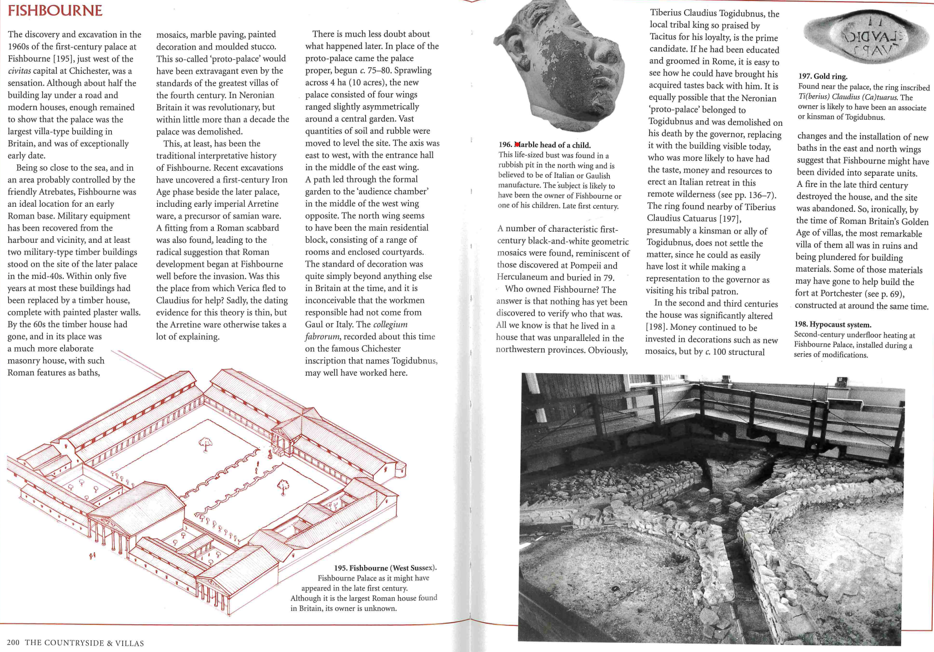

2. H.H. Scullard, Roman Britain: Outpost of the Empire, (ISBN-13: 978-0500274057) Colchester (C1st town and temple to Claudius) (Plan of town and reconstruction of temple to Claudius Inchtuthil fort plan Silchester baths plan

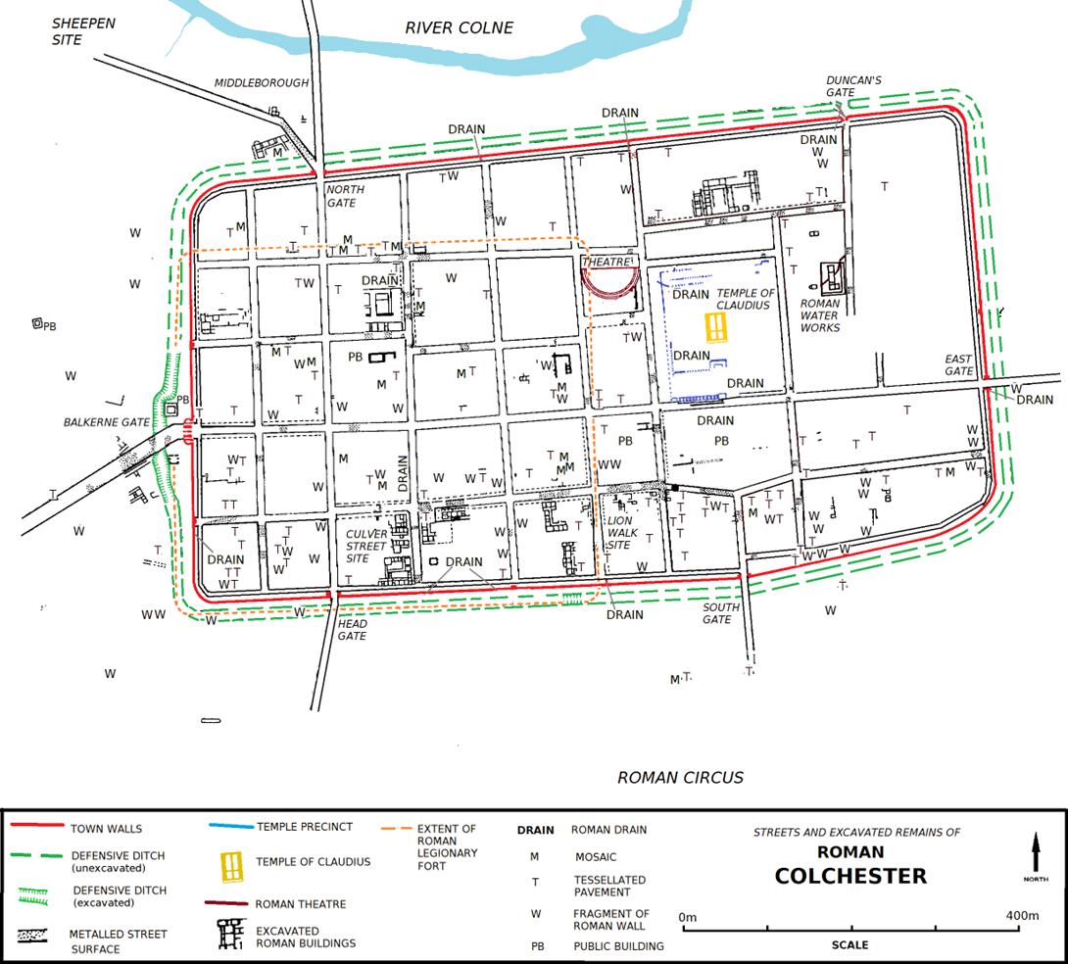

Inchtuthil fort plan

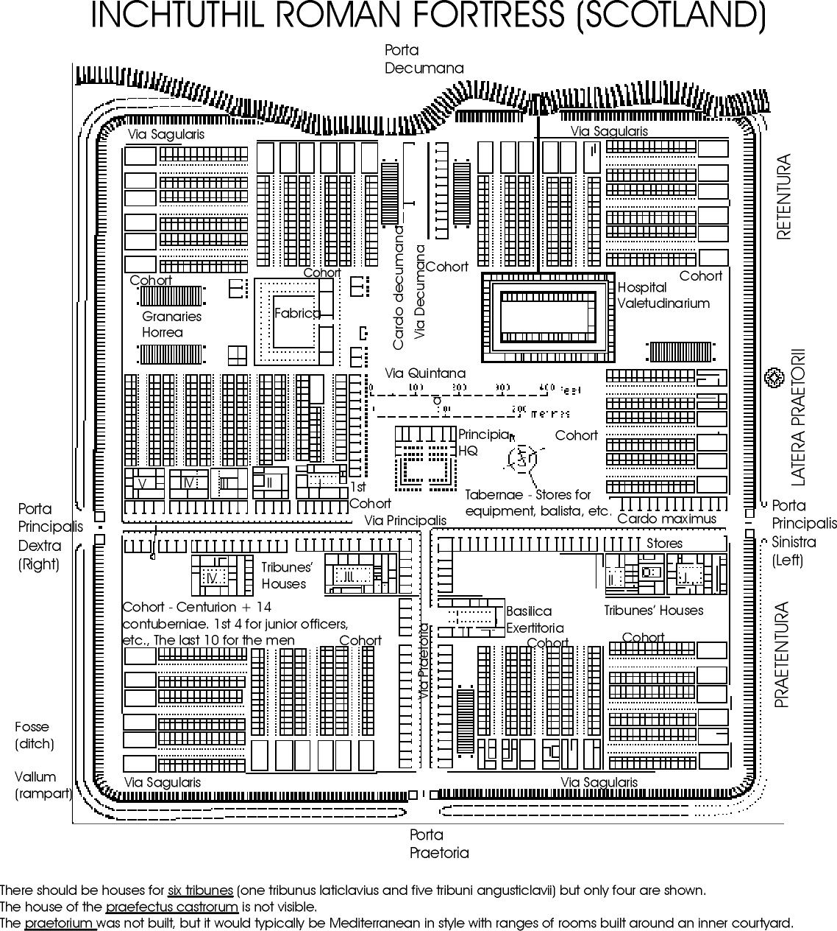

Silchester Baths
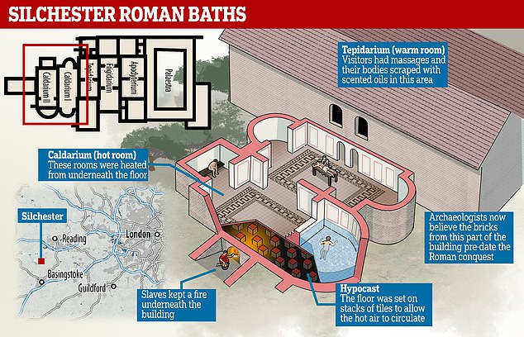

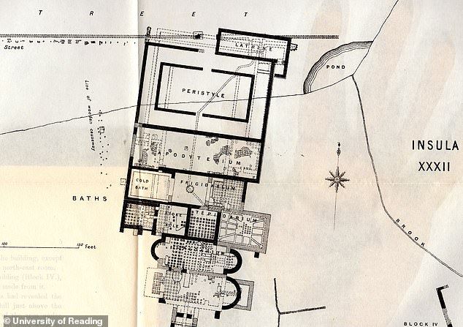

A natural spring there formed the focal point for the baths, which were often top of the agenda for builders when a new Roman settlement formed
Vindolanda fort (Plan of fort available at Vindolanda Tablets Online website)

