# Homework 1 Floating point form Answers

1. A certain computer holds floating point binary numbers using an 8-bit mantissa and a 4-bit exponent.

(a) Convert the following numbers from floating point binary.

(i) 0.1011100 0011 [1]

5.75

(ii) 1.0101101 0101 [1]

-20.75

(b) Convert the following numbers from decimal to normalised floating point binary.

(i) 13.25 [2]

In fixed point binary this is 1101.01

In normalised form the first digit after the binary point must be 1, so move the binary point 4 places left and set the exponent equal to 4.

Answer: 0.1101010 0100

(ii) -13.25 [2]

Find the twos complement, 10010.110

In normalised form, the first digit after the sign bit must be 0, so move the point 4 places left and set the exponent to 4

Answer: 1.0010110 0100

2. (a) What is the purpose of normalising a floating point binary number? [2]

It ensures the maximum level of precision for a given number of bits

(b) What is the most negative number that can be held in an 8-bit mantissa and a 4-bit exponent, expressed as a decimal number? [2]

1.0000000 0111 = -128

3. Insert the missing words in the following sentence:

In floating point binary representation, the larger the mantissa, the greater the ___precision___ and the larger the exponent, the greater the _____range_____ [2]

4. Numbers are stored in a computer system using fixed point binary with 5 places before and 7 places after the binary point.

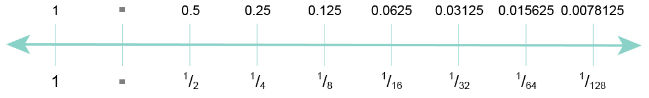

(a) What is the maximum value that can be held, to the nearest whole number? 32 [1]

(b) Explain what is meant by **underflow**. Describe a situation in which it could occur. [2]

When a number is too small to be represented. It could occur when storing the result of a number being divided by another e.g. 0.0078125 / 2

Total 15 marks