**+Explore Course:**

**Task 1: Skills Development:**

Try to think of at least three skills you’ve obtained from the course with some evidence to support.

|  |  |
| --- | --- |
| **Skill** | **Evidence** |
|  |  |
|  |  |
|  |  |

**Task 2: Transferrable Skills:**

Based on the skills that you’ve identified above, how could you apply them in a wider context?

|  |  |
| --- | --- |
| **New Context** | **Example of Skill Being Used** |
|  |  |
|  |  |

**Task 3: Documenting this evidence**

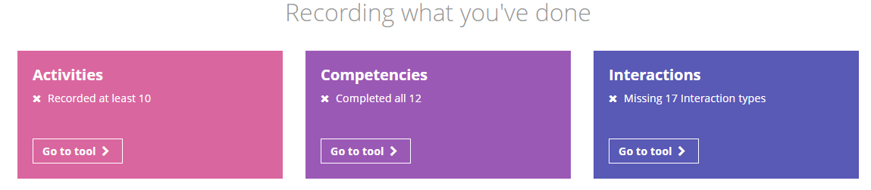Please log in to your Unifrog account in order to add these skills as ‘Competencies’.