**Poems of the Decade**

Teacher 1 does

1. The Furthest Distances
2. An Easy Passage
3. Material
4. Eat Me
5. The Gun
6. To My Nine Year Old Self
7. The Deliverer
8. Giuseppe

Teacher 2 Does

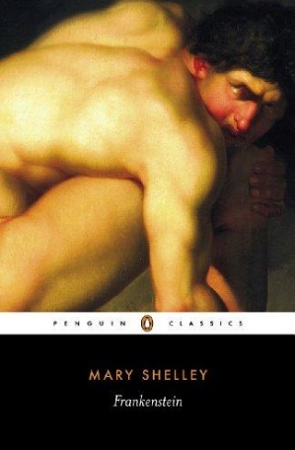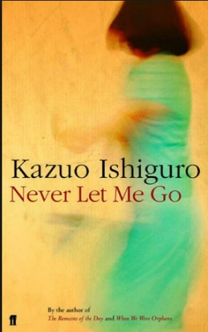

1. Genetics
2. Effects
3. From the Journal of a Disappointed Man
4. Chainsaw
5. 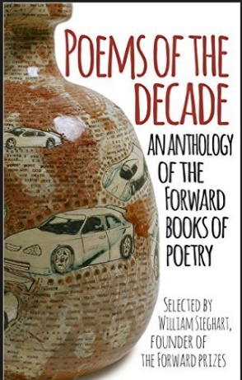Lammas Hireling
6. History
7. A Minor Role
8. On Her Blindness
9. Please Hold
10. Out of the Bag
11. Look, We have coming to Dover
12. Ode on a Grayson Perry Urn