**Godalming College**

**Geography Essential Guidance Handout**

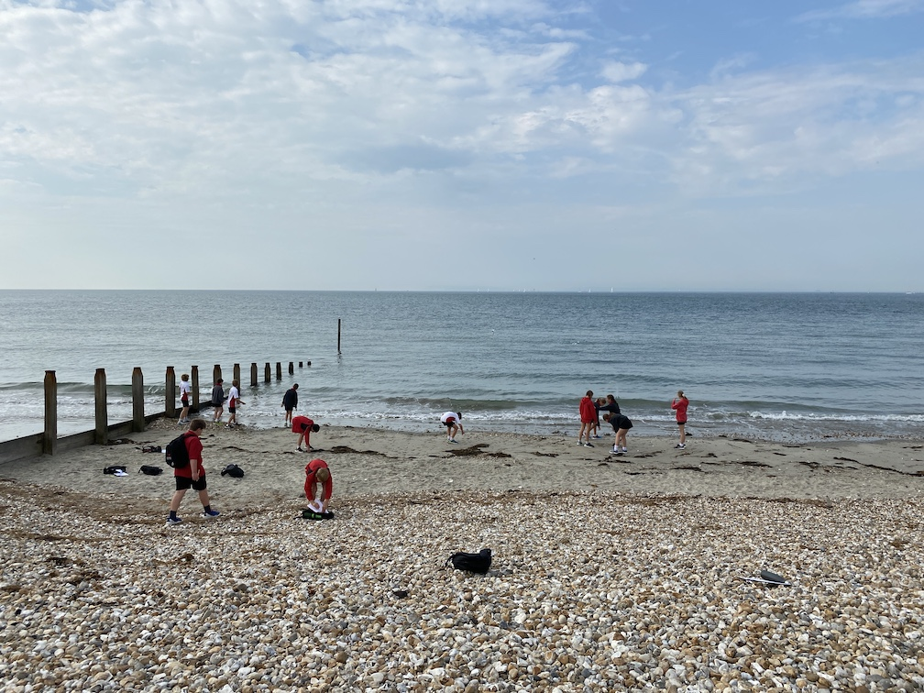 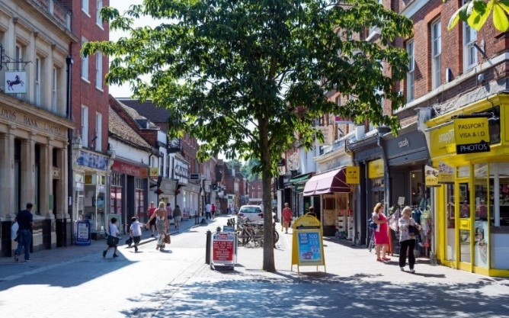

**NEA Schedule**

|  |  |  |  |
| --- | --- | --- | --- |
|  | **EASTER HOLIDAY**  **Students to read carefully through and familiarise themselves with the content of this document and the more detailed NEA guidance document on Godalming Online.**  **Start exploring the ideas and data collection techniques websites** | | |
| **w/b 17th April** | **Exploring NEA ideas, structure, introduction and methods**  **NEA planning forms** | | |
| **w/b 24th April** | **Further exploration of ideas** | **1-2-1s** | **NEA planning form to be completed** |
| **w/b 1st May** | **NEA planning form** | **1-2-1s** | **2023 candidate record form (proposal form) completed and submitted to class teacher** |
| **w/b/ 8th May** | **NEA planning form** | **1-2-1s** | **2023 candidate record form (proposal form) completed and submitted to class teacher** |
| **w/b 15th May** | **DEADLINE - CANDIDATE PROPOSAL FORM**  **Introduction to be started**  **Field data collection to be organised** | | |
| **w/b 22nd May** | **Continuation with introduction and method sections**  **Students to start collecting data** | | |
| **w/b 29th May** | **HALF TERM**  **DEADLINE – ALL DATA COLLECTION TO HAVE BEEN COMPLETED** | | |
| **w/b 5th June** | **FORMAL CHECK – INTRODUCTION** | | |
| **w/b 12th June** | **FORMAL CHECK – METHOD** | | |
| **w/b 26th June** | **FORMAL CHECK – CRITICAL ANALYSIS,** | | |
| **w/b 3rd July** | **FORMAL CHECK – CONCLUSION AND EVALUATION** | | |

**Coasts fieldwork ideas and data collection techniques**

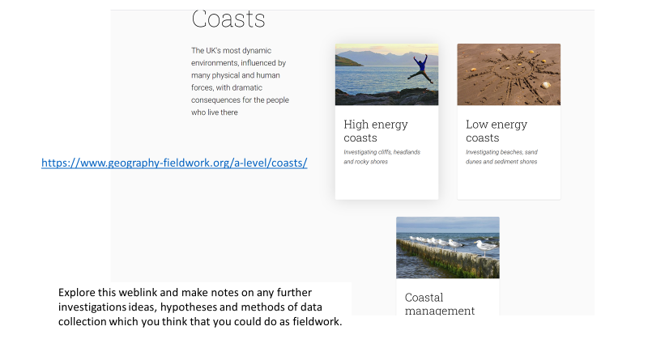

**Field Studies Council**

<https://www.field-studies-council.org/resources/16-18-geography/coasts/>

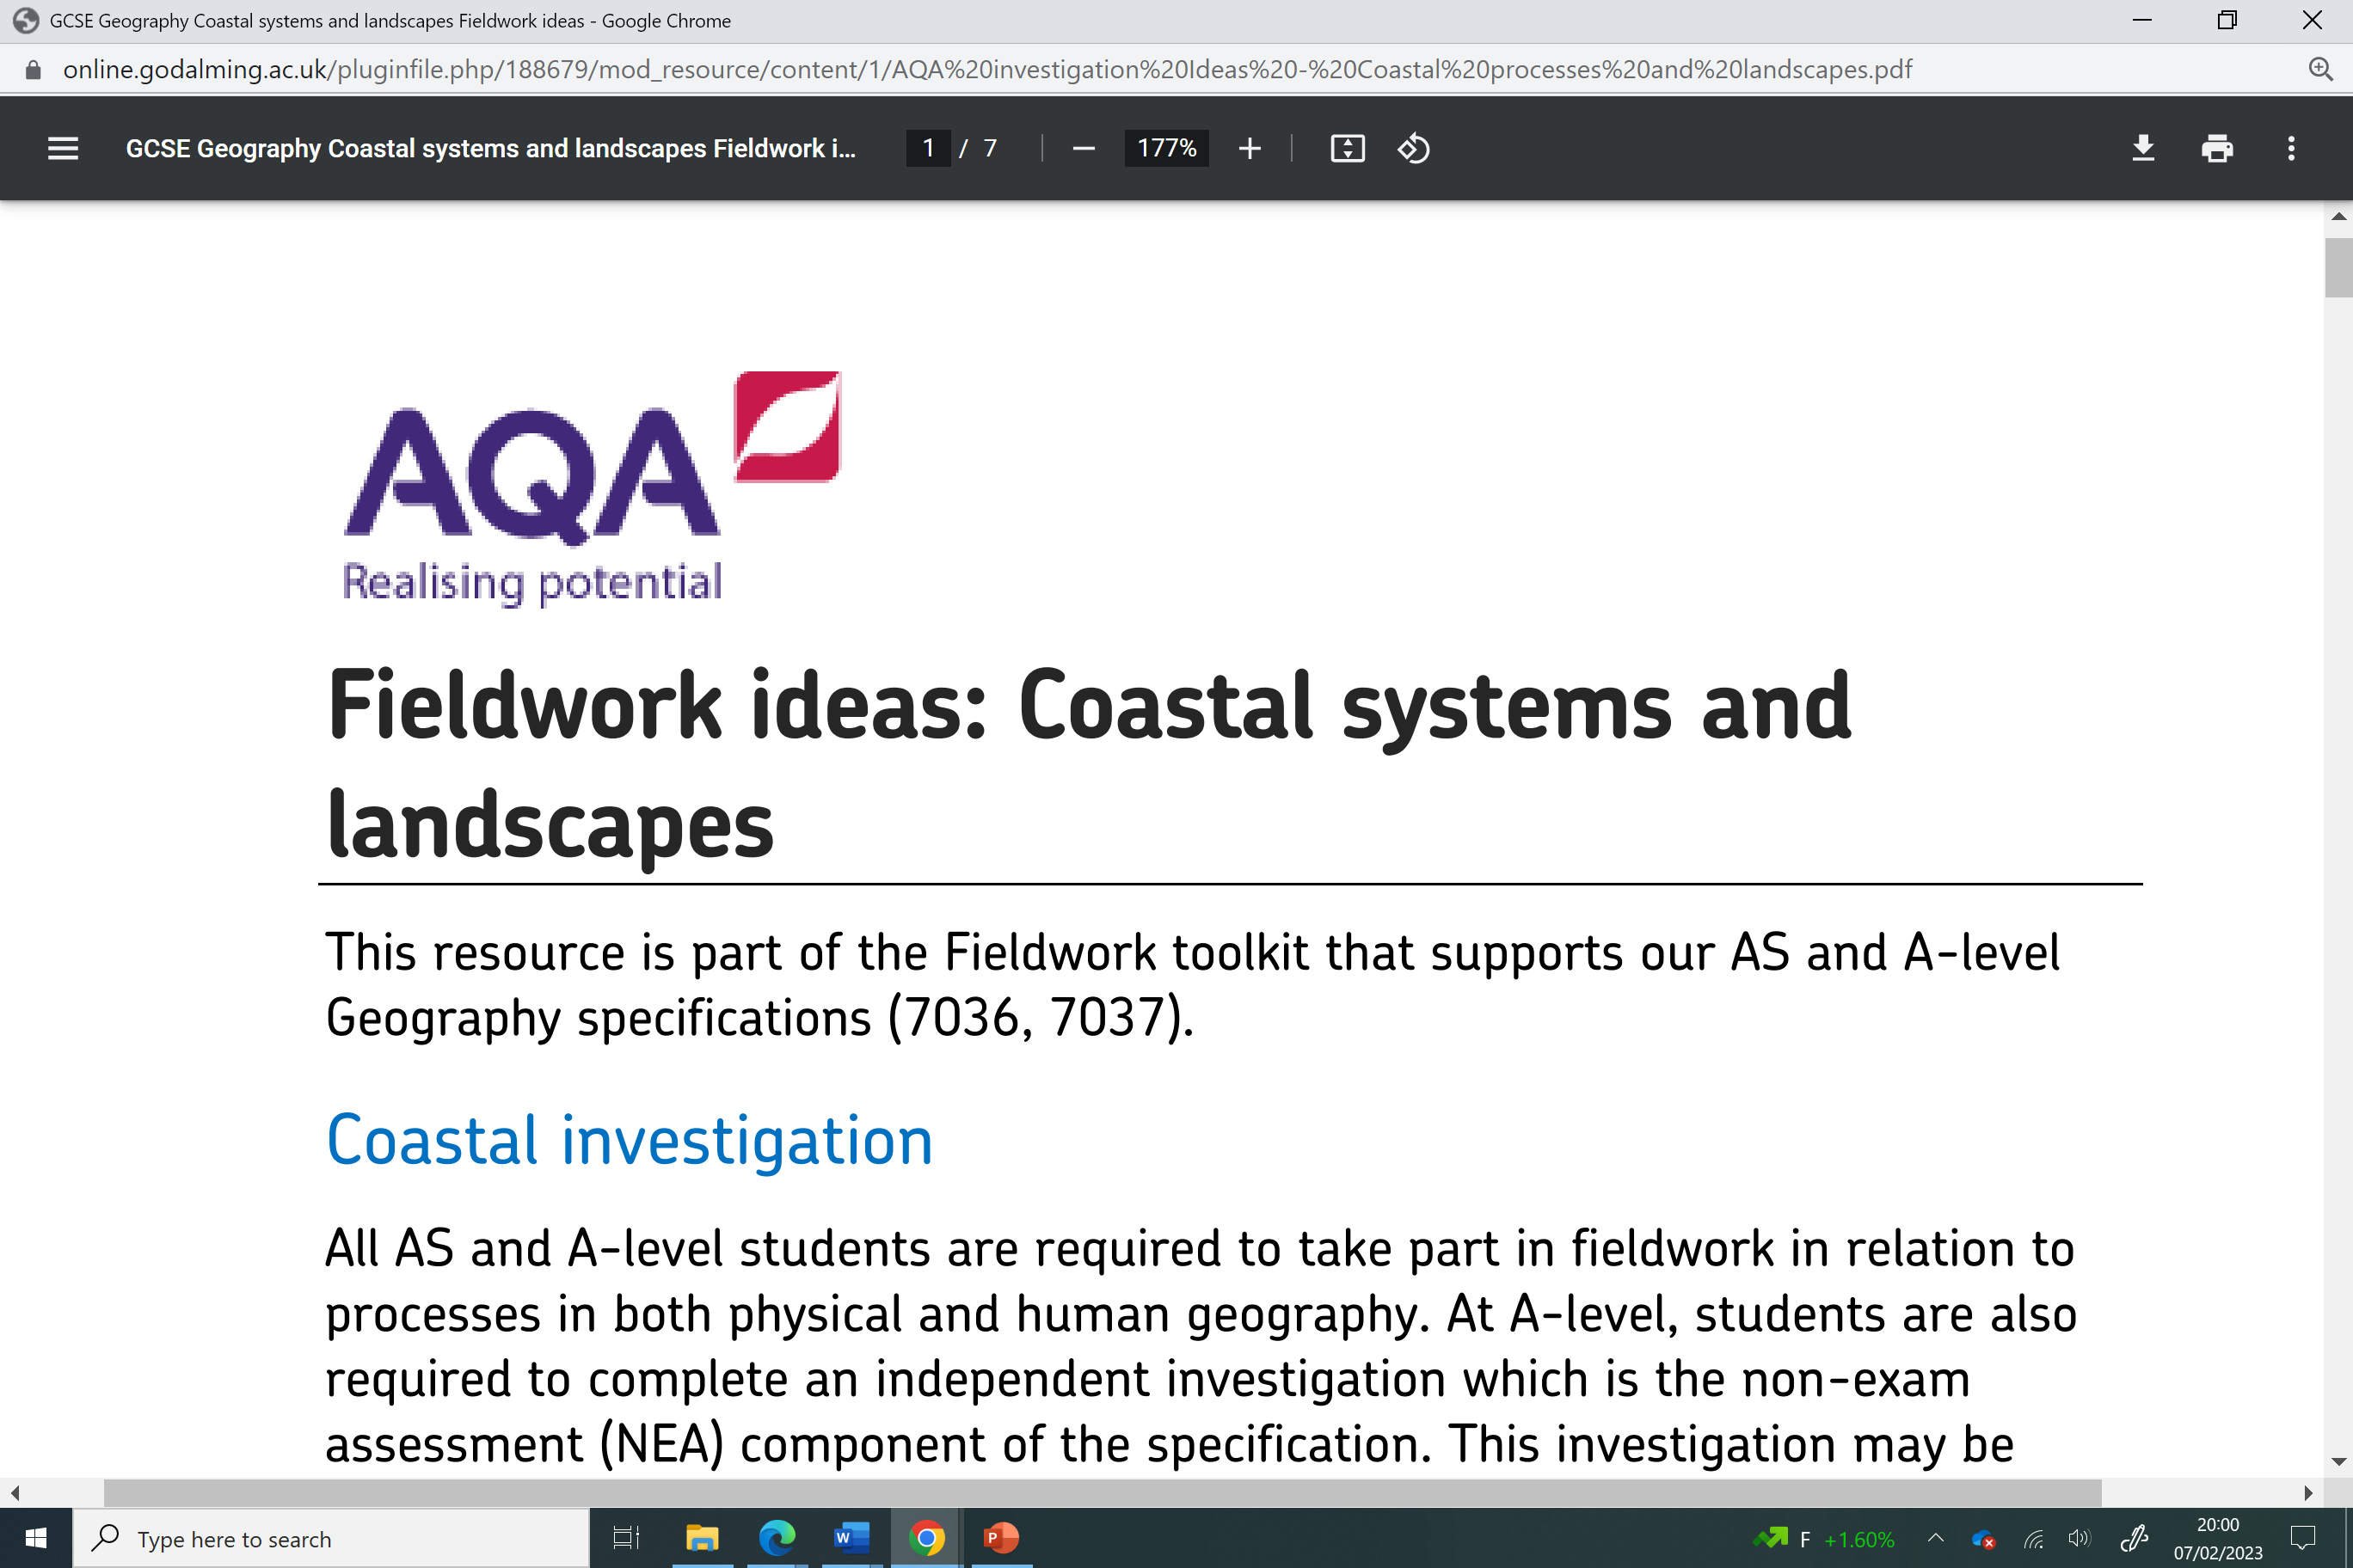

<https://online.godalming.ac.uk/pluginfile.php/188679/mod_resource/content/1/AQA%20investigation%20Ideas%20-%20Coastal%20processes%20and%20landscapes.pdf>

**Royal Geographical Society**

[**https://www.rgs.org/schools/teaching-resources/coasts-(1)/**](https://www.rgs.org/schools/teaching-resources/coasts-(1)/)

**The following video clips will give you a range of ideas as to what you could investigate as part of a coastal investigation.**

[**Coastal Geography Fieldwork at Millock, North Cornwall (instead of measuring the beach at different times of the year you could compare 2 beaches)**](https://www.youtube.com/watch?v=Fyk20HfdH20)

[**https://www.youtube.com/watch?v=Fyk20HfdH20**](https://www.youtube.com/watch?v=Fyk20HfdH20)

[**https://www.youtube.com/watch?v=g9jOvzLzWpw**](https://www.youtube.com/watch?v=g9jOvzLzWpw)

**New Zealand Measuring longshore drift fieldwork**

[**https://www.youtube.com/watch?v=-2Sm7kOAsjk**](https://www.youtube.com/watch?v=-2Sm7kOAsjk)

[**https://timeforgeography.co.uk/videos_list/coasts/investigating-beach-sand-dune-morphology/**](https://timeforgeography.co.uk/videos_list/coasts/investigating-beach-sand-dune-morphology/)

**Introduction to coastal fieldwork on the Fylde Coast**

[**https://www.youtube.com/watch?v=Eqf4IGV3yI8&list=PLKcXJcNzZvmsUmlInJ4IjbJhFasz4PkNS&index=5**](https://www.youtube.com/watch?v=Eqf4IGV3yI8&list=PLKcXJcNzZvmsUmlInJ4IjbJhFasz4PkNS&index=5)

**Risk assessment**

[**https://www.youtube.com/watch?v=5lHHQTTFHNg&list=PLKcXJcNzZvmsUmlInJ4IjbJhFasz4PkNS&index=6**](https://www.youtube.com/watch?v=5lHHQTTFHNg&list=PLKcXJcNzZvmsUmlInJ4IjbJhFasz4PkNS&index=6)

**Measuring height of groynes**

[**https://www.youtube.com/watch?v=Dj3gMKcDy5w&list=PLKcXJcNzZvmsUmlInJ4IjbJhFasz4PkNS&index=4**](https://www.youtube.com/watch?v=Dj3gMKcDy5w&list=PLKcXJcNzZvmsUmlInJ4IjbJhFasz4PkNS&index=4)

**Bi polar – rock groynes**

[**https://www.youtube.com/watch?v=7OMKgVjDB54&list=PLKcXJcNzZvmsUmlInJ4IjbJhFasz4PkNS&index=2**](https://www.youtube.com/watch?v=7OMKgVjDB54&list=PLKcXJcNzZvmsUmlInJ4IjbJhFasz4PkNS&index=2)

**Bi-polar revetments**

[**https://www.youtube.com/watch?v=IG3zPWxYrP8&list=PLKcXJcNzZvmsUmlInJ4IjbJhFasz4PkNS&index=3**](https://www.youtube.com/watch?v=IG3zPWxYrP8&list=PLKcXJcNzZvmsUmlInJ4IjbJhFasz4PkNS&index=3)

**Bi-polar rock armour**

[**https://www.youtube.com/watch?v=FVxyA3QW7Rg&list=PLKcXJcNzZvmsUmlInJ4IjbJhFasz4PkNS&index=1**](https://www.youtube.com/watch?v=FVxyA3QW7Rg&list=PLKcXJcNzZvmsUmlInJ4IjbJhFasz4PkNS&index=1)

**Human Geography fieldwork ideas and data collection techniques**



**Field Studies Council**

[**https://www.field-studies-council.org/resources/16-18-geography/place/**](https://www.field-studies-council.org/resources/16-18-geography/place/)

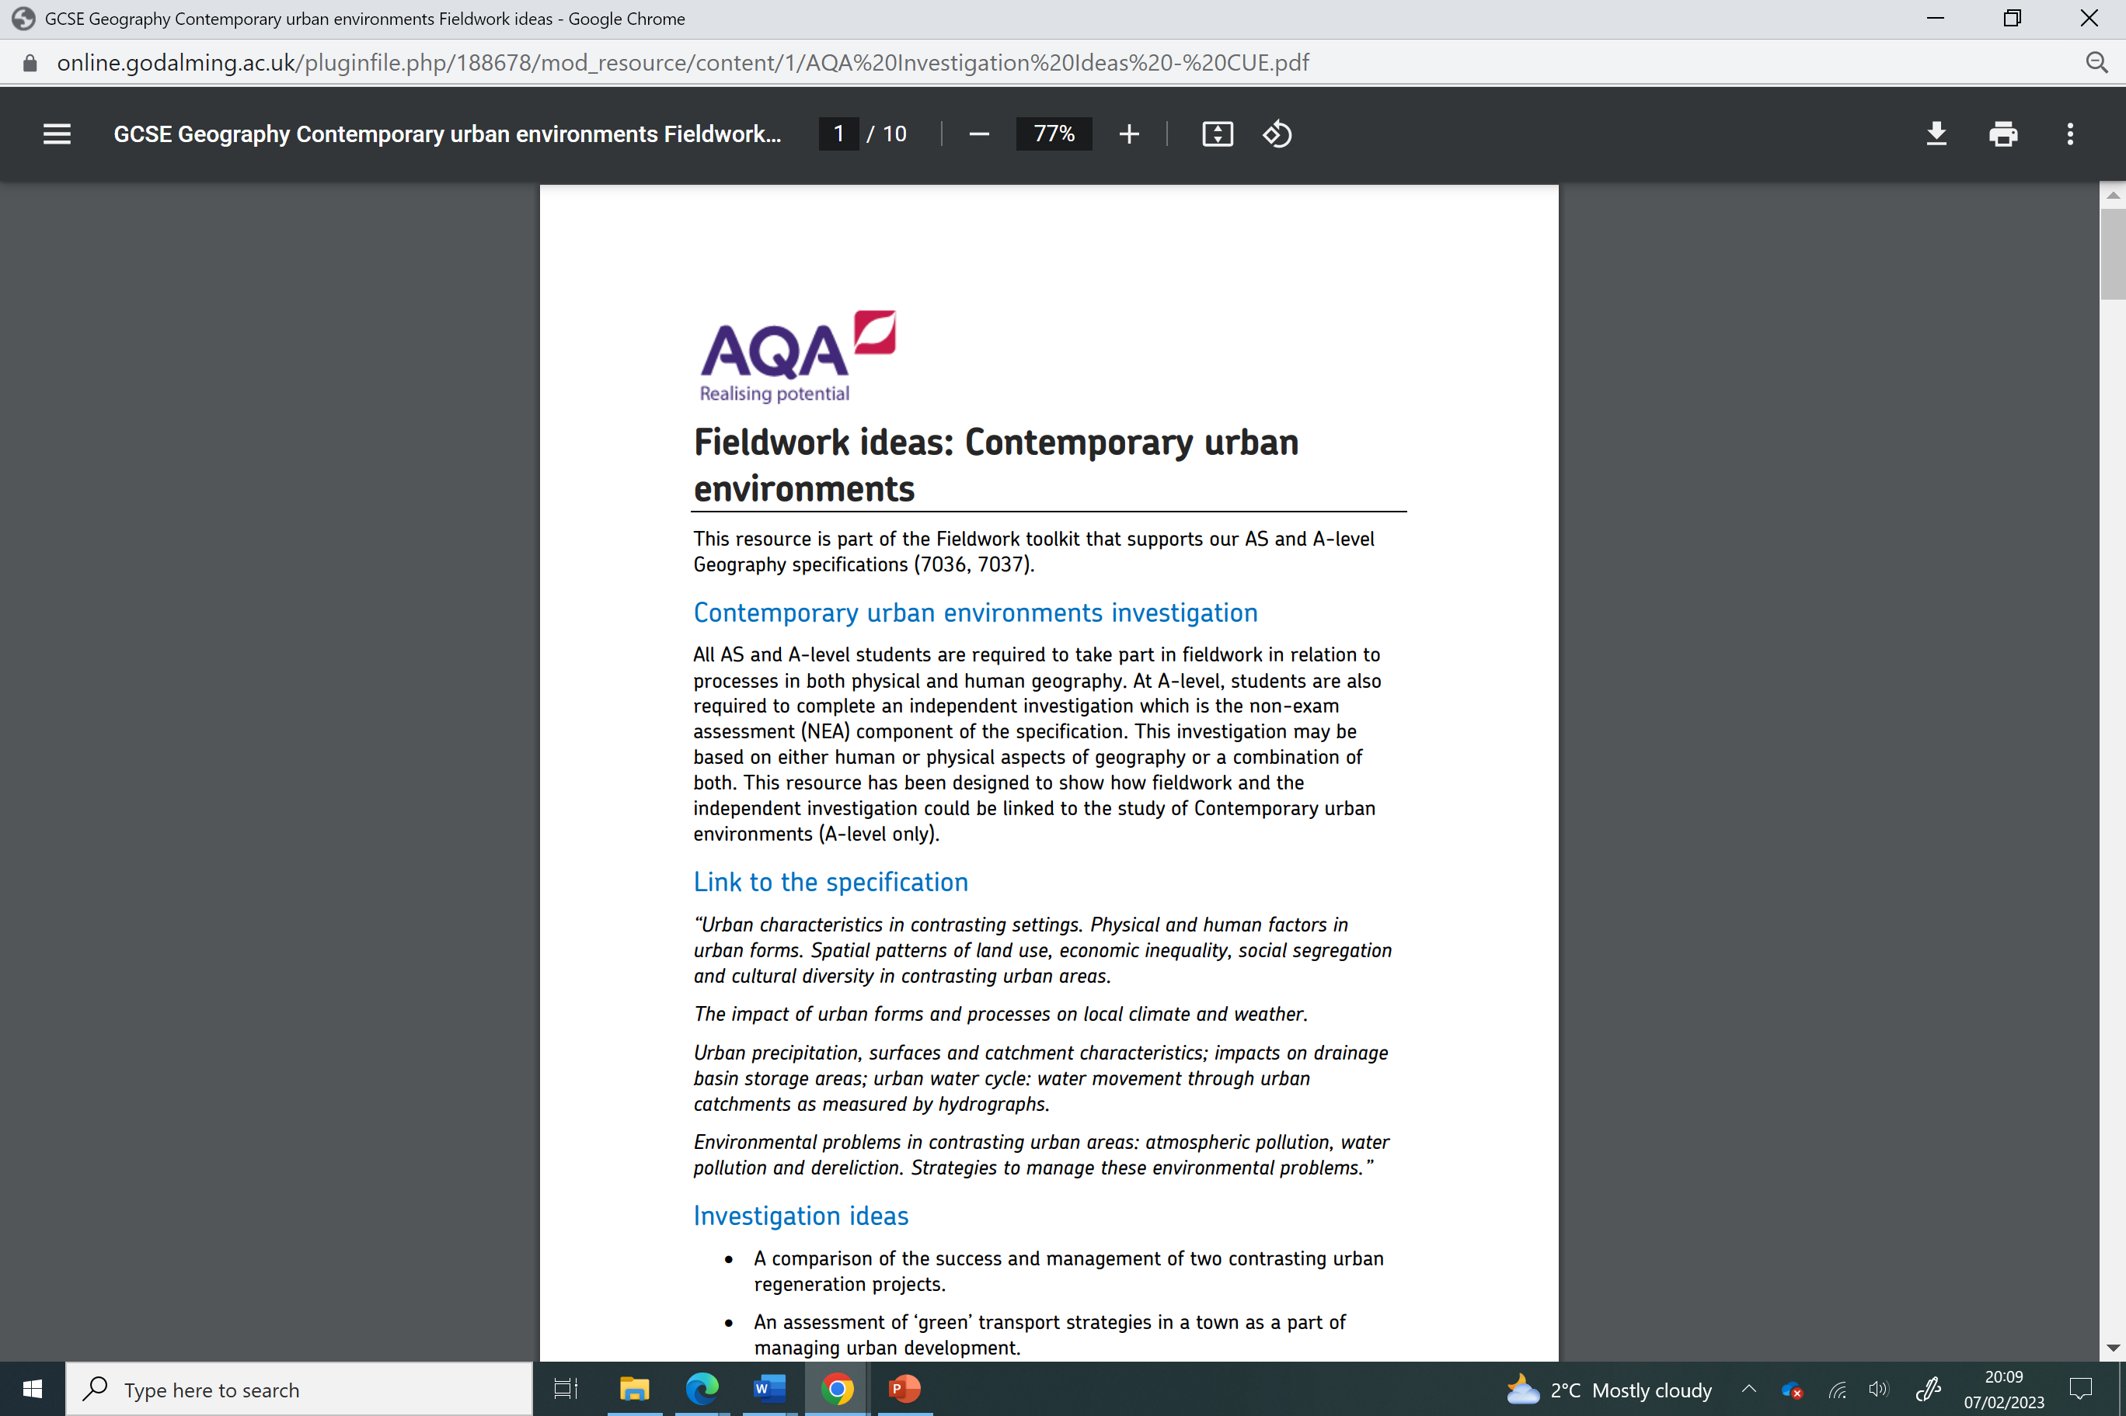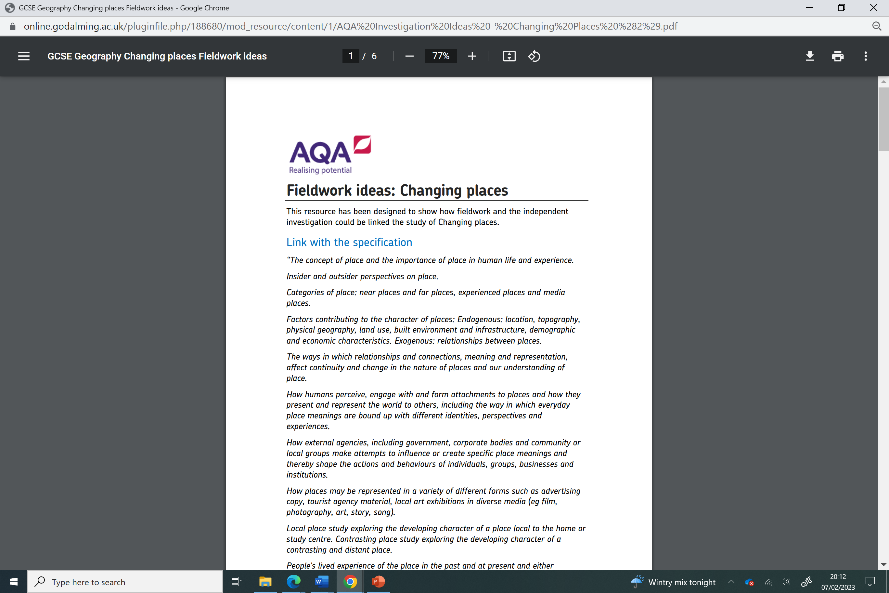

<https://online.godalming.ac.uk/pluginfile.php/188680/mod_resource/content/1/AQA%20Investigation%20Ideas%20-%20Changing%20Places%20%282%29.pdf>

<https://online.godalming.ac.uk/pluginfile.php/188678/mod_resource/content/1/AQA%20Investigation%20Ideas%20-%20CUE.pdf>

**Royal Geographical Society**

[**https://www.rgs.org/schools/teaching-resources/urban-and-settlement/**](https://www.rgs.org/schools/teaching-resources/urban-and-settlement/)

[**https://www.rgs.org/schools/teaching-resources/human-impact-studies/**](https://www.rgs.org/schools/teaching-resources/human-impact-studies/)

[**https://www.rgs.org/schools/teaching-resources/quality-of-life/**](https://www.rgs.org/schools/teaching-resources/quality-of-life/)

[**https://www.rgs.org/schools/teaching-resources/urban-studies/**](https://www.rgs.org/schools/teaching-resources/urban-studies/)

**Your investigation needs to be planned with every step of your NEA in mind**

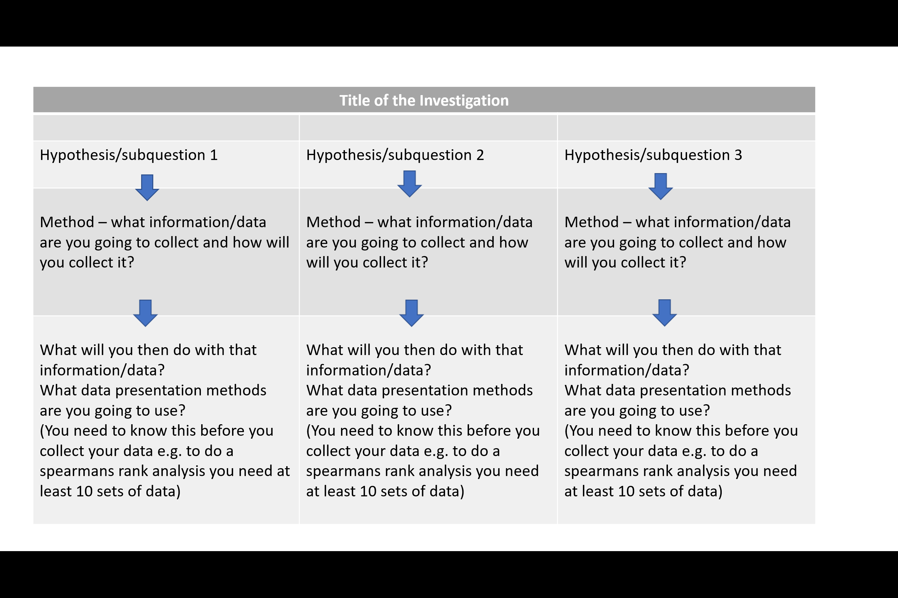

**You must have an idea of how all the sections of your investigation are linked before you start collecting any data. For example, you need to know how many sets of data you might need before you collect data so that you can complete the statistical test you are hoping to do or that you have chosen suitable streets to see if gentrification has occurred more in one area than another.**

**You need to know where exactly you will be collecting the data and so research needs to be carried out – this can be conducted remotely via the map tool on ArcGis, Google Earth or on Google Maps.**

**The following websites are also excellent for secondary secondary data and identifying suitable locations:-**

<https://maps.nls.uk/> Historical maps from National Library of Scotland

[https://geographyfieldwork.com](https://geographyfieldwork.com/BeachProfile.htm) Barcelona Field Studies

[https://www.geography-fieldwork.org](https://www.geography-fieldwork.org/a-level/coasts/) Field Studies Council – ideas for titles, methods and data presentation

<https://schools.esriuk.com/> ArcGIS

<https://datashine.org.uk/> Census maps

<https://www.nomisweb.co.uk/> Census data

<https://www.police.uk/> Local crime data

<https://www.gov.uk/government/publications/shoreline-management-plans-smps> Shoreline management plans

<https://maps.cdrc.ac.uk/#/geodemographics/imde2019/default/BTTTFFT/10/-0.1500/51.5200/> Index of multiple deprivation

<https://windy.app/forecast2/spot/61414/West+Wittering> Wind data

[Google Earth](https://earth.google.com/web/) Google Earth

<https://southerncoastalgroup-scopac.org.uk/scopac-research/sts-2012/> Scopac Map showing sediment transfer

**Student Planning Form**

|  |  |
| --- | --- |
| Student Name |  |
| Proposed independent Investigation title |  |
| Link to exam board specification  e.g. 3.2.3.4 Urban climate The impact of urban forms and processes on local climate and weather. Urban temperatures: the urban heat island effect. Precipitation: frequency and intensity. Fogs and thunderstorms in urban environments. Wind: the effects of urban structures and layout on wind speed, direction and frequency. Air quality: particulate and photo-chemical pollution. |  |
| Research questions/hypotheses  Keep it really simple and directly linked to the data you are planning to collect  e.g. pebble size will be greater on the backshore and smaller at the foreshore  or  Place X will have a higher crime rate than place Y |  |
|  |
|  |
| What are the geographical theories associated with your investigation e.g. theory of LSD or process of suburbanisation | **THIS IS ESSENTIAL – YOUR INVESTIGATION HAS TO LINK TO THEORY** |
| Proposed location for data collection  Go onto ArcGIS and produce a map showing the location and sampling points that you would use. |  |

**More copies of this form can be printed out from GoL.**

**It is found in the Independent Investigation Folder and within the NEA proposal and write-up folder**

|  |  |
| --- | --- |
| Risk assessment and ethical issues and concerns to consider |  |
| Methods of data collection:  Primary  Secondary  Quantitative  Qualitative  Systematic  Stratified  Random  Pragmatic/opportunistic |  |
| Possible methods of data presentation (including statistics) |  |

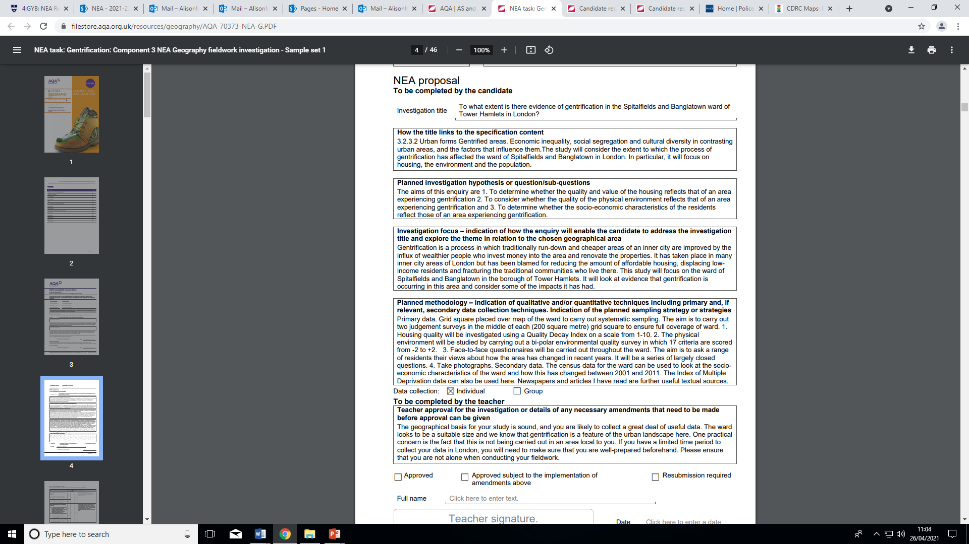

**A blank soft copy of this document can be found on GoL in the Independent Investigation folder.**

**It must be completed in as much detail as possible and approved by your class teacher. It is an integral part of your NEA and will be submitted with your investigation.**

### Teacher guidance for students

Teachers should:

* provide broad parameters for students’ investigation proposals (including themes from the specification, locations, availability of equipment, time constraints)
* explain what independence means
* advise on health and safety considerations, the use of equipment and potential ethical concerns
* discuss with students their initial exploratory planning and tentative investigation titles
* review each student’s independent investigation proposal. Within this review you should ensure that the proposed investigation can suitably access the specification requirements and you should give general guidance on the methodology and analytical tools that the student plans to use.
* advise on good practice such as referencing and using a bibliography system.

The above advice does not need to be recorded or taken into account when marking the work.

Teachers must not:

* provide students with a choice of titles or tasks from which they then choose
* mark work provisionally and share that mark so that the student may then improve it
* give specific guidance on how to make improvements to a draft in order to meet the assessment criteria without recording it as additional assistance on the Candidate record form (CRF) and taking it into account when marking the work.

These conditions apply equally to third party fieldwork providers. Failure to adhere to them constitutes malpractice. You must ensure that at all times you remain confident in the authenticity and independence of students’ work.

Assistance that goes beyond general advice includes (but is not limited to):

* providing templates or model answers for specific titles or students
* providing specific guidance on how to improve an individual student’s draft to meet the assessment criteria so that the student is no longer engaged in independent learning
* providing specific guidance on errors and omissions which limits students’ opportunities to show initiative themselves
* providing primary or secondary data not collected by the student either individually or as part of a group.

Any additional guidance of this nature must be recorded on the Candidate record form (CRF) and taken into account when marking the work. Annotation must be used to explain how marks were applied in the context of the additional assistance given. Failure to do so will be considered as malpractice.

If malpractice is suspected with regard to guidance and feedback to students, we will investigate. If malpractice is found to have taken place a penalty will be given dependent on the circumstances and severity of the malpractice. For full information, please see [Malpractice](https://www.aqa.org.uk/subjects/geography/as-and-a-level/geography-7037/non-exam-assessment-administration#Malpractice) and the JCQ instructions Suspected Malpractice in Examinations and Assessment.

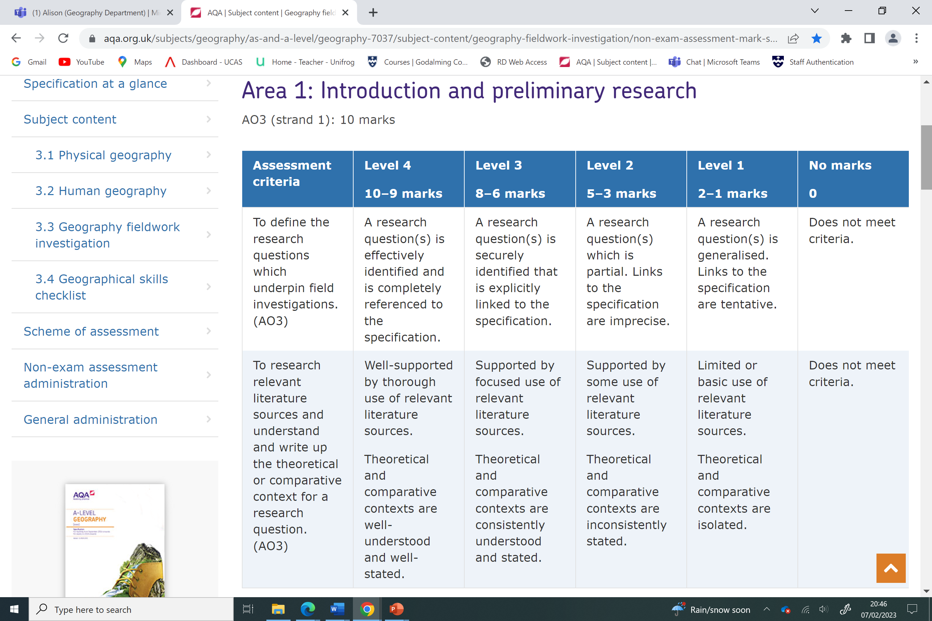

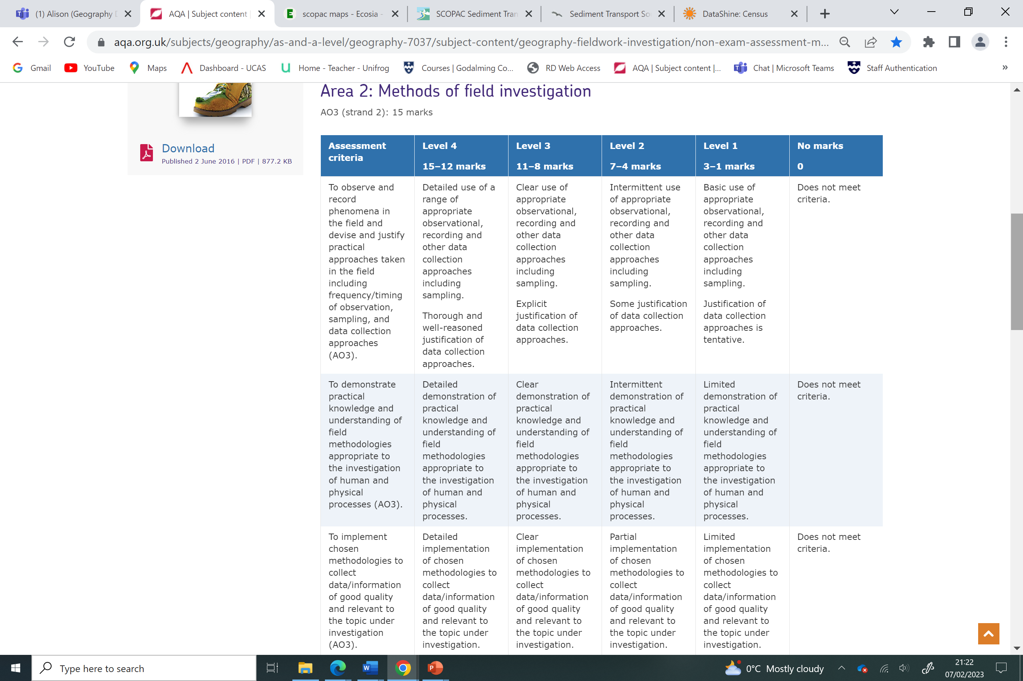

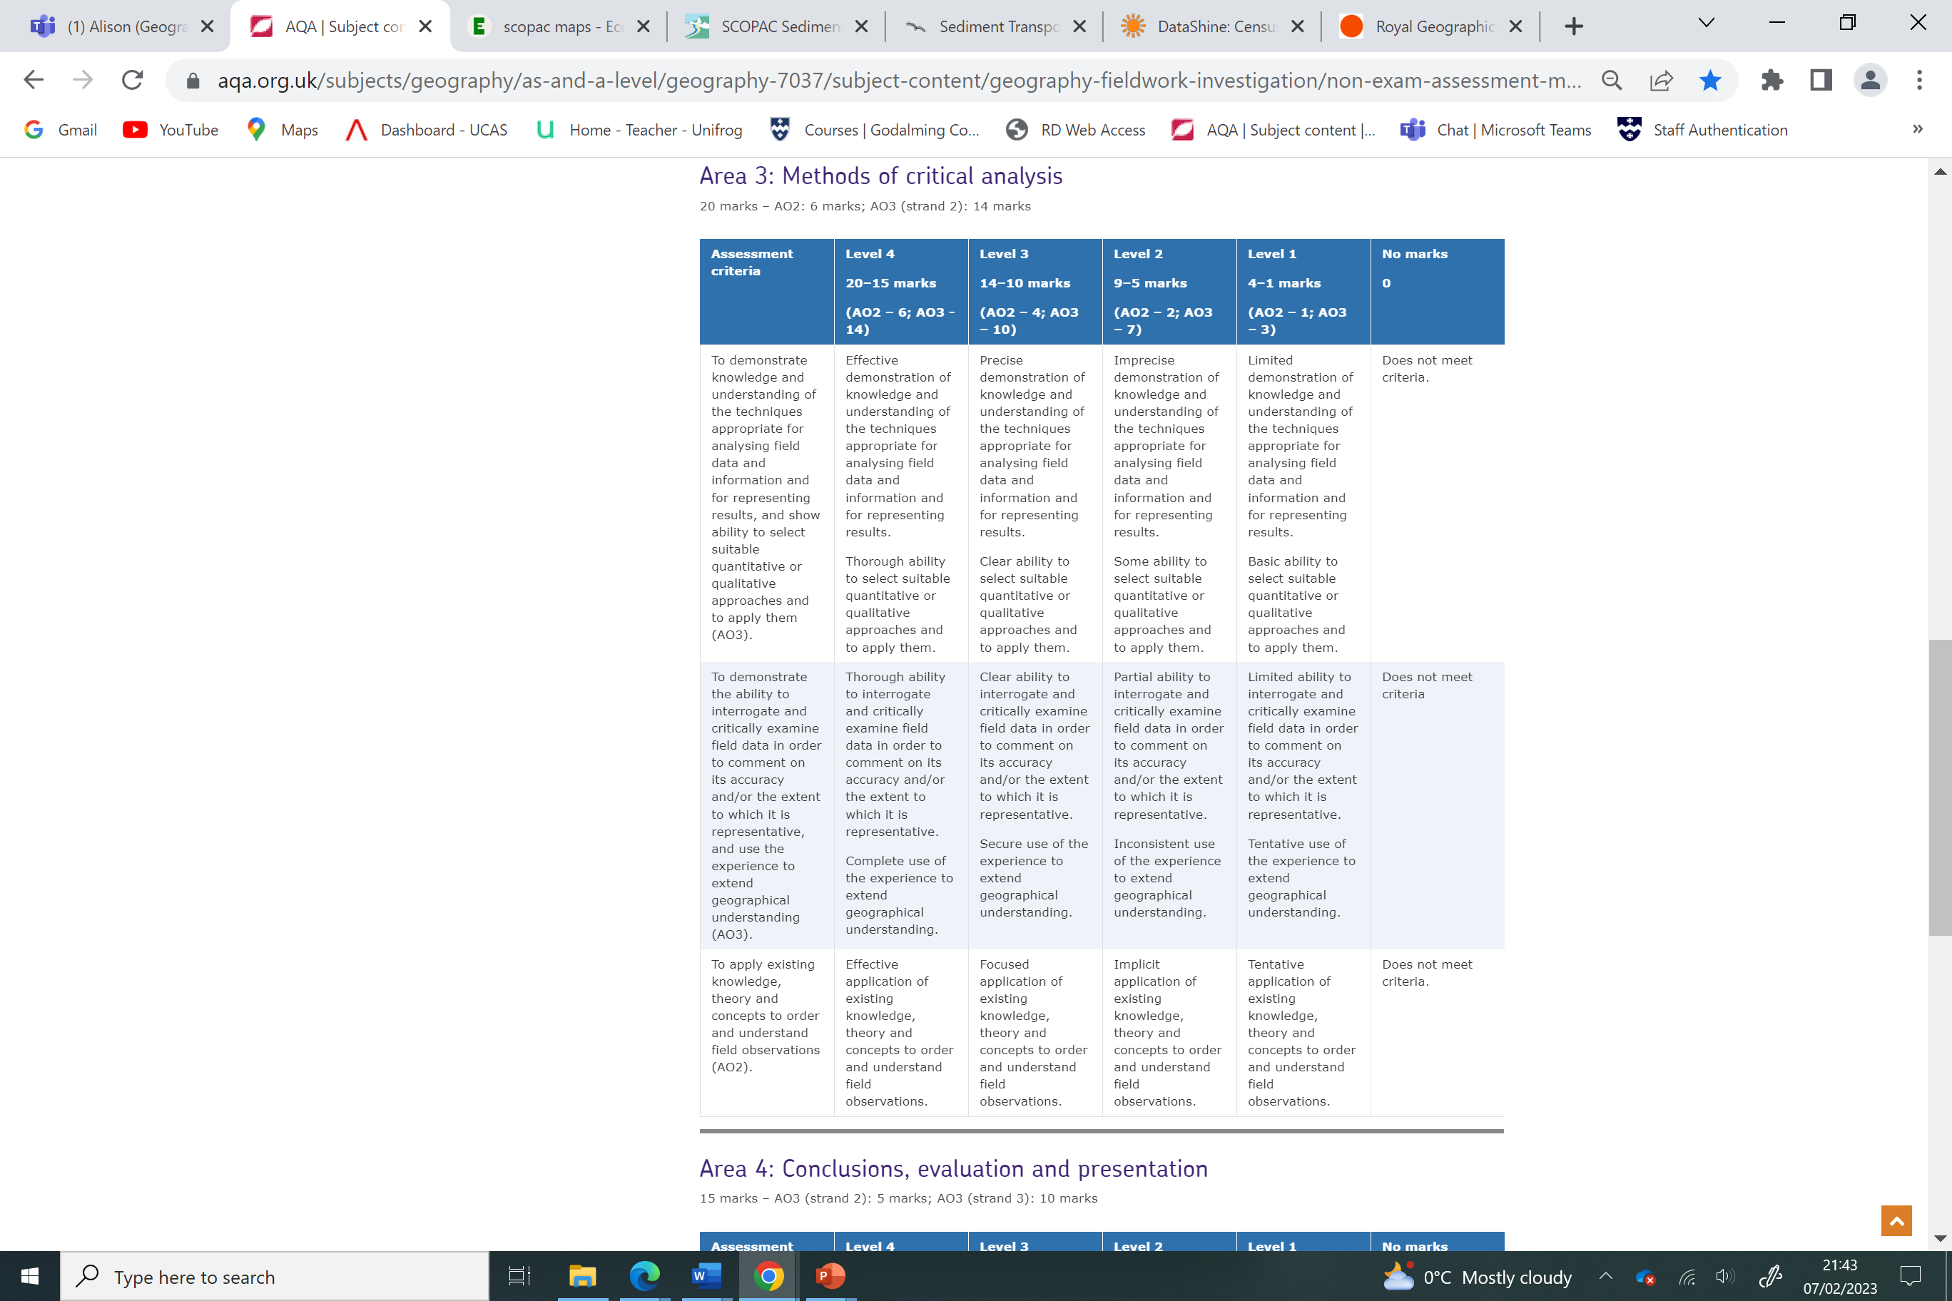

### 

How to use the referencing tool in Word:

1. Open a Word document
2. Type something that you have copied from a book/article/website
3. Click on the reference tab and insert citation and then click on new source
4. Complete as many of the fields as you can (some may not be relevant) and click OK
5. When you have completed all the citations you can click on the bibliography tab and it will automatically create a bibliography at the end of your document.   
     
   YOUR INVESTIGATION WILL START WITH RESEARCH AND SO THIS MUST BE COMPLETED FROM THE START

**Formatting Requirements**

* Use A4 page size
* Choose line spacing that aids readability (1.5 line spacing)
* Use Arial, Times, New Roman, Verdana, Candara or Calibri Fonts (11-12 points)
* Use page numbers
* Use spell/grammar check
* Include word count on the front cover page
* Include the following in a header or footer:
  + 5-digit centre number
  + Candidate number
  + Component Code

Abbreviations (acronyms) can be used if they are in common use and meaningful to the reader. They should be explained in the first instance, e.g. HDI (Human Development Index)

Table and figures, in general, should be comprehensible without reference to the text, i.e. labelled and numbered, followed by a short description of the contents.

* Include page breaks between the different sections of the investigation, e.g. Introduction, page break and then Methodology etc.
* Contents page (advisable to show structure)
* Referencing – make sure that this is integrated throughout. You should refer to all documents / websites that you have used to help you with the investigation, e.g. sampling techniques in your methodology – you may insert a reference to a particular fieldwork guide / book.
* Bibliography (at the end and Harvard style – see guidance on Godalming Online)
* Proof read your work to make sure that it makes sense
* Candidate record form – update and format

**Geography NEA Checklist**

**Name:**

**This checklist is designed to help you ensure you have fulfilled the minimum requirements of the NEA. It is not a guarantee of success as this will depend on the quality of the investigation itself.**

|  |  |
| --- | --- |
| **Area 1. Introduction and preliminary research - 10 marks** | **Evidence and page number in your Independent Investigation** |
| A research question(s) is effectively identified and is completely referenced to the specification with a suitable comment as to how it is relevant. |  |
| You may have broken your key question down into specific key questions or hypothesis. |  |
| Well-supported by thorough use of relevant literature sources and fully referenced within the text and a bibliography. |  |
| You have included clear maps to show where your study area is located. Maps should be labelled/annotated or referred to in your text. |  |
| Your maps each have a source, title, scale and north arrow. |  |
| You have linked your question to geographical theory (i.e. the type of information you would find in a text book and online sources). This may be a model, concept, idea or geographical theory. |  |
| You have compared your study area to another with similar characteristics/problems/management where relevant. |  |
| You have included a literature review table at the end of your introduction |  |

|  |  |
| --- | --- |
| **Area 2. Methods of field investigation - 15 marks** | **Evidence and page number(s) in your Independent Investigation** |
| You have included methods of primary data collection. |  |
| You have included sources of secondary data collection. |  |
| Every type of data collection links very closely to your coursework question. If it doesn’t, change the method! |  |
| You have explained in detail exactly how you will collect each type of data. |  |
| You have said whether each type of data collection is stratified, systematic, random or pragmatic and why you selected this method. |  |
| You have said how much data you will collect (frequency and repetition), when you will collect it and referred to any collection methods requiring timing. |  |
| You have been specific on the timing of your data collection (time of day, date, season etc.) |  |
| You have justified your choice of study sites, making clear reference to your question. |  |
| You have a detailed paragraph referring to the ethics of collecting accurate and fair data. |  |
| You have identified problems, limitations and improvements for your data collections methods. |  |
| You have made a clear point to explain why you think your data is as accurate as it can be (evaluation will come in later). |  |
| You have mapped and labelled individual data collection sites |  |

|  |  |
| --- | --- |
| **Area 3. Methods of critical analysis - 20 marks** | **Evidence and page number(s) in your Independent Investigation** |
| You have used at least 4 different presentation methods and included a range of styles of presentation methods. |  |
| Where possible, use a statistical test to show the significance of your findings. Tests such as Spearman’s or Standard deviation are ideal although simpler calculations such as the interquartile range are also acceptable. |  |
| Every type of presentation is accurate and complete with scales, north arrows, titles, sources etc. |  |
| You have evaluated how well you think you followed the ethical dimension of your fieldwork (look back at your methodology for this) |  |
| You have justified your choice of presentation methods and have suggested other possible methods you could have used in hindsight. |  |
| You have a detailed analysis of your field data presentation techniques. |  |
| You have linked every piece of data presentation back to your original question to form a **conclusion.** |  |
| You have used evidence (more than one piece of evidence per point) to back up your conclusive statements. |  |
| You have interrogated and critically examined your field data in order to comment on its accuracy and/or the extent to which it is representative. |  |
| You have clearly answered your overall question/aims/hypothesis, showing alternative answers too (how your evidence might show other answer). |  |
| You have used evidence to show how the experience has extended geographical understanding. |  |
| You have shown effective application of existing knowledge, theory and concepts to order and understand your field observations. |  |
| You have ensured photograph annotations are detailed and of good quality |  |

|  |  |
| --- | --- |
| **Area 4. Conclusions, evaluation and presentation - 15 marks** | **Evidence and page number(s) in your Independent Investigation** |
| You have written a coherent analysis of your fieldwork findings in order to answer a specific geographical questions. |  |
| You have a complete explanation of how the results relate to the wider context. |  |
| You have a thorough understanding of the ethical dimensions of field research. |  |
| You make frequent links back to the question and you have backed up each point with evidence. |  |
| You have questioned whether your conclusions would be any different if you had collected different data or changed your methodology. |  |
| You have evaluated whether you think you chose the right methods and if not, why not. You have suggested what other possible methods you could have used. |  |
| You have linked every piece of data presentation back to your original question (these are like mini conclusions). |  |
| Your report is well organised throughout. |  |
| You have used a wide range of key terms. |  |
| You have proof-read your NEA to eliminate SPAG errors |  |