Cotents page

1st page, an overview of how I filed my assets ensuring I’m organised

2nd page, Breakdown of the the creative process of my first scene

3rd, page breakdown of the creative process for my favourite shot

4th page, my unique lighting set up and effectiveness of last shot

5th page, index of secondary sources/ Legal onsiderations regarding music and sound effects

To help me with this project I organised my files accordingly. I named my first file assets, this contains all my content that I have sourced, primary and secondary, to help with my drama

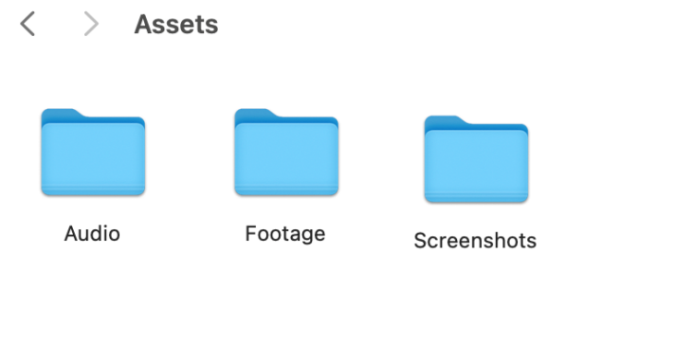Within my assets folder I have three distinct folders . These contain what they say on the front, however without them I wouldnt be able to allocate what type of content I needed. For my audio I have used tracks which arent mine and are fom a third party source. Thats why the audio is the only folder with a primary and secondary sub folders within.

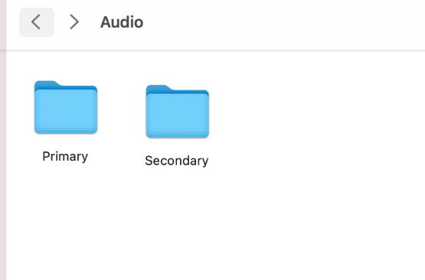

My footage is all in order and the names of each clip is an accurate description of whats in the shot. I have also numbered each shot, this has enabled me to make the editing process easier as I have numbered the clips. This is because as I’ve preplanned where I want each shot, creating the introduction to my drama will be easy to assemble when editing.

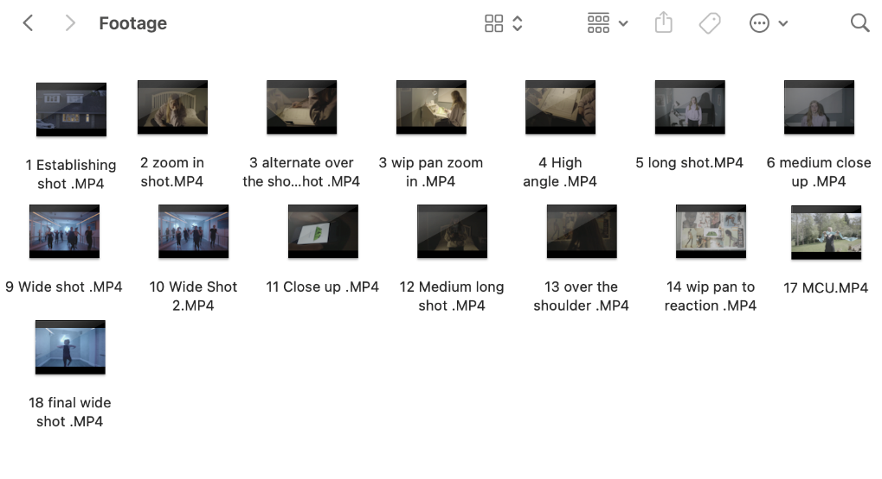I only shot primary footage so there was no need for me to create two different folders like I have done for audio. This is because I know straight away that alll the footage is mine as I shot it it using my camera in a log, thats why the colours look washed out.

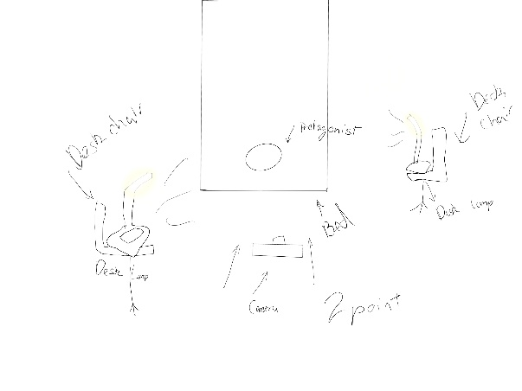The first shot of the protagonist uses a two-point lighting set up. This adds the rembrandt effect to the subject’s face, which helps reflect the mood of the scene. The harsh contrast of the makes the shadows prominent which visually shows the viewer how Izzy (the protagonist ) isn’t in her element as she ‘didn’t like school’. The lighting also made for a better looking shot, making the scene look professional and visually enticing for the demographic of teens. This first scene will contrast with when Izzy is dancing further into the episode. This allows for an easier understanding when Izzy is in her element and when she isn’t, which helps build tension within the narrative as the viewer knows when they arent feeling themselves under pressure. Struggiling to decide whats her ‘priority’ dance or her school work.

I was filming on a budget, so I only had access to two desk lamps, however they both worked effectively to achieve this effect. This scene was filmed in my sisters room, I set up both the lamps on desk chairs and adjusted them both accordingly until I successfully created this desired lighting effect. I turned all of my sisters lights on and left the two lamps to be the main source of light. This was to further add the point that Izzy left her work to the last minute as she ‘didn’t like school’.

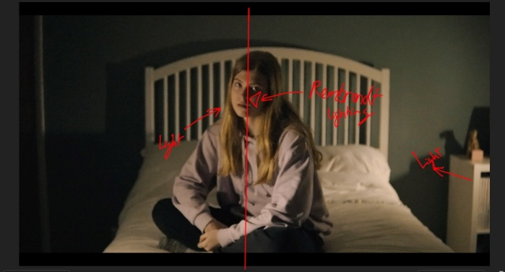The composition of this of this scene places the protagonist centre frame. This adds visual elegance to the scene which draws the watcher in. It also helps draw all the focus onto what Izzy is doing e.g., facial expressions and her physicality. As she doesn’t speak in the opening squence, the voice over I do helps drive the narrative forward. It also helps for an easier unstanding of what Izzy is doing within the shot. It adds further context to the character which makes the opening sequence a perfect introduction to the character and the start of the drama as the viewer is interested into what Izzy will do next after her accident.

The camera punches in, which enages the viewer straight from the start. This was a technique used in euphoria which is what the projects style is based on. The cinematography uses movements in every scene, which makes each second of the episodes lively. I wanted my drama to do that as it allows for a more enaging opening sequence.

For 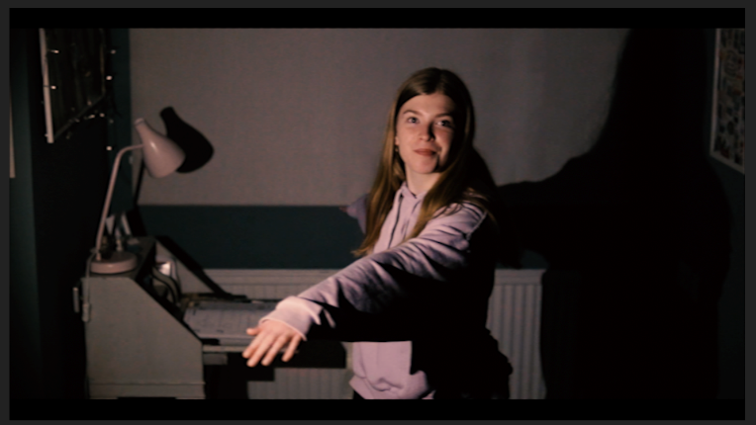this next shot I wanted to portray Izzy being in awee at becoming a dancer. When creating the project this was a scene I hadn’t planned out. During my creative processs of deciding how to use my minimal number of lights I had to effectively shape them around the protagonist. I realised that my side light can be used to create a sort of spotlight effect. The effect was achieved by my mum slowly lowering her the side lamp over Izzy to get the desired shot. The effect came out welll as it makes her downfall of her spraining her sprained her ankle, more upsetting as becoming ‘pro’ is her dream.

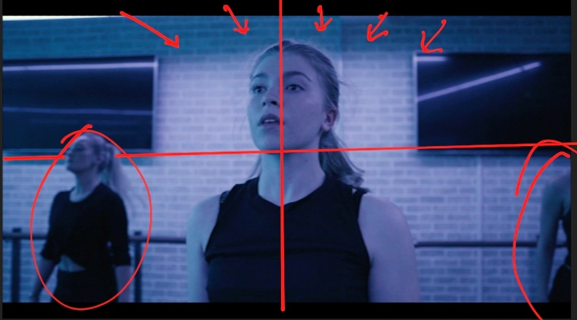The lighting odf the dance studio I filmed at was creative. There were LEDs surrounding the studio which could be chnaged to any colour I wanted. I went for a blue and purple effect, I loved how it looked on camera and it made her seem as if Izzy was in her own ‘euphoria’when she is dancing. Which further connotes how this is her dream that she is chasing to become a professional dancer. In this scene she is also centre frame, this is because I wanted the audinece to see that even though her passion is dance, being at the level that she wants to be is very challenging. I filmed with a f1.5 apture to achieve the blurred backgraound look. This helps Izzy stand out and also keeps all the attention onto how she is feeeling in the scene.

As I have already mentioned the camera moves a lot in the sequence. The use of punch ins and outs, whip pans and tracking shots all are successfullly used to create tension in the piece. For a teen audience this makes it more enjoyable and enticing as it’s not just the narrative that helps drive the drama forward it’s the way its shot to convay tension. As it builds up to her entering the competition but the movement stops when she sprains her ankle. The drama is paired perfectly with my song choice of ‘Nate Growing Up’ created by labrinth for Euphoria.It adds adrenaline to the opening sequence as its upbeat melody and the ‘ohs’ which are heard throughout the song builds tension. As the song starts to speed up showing the built up pressure and effort Izzy puts into her dance until the inevitable happens, as her chances of becoming professional fades way instantly.

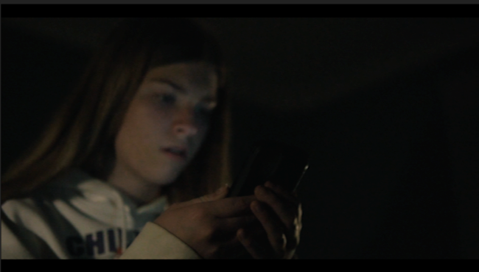This shot was simple yet affective as the phone screen was the main light source. It convays that she is fixated at her chance at becoming professional by winning Dance Nation. This was also used as the turing point for the protagonist as this scene is the turing point for her as she prioitises dance over everything else. The Dance Nation logo used was created by me this is because i wanted to have some originality to my drama. Giving Izzy a motive to push herself ‘further than she has before’.

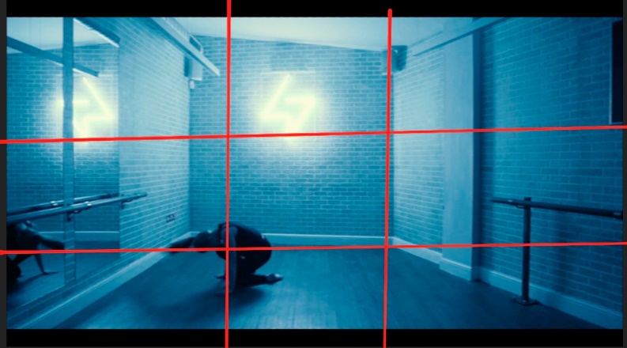

This is the last scene from the indroduction sequence for my drama. For this shot I used the rule of thirds to put Izzy in the bottom left corner of the frame. This is becuase it makes the scene seem much bigger than her. This dwarfing effect portrays the idea that she feels small, as her dreams of competing have faded faded so quickly. She is englufed in the shadows and is feeling a new low.

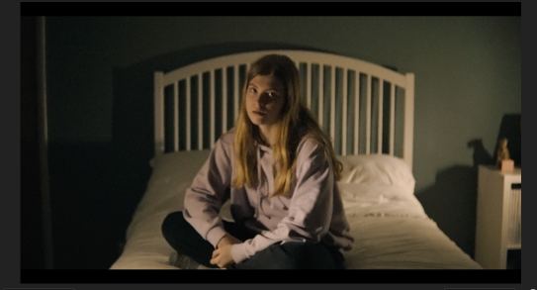

This scene can be contrasted with the first shot as in the first scene only half of her face is in the shadows. This is to show how even if ‘she didn’t like schoo’l she still had dance. Now she has ruined her chance of becoming professional and she feels as if she emmits to nothing. Drowning in a solemn atmosphere of regret and shame.

The blue lighting also depicts that she is upset as the the colour is also associated with sadness, She is also alone in the studio which is another factor which suggests that she feels like shes the only one thats face with the decision to prioitise her future job or her possible future career in dance.

**Index of secondary source**

|  |  |  |
| --- | --- | --- |
| Asset source of description | File label | Primary/secondary/audio |
| Music for video | Nate growing up.MP3 | Secondary |
| Sprained ankle | Bone Crack.MP3 | Secondary |
| In front of cheering fans | Cheering Fans.MP3 | Secondary |
| Voice over | VO.MP3 | Primary |

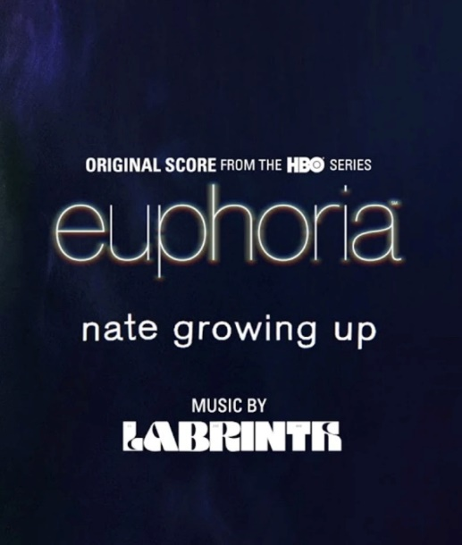The song Nate Growing Up is taken from a third party source which I have mentioned already. I’m aware that if I didn’t ask for permission for the use of the track with Milan Records (the label who own the rights to the song), I would be sued for copyright infringement. This because i would be seen as stealing their song. In the hopes to get he rights to use the song, I would send them a formal email addressing the use i’d have for the song .There’s a higher chance I would be able to use the song if the drama didn’t have the intention of making money from using it. The amount they would chance is completely up to the label and they can charge from 7 to 8 figures. The main reason why, is because the song is marketed as an ‘original track’ from the Euphoria soundtrack and the label want it to stay that way.

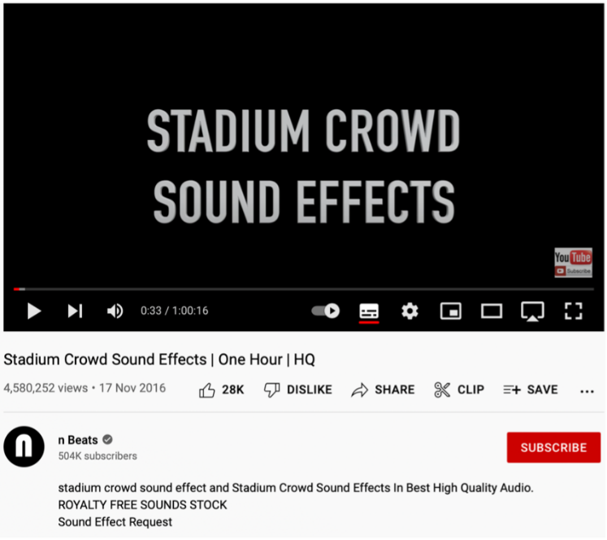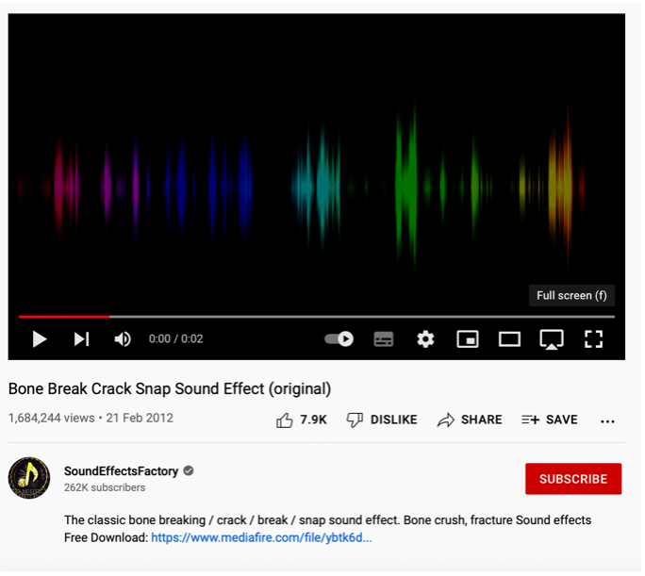My sound effect fro the crowds cheering and the bone crack when Izzy sprains her ankle were sourced from Youtube. They were posted on their channels with the intention of others using them for free without having to pay royalties. This was further confirmed by both of the videos descriptions.