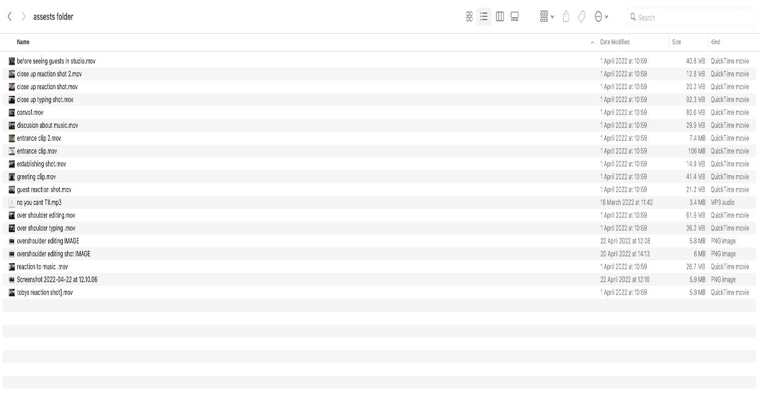

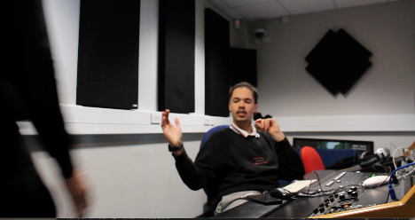In my assests folder shown above you can see the different clips, screen shots and audio files that have all been labeled in the folder. There are 3 different types of files in my asset folders the first is footage/clips. All clips for the segment are labeled, refering to the actions in the scene aswell as the shot type. an example of this is “close up typing shot” as mentioned this refers to both the type of shot and the action ivolved. This wil be extremely usfull when i come to the editing stage as i will know which scene is which in the folder. The second type of file in the folder are screenshots. These are used to analyse my editing techniques as the are screen grabs from final cut pro, showing how ive used them and there effectiveness. The third type of file in my folder is the audio clips. These are going to be used to underlay the videos used within final cut pro.

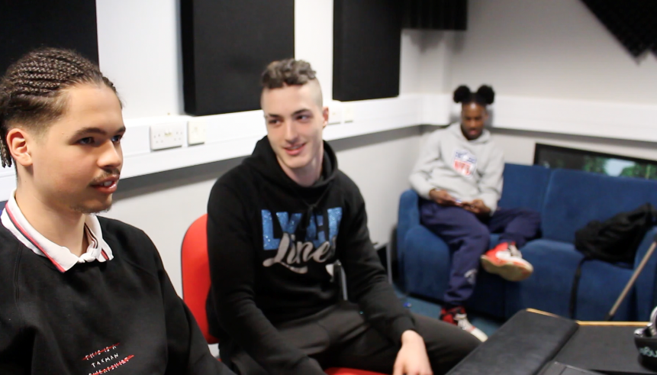before creating my film i designeated a target audience that i would aim the film at. This would be people, in the uk aged between 15-28 ( as this is the genral age range of uk hiphop listeners). I also chose the age range as being able to deliver a product like this to this age range effectively can spark much more traction for the film in comparison to a target audience of 28-60+ due to the nuse of social media by the younger age range. The final reason i chose this age range is as there visions and perceptions of current uk hiphop is so rich due to the countless number sub cultures and different influences within the genre. An example of this is seen by the main charectors friend that he invityes wearing a “lyca lines” sweatshirt which is deeply tied to the hiphop genre in the uk scene as it is promoted by artists with cult followings in the genre

when i began idea generation for my filom i began by doing a mindmap to generate ideas, once i had done this i began to get a grasp of the product that i would be making. I created storyboards of scenes to further understand and begin planning my film this was a massive help as i could visualise the end reuslt.

Throughtout the creative process i ensured that i followed the clear set mise-en-scene, codes and conventions of modern day uk hip-hop and grime within the genre on tv and video productions that have been uploaded to the internet (music videos/ uk hiphop documnetrys). codes and conventions include fashion ques, such as using reconisable brands within the hiphop scene as this can grasp the target audiences attention aswell as them possibly being able to relate to the artist with the film

When creating my charectors i wanted a both unique and recognisedable charector and i decided to reach out a current musician within the industry. I undertsood fully that the film i was creating is a fictional product but i felt that using a real rapper/musician would bring a leval of realness to the acting as he didnt really have to act but be himself. Although i used a current musician this didnt affect the plot and charector type i had intially invisioned. i wanted to base my film around an upcoming artist within the industry who is still finding his feeting and creating a base to jumpstart his career.

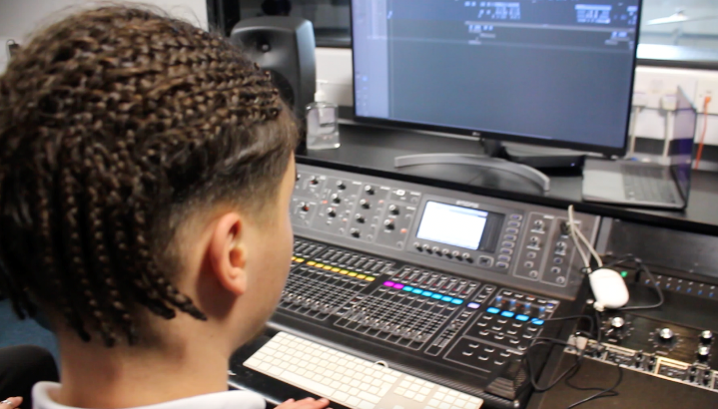when creating a plot for my film i wanted to show the creative process of making a song to release to the public. This includes the mixing and mastering process which involves tweaking and changing different aspects of the song using specialised music mixing equipment such as a mixing tabel which can be seen in this clip**.** I also wanted to portray through the plot that the hiphop creative is not an easy task and can take mulitple opinions before a song is ready for release. I aimed to not glorify a sense of ease in music production but being slightly more edgy and showing the struggles of doing so, this is also to ignite a creative spark within my younger taregt audience showing that becoming a musiction is abtainable but not easy.

When choosing a location for my shoot is decided that although was reradily avalaible to me, that filming at a college (Godalming College) was the best location for is it grounds the charectors within the film and makes them relatable to the taregt audience. Aswell as this the college also has a studio located in the music department aswell as a perfomance hall. which meant i was able to film the majority of my project on si

I used prodominantly natural and practical lighting throughou creating this film to keep a natural aesthtic, almost as if this was a documentry styled film, again this a fiction product. I felt this a very raw and real feel to it.

I focused also on framing and using techniques suchs as rule of thirds (rule of thirds having the focus in one third of the image) this can be seen in the image shown. I really enjoyed using this technique as although very basic is so vital to showing the viewers context to scenes and gives the viewer a greater idea of the location that is being filmed. I also used techniques such as an establishing shot, this helped my viewers see that this was being set in a college recording studio. I also used the over the should shot technique almost as a perspective shot to show my lead charector editing and mastering his song within the film. I used a close up of a handshake between both my lead and side charector when they did a handshake, i liked usung this technique as it helped me break up a very dialogue heavy scene.

Continuity was vital in this short films as if something apears out of nowhere it is very obvois, alothough my film is just over a mintue i had to reshoot over the space of 3 days to ensure quality. This meant my actors clothes they wore randomly on the first day became there costumes that would be the only clothinh they’d wear when being filmed. The continuity contiued the angles that i filmed at, laying markers on the floor of the studio for my tripod, this ensured when i had to re shoot that there wasnt a framing incontiunity.

The audio used within the scene is digectic but was added in in post. This means that charectors in the scene are reacting to it, but whilst filming there was no sound. the music used within my film is actuallty made by my lead actor and he gave me expressed permission to use it within my film, aswell as getting permission from his label to so. This meant that i did not have to spend money on gaining the copywright usage agreement for the usage of the song in my film.

s