BREAKDOWN OF “NO YOU CANT”
THIS IS A WRITTEN BREAKDOWN OF MY FILM “NO YOU CANT” ANALYSISING ALL VISUAL AND AUDIO TECHNIQUES USED IN THE PRODUCTION AND EDITING OF MY FILM.

VISUAL TECHNIQUES
Establishing pan shot, with title screen and blur effet
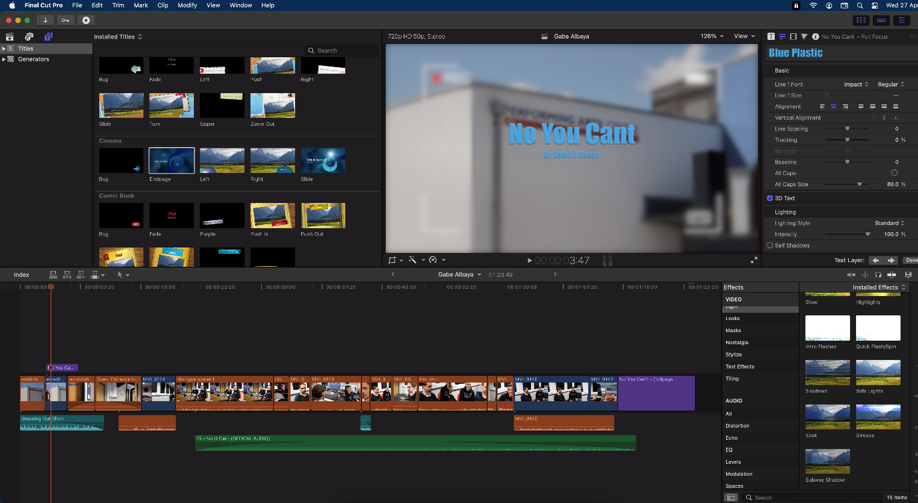

To start of my editing for my film product i began by putting in my establishing shot which was outside of the music department at godalming college or the “performing arts centre”. This staright away shows the viewer that this is going to be based around a performing art which they will very quickly is the case. My establishing shot utilised two tehcniques, firstly it used a blurred effect to highlight the title of the film, which i did by using the blur effect in the effects section of FCPX(Final Cut Pro X). Seconldy when putting my title in the film i used freeze frame of the establishing shot so that there was more time for the viewer to read it. the title is is the name of the song used within the film, created also by the main charector in the film. Also in the beggining sequence i utilised a non copywrite piece of music that is supported by FCPX (Final Cut Pro X) as i felt that having silence or background noise didnt fit the proffesional styled product i was aiming to create. Also whith my establishing shot(s) i used a camcorder effect, i felt this gave of a documentry styled production, again this a fictional product, this made the production look slightly more real, giving off an indie production vibe. To conclude my establishing shot was able to show the audience the title of the show, both show the location and time of day that the production was set in aswell as showing it was set in a college.

GUEST ENTRANCE, LOW MID SHOT
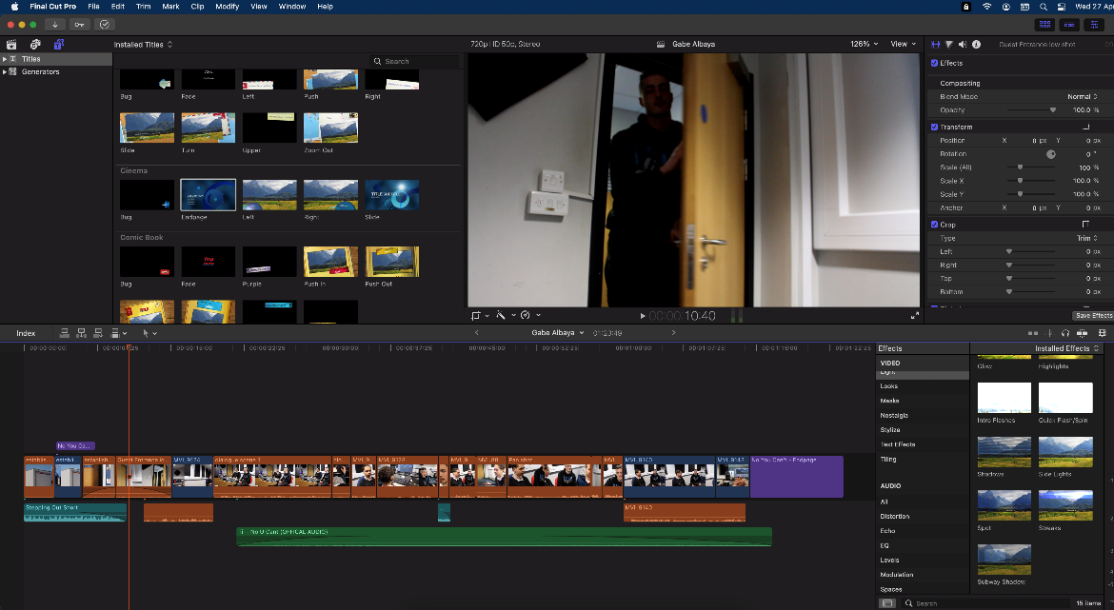
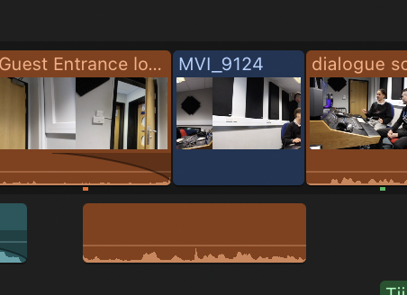
After establishing the film i begain by showing an entrance into the recording studio, that was shown before and durng this scene. I felt that showing the entrance of another charector whilst there was one static in the room signififed that the charector who entered the room isnt the lead role but has gone to meet them. I did this scene using a tripod and at a low angle, almost as if the camera was on the desk. In this scene i used a j cut as the side charector walked in of the main charector greeting him before the shot changes to them both on screen. this gave this scene a very fluid feel and allowed the scene transition to be smooth. the audio used for the j cut continues through the scene so there was no continutity issues following this.

DIALGOUE WIDE SHOT, PLOT PROGRESSION.

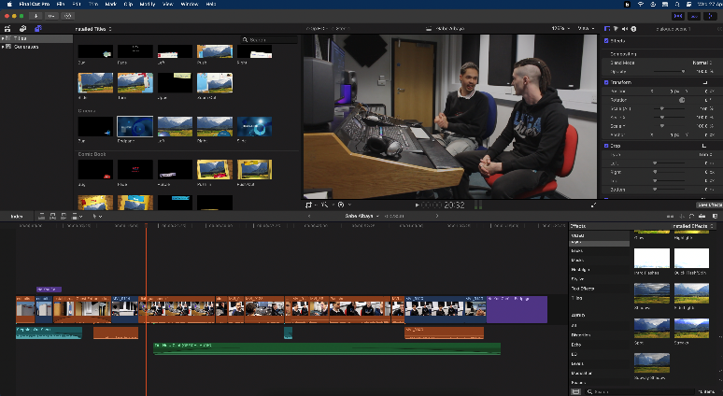
This scene utilises a wide shot to show the two charectors in the scene and the musical equipment used during the mix/mastering studio session the two are partacing in. this works as establishment for the plot as the dialgoue in the scen, though short explains why they are both there and what there intentions are, aswell as introcuing the two charectors in the film

WIDE PAN SHOT/OVERSHOULDER PAN SHOT
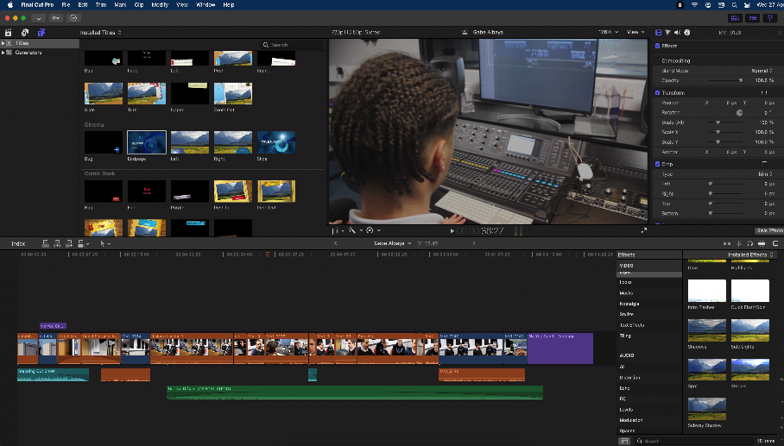
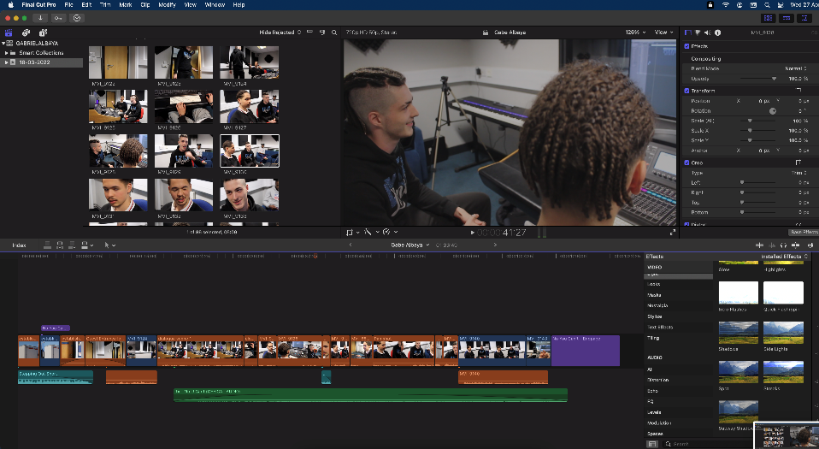
In this scene for the film i used an overhsoulder, panning wide shot the give another perspective of the recording studio for the viewer. In this scene i utilised the wide pan shot to show two things. First to show the artist making changes througj his music software. Secondly to show the side charectors reaction to this. This was one of two over shoulder shots, (the second showing him typing and clicking) this gives a very personal view of the scene almost as if it were a first person perspective shot.

Close UPS
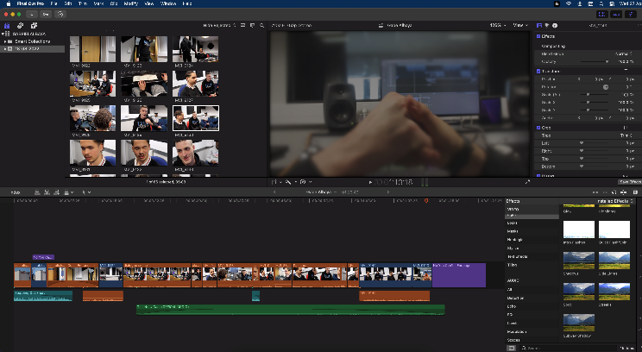
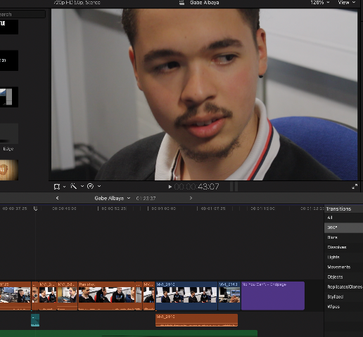

In this film i ultised close ups as they are so important to adding a personalised aesthic to a film. Aswell as this it is also the best shot to use when filming either reactions of micro actions( hand shakes, hand gesutures etc). In my first image shown you can see a reaction to a proposition made to main charector, this shows his geniune reaction to auidence showing that he is both able to listen and able to give otheres the time to speak. In my second image it is take from the closing scene of the film where thye main and side charectors are saying both there goodbyes and thanks yous. I used a close up to highlight there handshake whilst also using a focused centre blur as to not distract the viewer with the background. I think this worked effectively in its prupose

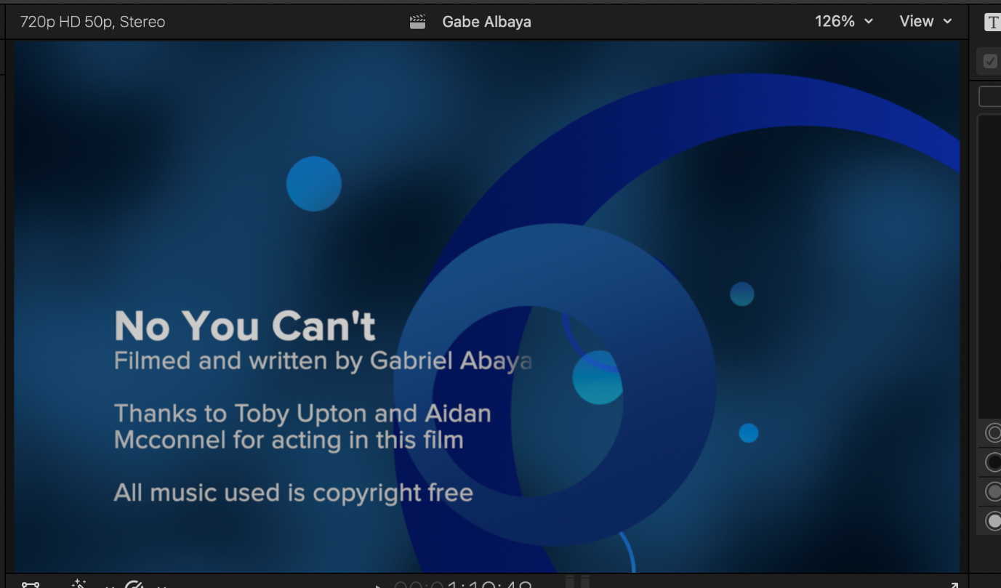
ENDING TITLE SEQUENCE

I used the ending title scene(credits), an effect that can be found in the titles section of FCPX, to highlight again the name of the film and give appraisals to the actors within the film aswell as putting who wrote and filmed the film aswell. The ending also makes highlight that none of the songs within the piece are copywritten, i will speak about this more later in the breakdown

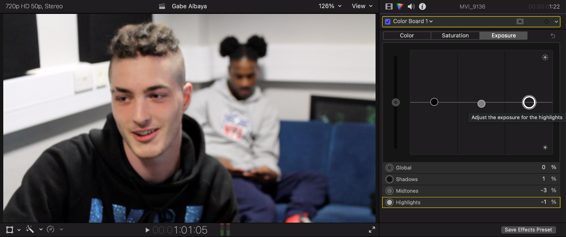
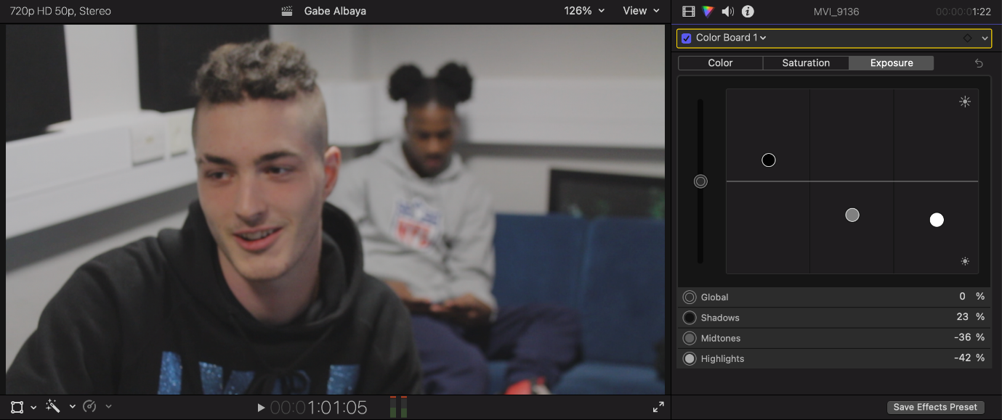
Colour balancing to achieve lowkey lighting(LIGHTING WITHIN FILM)
Throughout all the scenes in the studio i adjusted the grayscale/colour board to achieve a lowerkey lighting setup. As i wanted both practical/natural lighting i used the studios pre existing lights to light but when it came to editing my film i felt the lighting was too harsh. I also intially intended to have low key lighting. So i decdided the fix for this was to fix this using FCPXs colourgrading software by highlighting darker colours over brighter greys and whites within the scene. I feel that this worked really effectively as it did not affect colours such as the blue design on the side charectors hoodie but did change the lightings image into a more lowkey lighting theme

AUDIO TECHNIQUES/ELEMENTS

J cut
Early on in my film i used a j cut to start dialogue between two charectors. I did this by detaching the audio from the dialogue scene and shortenning the beginning of the dialogue scene. This meant i could overlay this audio over the clip that is before the dialgoue scene(side charectors entrance) so that it seems the conversation begins as the side charector enters the room. This, unless looking at the timeline of the film, does not stand out, which was what is how i intended.

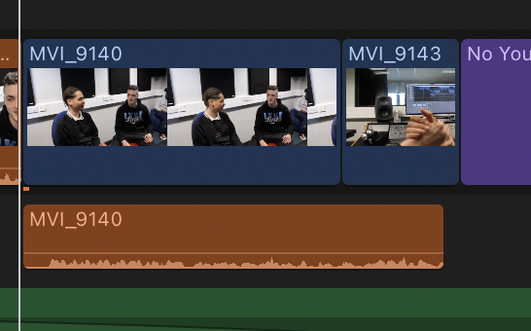
L cut
In the end of my film i used a L cut to transition between the closing dialgoue scene and the closing scene. I did this by scrpiting this scene so that just before the two finsihed there dialgoue i would make a clapping noise with my hand henind the camera. after this i then filmed a close up shot of the charetors doing a handshake. I was then able to shorten the visual of the closing dialgoue scene and place the hand shaking video in line with the clapping noise i made. This worked effectively as the dialogue was able to contiue without and conitunity or visuals errors.

Music within the film

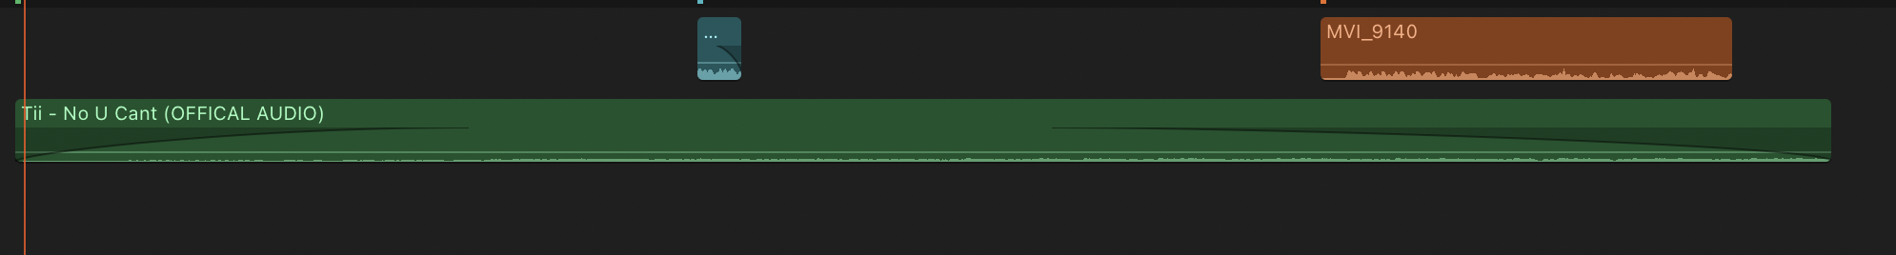
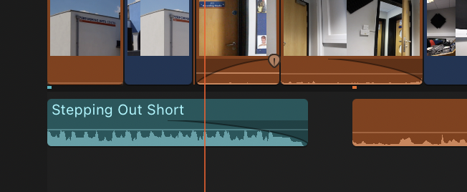
I used two pieces of music within my film. First i used, as earlier mentioned, a short copywrite free piece of music that comes with the purchace of Final Cut Pro X. this was a gentle piece that was perfect for the intorduction of my film.
The second piece of music i used was made by a personal friend of myself and he directly spoke to his label about getting permission for my production, which they granted, ensuring i would have no set backs or worrys in the way of copywrite disagreements.

Use of audio to fix continiuty error
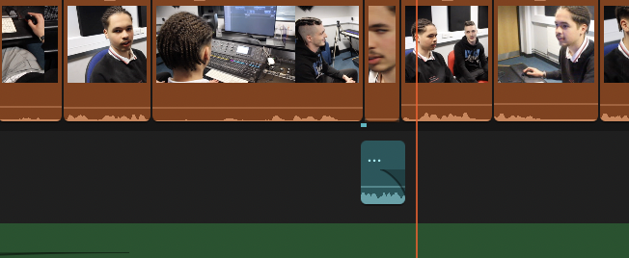
When it came to editing my film i reolised id missed a very short scene of dialgoue that was vital to the scripted conversaton. I found a way around this. I spliced a section of audio from an outtake where the side charector says “hey actually” and overlayed this on another outake of the main charector reacting to a question. This meant i was able to fix the continuty error without needing(as i wasnt able to reshoot the scene) to reshoot the scene.

