**How far does the evidence help us to understand the aims of those who tried to control the succession throughout this period? [30] *2022 EXAM PAPER***

**EXAMPLE 1**

*Annotate to show: the overall argument the paragraph is making; where it uses own knowledge; where it uses source evidence; where it evaluates the views in the source; how well it uses the sources*

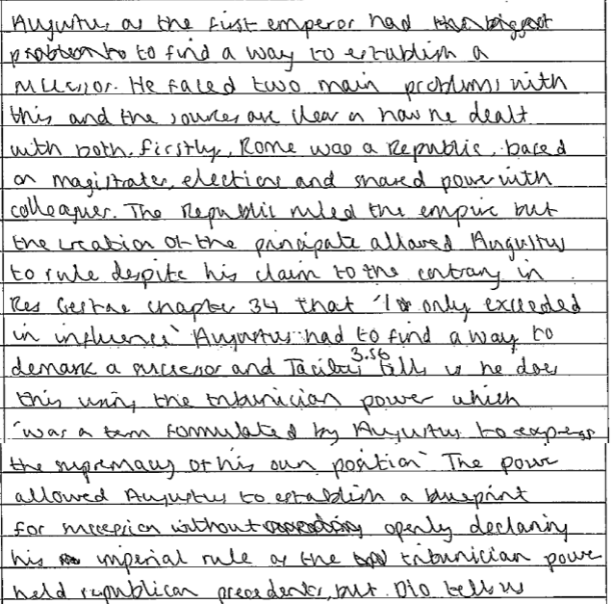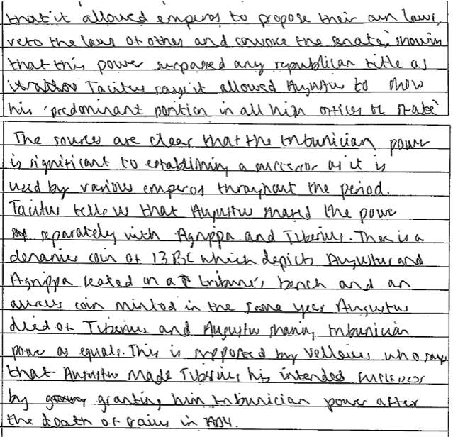

**EXAMPLE 2**

*Annotate to show: the overall argument the paragraph is making; where it uses own knowledge; where it uses source evidence; where it evaluates the views in the source; how well it uses the sources*

