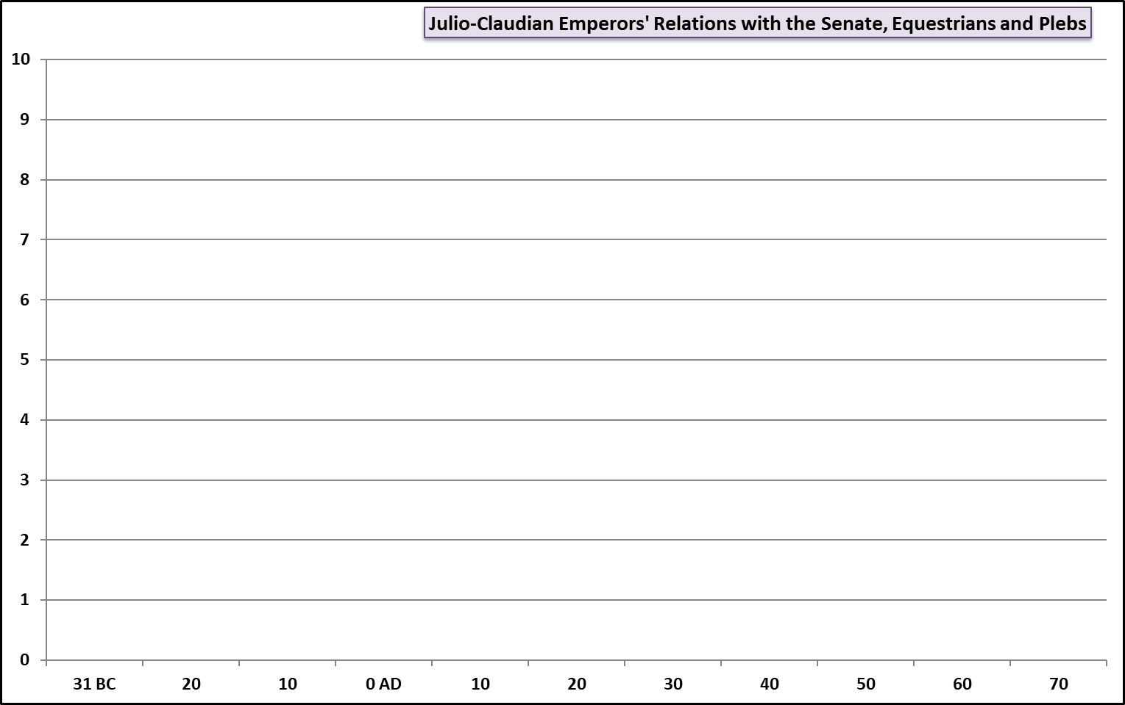

**GOOD RELATIONSHIP**

**Bad Relationship**

**Hints:** The Fist Constitutional Settlement (27 BC); Agrippa; Egypt; Grain shortage in Rome (23 BC); Senatorial list reduced (29 & 18 BC) Accession of Tiberius (14); Treason Trials; Sejanus; Accession of Gaius (37); Gaius Revised the list of equestrians; Gaius denounces the Senate (39); Assassination of Gaius (41); Accession of Claudius (41); Gauls admitted to the Senate (48)

**TASK:** plot two lines on the graph above. One showing the changing relationship between the emperors and the **Senate**, the other the **Plebs.** Label each point you plot and describe what the event is and how it changed the relationship. Don’t worry too much about the exact numbers – the aim of this is to illustrate how these relationships changed and when they had particular high/low points