**Roman Revision – Key Debate 3: The Benefits of Imperial rule for the inhabitants of Rome**

***Augustus***

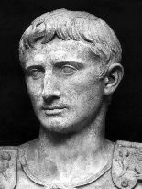

***Evidence that ordinary Romans benefitted***

***Evidence that ordinary Romans did not benefit***

***Key Sources***

***Evidence that ordinary Romans benefitted***

***Evidence that ordinary Romans did not benefit***

***Key Sources***

***Evidence that ordinary Romans benefitted***

***Evidence that ordinary Romans did not benefit***

***Key Sources***

***Evidence that ordinary Romans benefitted***

***Evidence that ordinary Romans did not benefit***

***Key Sources***

***Evidence that ordinary Romans benefitted***

***Evidence that ordinary Romans did not benefit***

***Key Sources***

***Tiberius***

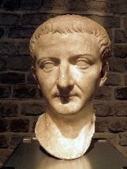

***Gaius***

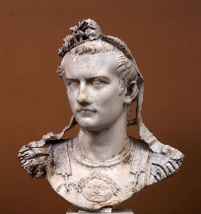

***Claudius***

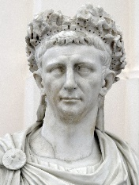

***Nero***

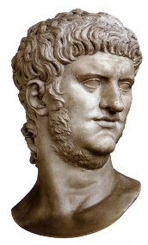

**‘Bread and Circuses – this is all the emperors contributed towards the well-being of the people of the city of Rome.’ How far do you agree with this view? [30]**

|  |  |
| --- | --- |
| ***Evidence from the sources and your own knowledge to support the question*** | ***Evidence from the sources and your own knowledge to challenge the question*** |
|  |  |
| **Overall Conclusion** | |
|  | |

|  |  |  |  |
| --- | --- | --- | --- |
| **Level**  **Mark** | **AO1 (5 marks)** | **AO2 (10 marks)** | **A03 (15 marks)** |
| **5**  ***25-30*** | Very good range of accurate and detailed knowledge and a sophisticated understanding of relevant historical features and characteristics. There is a consistent focus on the question throughout the answer. | Excellent explanation that convincingly and very thoroughly analyses and appraises historical events and periods in order to reach substantiated, sustained, and well-developed judgements. | Very good range of fully appropriate examples from the ancient sources. The sources are thoroughly analysed and evaluated, to reach logically reasoned, well-developed judgements about how the way they portray events relates to the context in which they were produced, and to draw fully substantiated and convincing conclusions about the historical issue in the question. |
| **4**  ***19-24*** | Good range of accurate and detailed knowledge and a well-developed understanding of relevant historical features and characteristics. There is a consistent focus on the question throughout the answer. | Good explanation that convincingly and thoroughly analyses and appraises historical events and periods in order to reach substantiated and developed judgements. | Good range of appropriate examples from the ancient sources. The sources are analysed and evaluated, to reach logically reasoned, developed judgements about how the way they portray events relates to the context in which they were produced, and to draw substantiated and convincing conclusions about the historical issue in the question. |
| **3**  ***13-18*** | Reasonable range of accurate and sometimes detailed knowledge and a reasonable understanding of relevant historical features and characteristics. There is a consistent focus on the question through most of the answer. | Good explanation that convincingly analyses and appraises historical events and periods in order to reach supported judgements, though these are not consistently developed. | A range of appropriate examples from the ancient sources. The sources are analysed and evaluated, to reach logically reasoned judgements about how the way they portray events relates to the context in which they were produced, and to draw supported, plausible conclusions about the historical issue in the question. |
| **2**  ***7-12*** | Limited range of accurate knowledge and understanding of relevant historical features and characteristics, though this may lack detail. The question is generally addressed, but the response loses focus in places. | An explanation that analyses and appraises historical events and periods, and this is linked appropriately to judgements made, though the way in which it supports the judgements may not always be made fully explicit. | Some appropriate examples from the ancient sources. The sources are analysed and evaluated, to reach judgements about how the way they portray events relates to the context in which they were produced, and to draw some supported conclusions about the historical issue in the question. |
| **1**  ***1-6*** | Some limited knowledge and understanding of relevant historical features and characteristics, though lacking detail and in places inaccurate. The question is only partially addressed. | Some explanation which analyses and appraises historical events and periods in places, and this is linked appropriately to some of the judgements made, though the way in which it supports the judgements is not made explicit. | Limited selection of appropriate examples from the ancient sources. The sources are analysed and evaluated in a basic way, and this is linked to basic, generalised judgements about how the way they portray events relates to the context in which they were produced. There are some basic conclusions about the historical issue in the question, though these may only be implicitly linked with the analysis and evaluation of the sources. |