TOPIC 4 – Roman Control
TASK: answer each of the questions below to revise your understanding of this topic. For each question add two specific sources which are essential to answer it
What was the role of Governor and how did it contribute to stability in the province? | How did Roman administration, other than the Governor, contribute to stability in the province? | Why did client kingdoms emerge in Britain and how significant were they in helping to establish or maintain Roman control?
How did the combat role of the army help to maintain control in the province? | How did the deployment of the army help to maintain control in the province? | How did the non-combat role of the army help to maintain control in the province?
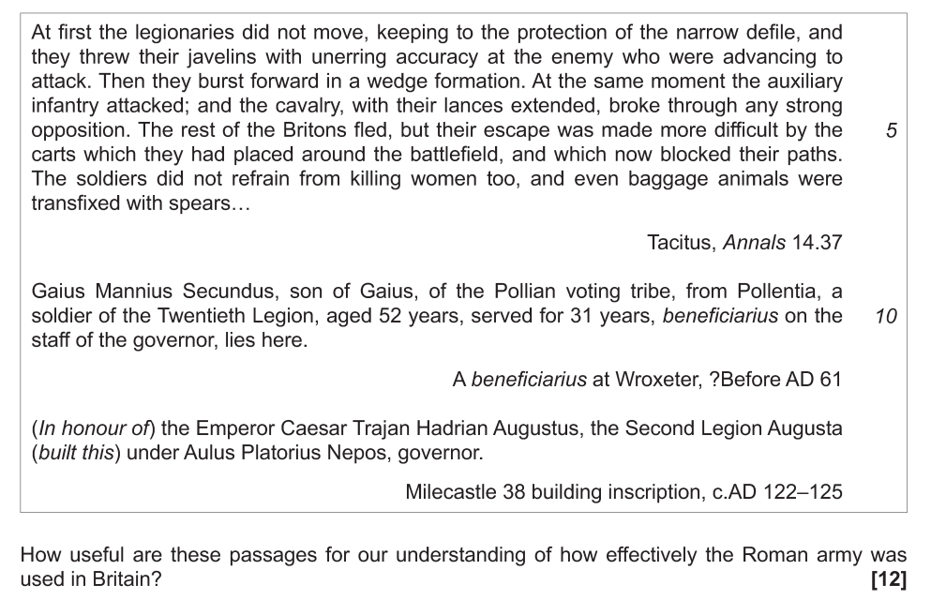
‘The Roman governors of Britain spent all their time fighting with the natives.’ To what extent do you agree with this statement? [36] (2019)

