# Computer Science Easter Revision Questions

# Name

|  |  |  |  |  |  |  |  |  |  |  |  |  |  |  |  |  |  |  |  |  |  |  |  |  |  |  |  |  |  |  |  |  |  |  |  |  |  |  |  |  |  |  |  |  |  |  |  |  |  |  |  |  |  |  |  |  |  |  |  |  |  |  |  |  |  |  |  |  |  |  |  |  |  |  |  |  |  |  |  |  |  |  |  |  |  |  |  |  |  |  |  |  |  |  |  |  |  |  |  |  |  |  |  |  |  |  |  |  |  |  |  |  |  |  |  |  |  |  |  |  |  |  |  |  |  |  |  |  |  |  |  |  |  |  |  |  |  |  |  |  |  |  |  |  |  |  |  |  |  |  |  |
| --- | --- | --- | --- | --- | --- | --- | --- | --- | --- | --- | --- | --- | --- | --- | --- | --- | --- | --- | --- | --- | --- | --- | --- | --- | --- | --- | --- | --- | --- | --- | --- | --- | --- | --- | --- | --- | --- | --- | --- | --- | --- | --- | --- | --- | --- | --- | --- | --- | --- | --- | --- | --- | --- | --- | --- | --- | --- | --- | --- | --- | --- | --- | --- | --- | --- | --- | --- | --- | --- | --- | --- | --- | --- | --- | --- | --- | --- | --- | --- | --- | --- | --- | --- | --- | --- | --- | --- | --- | --- | --- | --- | --- | --- | --- | --- | --- | --- | --- | --- | --- | --- | --- | --- | --- | --- | --- | --- | --- | --- | --- | --- | --- | --- | --- | --- | --- | --- | --- | --- | --- | --- | --- | --- | --- | --- | --- | --- | --- | --- | --- | --- | --- | --- | --- | --- | --- | --- | --- | --- | --- | --- | --- | --- | --- | --- | --- | --- | --- | --- | --- | --- |
| Paper1   |  |  |  | | --- | --- | --- | | Q | Mark | Comment | | Qu1 |  |  | | Qu2 |  |  | | Qu3 |  |  | | Qu4 |  |  | | Qu5 |  |  | | Qu6 |  |  | | Qu7 |  |  | | Qu8 |  |  | | Qu9 |  |  | | Qu10 |  |  | | Qu11 |  |  | | Qu12 |  |  | | Qu13 |  |  | | Paper2   |  |  |  | | --- | --- | --- | | Q | Mark | Comment | | Qu1 |  |  | | Qu2 |  |  | | Qu3 |  |  | | Qu4 |  |  | | Qu5 |  |  | | Qu6 |  |  | | Qu7 |  |  | | Qu8 |  |  | | Qu9 |  |  | | Qu10 |  |  | | Qu11 |  |  | | Qu12 |  |  | | Qu13 |  |  | | Qu14 |  |  | | Qu15 |  |  | | Qu16 |  |  | | Qu17 |  |  | | Qu18 |  |  | | Qu19 |  |  | | Qu20 |  |  | | Qu21 |  |  | | Qu22 |  |  | | Qu23 |  |  | | Qu24 |  |  | | Qu25 |  |  | | Qu26 |  |  | | Qu27 |  |  | | Qu28 |  |  | | Qu29 |  |  | | Qu30 |  |  | | Qu31 |  |  | | Qu32 |  |  | | Qu33 |  |  | | Qu34 |  |  | | Qu35 |  |  | |

|  |  |  |
| --- | --- | --- |
| Paper1 Section A questions.  **100 minutes 76 marks** | | |
|  |

**Q1.**

In a particular programming language, the correct syntax for a real number, natural number and digit is defined by the syntax diagrams in the diagram below.

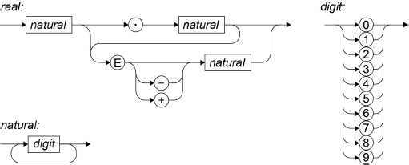

(a)     Write **Yes** or **No** in the unshaded cells in the table to identify whether or not the numbers listed in the table are valid real numbers which conform to the correct syntax for this language.

|  |  |
| --- | --- |
| **Real number** | **Valid? (Yes/No)** |
| 87.000 |  |
| 97+12 |  |
| 12.31E+12 |  |

**(3)**

(b)     In Backus-Naur Form (BNF) the following production rule has been written to define a digit:

<digit> ::= 0 | 1 | 2 | 3 | 4 | 5 | 6 | 7 | 8 | 9

Write a BNF production rule to define a natural number that is equivalent to the definition in the syntax diagram in the diagram.

**(2)**

**(Total 5 marks)**

**Q3.**

The table below lists some well-known algorithms.

|  |
| --- |
| **Algorithm** |
| Linear search |
| Merge sort |
| Binary search |
| Post-order tree-traversal |

(a)     Which of the algorithms listed in the table has *0*(*n* log *n*) time complexity?

**(1)**

(b)     How many of the algorithms listed in the table are algorithms used to solve tractable problems?

**(1)**

**(Total 2 marks)**

**Q4.**

(a)     State the time complexity for the bubble sort algorithm in terms of 𝑛, where 𝑛 is the number of items in the list to be sorted.

**(1)**

(b)     Explain why the bubble sort algorithm has the time complexity stated in your answer to part **(a)**.

**(2)**

**(Total 3 marks)**

**Q2.**

Postcodes are used to aid the sorting of mail and help to ensure that mail being sent arrives at the correct destination as quickly as possible.

The format of a UK postcode (ignoring any spaces) is shown in **Figure 1**.

**Figure 1**

|  |
| --- |
| •   1 or 2 letters  •   followed by:         ◦   1 numeric digit or         ◦   2 numeric digits or         ◦   1 numeric digit then 1 letter  •   followed by 1 numeric digit  •   followed by 2 letters |

When a post box is emptied in the town of Ipswich the mail in the post box is taken to a central sorting office. Each item is looked at and placed in one of three vans depending upon the postcode written on the envelope.

Postcodes that begin with IP1, IP2, IP3 or IP4 followed by one numeric digit and two letters, eg IP2 8QY, are for mail being sent to an address in the town of Ipswich and go in Van A. Other postcodes that begin with IP, eg IP5 3QW, are for areas not in the town but near to Ipswich and go in Van B. Postcodes that start with anything other than IP, eg CO3 5FN, are not for the Ipswich area and go in Van C. IP postcodes do not use the full range of formats available for UK postcodes.

A finite state machine (FSM) could be used to sort mail using postcodes. **Figure 2** shows a state transition diagram for an FSM used at the Ipswich sorting office.

In **Figure 2**, if a transition is not defined from a state for a particular input symbol then the FSM will stop processing the input and it will be rejected.

1. If the FSM in **Figure 2** reaches state S12 what does it mean?

**(1)**

(b)     If the FSM in **Figure 2** finishes at state S11 what does it mean?

**(1)**

(c)     Assuming that the FSM in **Figure 2** can be used to recognise any valid IP postcode, state **one** format used for UK postcodes that IP postcodes do **not** use.

**(1)**

**Figure 2**

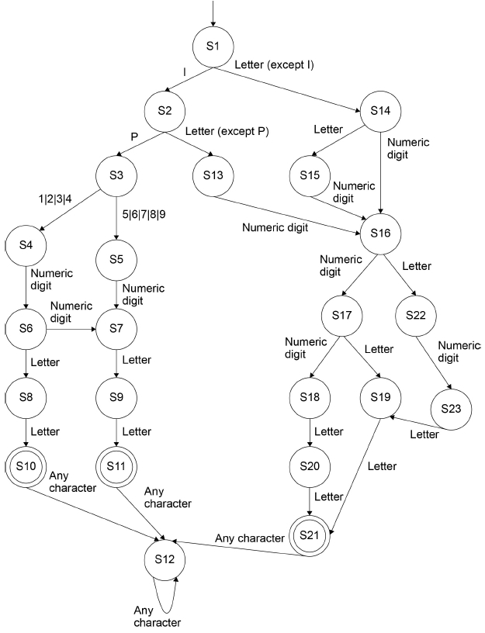

(d)     The language recognised by an FSM can also be represented by a regular expression. When writing regular expressions \d is used to represent any numeric digit and \a is used to represent any alphabetic character.

For example, the regular expression \d \d \a \d describes the language of all strings that contain two numeric digits followed by one letter and then one numeric digit.

Write a regular expression that represents a valid UK postcode as described in **Figure 1**. In your answer you should only use the | metacharacter once.

**(4)**

**(Total 7 marks)**

**Q5. Figure 1** shows the data Norbert, Phil, Judith, Mary, Caspar and Tahir entered into a binary search tree.

**Figure 2** contains pseudo-code for a recursive binary tree search algorithm.

**Figure 1**

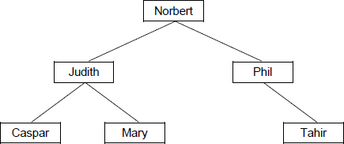

**Figure 2**

FUNCTION TreeSearch(target, node)

  OUTPUT ‘Visited ’, node

  IF target = node THEN

    RETURN True

  ELSE IF target > node AND Exists(node, right) THEN

    RETURN TreeSearch(target, node.right)

  ELSE IF target < node AND Exists(node, left) THEN

    RETURN TreeSearch(target, node.left)

  ENDIF

  RETURN False

ENDFUNCTION

The subroutine Exists takes two parameters – a node in the binary tree and a direction (left or right). It returns a Boolean value indicating if the node given as a parameter has a child node in the direction specified by the second parameter. For instance, Exists(Mary, left) will return a value of False as there is no node to the left of Mary in the binary tree.

node.right evaluates to the child node to the right of node, eg Judith.right is Mary.

node.left evaluates to the child node to the left of node, eg Judith.left is Caspar.

(a)     What is meant by a recursive subroutine?

**(1)**

(b)     There are two base cases for the subroutine TreeSearch. State **one** of the base cases.

**(1)**

(c)     Complete the unshaded cells of the table below to show the result of tracing the TreeSearch algorithm shown in **Figure 2** with the function call TreeSearch(Olivia, Norbert). You may not need to use all of the rows.

|  |  |
| --- | --- |
| **Function call** | **Output** |
| TreeSearch(Olivia, Norbert) |  |
|  |  |
|  |  |
|  |  |
|  |  |

**(3)**

**(Total 5 marks)**

**Q6.**

In a simple two-dimensional game the game mechanics are handled by the use of vectors.

In **Figure 1** you can see the current position of the enemy  and the hero .

**Figure 1**

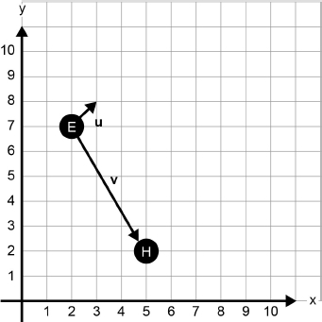

The enemy is currently looking in the direction shown by the vector **u** in **Figure 1**. Vector **u** can be described as [1, 1].

The vector from the enemy to the hero can be represented by the vector **v** in **Figure 1**. Vector **v** can be described as [3, −5].

1. Calculate the dot product of **u** and **v**.

**(1)**

The hero is going to move.

The current position of the hero can be described by the vector [5, 2].

The movement of the hero can be described by the vector [3, 1].

To process the movement the game updates the screen using the following operation:

new position = current position vector + movement vector

The dot product can be used to calculate if the enemy can see the hero by using the algorithm given in **Figure 2**.

**Figure 2**

u ⟵ [1, 1]

v ⟵ [position of hero] - [position of enemy]

IF u.v > 0 THEN

    EnemyCanSee ⟵ True

ELSE

    EnemyCanSee ⟵ False

ENDIF

1. Perform vector addition to calculate the **new position** of the hero.

**(1)**

(c)     Complete the unshaded cells of the table below to work out if the enemy can see the hero in this **new position**.

|  |  |
| --- | --- |
| **Calculation** | **Result** |
| u | [1, 1] |
| v = [position of hero] - [position of enemy] |  |
| u.v |  |
| EnemyCanSee |  |

**(3)**

**Figure 2** shows the scene later on in the game. The route between the enemy and the hero is blocked by a solid wall indicated by shading.

**Figure 2**

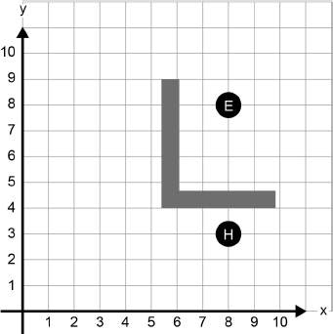

To move the enemy the game has an algorithm that computes the shortest path between the enemy and the hero. To find the shortest path it looks at every possible path between the enemy and the hero.

This algorithm currently struggles to compute the shortest path quickly enough and it has been suggested that the use of a heuristic technique might help.

1. Explain what is meant by a heuristic technique, giving an example of a heuristic technique that might reduce the time taken by the shortest path algorithm.

**(2)**

**(Total 7 marks)**

**Q7.**

Explain the differences between static and dynamic data structures.

**(Total 2 marks)**

**Q8.**

Two frequently completed actions when using a particular piece of software are **undo** and **repeat**.

The **undo** action results in the state changing from the current state to the state previous to the user’s most recent action, eg if the last action the user completed was to change the font of a selected piece of text from Courier New to Chiller then if the **undo** action is selected the result will be to change the font of that text back to Courier New.

The user is able to keep using the **undo** action to go back through all previous states.

The **repeat** action results in the user’s most recent action being applied again, eg if the last action the user completed was to change the font of a piece of text to Chiller then if the **repeat** action is selected the result will be to change the font of the currently selected text to Chiller.

The user is able to keep using the **repeat** action to apply the most recent action multiple times. The **repeat** action will only work when there is a most recent action that can be applied again.

1. Explain how a single stack can be used in the implementation of the repeat action **and** the undo action.

**(5)**

(b)     State the type of error that occurs if the user tries to complete an undo action before they have completed any other actions.

**(1)**

**(Total 6 marks)**

**Q9.**

The famous detective John Stout was called in to solve a perplexing murder mystery. He determined the following facts.

a       Nathan, the murdered man, was killed by a blow on the head.

b       Either Suzanne or Martin was in the dining room at the time of the murder.

c       If Peter was in the kitchen at the time of the murder, then Ian killed Nathan using poison.

d       If Suzanne was in the dining room at the time of the murder, then Steve killed Nathan.

e       If Peter was not in the kitchen at the time of the murder, then Martin was not in the dining room when the murder was committed.

f        If Martin was in the dining room at the time the murder was committed, then Paul killed Nathan.

g       If Kevin was in the hall at the time of the murder, then Suzanne killed Nathan by a blow to the neck with a saucepan.

(a)     Who murdered Nathan?

**A**        Paul

**B**        Steve

**C**        Suzanne

**D**        Ian

**E**        It is not possible for John Stout to solve the crime.

**(1)**

(b)     Explain how you know your answer to (a) is correct.

Use the space below for rough working.

**(2)**

**(Total 3 marks)**

**Q10.**

A finite state machine (FSM) can be used to define a language: a string is allowed in a language if it is accepted by the FSM that represents the rules of the language.

**Figure 1** shows the state transition diagram for an FSM.

**Figure 1**

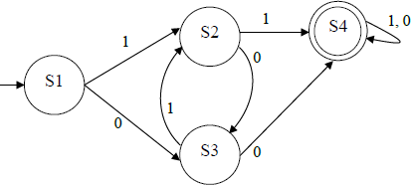

An FSM can be represented as a state transition diagram or as a state transition table. The table below is an incomplete state transition table for **Figure 1** .

(a)     Complete the table.

|  |  |  |
| --- | --- | --- |
| **Original state** | **Input** | **New state** |
| S3 |  |  |
| S3 |  |  |

**(1)**

(b)     Any language that can be defined using an FSM can also be defined using a regular expression.

The FSM in **Figure 1** defines the language that allows all strings containing at least, either two consecutive 1s or two consecutive 0s.

The strings 0110, 00 and 01011 are all accepted by the FSM and so are valid strings in the language.

The strings 1010 and 01 are not accepted by the FSM and so are not valid strings in the language.

Write a regular expression that is equivalent to the FSM shown in **Figure 1** .

**(3)**

(c)     Backus-Naur Form (BNF) can be used to define the rules of a language.

**Figure 2** shows an attempt to write a set of BNF production rules to define a language of full names.

|  |  |
| --- | --- |
| **Figure 2** |  |
|  | Note: underscores (_) have been used to denote spaces. Note: rule numbers have been included but are not part of the BNF rules. |
| **Rule number** |  |
| 1 | <fullname> ::= <title>_<name>_<endtitle> |                <name> |                <title>_<name> |                <name>_<endtitle> |
| 2 | <title> ::= MRS | MS | MISS | MR | DR | SIR |
| 3 | <endtitle> ::= ESQUIRE | OBE | CBE |
| 4 | <name> ::= <word> |            <name>_<word> |
| 5 | <word> ::= <char><word> |
| 6 | <char> ::= A | B | C | D | E | F | G | H | I |            J | K | L | M | N | O | P | Q | R |            S | T | U | V | W | X | Y | Z |

BNF can be used to define languages that are not possible to define using regular expressions. The language defined in **Figure 2** could not have been defined using regular expressions.

Complete the table below by writing either a **‘Y’** for **Yes** or **‘N’** for **No** in each row.

|  |  |
| --- | --- |
| **Rule number (given in Figure 2)** | **Could be defined using a regular expression** |
| 1 |  |
| 2 |  |
| 3 |  |
| 4 |  |
| 5 |  |
| 6 |  |

**(1)**

(d)     There is an error in rule 5 in **Figure 2** which means that no names are defined by the language.

Explain what is wrong with the production rule and rewrite the production rule so that the language does define some names – the names ‘BEN D JONES’, ‘JO GOLOMBEK’ and ‘ALULIM’ should all be defined.

**(2)**

**(Total 7 marks)**

**Q11.**

The Cat transportation company (CTC) is a business that specialises in preparing cats for cat shows.

They need to take five cats to the AQA cat show. They will transport the cats in their van. CTC owns only one van.

They cannot put all the cats in their van at the same time because some of the cats get stressed when in the company of some of the other cats. The cats would not therefore arrive in top condition for the cat show if they were all in the van at the same time.

The graph in **Figure 1** shows the relationships between the five cats (labelled 1 to 5). If there is an edge between two cats in the graph then they **cannot** travel in the van together at the same time.

**Figure 1**

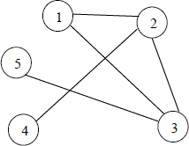

(a)     Explain why the graph in **Figure 1** is **not** a tree.

**(1)**

(b)     Represent the graph shown in **Figure 1** as an adjacency list by completing **Table 1** .

**Table 1**

|  |  |
| --- | --- |
| **Vertex (in Figure 1)** | **Adjacent vertices** |
| 1 |  |
| 2 |  |
| 3 |  |
| 4 |  |
| 5 |  |

**(2)**

(c)     **Table 2** shows how the graph in **Figure 1** can be represented as an adjacency matrix.

**Table 2**

|  |  |  |  |  |  |
| --- | --- | --- | --- | --- | --- |
| **Vertex (in Figure 1)** | **1** | **2** | **3** | **4** | **5** |
| **1** | 0 | 1 | 1 | 0 | 0 |
| **2** | 1 | 0 | 1 | 1 | 0 |
| **3** | 1 | 1 | 0 | 0 | 1 |
| **4** | 0 | 1 | 0 | 0 | 0 |
| **5** | 0 | 0 | 1 | 0 | 0 |

Explain the circumstances in which it is more appropriate to represent a graph using an adjacency list instead of an adjacency matrix.

**(2)**

(d)     **Figure 2** shows an algorithm, written in pseudo-code, that CTC use.

**Figure 2**

            NoOfCats ← 5  
            Cat[1] ← 1  
            FOR A ← 2 TO NoOfCats  
              B ← 1  
              C ← 1  
              WHILE B < A DO  
                IF M[A, B] = 1  
                  THEN  
                    IF Cat[B] = C  
                      THEN  
                        B ← 1  
                        C ← C + 1  
                      ELSE B ← B + 1  
                    ENDIF  
                  ELSE B ← B + 1  
                ENDIF  
              ENDWHILE  
              Cat[A] ← C  
            ENDFOR

The two-dimensional array, M, is used to store the adjacency matrix shown in **Table 2**.

Complete **Table 3** to show the result of tracing the algorithm in **Figure 2**.

**Table 3**

|  |  |  |  |  |  |  |  |  |
| --- | --- | --- | --- | --- | --- | --- | --- | --- |
|  |  |  |  | **Cat** | | | | |
| **NoOfCats** | **A** | **B** | **C** | **1** | **2** | **3** | **4** | **5** |
|  |  |  |  |  |  |  |  |  |
|  |  |  |  |  |  |  |  |  |
|  |  |  |  |  |  |  |  |  |
|  |  |  |  |  |  |  |  |  |
|  |  |  |  |  |  |  |  |  |
|  |  |  |  |  |  |  |  |  |
|  |  |  |  |  |  |  |  |  |
|  |  |  |  |  |  |  |  |  |
|  |  |  |  |  |  |  |  |  |
|  |  |  |  |  |  |  |  |  |
|  |  |  |  |  |  |  |  |  |
|  |  |  |  |  |  |  |  |  |
|  |  |  |  |  |  |  |  |  |
|  |  |  |  |  |  |  |  |  |
|  |  |  |  |  |  |  |  |  |
|  |  |  |  |  |  |  |  |  |
|  |  |  |  |  |  |  |  |  |
|  |  |  |  |  |  |  |  |  |
|  |  |  |  |  |  |  |  |  |

**(6)**

(e)     Explain the purpose of the algorithm in **Figure 2**.

**(1)**

(f)      After a cat show, CTC needs to return the cats to their owners. They can have all the cats in the van at the same time because the show is now finished.

CTC likes to plan the return journey so that the shortest possible distance is travelled by the van. This is an example of an intractable problem.

What is meant by an intractable problem?

**(2)**

(g)     What approach might a programmer take if asked to solve an intractable problem?

**(2)**

**(Total 16 marks)**

**Q12.**

The code below shows an incomplete algorithm for a binary search.

PROCEDURE BSearch(List, F, L,  
ItemToFind)  
  Found ← False  
  Failed ← **(1)**__________________  
  WHILE NOT Failed AND NOT Found  
    M ← (F + L) DIV 2  
    IF List[M] = ItemToFind  
      THEN Found ← True  
      ELSE  
        IF F >= L  
          **(2)**__________________  
          ELSE  
            IF List[M] > ItemToFind  
              THEN **(3)**__________________  
              ELSE F ← M + 1  
            ENDIF  
         ENDIF  
     ENDIF  
   ENDWHILE  
   IF Found = True  
     THEN OUTPUT "Item is in list"  
     ELSE OUTPUT "Item is not in list"  
   ENDIF  
 ENDPROCEDURE

The DIV operator calculates the whole number result of integer division. For example, 15 DIV 4 = 3, 17 DIV 4 = 4.

(a)     What code should be added at position **(1)**? **(1)**

(b)     What code should be added at position **(2)**? **(1)**

(c)     What code should be added at position **(3)**? **(2)**

The table below contains a list of orders of time complexity (in no particular order).

|  |
| --- |
| **Order of time complexity** |
| O(1) |
| O(n2) |
| O(log n) |
| O(kn) |
| O(n) |

Which of the orders of time complexity given in the table :

1. could be the time complexity of an intractable problem?

**(1)**

(e)     is the time complexity for a binary search?

**(1)**

(f)      is the time complexity for getting the first item in a list?

**(1)**

(g)     is the time complexity for a linear-search algorithm?

**(1)**

(h)     Explain why a linear-search has the order of time complexity given in your answer to question (g)

**(2)**

**(Total 10 marks)**

**Q13.**

Convert the following Reverse Polish Notation expressions to their equivalent infix expressions.

1. 3 4 *

**(1)**

(b)     12 8 + 4 *

**(1)**

(c)     Reverse Polish Notation is an alternative to standard infix notation for writing arithmetic expressions.

State **one** advantage of Reverse Polish Notation over infix notation.

**(1)**

**(Total 3 marks)**

**7517Paper2Revision 300 minutes 200 marks**

**Q1.**

**Figure 1** shows some of the internal components of a processor and how the processor is connected to the main memory. The internal connections within the processor are not shown.

**Figure 1**

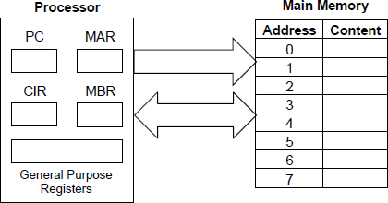

Describe how an instruction is fetched from main memory during the **fetch stage** of the fetch-execute cycle.

Your description should cover the use of registers and buses, together with the role of main memory.

_______________________________________________________________________

_______________________________________________________________________

_______________________________________________________________________

_______________________________________________________________________

_______________________________________________________________________

_______________________________________________________________________

_______________________________________________________________________

_______________________________________________________________________

_______________________________________________________________________

_______________________________________________________________________

_______________________________________________________________________

_______________________________________________________________________

_______________________________________________________________________

_______________________________________________________________________

**(Total 4 marks)**

**Q2.**

During the **decode and execute stages** of the fetch-execute cycle the instruction that is being processed is stored in the CIR. Explain why the instruction could **not** be processed directly from the MBR.

_______________________________________________________________________

_______________________________________________________________________

_______________________________________________________________________

_______________________________________________________________________

_______________________________________________________________________

_______________________________________________________________________

**(Total 2 marks)**

**Q3.**

Explain why the Harvard architecture is sometimes used in preference to the von Neumann architecture.

_______________________________________________________________________

_______________________________________________________________________

_______________________________________________________________________

_______________________________________________________________________

_______________________________________________________________________

_______________________________________________________________________

**(Total 2 marks)**

**Q4.**

**Figure 1** shows a message being encrypted using a Caesar cipher.

**Figure 1**

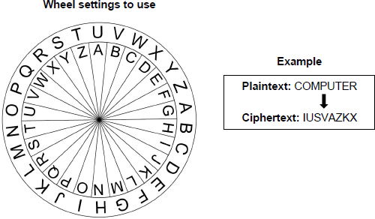

Decrypt the ciphertext "QGOZRKT" using the Caesar cipher with the settings shown in **Figure 1**.

_______________________________________________________________________

**(Total 1 mark)**

**Q5.**

The Vernam cipher is a more sophisticated cipher system that, under certain circumstances, offers perfect security.

State **two** conditions that must be met for the Vernam cipher to offer perfect security.

**Condition 1**

_______________________________________________________________________

_______________________________________________________________________

**Condition 2**

_______________________________________________________________________

_______________________________________________________________________

**(Total 2 marks)**

**Q6.**

Both the Caesar and Vernam ciphers are symmetric ciphers, whereas a public and private key encryption system is an asymmetric cipher system.

Explain the difference between a symmetric and an asymmetric cipher system

_______________________________________________________________________

_______________________________________________________________________

_______________________________________________________________________

_______________________________________________________________________

_______________________________________________________________________

**(Total 1 mark)**

**Q7.**

In a particular communications system, eight different voltage levels are used to encode the value of groups of bits. Each voltage level encodes the value of one group of bits.

(a)     Given that eight different voltage levels are used, how many bits can be in a group that is encoded by a voltage level?

___________________________________________________________________

___________________________________________________________________

**(1)**

(b)     The baud rate for this system is 500 baud.

What is the system’s bit rate?

___________________________________________________________________

___________________________________________________________________

**(1)**

The graph below shows three suggested relationships between bandwidth and bit rate.

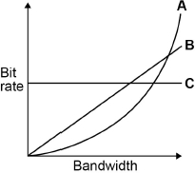

(c)     Shade **one** lozenge to indicate which of the lines, **A**, **B** or **C** in the graph, shows the correct relationship between bandwidth and bit rate.



**(1)**

(d)     The system sends the data over a long distance using serial communication.

Explain why serial communication is more appropriate in this instance than parallel communication.

___________________________________________________________________

___________________________________________________________________

___________________________________________________________________

___________________________________________________________________

___________________________________________________________________

___________________________________________________________________

**(2)**

**(Total 5 marks)**

**Q8.**

A computer process, X, can only start executing once processes A and B have finished executing and either communication channel C or communication channel D or both are available to use.

The states of processes and communication channels can be read using the following Boolean variables:

•   **A** is set to TRUE if process A has completed and FALSE if process A is still running.

•   **B** is set to TRUE if process B has completed and FALSE if process B is still running.

•   **C** is set to TRUE if communication channel C is available and FALSE if it is not available.

•   **D** is set to TRUE if communication channel D is available and FALSE if it is not available.

The Boolean variable **X** should be set to TRUE if the values of the variables **A**, **B**, **C** and **D** indicate that process X can start and to FALSE if they indicate that process X cannot start yet.

(a)     Draw a logic circuit that will represent the logic of the system described above for the inputs **A**, **B**, **C** and **D** and the output X.

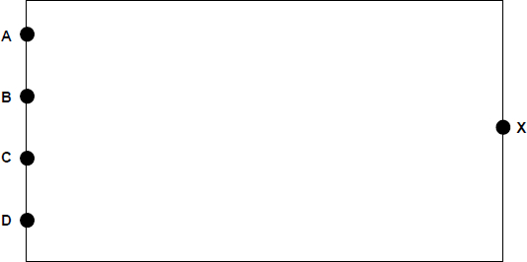

**(3)**

(b)     Write a Boolean expression to represent the logic used to start process X.

**X =**________________________________________________________________

**(2)**

**(Total 5 marks)**

**Q9.**

Using the rules of Boolean algebra, simplify the following Boolean expression.



You **must** show your working.

_______________________________________________________________________

_______________________________________________________________________

_______________________________________________________________________

_______________________________________________________________________

_______________________________________________________________________

_______________________________________________________________________

_______________________________________________________________________

_______________________________________________________________________

_______________________________________________________________________

_______________________________________________________________________

_______________________________________________________________________

_______________________________________________________________________

Answer _________________________________________

**(Total 4 marks)**

**Q10.**

D-type flip-flops can be included in logic circuits.

Explain the general purpose of a D-type flip-flop.

_______________________________________________________________________

_______________________________________________________________________

**(Total 1 mark)**

**Q11.**

One input to a D-type flip-flop is a data signal.

State what the other input to a D-type flip-flop is **and** what it is used for.

_______________________________________________________________________

_______________________________________________________________________

_______________________________________________________________________

_______________________________________________________________________

_______________________________________________________________________

_______________________________________________________________________

**(Total 2 marks)**

**Q12.**

**Figure 1** shows the structure of an example machine code instruction, taken from the instruction set of a particular processor.

**Figure 1**

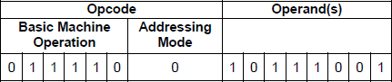

State the purpose of the operand part of an instruction **and** explain how the addressing mode is related to this.

_______________________________________________________________________

_______________________________________________________________________

_______________________________________________________________________

_______________________________________________________________________

_______________________________________________________________________

_______________________________________________________________________

**(Total 2 marks)**

**Q13.**

**Figure 1** shows an assembly language program together with the contents of a section of the main memory of the computer that the program will be executed on. Each main memory location and register can store a 16-bit value.

The assembly language instruction set that has been used to write the program is listed in **Table 1** after part **(b)**.

**Figure 1**

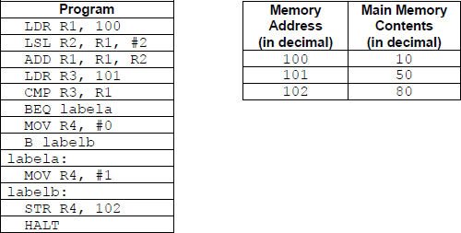

(a)     Complete the trace table below, **in decimal**, to show how the values stored in the registers and main memory change as the program in **Figure 1** is executed. You may not need to use all of the rows.

|  |  |  |  |  |  |  |
| --- | --- | --- | --- | --- | --- | --- |
| **Register Contents** | | | | **Main Memory Location Contents** | | |
| **R1** | **R2** | **R3** | **R4** | **100** | **101** | **102** |
|  |  |  |  |  |  |  |
|  |  |  |  |  |  |  |
|  |  |  |  |  |  |  |
|  |  |  |  |  |  |  |

**(4)**

(b)     Explain what the assembly language program in **Figure 1** does.

___________________________________________________________________

___________________________________________________________________

___________________________________________________________________

**(1)**

**Table 1 – standard AQA assembly language instruction set**

|  |  |
| --- | --- |
| LDR Rd, <memory ref> | Load the value stored in the memory location specified by <memory ref> into register d. |
| STR Rd, <memory ref> | Store the value that is in register d into the memory location specified by <memory ref>. |
| ADD Rd, Rn, <operand2> | Add the value specified in <operand2> to the value in register n and store the result in register d. |
| SUB Rd, Rn, <operand2> | Subtract the value specified by <operand2> from the value in register n and store the result in register d. |
| MOV Rd, <operand2> | Copy the value specified by <operand2> into register d. |
| CMP Rn, <operand2> | Compare the value stored in register n with the value specified by <operand2>. |
| B <label> | Always branch to the instruction at position <label> in the program. |
| B<condition> <label> | Branch to the instruction at position <label> if the last comparison met the criterion specified by <condition>.  Possible values for <condition> and their meanings are:           EQ: equal to               NE: not equal to           GT: greater than         LT: less than |
| AND Rd, Rn, <operand2> | Perform a bitwise logical AND operation between the value in register n and the value specified by <operand2> and store the result in register d. |
| ORR Rd, Rn, <operand2> | Perform a bitwise logical OR operation between the value in register n and the value specified by <operand2> and store the result in register d. |
| EOR Rd, Rn, <operand2> | Perform a bitwise logical XOR (exclusive or) operation between the value in register n and the value specified by <operand2> and store the result in register d. |
| MVN Rd, <operand2> | Perform a bitwise logical NOT operation on the value specified by <operand2> and store the result in register d. |
| LSL Rd, Rn, <operand2> | Logically shift left the value stored in register n by the number of bits specified by <operand2> and store the result in register d. |
| LSR Rd, Rn, <operand2> | Logically shift right the value stored in register n by the number of bits specified by <operand2> and store the result in register d. |
| HALT | Stops the execution of the program. |

**Labels**: A label is placed in the code by writing an identifier followed by a colon (:). To refer to a label the identifier of the label is placed after the branch instruction.

**Interpretation of <operand2>**

<operand2> can be interpreted in two different ways, depending on whether the first character is a # or an R:

•   # – use the decimal value specified after the #, eg #25 means use the decimal value 25.

•   Rm – use the value stored in register m, eg R6 means use the value stored in register 6.

The available general purpose registers that the programmer can use are numbered 0 to 12.

**(Total 5 marks)**

**Q14.**

Discuss the advantages and disadvantages of programming using a high-level language compared to programming using assembly language.

_______________________________________________________________________

_______________________________________________________________________

_______________________________________________________________________

_______________________________________________________________________

_______________________________________________________________________

_______________________________________________________________________

_______________________________________________________________________

_______________________________________________________________________

_______________________________________________________________________

_______________________________________________________________________

_______________________________________________________________________

_______________________________________________________________________

_______________________________________________________________________

_______________________________________________________________________

_______________________________________________________________________

**(Total 4 marks)**

**Q15.**

In a functional programming language a function named square and three lists a, b and c are defined as follows.

square x = x * x

a = [1, 3, 5]

b = [1, 5, 10, 15]

c = [9, 7, 2]

(a)     What is the list or value that is the result of applying the functions head(tail(tail b))?

___________________________________________________________________

**(1)**

(b)     Calculate the results of making the function calls listed in **Table 1** with the lists a, b and c above.

**Table 1**

|  |  |
| --- | --- |
| **Function Call** | **Result** |
| map square a |  |
| filter (<10) b |  |
| fold (+) 0 c |  |

**(3)**

(c)     map is an example of a higher-order function.

Explain what a higher-order function is.

___________________________________________________________________

___________________________________________________________________

___________________________________________________________________

___________________________________________________________________

**(1)**

**(Total 5 marks)**

**Q16.** Between 2008 and 2010, a company that was gathering data for an online mapping system, using cars fitted with cameras and WiFi equipment, collected some information that was being transmitted on personal WiFi networks. The company apologised for doing this and an investigation found that a small number of software developers had been responsible for adding this functionality to the mapping system data collection software.

In the context of this example, discuss:

•   how it was possible for this data to be collected.

•   what steps the owners of the networks could have taken to prevent the data from being collected.

•   what legal and ethical issues might have arisen as a result of collecting this data.

•   what lessons the company might have learnt from the incident and how their practices might have changed as a result of it.

In your answer you will be assessed on your ability to follow a line of reasoning to produce a coherent, relevant and structured response.

**(Total 12 marks)**

**Q17.** Two methods of representing and playing music on a computer are sampled sound and MIDI.

Sound is being sampled using a 16-bit sample resolution and a sample rate of 20 000 Hz.

1 Hz is one sample per second.

(a)     Calculate the amount of storage space that will be required to store 30 seconds of recorded sound. Express your answer in kilobytes.

You **must** show your working.

___________________________________________________________________

___________________________________________________________________

___________________________________________________________________

___________________________________________________________________

___________________________________________________________________

Answer _________________________________________

**(2)**

(b)     The highest frequency component in the sound that is being sampled is 14 500 Hz. The sample rate of 20 000 Hz is not high enough to enable a faithful reproduction of the original sound from the sample.

Explain why this is the case, justifying your response.

___________________________________________________________________

___________________________________________________________________

___________________________________________________________________

___________________________________________________________________

________________________________________________________________(**2)**

**(Total 4 marks)**

**Q18.**

MIDI is a system that can be used to enable musical devices to communicate and to represent music on a computer.

Explain how MIDI represents music **and** the advantages of using MIDI for representing music instead of using sampled sound.

_______________________________________________________________________

_______________________________________________________________________

_______________________________________________________________________

_______________________________________________________________________

_______________________________________________________________________

_______________________________________________________________________

_______________________________________________________________________

_______________________________________________________________________

_______________________________________________________________________

_______________________________________________________________________

_______________________________________________________________________

_______________________________________________________________________

**(Total 4 marks)**

**Q19.**

**Figure 1** shows the physical topology of a local area network (LAN) and its connection to the Internet. The LAN uses the IPv4 protocol.

**Figure 1**

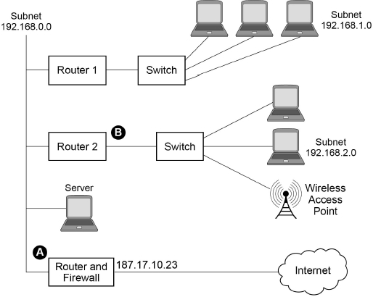

State suitable IP addresses for:

The ‘Router and Firewall’ port labelled  _____________________________________

The ‘Router 2’ port labelled  ______________________________________________

**(Total 2 marks)**

**Q20.**

Explain the difference between a physical topology and a logical topology.

_______________________________________________________________________

_______________________________________________________________________

_______________________________________________________________________

_______________________________________________________________________

_______________________________________________________________________

_______________________________________________________________________

**(Total 2 marks)**

**Q21.**

Explain the differences between client-server and peer-to-peer networking.

_______________________________________________________________________

_______________________________________________________________________

_______________________________________________________________________

_______________________________________________________________________

_______________________________________________________________________

_______________________________________________________________________

_______________________________________________________________________

_______________________________________________________________________

_______________________________________________________________________

_______________________________________________________________________

_______________________________________________________________________

_______________________________________________________________________

_______________________________________________________________________

_______________________________________________________________________

**(Total 4 marks)**

**Q22.**

A garage services and repairs cars. It uses a relational database to keep track of the jobs that customers have booked for it to carry out. The database includes jobs that have been completed and jobs that are waiting to be done.

The details of the jobs that the garage does, together with the parts that it stocks and uses are stored in the database using the four relations shown in **Figure 1**.

**Figure 1**

|  |
| --- |
| Job (JobID, CarRegNo, JobDate, InGarage, JobDuration)  Car (CarRegNo, Make, Model, OwnerName, OwnerEmail, OwnerTelNo)  Part (PartID, Description, Price, QuantityInStock)  PartUsedForJob (JobID, PartID, QuantityUsed) |

•   Each car has a unique CarRegNo.

•   A type of car can be uniquely identified by the combination of its Make and Model. Different Makes may use the same Model name and a particular manufacturer (Make) will produce several different car Models.

•   A booking made for a car on a particular date counts as one job, regardless of how many different tasks are completed upon it.

•   A job might require the use of any number of parts, including zero.

•   Some of the details are stored in the database as soon as a booking is made and others are only added when a job has been completed.

The attribute JobID is the Entity Identifier (Primary Key) of the Job relation.

(a)     If the JobID attribute were not included in the Job relation, which other attribute or attributes that are currently in the relation could probably be used as an Entity Identifier (Primary Key) instead?

___________________________________________________________________

**(1)**

It has been suggested that the owner details (OwnerName, OwnerEmail, OwnerTelNo) should not be stored in the Car relation and that a new relation should be created to store owner details separately from car details.

(b)     Explain why storing the owner details separately would improve the design of the database.

___________________________________________________________________

___________________________________________________________________

___________________________________________________________________

___________________________________________________________________

**(2)**

(c)     On the incomplete Entity-Relationship diagram below show the degree of any **three** relationships that exist between the entities.

|  |  |  |
| --- | --- | --- |
| Job |  | Car |
|  |  |  |
|  |  |  |
| Part |  | PartUsedForJob |

**(2)**

When an appointment is made for a job, this is represented in the Job relation. At the time of booking, the InGarage attribute is set to False and the JobDuration attribute is set to 0:00. When the car arrives at the garage the value of the InGarage attribute is changed to True. When the job is finished the value of the JobDuration attribute is updated to indicate how long the job took and details of the parts used are recorded in the database.

The Job with JobID 206 has been completed. The job took 1 hour 30 minutes (1:30) and used two of the parts with PartID 12.

(d)     Write the SQL commands that are required to record the amount of time that the job took in the database.

___________________________________________________________________

___________________________________________________________________

___________________________________________________________________

___________________________________________________________________

___________________________________________________________________

**(3)**

(e)     Write the SQL commands that are required to record in the database the fact that two of the parts with PartID 12 were used.

___________________________________________________________________

___________________________________________________________________

___________________________________________________________________

___________________________________________________________________

**(2)**

**Figure 1** is repeated below.

|  |
| --- |
| Job (JobID, CarRegNo, JobDate, InGarage, JobDuration)  Car (CarRegNo, Make, Model, OwnerName, OwnerEmail, OwnerTelNo)  Part (PartID, Description, Price, QuantityInStock)  PartUsedForJob (JobID, PartID, QuantityUsed) |

A mechanic needs to produce a list of all of the parts used on the job with JobID 93 for a customer.

This list must include the PartID, Description, Price (each) and QuantityUsed of each part, and no other details. The parts in the list should be ordered by PartID with the parts with the lowest PartIDs nearest to the top of the list.

(f)      Write an SQL query to produce the list.

___________________________________________________________________

___________________________________________________________________

___________________________________________________________________

___________________________________________________________________

___________________________________________________________________

___________________________________________________________________

___________________________________________________________________

___________________________________________________________________

___________________________________________________________________

___________________________________________________________________

___________________________________________________________________

___________________________________________________________________

___________________________________________________________________

**(5)**

There are restrictions on which parts can be fitted to which cars. For example:

•   The driver’s door mirror with PartID 104 can only be fitted to one particular make and model of car.

•   The ignition switch with PartID 27 can be fitted to any model of car for one particular make as the maker uses the same ignition switch in all models.

•   The tyre with PartID 97 can be fitted to a wide range of cars of different makes and models as it is a standard size.

If the information about which parts could be fitted to which makes and models of cars were represented in the database, it could be used to help a mechanic identify the correct parts to use for a job.

(g)     Explain how the database design could be modified to represent which makes and models of car a part can be fitted to.

___________________________________________________________________

___________________________________________________________________

___________________________________________________________________

___________________________________________________________________

___________________________________________________________________

___________________________________________________________________

___________________________________________________________________

___________________________________________________________________

___________________________________________________________________

**(3)**

**(Total 18 marks)**

**Q23.**

A particular computer uses a **normalised** floating point representation with an 8-bit mantissa and a 4-bit exponent, both stored using **two’s complement**.

Four bit patterns that are stored in this computer’s memory are listed in **Figure 1** and are labelled **A**, **B**, **C** and **D**. Some of the bit patterns are valid normalised floating point numbers.

**Figure 1**

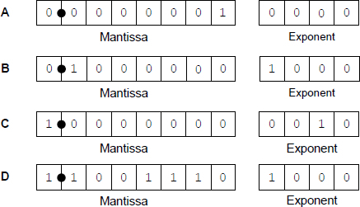

(a)     Shade **one** lozenge to indicate which bit pattern (**A–D**) in **Figure 1** represents a negative normalised value.



**(1)**

(b)     Shade **one** lozenge to indicate which bit pattern (**A–D**) in **Figure 1** represents the smallest positive normalised value.



**(1)**

(c)     The following is a floating point representation of a number:



Calculate the decimal equivalent of the number. You **must** show your working.

___________________________________________________________________

___________________________________________________________________

___________________________________________________________________

___________________________________________________________________

Answer _________________________________________

**(2)**

(d)     Write the normalised floating point representation of the decimal value 58.5 in the boxes below. You **must** show your working.

___________________________________________________________________

___________________________________________________________________

___________________________________________________________________

___________________________________________________________________

Answer



**(3)**

There can be a loss of precision when a decimal number is stored when using a floating point system.

The closest possible representation of the decimal number 13.8 is shown below.



By converting this bit pattern back into denary it can be seen that the actual number stored is 13.75, not 13.8.

(e)     Calculate the absolute error that has occurred.

___________________________________________________________________

___________________________________________________________________

Answer _________________________________________

**(1)**

(f)      Calculate the relative error that has occurred. Express your answer as a percentage to two decimal places.

___________________________________________________________________

___________________________________________________________________

Answer _________________________________________

**(1)**

**(Total 9 marks)**

**Q24.**

The diagram below shows how some of the components of a computer system can be connected together.

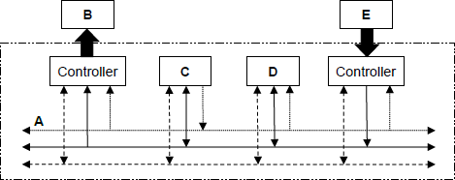

The table below lists the names of six components in the column headings and the five letters (**A-E**) from the diagram in the row headings.

For each row in the table, shade **one** lozenge, in the appropriate column, to indicate which component in the diagram has been labelled with the row letter.

As an example, the first row has been completed for you, to indicate that component **A** in the diagram is the Address bus.

|  |  |  |  |  |  |  |
| --- | --- | --- | --- | --- | --- | --- |
|  | **Processor** | **Address bus** | **Data bus** | **Main memory** | **Keyboard** | **Visual display unit** |
| **A** |  |  |  |  |  |  |
| **B** |  |  |  |  |  |  |
| **C** |  |  |  |  |  |  |
| **D** |  |  |  |  |  |  |
| **E** |  |  |  |  |  |  |

**(Total 4 marks)**

**Q25.**

The internal buses in a computer use parallel communication while most peripherals communicate with a computer using serial communication.

(a)     Explain the differences between the ways in which parallel and serial communications carried out.

___________________________________________________________________

___________________________________________________________________

___________________________________________________________________

___________________________________________________________________

**(2)**

(b)     Most peripherals, such as printers and keyboards, communicate with a computer using a serial connection.

Apart from the widespread availability of USB (Universal Serial Bus) ports, explain why peripherals usually use a serial communication method such as USB instead of parallel communication.

___________________________________________________________________

___________________________________________________________________

**(1)**

(c)     In communications systems, a distinction is made between the bit rate and the baud rate.

Define the term baud rate.

___________________________________________________________________

___________________________________________________________________

**(1)**

(d)     Explain how it is possible for the bit rate to be higher than the baud rate.

___________________________________________________________________

___________________________________________________________________

**(1)**

**(Total 5 marks)**

**Q26.** A burglar alarm system is to be implemented that has the following sensors:

•        a door sensor **D** that outputs TRUE when the door is open and FALSE when the door is shut

•        a pressure mat sensor **M** that outputs TRUE while a weight is detected on it and FALSE when no weight is detected on it.

The alarm also has a key **K** that turns the alarm on and off. **K** outputs a TRUE signal when the alarm is switched on and FALSE when the alarm is off.

The alarm output **A** sounds a bell. It should be TRUE if:

•        the alarm is on AND

•        either of the sensors **D** or **M** are set to the value TRUE.

(a)     Draw a logic circuit that will behave as described above for the inputs **D**, **M** and **K** and the output **A**.

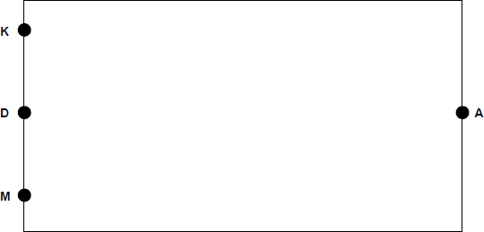

**(2)**

(b)     Write a Boolean expression to represent the logic of this alarm system.

**A=**________________________________________________________________

**(2)**

(c)     In this alarm system, the alarm bell will sound only while the door is open or a weight is placed on the pressure mat. If someone who has stepped on to the mat moves off it, or an open door is closed, the alarm bell will stop ringing.

A D-type flip-flop could be incorporated into the logic circuit so that the alarm bell would continue to sound after a person closed the door or moved off the pressure mat.

Explain how this could be achieved. In your answer refer to:

•        why a D-type flip-flop would be suitable for this task

•        where the D-type flip-flop would need to be inserted into the circuit

•        what additional input the D-type flip-flop would need.

___________________________________________________________________

___________________________________________________________________

___________________________________________________________________

___________________________________________________________________

___________________________________________________________________

_______________________________________________________________**(3)**

**(Total 7 marks)**

**Q27.**

The phrase “Internet of Things” is used to describe the connection of many everyday devices such as home heating controls, utility meters, cars and environmental sensors to the Internet. It is believed that tens of billions of devices will be connected to the Internet of Things by the end of the decade.

One anticipated use of the Internet of Things is to monitor the food that consumers have inside their fridges. This data could be gathered automatically from consumers’ devices by retailers who sell food. Retailers could use the data to analyse consumer consumption habits or automatically prepare deliveries for customers.

In the context of an Internet connected fridge, discuss the technologies that will be required to make the Internet of Things work.

You may wish to consider how the data might be captured, how networking technologies are changing to provide the necessary infrastructure, and how the data gathered by retailers could be stored and processed, from a hardware and software viewpoint.

_______________________________________________________________________

_______________________________________________________________________

_______________________________________________________________________

_______________________________________________________________________

_______________________________________________________________________

_______________________________________________________________________

_______________________________________________________________________

_______________________________________________________________________

_______________________________________________________________________

_______________________________________________________________________

_______________________________________________________________________

_______________________________________________________________________

_______________________________________________________________________

_______________________________________________________________________

_______________________________________________________________________

_______________________________________________________________________

_______________________________________________________________________

_______________________________________________________________________

_______________________________________________________________________

_______________________________________________________________________

_______________________________________________________*(Allow 1 extra page)*

**(Total 12 marks)**

**Q28.**

The icon below is represented in a computer's memory as a bitmap image.

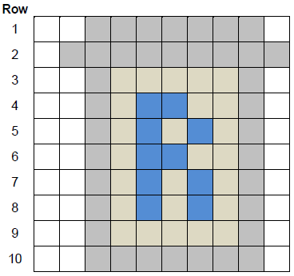

Four different colours have been used in the icon.

**Row 1** of the icon is represented in the computer's memory as the bit pattern:

|  |  |  |  |  |  |  |  |  |  |  |  |  |  |  |  |  |  |  |  |
| --- | --- | --- | --- | --- | --- | --- | --- | --- | --- | --- | --- | --- | --- | --- | --- | --- | --- | --- | --- |
| 1 | 1 | 1 | 1 | 0 | 0 | 0 | 0 | 0 | 0 | 0 | 0 | 0 | 0 | 0 | 0 | 0 | 0 | 1 | 1 |

(a)     What are the bit patterns that have been used to represent a grey pixel and a white pixel?

|  |  |  |
| --- | --- | --- |
| Grey pixel: ________ |  | White pixel: ________ |

**(1)**

(b)     State **one** possible 20-bit representation for **Row 4** of the icon.

|  |  |  |  |  |  |  |  |  |  |  |  |  |  |  |  |  |  |  |  |
| --- | --- | --- | --- | --- | --- | --- | --- | --- | --- | --- | --- | --- | --- | --- | --- | --- | --- | --- | --- |
|  |  |  |  |  |  |  |  |  |  |  |  |  |  |  |  |  |  |  |  |

**(1)**

(c)     Calculate the number of bytes required to represent all the pixel data in the icon as a bitmap.

Show your working.

___________________________________________________________________

___________________________________________________________________

___________________________________________________________________

___________________________________________________________________

Answer ___________________________

**(2)**

(d)     When the bitmap is saved as a file, the file size is bigger than the answer to (c). This is because metadata is saved in the file with the pixel data

State **one** item of metadata that would be stored in a bitmap file.

___________________________________________________________________

___________________________________________________________________

**(1)**

(e)     Run-length encoding (RLE) is an example of a compression method that could be used to reduce the amount of memory required to store the icon.

Describe the principle used by RLE to compress a file and explain why RLE is an appropriate compression method for compressing images such as icons.

___________________________________________________________________

___________________________________________________________________

___________________________________________________________________

___________________________________________________________________

___________________________________________________________________

___________________________________________________________________

**(3)**

**(Total 8 marks)**

**Q29.**

**Figure 1** shows the structure of an example machine code instruction, taken from the instruction set of a particular processor.

**Figure 1**

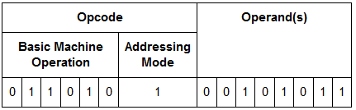

(a)     How many different basic machine operations could be supported by the instruction set of the processor used in the example in **Figure 1**?

**(1)**

**Figure 2** shows an assembly language program together with the contents of a section of the main memory of the computer that the program will be executed on.

The assembly language instruction set that has been used to write the program is listed in **Table 1**.The lines of the assembly language program have been numbered to help you answer question parts (**b**) to (**d**)

**Figure 2**

|  |  |  |  |  |
| --- | --- | --- | --- | --- |
| **Line** | **Command** |  | **Memory Address (in decimal)** | **Main Memory Contents (in decimal)** |
| **1** | LDR  R2,   #100 |  |
| **2** | LDR  R3,   101 |  |
| **3** | ADD  R2,   R2,   R3 |  | 100 | 23 |
| **4** | LSL  R3,   R2,   #1 |  | 101 | 10 |
| **5** | HALT |  | 102 | 62 |
|  |  |  | 103 | 18 |

(b)     What value will be stored in register R2 immediately after the command in line 1 has been executed?

___________________________________________________________________

**(1)**

(c)     What value will be stored in register R2 immediately after the program has executed the commands from line 1 through to line 3?

___________________________________________________________________

**(1)**

(d)     What value will be stored in register R3 after the complete program has finished executing?

___________________________________________________________________

Programs written in a high-level language can be compiled or interpreted.

Companies that develop computer programs to sell usually compile the final version of a program before distributing it to customers.

(e)     Explain why the final version of a computer program is usually translated using a compiler.

___________________________________________________________________

___________________________________________________________________

___________________________________________________________________

___________________________________________________________________

**(2)**

(f)     The JavaScript programming language can be used to write programs that are executed in a web browser on any Internet user’s computer.

Explain why programs written in the JavaScript language, to be executed in a web browser, are interpreted rather than compiled.

___________________________________________________________________

___________________________________________________________________

______________________________________________________________**(2)**

**(Total 8 marks)**

**Q30.**

The diagram below shows the physical topology of a local area network (LAN) and its connection to the Internet. The LAN uses the IPv4 protocol.

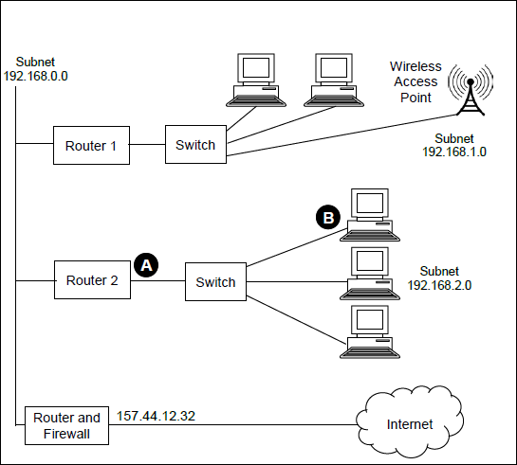

(a)     State suitable IP addresses for:

The ‘Router 2’ port labelled  : __________________________

The computer network interface card labelled  :________________________

**(2)**

(b)     State **one** advantage of the star topology over the bus topology, and explain how this is achieved.

___________________________________________________________________

___________________________________________________________________

___________________________________________________________________

___________________________________________________________________

**(2)**

(c)     Laptop computers connect to the network using WiFi. They use carrier sense multiple access with collision avoidance (CSMA / CA) to determine when to transmit data.

Describe how the CSMA / CA method is used.

___________________________________________________________________

___________________________________________________________________

___________________________________________________________________

___________________________________________________________________

___________________________________________________________________

___________________________________________________________________

___________________________________________________________________

___________________________________________________________________

___________________________________________________________________

___________________________________________________________________

___________________________________________________________________

___________________________________________________________________

___________________________________________________________________

**(6)**

(d)     Each packet of data transmitted around the LAN includes a checksum, which is used for error detection.

Explain how the checksum is used for error detection.

___________________________________________________________________

___________________________________________________________________

___________________________________________________________________

___________________________________________________________________

___________________________________________________________________

___________________________________________________________________

**(3)**

**(Total 13 marks)**

**Q31.**

A particular computer uses a **normalised** floating point representation with an 8-bit mantissa and a 4-bit exponent, both stored using **two’s complement**.

Four bit patterns that are stored in this computer’s memory are listed in the figure below and are labelled **A, B, C, D**. Three of the bit patterns are valid floating point numbers and one is not.

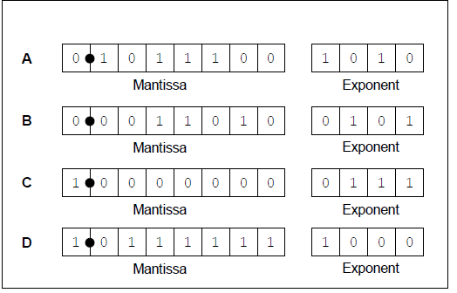

(a)     Complete the table below. In the Correct letter (**A-D**) column shade the appropriate lozenge **A, B, C or D** to indicate which bit pattern from above is an example of the type of value described in the Value description column.

Do **not** use the same letter more than once.

|  |  |
| --- | --- |
| **Value description** | **Correct letter (A-D)** |
| A positive normalised value |  |
| The most negative value that can be represented |  |
| A value that is not valid in the representation because it is not normalised |  |

**(3)**

(b)     The following is a floating point representation of a number:



|  |  |  |
| --- | --- | --- |
| Mantissa |  | Exponent |

Calculate the decimal equivalent of the number. Show how you have arrived at your answer.

___________________________________________________________________

___________________________________________________________________

Answer ___________________________

**(2)**

(c)     Write the normalised floating point representation of the negative decimal value -6.75 in the boxes below. Show how you have arrived at your answer.

___________________________________________________________________

___________________________________________________________________

___________________________________________________________________

___________________________________________________________________

Answer:



|  |  |  |
| --- | --- | --- |
| Mantissa |  | Exponent |

**(3)**

(d)     An alternative two's complement format representation is proposed. In the alternative representation 6 bits will be used to store the mantissa and 6 bits will be used to store the exponent.

**Existing Representation** (8-bit mantissa, 4-bit exponent):



|  |  |  |
| --- | --- | --- |
| Mantissa |  | Exponent |

**Proposed Alternative Representation** (6-bit mantissa, 6-bit exponent):



|  |  |  |
| --- | --- | --- |
| Mantissa |  | Exponent |

Explain the effects of using the proposed alternative representation instead of the existing representation.

___________________________________________________________________

___________________________________________________________________

___________________________________________________________________

___________________________________________________________________

**(2)**

**(Total 10 marks)**

**Q32.** A school stores information about its sports day in a relational database.

The details of the track events are stored using the three relations in **Figure 1** .

|  |
| --- |
| **Figure 1** |
| Athlete (AthleteNumber, Forename, Surname, Class, Gender, DateOfBirth) |
| Race (RaceNumber, Gender, Distance, Type, StartTime) |
| RaceEntryAndResult (RaceNumber, AthleteNumber, TimeSet) |

Each athlete who takes part in a race is given a unique AthleteNumber. Athletes can run in more than one race. If they do, they keep the same AthleteNumber for the entire day.

Many races are run throughout the day. An example race would be the boys 80m hurdles, the third race of the day, which starts at 13:30. The entry in the Race table for this race is shown in the table:

|  |  |  |  |  |
| --- | --- | --- | --- | --- |
| **RaceNumber** | **Gender** | **Distance** | **Type** | **StartTime** |
| 3 | Boys | 80 | Hurdles | 13:30 |

When an athlete is entered into a race, a record of the entry is created in the RaceEntryAndResult table. Initially, the TimeSet is recorded as 00:00.00 (meaning 0 minutes, 0 seconds, 0 hundredths of a second) to indicate that the race has not yet been run. After the race has been run, if the athlete successfully completes it, then their TimeSet value is updated to record the time that they achieved in minutes, seconds and hundredths of a second. The TimeSet value remains at 00:00.00 for athletes who fail to complete the race.

The primary keys in the Athlete and Race relations have been identified in **Figure 1** by underlining them. The correct primary key for the RaceEntryAndResult relation has not been identified.

(a)     In **Figure 2** below, underline the appropriate attribute name(s) to identify the correct primary key for this relation.

|  |
| --- |
| **Figure 2** |
| RaceEntryAndResult (RaceNumber, AthleteNumber, TimeSet) |

**(1)**

(b)     Relations in a database should usually be fully normalised.

Define what it means for a database to be fully normalised.

___________________________________________________________________

___________________________________________________________________

___________________________________________________________________

___________________________________________________________________

**(2)**

(c)     On the incomplete Entity-Relationship diagram below show the degree of the **three** relationships that exist between the entities.

|  |  |  |  |  |  |  |  |  |  |
| --- | --- | --- | --- | --- | --- | --- | --- | --- | --- |
| Athlete | | | |  | | RaceEntryAndResult | | | |
|  |  |  |  |  |  |  |  |  |  |
|  | | | Race | | | |  | | |

**(2)**

(d)     Athlete number 27 is to be entered into race number 6.

Write the SQL commands that are required to make this entry.

___________________________________________________________________

___________________________________________________________________

___________________________________________________________________

___________________________________________________________________

**(2)**

(e)     **Figure 1** is repeated below.

|  |
| --- |
| **Figure 1 (repeated)** |
| Athlete (AthleteNumber, Forename, Surname, Class, Gender, DateOfBirth) |
| Race (RaceNumber, Gender, Distance, Type, StartTime) |
| RaceEntryAndResult (RaceNumber, AthleteNumber, TimeSet) |

Athlete number 27 sets a time of 0:18.76 (0 minutes, 18 seconds, 76 hundredths of a second) for race number 6.

Write the SQL commands that are required to update the athletes entry for this race, to store this time in the TimeSet field.

___________________________________________________________________

___________________________________________________________________

___________________________________________________________________

___________________________________________________________________

___________________________________________________________________

___________________________________________________________________

**(3)**

(f)     The competition organisers want to produce a list of all of the athletes who took part in race number 6 with the athlete who won (set the lowest time) at the top and the other athletes below the winner in the order in which they finished.

Only athletes who finished the race should be included in the list.

The following information should appear for each athlete: AthleteNumber, Forename, Surname and TimeSet.

Write an SQL query to produce the list.

___________________________________________________________________

___________________________________________________________________

___________________________________________________________________

___________________________________________________________________

___________________________________________________________________

___________________________________________________________________

___________________________________________________________________

___________________________________________________________________

**(5)**

(g)     The database system is to be extended for use in an inter-school athletics league. Users at any school in the county will be able to access the system to input the results of races.

It is possible that two users might try to access or update the system at the same time.

Explain the conditions under which simultaneous access to a database could cause a problem, and how this could be dealt with.

___________________________________________________________________

___________________________________________________________________

___________________________________________________________________

___________________________________________________________________

___________________________________________________________________

___________________________________________________________________

___________________________________________________________________

**(3)**

**(Total 18 marks)**

**Q33.** Two computers, **A** and **B**, are involved in a secure communication that uses asymmetric encryption. **A** is sending a message to **B**.

Each computer has a public key and a private key.

(a)     Complete the missing words in the following paragraph.

|  |
| --- |
| **A** will encrypt the message using __________________________key. The message |
| will be decrypted by **B** using __________________________key. |

**(2)**

(b)     The security of the communication could be improved by the addition of a digital signature.

State **two** benefits of including a digital signature.

___________________________________________________________________

___________________________________________________________________

___________________________________________________________________

**(2)**

**(Total 4 marks)**

**Q34.** (a)     The table below lists six Boolean equations. Three of them are correct, the others are not. Shade the lozenges next to the **three** equations that are correct.

|  |  |
| --- | --- |
| **Equation** | **Correct? (Shade three)** |
| A ⋅ = 1 |  |
| A + B = |  |
| A + 1 = 1 |  |
| A ⋅( A + B ) = A |  |
| A + ( A ⋅B ) = B |  |
| A ⋅1 = 1 |  |

**(3)**

(b)     Use Boolean algebra to simplify the following expression:



Show your working.

___________________________________________________________________

___________________________________________________________________

Answer _________________________**(3)**

**(Total 6 marks)**

**Q35.**

In a functional programming language, a recursively defined function named map and a function named double are defined as follows:

map  f  []      =  []  
map  f  (x:xs)  =  f  x  :  map  f  xs

double  x       =  2  *  x

The function x has two parameters, a function f, and a list that is either empty (indicated as []), or non-empty, in which case it is expressed as (x:xs) in which x is the head and xs is the tail, which is itself a list.

(a)     In **Table 1**, write the value(s) that are the head and tail of the list  
[ 1, 2, 3, 4 ].

**Table 1**

|  |  |
| --- | --- |
| Head |  |
| Tail |  |

(b)     The result of making the function call double 3 is 6.

**(1)**

Calculate the result of making the function call listed in **Table 2**.

**Table 2**

|  |  |
| --- | --- |
| **Function Call** | **Result** |
| map  double  [  1,  2,  3,  4  ] |  |

**(1)**

(c)     Explain how you arrived at your answer to part (**b**) and the recursive steps that you followed.

___________________________________________________________________

___________________________________________________________________

___________________________________________________________________

___________________________________________________________________

___________________________________________________________________

___________________________________________________________________

___________________________________________________________________

**(3)**

**(Total 5 marks)**