

Answers

### Answers to contribution calculations on page 2:

|  |  |  |  |
| --- | --- | --- | --- |
|  | Selling price per unit | Variable cost per unit | Contribution per unit (£) |
| A | £4.50 | 79p | £3.71 |
| B | £36.00 | £4.99 | £31.01 |
| C | £199.00 | £64.99 | £134.01 |

### Answers to break-even calculations on page 3:

|  |  |  |  |
| --- | --- | --- | --- |
|  | Contribution | Fixed costs | Break-even  (in units) |
| A | £18.50 | £1,000 | 55 units  (Round up) |
| B | £99 | £2,500 | 26 units  (Round up) |
| C | £3,000 | £250,000 | 84 units  (round up) |

Answers to break-even practice calculation questions

### Answer to break-even practice question 1 on page 5

* First calculate contribution SP-VC
* £20 - £3
* Contribution is £17
* Now use the break-even formula FC/C
* £1000/£17
* Break even (in units is)58.82
* Always round up in break-even
* You need to sell 59 H Shirts to break-even

### Answer to break-even practice question 2 on page 5

* First calculate contribution SP-VC
* £20 - £7
* Contribution is £13
* Now use the break-even formula FC/C
* £1000/£13
* Break even (in units is) 76.72
* Always round up in break-even
* You need to sell 77 H Shirts to break-even

### Answer to break-even practice question 3 on page 5

* First calculate contribution SP-VC
* £20 - £7
* Contribution is £13
* Now use the break-even formula FC/C
* £1250 / £13
* Break even (in units is) 96.15
* Always round up in break-even
* You need to sell 97 H Shirts to break-even

### Answers to Total Costs grid on page 7

|  |  |  |  |
| --- | --- | --- | --- |
|  | Fixed costs | Variable costs | Total costs |
| 0 units | £1,000 | £0 | £1,000 |
| 500 units | £1,000 | £2,500 | £3,500 |
| 1000 units | £1,000 | £5,000 | £6,000 |

### Answer to the break-even graph question on page 11

The area to the left of the break-even point would indicate Loss

### Answer to break-even chart practice question on page 12

Shade this area to indicate profit

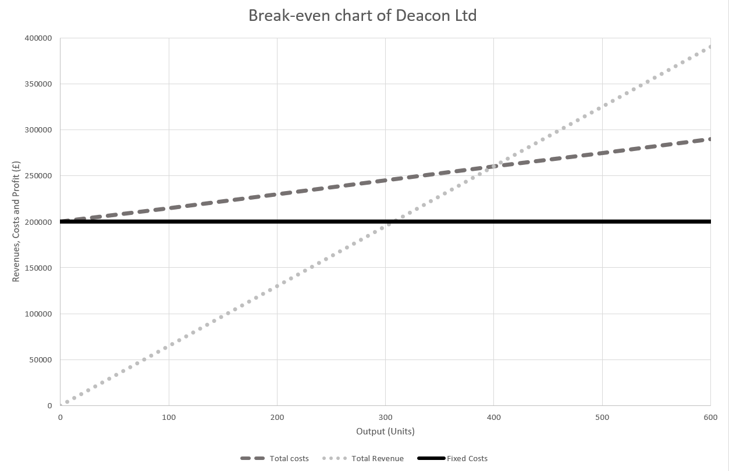

This is the break-even point

The break-even point is 400 units (reading from the chart)

### Answer to margin of safety practice question 1 on page 15

* Use the Margin of Safety (MoS) formula: Actual units – Break-even units
* 46,000 – 25,000 = 21,000
* If the cost of raw materials increases
* 46,000 – 29,000 = 17,000
* The difference
* 21,000-17,000 = 4,000

### Answer to margin of safety practice question 2 on page 15

1. To calculate the Total Revenue (TR) use the formula Q x P
2. £18 = £1080

1. To calculate break-even first calculate contribution SP-VC

* £18 - £1 = £17
* Contribution is £17
* Now use the break-even formula FC/C
* £90 / £17
* Break even (in units is) 5.29
* Always round up in break-even
* Cleaner homes will need to wash the windows of 6 houses to break-even

1. To calculate the Margin of Safety (MoS) use the formula:

* Actual units – Break-even units
* 60 – 6 = 54
* Margin of safety is washing the windows of 54 houses

### Answer to extra practice question 1 on page 16

* To calculate break-even first calculate contribution SP-VC
* £1000 - £800 = £200
* Contribution is £200
* Now use the break-even formula FC/C
* £12,000 / £200
* Break even (in units is) 60
* Vision One needs to sell 60 TVs per year to break even

### Answer to extra practice question 2 on page 16

1. To calculate break-even first calculate contribution SP-VC

* £12.50 - £2.25 = £10.25
* Contribution is £10.25
* Now use the break-even formula FC/C
* £2000 / £10.25
* Break even (in units is) 195.12
* Always round up with break-even
* Beak-even is 196 items of jewellery a year

1. To calculate the Margin of Safety (MoS) use the formula:

* Actual units – Break-even units
* 350 – 196 = 154
* Margin of safety is 154 items of jewellery