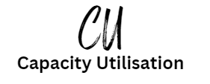 

Introduction

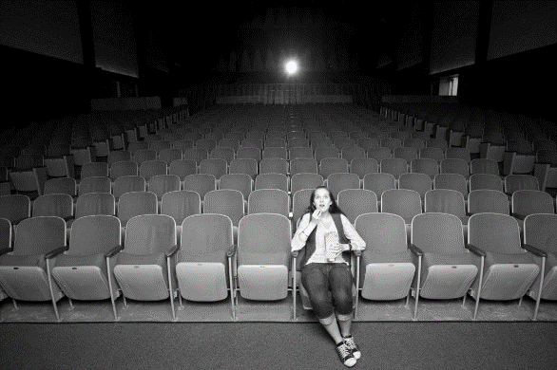Capacity utilisation is the idea that every business has a maximum level, in a restaurant this could be the number of seats at tables e.g. 26 seats. In a factory this could be the number of units that the factory can produce in a day, this may be constrained by the types of machines and numbers of staff e.g. 2,000 bags of crisps a day. If the business runs at this maximum level of capacity, we would say it is running at 100%. A concert or match, that is sold out, is a 100% capacity audience.

Now you would think that running at 100% would be ideal, the best way to maximise profits and achieve your business objectives. This is not always the case, and exam questions will need you to understand and discuss this.

These are the three things you need to learn for capacity utilisation:

a) Capacity utilisation – using the formula

b) Implications of under and over utilisation of capacity

c) Ways of improving capacity utilisation

Capacity Utilisation using the formula

This is the formula we use to calculate capacity utilisation:

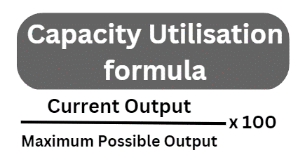

Try some exercises using the formula

|  |  |  |
| --- | --- | --- |
| Current Output | Maximum Possible Output | Capacity utilisation |
| 8,000 units per week | 10,000 units per week |  |
| 247,544 cars per year | 450,000 cars per year |  |
| 2,000 tickets sold | 3,000 stadium seats |  |
| 15,000 units per year | 12,000 units per year |  |

Implications of under and over utilisation of capacity

# Under capacity

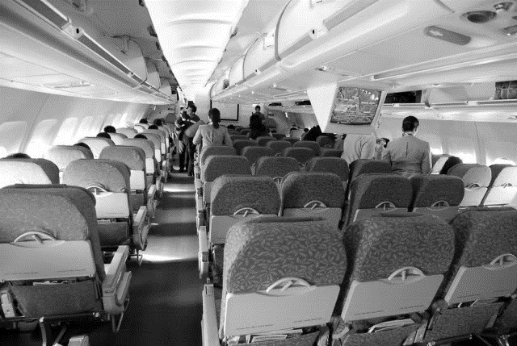This is the idea that a business is running at less than their maximum. For example; a dog grooming salon business has enough appointments, space and staff to groom 60 dogs a week, that is 10 dogs a day for a 6-day week. If the business runs at 100% capacity it does not leave any time to wash down and sterilise equipment, to maintain the salon, to chat to loyal customers, to fit in a regular customer who didn’t have time to book and to give staff adequate tea and lunch breaks. So the salon runs at 80% capacity. We would say that the salon is running under-capacity.

# Over capacity

This is the idea that occasionally a business may want to run at 110% or 120% capacity, perhaps to fulfil a special client order, or take advantage of good weather. For example, a business which makes teaspoons may have a special order in from a chain of hotels. They already run at 99% capacity, but they would need to run at 110% to fulfil the order. They could give staff overtime, they could take on temporary staff to cover the order, they could subcontract the work out to another company and buy them in. So running at 110% can also be OK. In a pub this might mean opening a beer garden to accommodate more drinkers and diners. The key is to look at the context of the question. We would say the pub is running at over-capacity. The downside is; less time for quality control, demotivating for staff, failure of equipment if not maintained properly.

Ways of improving capacity utilisation

# Increasing sales

If the business is running at under capacity they can increase the demand for the product or service through sales promotions and advertising.

# HRM solutions

If the business needs to run over capacity it can increase staff hours if there is a new contract that needs to be fulfilled. This may mean overtime which can be a popular way for existing staff to earn extra money.

If the business is running at under capacity they may choose to make some staff redundant. This will improve the costs and profitability of the business.



# Outsourcing

Some of the production can be outsourced to other manufacturers who are working under capacity. This will allow the business to take on the contract for the extra work.

# Reducing maintenance time

If the amount of time given to maintaining machines is reduced then they can be used more often to produce more goods. This is a short-term strategy. In the long term if machines are not serviced regularly they will break more often.

Practice questions

# Practice question 1

Hydroboat Ltd is a business that cleans narrow boats in a marina. They currently clean 250 boats a year but they have enough staff and resources to clean 400 boats a year. Calculate their capacity utilisation. Show your workings out.

Answer Box

# Practice question 2

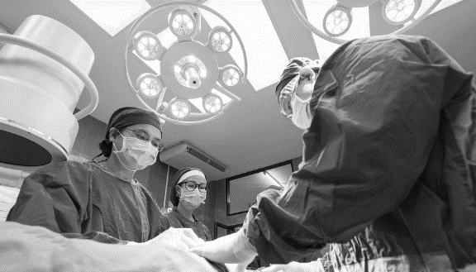

Midic Ltd is a thriving UK company based in Dottingham. They manufacture medical supplies for hospitals such as gowns, gloves and masks. They currently have a capacity utilisation of 100%. Discuss ways in which they could increase their capacity to work above 100%.

# Example question 3



DuNoodle is an organic restaurant in Morkshire that currently operates at 70% capacity. Discuss the benefits and drawbacks of this business strategy.

# Example question 4



Bonity is business which runs a series of children’s nurseries in Swinton. The current capacity utilisation is 75% but the manager wants it to increase it to 92%. Assess the impact on employee motivation of the proposal to increase the capacity utilisation.

# Practice question 5



Jamba is a small business based in Mevon, they manufacture gluten free smoothies for national supermarket chains. Jamba currently work at a capacity utilisation of 65%. Explain the benefits and drawbacks for Jamba operating below 100% capacity utilisation.

# Practice question 6





A bowling alley has some capacity utilisation problems. They have too many customers who arrive without booking a lane. This means that the bowling alley often does not have enough lanes, staff or food to accommodate the customers, resulting in lots of complaints. Discuss how the bowling alley can solve their capacity utilisation problems.

# Practice question 7

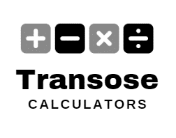

Transose is a business in Dottingham that manufactures calculators. They are currently producing 35,500 calculators a month. Their maximum capacity is 46,500 calculators a month. Calculate their current capacity utilisation, show your working and give your result to two decimal places.

# Practice question 8

The global pottery industry reports an industry average capacity utilisation of 78% which is decreasing. Trufy is a small pottery business, based in Dottingham in the UK. They are considering reducing their prices. Discuss if this is a good strategy, given the current industry capacity.

# Practice question 9





The Bees are a team of rugby players, play at a ground with a capacity of 10,000. All the tickets are sold out at every game. Discuss what will happen if the team raises their ticket prices. Refer to capacity utilisation and price elasticity in your answer.

# Practice question 10

Scnadi Tents Ltd is an event company which specialises in kids birthday parties. They set up small tents in customer’s houses for themed sleepovers. Use the data below to calculate their capacity utilisation for the four quarters last year. Show your workings and round the result to two decimal places.

|  |  |  |  |  |
| --- | --- | --- | --- | --- |
|  | Q1 | Q2 | Q3 | Q4 |
| Current output | 40 parties | 30 parties | 50 parties | 60 parties |
| Maximum output | 210 parties | 210 parties | 210 parties | 210 parties |
| Capacity Utilisation |  |  |  |  |

Summary of Capacity Utilisation Formulae

