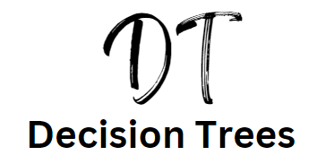

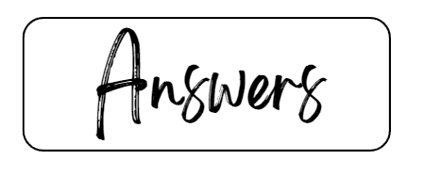

## 

## Answer to example tree 1 on page 7:

* Node A = (£22m x 0.2 = £4.4m) + (£4.8m x 0.8 = £3.84) = £8.24 then minus the original cost of the project £2m Node A is £6.24m
* Node B = (£7.3m x 0.4 = £2.92m) + (£0.6 x 0.6 = £0.36m) = £3.28m then minus the original cost of the project £0.7m Node B is £2.58m
* Project A would be the one to get the investment

## Answer to example tree 2 on page 8:

* Node A = (£20m x 0.7 = £14m) + (£5m x 0.3 = £1.5m) = £15.5m then minus the original cost of the project £10m Node A is £5.5m
* Node B = (£8m x 0.8 = £6.4m) + (£3m x 0.2 = £0.6m) = £7m then minus the original cost of the project £5m Node B is £2m
* Project A would be the one to get the investment

## Answer to example tree 3 on page 9:

* Node A = (50,000 x 0.6 = 30,000) + (30,000 x 0.4 = 12,000) = £42,000 then minus the original cost of the project £2,000 Node A is £40,000
* Node B = (100,000 x 0.6 = 60,000) + (-40,000 x 0.4 = -16,000) = £44,000 then minus the original cost of the project £3,000 Node B is £41,000
* Node C = (30,000 x 0.6 = 18,000) + (10,000 x 0.4 = 4,000) = £22,000 then minus the original cost of the project £4,000 Node C is £18,000
* Project B would be the one to get the investment

## Answer to example tree 4 on page 10:

* Node A = £40m + £20m + £0.4m = £60.4m cost of project unknown
* Node B = £10m + £10m + £1.4m = £21.4m cost of project unknown
* Node C = £120m + £8m + £1.8m = £129.8m cost of project unknown
* Node D = £60m + £6m + £0.2m = £66.2m cost of project unknown
* Without knowing the cost of the projects then project C would get the investment and the go ahead.