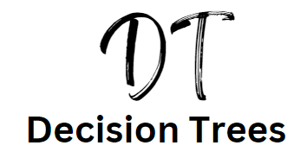

Introduction

Decision trees are used in a variety of businesses to directly compare the outcome of two or more projects against an expected reward. This is useful when the probability of success or failure (or outcome) is known. This would be from previous projects of a similar nature carried out by the business. Historical data will help the business to decide what the probabilities of an outcome are. The good news is you don’t have to work out the probabilities in decision trees and the calculations are quite straightforward.

## What you need to know for the exam:

a) How to construct and interpret simple decision tree diagrams

b) How to make calculations and interpret figures generated by

these techniques

c) Limitations of using decision trees

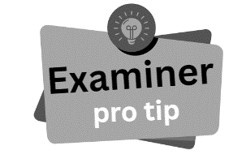

You won’t have to draw a decision tree from scratch. Usually you will be given a partially complete one and asked to finish the calculations. Some questions also ask you to comment on the usefulness and limitations of a decision tree in context of the case study you have been given.

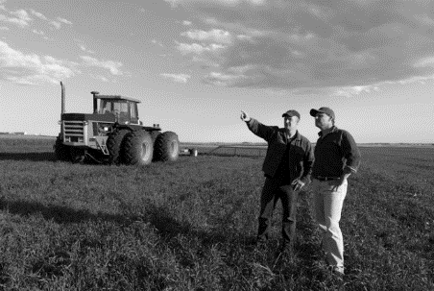Decision Tree Example

Figure : Farmer making a decision about crops

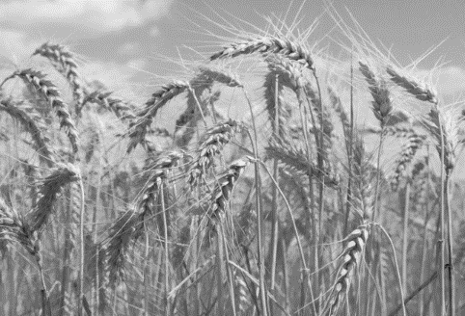A farmer is considering to either plant wheat or potatoes in their field. They know from previous years’ experience the probability of success or failure of each type of crop and also how much revenue each crop is likely to yield.

Figure : Field of Wheat

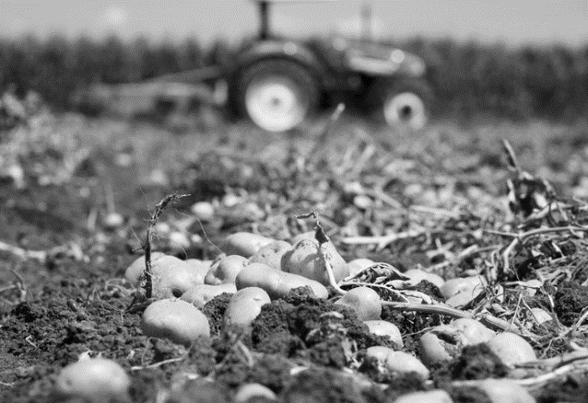The farmer can use a decision tree to calculate which crop they should plant, to get the best return on their investment.

Figure : Field of potatoes

The farmer will need to allocate resources to planting the crops, tending the plants and harvesting. These are all costs that must be paid for. It would be better business sense to allocate resources based on sound decision making. Decision trees help to make those decisions.

Decision Tree Explained

This is a simple decision tree:

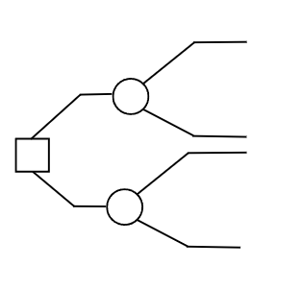

See a square – make a decision

The square at the start of a decision tree is the **decision** that needs to be made. In this example, the decision is to plant either wheat or potatoes.

See a circle make a calculation

At the circle (or node) there are a pair of calculations to be made:

1. Probability x yield. Make this calculation for each arm leading from the circle
2. Minus the outcomes from each circle (or node)
3. Choose the highest final profit or loss figure for each circle (or node)

Decision Tree Walkthrough

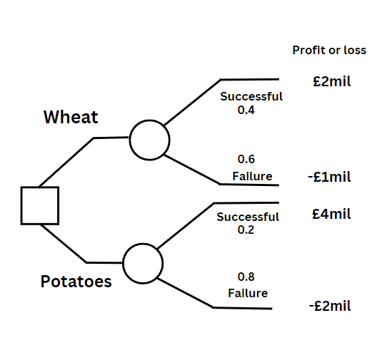

Step 1: First calculate the probability of the yield

Wheat

Successful crop: 0.4 x £2mil = £800,000

Unsuccessful crop: 0.6 x -£1mil = (-£600,000)

Potatoes

Successful crop: 0.2 x £4mil = £800,000

Unsuccessful crop: 0.8 x -£2mil = (-£1,600,000)

Step 2: Add the probability of each option together

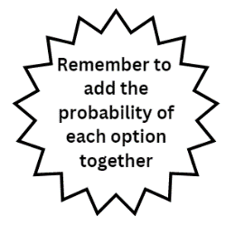Wheat

£800,000 + (-£600,000) = £200,000

Potatoes

(-£1,600,000) + £800,000 = (-£800,000)

Step 3: Choose the best yield / return on investment

The wheat yields £200,000 and the potatoes yield (-£800,000) so the obvious choice would be for the farmer to choose to plant wheat in the field.

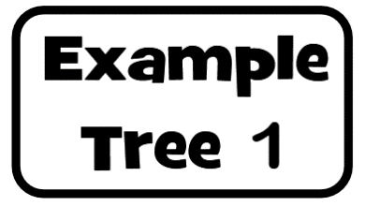

Notice that the probability of success and failure ALWAYS add up to 1, so if you are only given one probability in a question you can fill in the rest.

At this point there are two options or decisions to be made. The costs of each of these decisions is also sometimes given.

**Launch a new product at a cost of £2 million**

**Start a marketing campaign on the old product at a cost of**

**£0.7 million**

A

B

Success

Failure

Failure

0.2

0.8

0.4

0.6

£22m

£4.8m

£7.3m

£0.6m

Success

At the end the outcomes are shown. Sometimes the outcomes will be a loss, in that case you should minus them.



Step 1 multiply the outcome by the probability on each leg of the node. The first one is done for you, can you fill in the rest?

**Launch a new product at a cost of £2 million**

**Start a marketing campaign on the old product at a cost of**

**£0.7 million**

A

B

Success

Failure

Failure

0.2

0.8

0.4

0.6

£22m

£4.8m

£7.3m

£0.6m

Success

£22m x 0.2 = £4.4m



Now take the totals on the nodes and add them together. Use these totals and minus the cost of the project to make a final decision – which would you choose A or B? Choose the node with the highest outcome.

**Launch a new product at a cost of £2 million**

**Start a marketing campaign on the old product at a cost of**

**£0.7 million**

A

B

Success

Failure

Failure

0.2

0.8

0.4

0.6

£22m

£4.8m

£7.3m

£0.6m

Success

£22m x 0.2 = £4.4m

£4.4m + £3.84m = £8.24m – £2m cost = £6.24

£4.8m x 0.8 = £3.84m

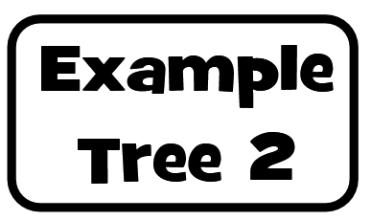

Calculate the decision tree and comment on if project A or project B should get the investment – check your answers at the end of this section

A

B

Success

Failure

Failure

0.7

0.3

0.8

0.2

£20m

£5m

£8m

£3m

Success

Cost of project A is £10m

Cost of project B is £5m

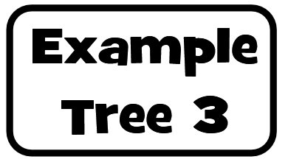

In this example you have three nodes, so three pairs of calculations to make.

A

C

Success

Failure

Failure

0.6

0.4

0.6

0.4

£50,000

£30,000

£30,000

£10,000

Success

B

£100,000

(£-40,000)

0.4

Failure

0.6

Success

Cost £2,000

Cost £4,000

Cost £3,000

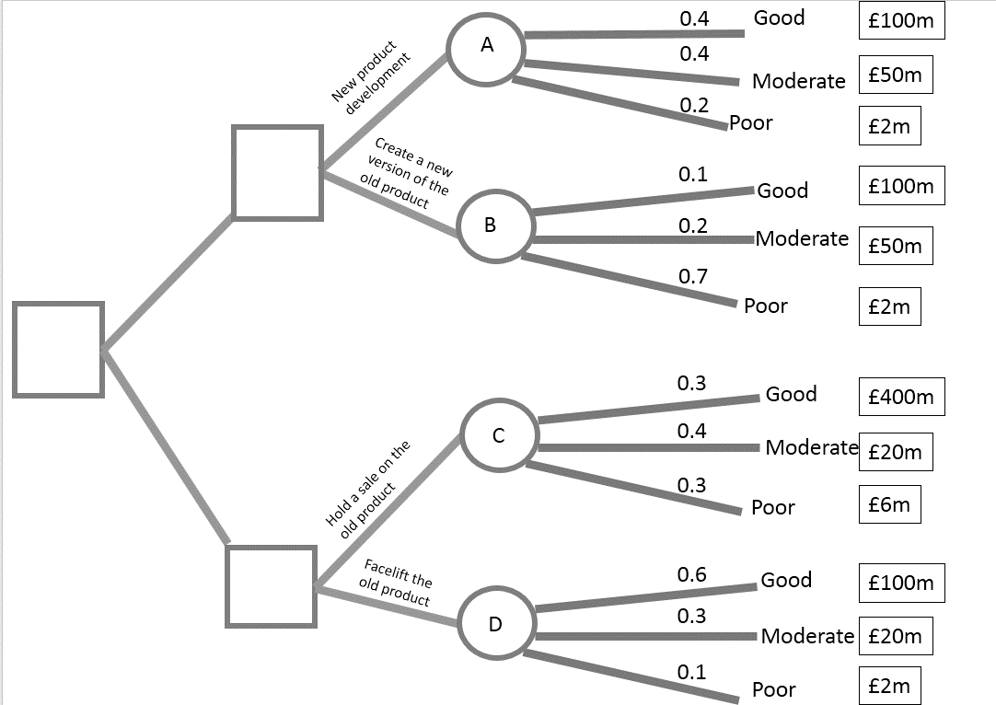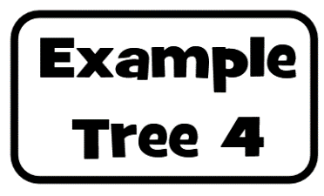

In this example there are three outcomes on each node – they still add up to 1, can you complete this tree and decide which project the business should undertake?

New products

Old products

Limitations of Decision Trees

You may get a decision tree question in your exam which just asks for “The usefulness to business xyz of using decision tree analysis when deciding to…”

The best answers weigh up the uses (in context) and the limitations

## Limitations

1. The outcomes and probabilities are all estimates and predictions, anything could happen, every business could suffer from external shocks such as a recession
2. Decision trees are based on predicted data of the potential impact of the decision which is made from it should not be taken without consideration of other factors apart from the tree (quantitative and qualitative data). For example, if the decision is to recall a car or facelift an old model these would be very expensive decisions to get wrong and so should not be based just on a decision tree outcome.
3. Decision tree does not take into account unforeseen costs and circumstances such as a delay in delivery.
4. Using decision trees might fit with a cautious business culture but this is likely to be less important than the need to act quickly to respond to market trends, which would suggest the decision trees are not that useful
5. Some of the estimates could be very inaccurate. If they are based on historical data, take in to account what was happening that year e.g. pandemic, floods, recession
6. The use of decision trees is limited because the impact of expenses such as advertising are hard to forecast