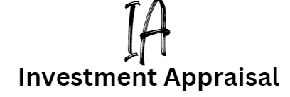

Introduction

Investment Appraisal (IA) is a tool used by businesses to compare projects, to help them to work out which project will best meet their business objectives e.g. profit maximisation or cost efficiency.



Imagine you are the Finance Manager in a business. Your job is to ask department managers for new project ideas and then to decide which project should go forwards. You are at a board meeting with the other managers who are all pitching their project ideas to you.

The business does not have infinite money (or capital) to invest in all the projects, so you use IA methods to help narrow it down. IA will help you to decide which project should get the funding.



There are 3 methods of IA to help business managers to decide which project should get the funding:

1. Payback
2. Average Rate of Return (ARR)
3. Net Present Value (NPV)

In exam questions, you will probably be asked for just two of the three methods. However, you still need to learn all three methods, as you do not know which ones will be asked.

Payback method explained

A business will use the payback method to simply work out how long each project will take to pay back the initial investment to the business. Payback is the time period for the original financial investment cost of a project to be fully recovered. Year 0 is the start of the project and when the initial investment was made, which is why the figure at year 0 is a minus.

|  |  |
| --- | --- |
|  | **Project A** |
| **Year 0** | -£150,000  *This is the initial investment made into the project which is why it is a minus as it is owed back to the investor* |
| **Year 1** | £50,000  *This is the amount that the business can pay back to the investor in year 1* |
| **Year 2** | £50,000  *This is the amount that the business can pay back to the investor in year 2, so now the investor has £50,000 and £50,000 a total of £100,000 back, so the project has not yet paid for itself* |
| **Year 3** | £50,000  *Finally the investment is paid back, £50,000 + £50,000 + £50,000, a total of £150,000. So the project pays back in year 3 in this example.* |
| **Year 4** | £60,000 |
| **Year 5** | £65,000 |
| **Payback** | Year 3 |

In the exams you will need to compare two or more projects, the one the pays back the soonest would be the best option. Imagine if you were owed money by a friend who had borrowed it from you, you would want it back as soon as possible so you can use it for something else. The sample principal applies in business.

Often the information is in a table and sometimes appears in the case study text so you need to be ready for all methods.

Payback method walkthrough

|  |  |  |  |  |
| --- | --- | --- | --- | --- |
|  | **Project A** | **Project B** | **Project C** | **Project D** |
| **Year 0** | -£150,000 | -£67,000 | -£215,000 | -£89,000 |
| **Year 1** | £50,000 | £60,000 | £45,000 | £70,000 |
| **Year 2** | £50,000 | £14,000 | £47,000 | £65,000 |
| **Year 3** | £50,000 | £16,000 | £49,000 | £66,000 |
| **Year 4** | £60,000 | £18,000 | £51,000 | £68,000 |
| **Year 5** | £65,000 | £20,000 | £53,000 | £66,000 |
| **Payback** | 3 years | 1 year 6 months | 4 years 6 months | 1 year 4 months |

Walkthrough calculation of Payback on Project B:

In project B the business intends to invest £67,000. It pays back £60,000 in the first year but this is not enough, so we need to get £7,000 from year 2. We use this formula:

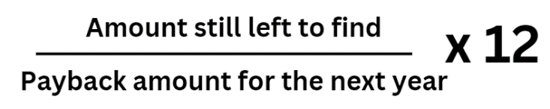

7,000 / 14,000 x 12 (months) = 6 months

Project B will take 1 year and 6 months to payback. Already we can see this might be better for the business than project A, because it pays back the investment in a shorter period.



ARR method explained

Payback does not take into account how much profit can be made from the investments over the lifetime of the projects. So a business will use ARR (which stands for average rate of return) and compare annual profit generated by the project with the initial amount invested in it. ARR shows the expected profitability of an investment project over the projected cash flow period.

Generally, a business could earn up to 5% in a savings account, and this would be a risk free investment.

Any result you get needs to be compared to that. So below 5% the investment would be too risky for the potential return. Above 5% and the investment would be well worth it. The project with the highest ARR would be the one that gets the investment.

|  |  |
| --- | --- |
|  | **Project A** |
| **Year 0** | -£150,000 |
| **Year 1** | £50,000 |
| **Year 2** | £50,000 |
| **Year 3** | £50,000*.* |
| **Year 4** | £60,000 |
| **Year 5** | £65,000 |
| **ARR%** |  |

* Step 1: Add up all of the cash inflows from years 1 - 5

£50,000 + £50,000 + £50,000 + £60,000 + £65,000 = £275,000

* Step 2: Minus the original cost of the project

£275,000 - £150,000 = £125,000

* Step 3: Divide this by the number of years the project runs for

£125,000 / 5 years = £25,000

* Step 4: Divide that figure by the cost of the project and x 100 to get a percentage and compare this with a 5% bank account

£25,000 / £150,000 x 100 = 16.67%

ARR method walkthrough

|  |  |  |  |  |
| --- | --- | --- | --- | --- |
|  | **Project A** | **Project B** | **Project C** | **Project D** |
| **Year 0** | -£150,000 | -£67,000 | -£215,000 | -£89,000 |
| **Year 1** | £50,000 | £60,000 | £45,000 | £70,000 |
| **Year 2** | £50,000 | £14,000 | £47,000 | £65,000 |
| **Year 3** | £50,000 | £16,000 | £49,000 | £66,000 |
| **Year 4** | £60,000 | £18,000 | £51,000 | £68,000 |
| **Year 5** | £65,000 | £20,000 | £53,000 | £66,000 |
| **ARR %** |  | 18.21% |  |  |

Walkthrough calculation of ARR on Project B:

* Step 1: Add up all of the cash inflows from years 1 - 5

£60,000 + £14,000 + £16,000 + £18,000 + £20,000 = £128,000

* Step 2: Minus the original cost of the project

£128,000 - £67,000 = £61,000

* Step 3: Divide this by the number of years the project runs for

£61,000 / 5 years = £12,200

* Step 4: Divide that figure by the cost of the project and x 100 to get a percentage

£12,200 / £67,000 x 100 = 18.21%

Compare all the ARR figures for all 4 projects - you are looking for the highest percentage as this will be the most profitable project. You can also compare against investing instead at 5% in a bank savings account, which would be an opportunity cost for the business.

NPV method explained

In the future money will not be worth what it is now, unfortunately, ARR and Payback methods of IA don’t take this into consideration, but NPV (which stands for Net Present Value) does. NPV is the value today of the estimated cash flows from the project.

The NPV is found by discounting future money to make allowance for the opportunity cost of tying up the capital. For example, the money from the project investment could have been used elsewhere in the business. You are looking for a return greater than zero £0.

Limitations of NPV:

* NPV is the value today of future estimated cash flows resulting from investment in a project
* The projected cash flows are always estimates and the project may be more or less successful depending on economic factors
* The business could have invested the cash in a bank account instead, at a lower risk
* NPV relies on accurately estimating the interest rate being charged by lenders for the lifetime of the investment, these may change and effect expected returns



1. If you get an NPV question, you will be given the discount table so don’t worry that you will have to calculate all the discount values
2. You may be asked to; make several calculations, one calculation or just to discuss the uses and limitations of IA methods.
3. Show your answers for ARR to two decimal places, and always include the percentage sign when multiplying by 100 e.g. 18.89%
4. With payback calculations **always** round up to the nearest month, as rounding down won’t show the business when the project pays back, and would be incorrect.

NPV method walkthrough

XYZ Ltd owns a chain of superstores, some of which are in dire need of a refit. These are the estimated costs of the refit of the Dottingham superstore. The business wants to know if it will be financially beneficial to carry out the refit. Calculate the NPV of the project. The project is likely to cost £220,000

Method

1. Multiply the discount factor by the net cash flow and complete the table below
2. To calculate the NPV add up all the discounted cash flows from years 1 to 5 and then minus the original investment cost (in this example it is £220,000)
3. Complete the table below:

|  |  |  |  |
| --- | --- | --- | --- |
| Year | Discount factor | Net cash flow | Discounted cash flow |
| 1 | 0.990 | £85,000 | £84,150 |
| 2 | 0.980 | £75,000 |  |
| 3 | 0.971 | £60,000 |  |
| 4 | 0.961 | £45,000 |  |
| 5 | 0.951 | £30,000 |  |
| NPV: | | |  |

Summary activity

# Read the following statements and put them into the correct boxes:

1. Calculates the length of time taken to repay the initial capital cost
2. Shows that the value of money is affected by interest rates
3. Used to assess the amount of risk involved by calculating how long it takes to recover the cost of the investment
4. Shows profitability
5. Shows the future value of money
6. Uses a discounted rate table
7. Simple to calculate
8. Estimates total income over a lifespan
9. Easy to compare against a 5% savings account
10. 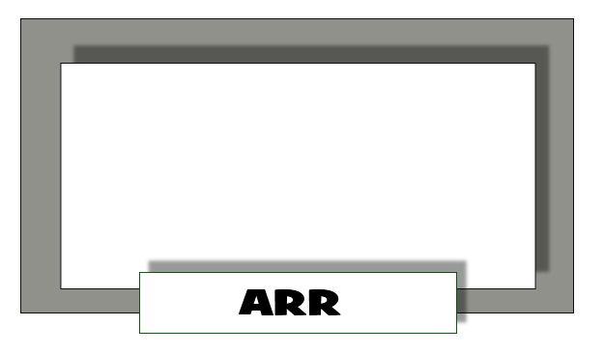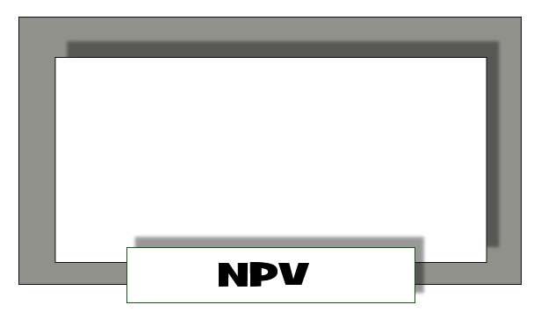Shows how hard the money is working for the investor

# Practice question 1

XYZ Ltd sells clothes in a series of stores throughout the UK. The following information is there to assist XYZ’s Managers to perform an investment appraisal. This is to help the managers to decide if they should buy new store premises in Dottingham.

Using the data in the table below, calculate the Payback period and the Average Rate of Return for this project.

|  |  |
| --- | --- |
| Year | Net Cash flow |
| 0 | -£12 million |
| 1 | £2 million |
| 2 | £3 million |
| 3 | £3 million |
| 4 | £4 million |
| 5 | £5 million |

# Image result for tna baggingPractice question 2

XYZ Ltd makes crisps and they are considering installation of a new crisp bagging machine in their factory at a cost of £120,000. This would replace four trained workers. The business currently earns 7% in a fixed term savings account.

Using NPV, Payback and ARR evaluate if XYZ Ltd should invest in the new crisp bagging machine.

|  |  |  |  |
| --- | --- | --- | --- |
| Year | Discount factor | Net cash flow | Discounted cash flow |
| 0 |  | -£120,000 |  |
| 1 | 0.935 | £50,000 |  |
| 2 | 0.873 | £50,000 |  |
| 3 | 0.816 | £40,000 |  |
| 4 | 0.763 | £40,000 |  |

# Practice question 3

XYZ Ltd are estate agents and they have several locations, selling houses and flats in Dottingham. XYZ Ltd are considering investing in a new computer program to help match property being sold to property buyers. It will cost XYZ Ltd £5 million to develop and install and is expected to be useful for 5 years, after which time it will need to be replaced. It is expected to provide a net return of £1.5 million per year.

Calculate the payback period and the ARR for the new computer program. Show your workings.

# Practice question 4

XYZ Ltd manufacture pottery from a seam of clay behind their factory. They ship their pottery all over the world. They want to open a new manufacturing centre in Derby. Calculate the Payback and the ARR and comment on the plans for this project.

This new factory will cost £500 million and net cash flows are expected to be as follows:

|  |  |
| --- | --- |
| Year | Net Cash flow |
| 1 | £85m |
| 2 | £95m |
| 3 | £85m |
| 4 | £100m |
| 5 | £110m |
| 6 | £120m |
| 7 | £140m |
| 8 | £140m |
| 9 | £120m |
| 10 | £110m |

# Practice question 5

XYZ PLC make electric cars and they need to find out the NPV of a new car assembly factory which they intend to build in Dottingham. The factory is expected to cost £50million to build. Carry out calculations to help them find out the NPV at a rate of 5%of the project given the tables below and comment on the plans for the project:

|  |  |  |  |
| --- | --- | --- | --- |
| Year | Discount factor | Net cash flow | Discounted cash flow |
| 1 | 0.952 | £10 million |  |
| 2 | 0.907 | £20 million |  |
| 3 | 0.864 | £30 million |  |
| NPV: | | |  |

# Practice question 6

XYZ Ltd manufacture plastic duck bath toys and they are determined to become a greener company, so they are looking into installing equipment to reduce waste and pollution at their Burton-On-Trent factory. The project will cost XYZ Ltd £600,000. This new equipment is expected to be useful for 4 years. Using the table below calculate the ARR and the payback and comment on the plans for the project.

|  |  |
| --- | --- |
| Year | Net Cash flow |
| 1 | £100,000 |
| 2 | £400,000 |
| 3 | £400,000 |
| 4 | £180,000 |

