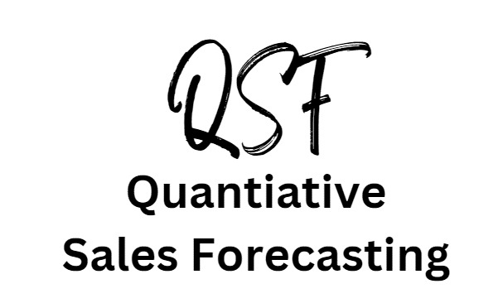

# 

# Answer to 4 quarter moving average walkthrough on page 7

|  |  |  |  |  |  |
| --- | --- | --- | --- | --- | --- |
| Year and Quarter | Sales  £000 | 4 Quarter Total | 8 Period Total | 4 Quarter moving average (Trend) | Variation |
| 2020 Q1 | 72 |  |  |  |  |
|  |  |  |  |  |  |
| 2020 Q2 | 73 |  |  |  |  |
|  |  | 289 |  |  |  |
| 2020 Q3 | 74 |  | 579 | 72.38 | 1.62 |
|  |  | 290 |  |  |  |
| 2020 Q4 | 70 |  | 581 | 72.63 | -2 |
|  |  | 291 |  |  |  |
| 2021 Q1 | 73 |  | 583 | 72.88 | 0.12 |
|  |  | 292 |  |  |  |
| 2021 Q2 | 74 |  | 582 | 72.75 | 1.25 |
|  |  | 290 |  |  |  |
| 2021 Q3 | 75 |  | 579 | 72.38 | 2.62 |
|  |  | 289 |  |  |  |
| 2021 Q4 | 68 |  | 579 | 72.38 | 2.62 |
|  |  | 290 |  |  |  |
| 2022 Q1 | 72 |  | 582 | 72.75 | 1.25 |
|  |  | 292 |  |  |  |
| 2022 Q2 | 75 |  | 586 | 73.25 | 1.75 |
|  |  | 294 |  |  |  |
| 2022 Q3 | 77 |  |  |  |  |
|  |  |  |  |  |  |
| 2022 Q4 | 70 |  |  |  |  |

# Answer to practice question 1 on page 12

|  |  |
| --- | --- |
| Month | Number of monthly diners |
| May | 140 |
| June | 200 |
| July | 280 |
| Aug | 280 |
| Sept | 290 |
| Oct | 350 |
| Nov | 368 |
| Dec | 380 |

3 Period moving average for May to July is 206.67

140 + 200 + 280 / 3 = 206.67

3 period moving average for Oct – Dec is 366

350 + 368 + 380 / 3 = 366

Difference is 366 – 206.67 = 159.33

# Answer to practice question 2 on page 13

|  |  |  |
| --- | --- | --- |
| Month | % occupancy | 3 period moving average |
| May | 23 |  |
| June | 32 | 37 |
| July | 56 | 62.67 |
| Aug | 100 | 66.33 |
| Sept | 43 | 73.67 |
| Oct | 78 | 47.33 |
| Nov | 21 | 63 |
| Dec | 90 |  |

# Answer to practice question 3 on page 14

|  |  |  |  |
| --- | --- | --- | --- |
| Month | Number of passengers | 3 period moving average | Variation |
| Jan | 1235 |  |  |
| Feb | 1050 | 1081 | -31 |
| March | 985 | 1000 | -15 |
| May | 965 | 982.67 | -898 |
| June | 998 | 1094.33 | -96.33 |
| Oct | 1320 | 1112.67 | 207.33 |
| Nov | 1020 | 1228 | -208 |
| Dec | 1344 |  |  |

# Answer to practice question 4 pages 15 and 16

|  |  |  |  |  |  |
| --- | --- | --- | --- | --- | --- |
| Year and Quarter | Sales  £000 | 4 Quarter Total | 8 Period Total | 4 Quarter moving average (Trend) | Variation |
| 2020 Q1 | 28 |  |  |  |  |
|  |  |  |  |  |  |
| 2020 Q2 | 49 |  |  |  |  |
|  |  | 168 |  |  |  |
| 2020 Q3 | 56 |  | 343 | 42.88 | 13.12 |
|  |  | 175 |  |  |  |
| 2020 Q4 | 35 |  | 357 | 44.62 | -9.62 |
|  |  | 182 |  |  |  |
| 2021 Q1 | 35 |  | 371 | 46.38 | -11.38 |
|  |  | 189 |  |  |  |
| 2021 Q2 | 56 |  | 385 | 48.13 | 7.87 |
|  |  | 196 |  |  |  |
| 2021 Q3 | 63 |  | 399 | 49.88 | 13.12 |
|  |  | 203 |  |  |  |
| 2021 Q4 | 42 |  | 413 | 51.63 | -9.63 |
|  |  | 210 |  |  |  |
| 2022 Q1 | 42 |  | 427 | 53.38 | -11.38 |
|  |  | 217 |  |  |  |
| 2022 Q2 | 63 |  | 441 | 55.13 | 7.87 |
|  |  | 224 |  |  |  |
| 2022 Q3 | 70 |  |  |  |  |
|  |  |  |  |  |  |
| 2022 Q4 | 49 |  |  |  |  |

* A = 51.63
* B= -9.63
* C= 53.38
* D= -11.38



# Answer to practice question 4 pages 15 and 16

# Interpretation of findings

* Lower sales revenue in Q1s and Q4s when compared to Q2 and Q3
* Variation in winter quarters (Q4 and Q1) are negative, which means sales are below trend. Probably due to customers not wanting to drive or make kit cars in the winter.
* Between 2020 and 2022 the moving averages have increased, the trend is upwards suggesting growth. The upward trend in sales in that period supports this conclusion.

# 

# Answer to practice question 5 on page 17

Note: This was a general question, in an exam you would need to be able to apply your statements to a given business.

Limitations

* QSF is future predictions made from past data
* Extrapolation of past data to make sales forecasts can be problematic because of the dynamic nature of business
* External factors may have had an impact on previous sales demand e.g. sales of face masks due to the pandemic
* Demand for products and services may be dependent upon PESTLE factors

Counterbalance (uses)

* Time series data is numerical which makes it easy to read and interpret, so a business would be able to quickly draw conclusions from it
* No issue with bias in comparison to qualitative techniques such as market research
* Time series analysis helps a business to identify seasonal patterns e.g. being busier in the winter
* Data fluctuations can be smoothed out using time series analysis to help a business to identify trends