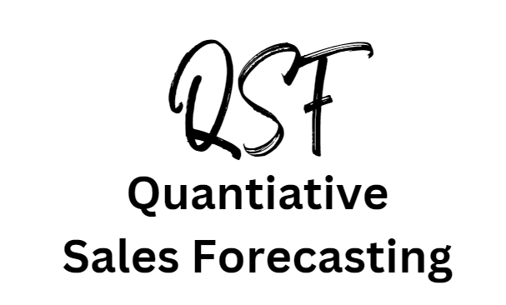

Introduction

|  |  |
| --- | --- |
| Year | Sales in  £millions |
| 2014 | 20 |
| 2015 | 21 |
| 2016 | 22 |
| 2017 | 24 |
| 2018 | 27 |
| 2019 | 22 |
| 2020 | 12 |
| 2021 | 15 |
| 2022 | 26 |
| 2023 | 28 |
| 2024 | ? |
| 2025 | ? |
| 2026 | ? |
| 2027 | ? |
| 2028 | ? |

Imagine you work in the marketing department of a multinational company. You have sales data on your desk that goes back to 2014 and your boss has asked you to predict future sales levels based on this data. Your boss wants you to predict five years into the future; 2024 through to 2028.

Your boss explains that the whole business will; hire staff, schedule production, buy in raw materials and advertise based on the predictions that you make.

The table on the right is the sales data that is on your desk, you could make a guess at the next 5 years of sales 2024 – 2028. Instead of guessing you would need to be more certain using a quantitative sales forecasting

There are few methods that you can use to get this right, to forecast sales using quantitative methods. This means using the historical sales data to predict what sales levels will be in the future. In business it is a big responsibility to get this right, which is why it is in the exams.

# What you need to know for the exam:

1. Calculation of time-series analysis; moving averages
   1. Three period
   2. Four quarter
2. Interpretation of scatter graphs and line of best fit – extrapolation of past data to future
3. Limitations of quantitative sales forecasting techniques

3 point moving average walkthrough

3 point moving average walkthrough step 1

Take 3 years of data and calculate the average. Do this all the way down the table. The first calculation has been done for you, complete the table.

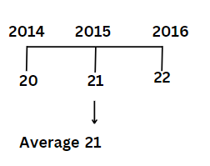20 + 21 + 22 ÷ 3 = 21

|  |  |  |
| --- | --- | --- |
| Year | Sales in  £millions | 3 point moving average |
| 2014 | 20 |  |
| 2015 | 21 | 21 |
| 2016 | 22 |  |
| 2017 | 24 |  |
| 2018 | 27 |  |
| 2019 | 22 |  |
| 2020 | 12 |  |
| 2021 | 15 |  |
| 2022 | 26 |  |
| 2023 | 28 |  |

3 point moving average walkthrough step 2

1. Go back to the original table and calculate the difference between the sales and the moving average, the result is called a variation.
2. The total variations (when they are all added up) are £0.32 million
3. Divide the total amount of variations (£0.32 million) by the number of variations, in this example there are 8 years with variation

£0.32m ÷ 8 = £0.04 million

1. Add £0.04 million to 2023 sales of £28 million
2. This gives us a final result of £28.04 million as a sales forecast for 2024

|  |  |  |  |
| --- | --- | --- | --- |
| Year | Sales in  £millions | 3 point moving average | Variation |
| 2014 | 20 |  |  |
| 2015 | 21 | 21 | 0 |
| 2016 | 22 | 22.33 | +0.33 |
| 2017 | 24 | 24.33 | +0.33 |
| 2018 | 27 | 24.33 | -2.67 |
| 2019 | 22 | 20.33 | -1.67 |
| 2020 | 12 | 16.33 | +4.33 |
| 2021 | 15 | 17.67 | +2.67 |
| 2022 | 26 | 23 | -3 |
| 2023 | 28 |  | Total variation  In millions £ |

Total is £0.32

Million

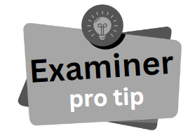Notice that answers are in two decimal places (where appropriate) rounded up. You will lose 1 mark in a 4 mark question if you do not express your answers to 2 decimal places.

Four Quarter moving average walkthrough

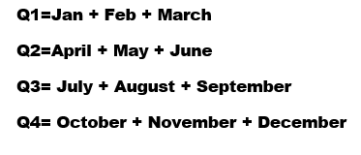A business will have historical sales data for each Quarter of the year. A Quarter of any year is 3 months.

To smooth out the peaks and troughs in sales data, a business would use the Four Quarter Moving Average method. Follow the steps to complete the table.

4 quarter moving average walkthrough step 1

In the column 4 Quarter Total add up all the values for the 4 Quarters that the value is in the middle of. Complete the table.

72 + 73 + 74 + 70 = 289

|  |  |  |
| --- | --- | --- |
| Year and Quarter | Sales  £000 | 4 Quarter Total |
| 2020 Q1 | 72 |  |
|  |  |  |
| 2020 Q2 | 73 |  |
|  |  | 289 |
| 2020 Q3 | 74 |  |
|  |  | 290 |
| 2020 Q4 | 70 |  |
|  |  | 291 |
| 2021 Q1 | 73 |  |
|  |  | 292 |
| 2021 Q2 | 74 |  |
|  |  |  |
| 2021 Q3 | 75 |  |
|  |  |  |
| 2021 Q4 | 68 |  |
|  |  |  |
| 2022 Q1 | 72 |  |
|  |  |  |
| 2022 Q2 | 75 |  |
|  |  |  |
| 2022 Q3 | 77 |  |
|  |  |  |
| 2022 Q4 | 70 |  |

4 quarter moving average walkthrough step 2

Now add up the two 4 quarter values to give an 8 period total (essentially it’s the total sales of the business for two years). This will help to smooth out the fluctuations in sales data. The first ones have been done for you, complete the table.

|  |  |  |  |
| --- | --- | --- | --- |
| Year and Quarter | Sales  £000 | 4 Quarter Total | 8 Period Total |
| 2020 Q1 | 72 |  |  |
|  |  |  |  |
| 2020 Q2 | 73 |  |  |
|  |  | 289 |  |
| 2020 Q3 | 74 |  | 579 |
|  |  | 290 |  |
| 2020 Q4 | 70 |  | 581 |
|  |  | 291 |  |
| 2021 Q1 | 73 |  | 583 |
|  |  | 292 |  |
| 2021 Q2 | 74 |  |  |
|  |  |  |  |
| 2021 Q3 | 75 |  |  |
|  |  |  |  |
| 2021 Q4 | 68 |  |  |
|  |  |  |  |
| 2022 Q1 | 72 |  |  |
|  |  |  |  |
| 2022 Q2 | 75 |  |  |
|  |  |  |  |
| 2022 Q3 | 77 |  |  |
|  |  |  |  |
| 2022 Q4 | 70 |  |  |

4 quarter moving average walkthrough step 3

Now divide this 8 period total by 8 to get an average. Complete the table.

For example: 583 ÷ 8 = 72.88

|  |  |  |  |  |
| --- | --- | --- | --- | --- |
| Year and Quarter | Sales  £000 | 4 Quarter Total | 8 Period Total | 4 Quarter moving average (Trend) |
| 2020 Q1 | 72 |  |  |  |
|  |  |  |  |  |
| 2020 Q2 | 73 |  |  |  |
|  |  | 289 |  |  |
| 2020 Q3 | 74 |  | 579 | 72.38 |
|  |  | 290 |  |  |
| 2020 Q4 | 70 |  | 581 | 72.63 |
|  |  | 291 |  |  |
| 2021 Q1 | 73 |  | 583 | 72.88 |
|  |  | 292 |  |  |
| 2021 Q2 | 74 |  |  |  |
|  |  |  |  |  |
| 2021 Q3 | 75 |  |  |  |
|  |  |  |  |  |
| 2021 Q4 | 68 |  |  |  |
|  |  |  |  |  |
| 2022 Q1 | 72 |  |  |  |
|  |  |  |  |  |
| 2022 Q2 | 75 |  |  |  |
|  |  |  |  |  |
| 2022 Q3 | 77 |  |  |  |
|  |  |  |  |  |
| 2022 Q4 | 70 |  |  |  |

4 quarter moving average walkthrough step 4

Now minus the 4 Quarter Moving Average trend from the sales £000 figure. This will give you a difference, which is called a ‘variation’. In an exam you may be asked to complete a small section of a table. If the trend figure is the larger figure then the result is a negative number. All figures should be shown to two decimal places and rounded up or down as appropriate.

For example:

* Sales £000 = 74
* 4 Quarter Moving Average = 72.38
* Variation = 74 – 72.38 = 1.62

|  |  |  |  |  |  |
| --- | --- | --- | --- | --- | --- |
| Year and Quarter | Sales  £000 | 4 Quarter Total | 8 Period Total | 4 Quarter moving average (Trend) | Variation |
| 2020 Q1 | 72 |  |  |  |  |
|  |  |  |  |  |  |
| 2020 Q2 | 73 |  |  |  |  |
|  |  | 289 |  |  |  |
| 2020 Q3 | 74 |  | 579 | 72.38 | 1.62 |
|  |  | 290 |  |  |  |
| 2020 Q4 | 70 |  | 581 | 72.63 | -2.63 |
|  |  | 291 |  |  |  |
| 2021 Q1 | 73 |  | 583 | 72.88 | 0.12 |
|  |  | 292 |  |  |  |
| 2021 Q2 | 74 |  |  |  |  |
|  |  |  |  |  |  |
| 2021 Q3 | 75 |  |  |  |  |
|  |  |  |  |  |  |
| 2021 Q4 | 68 |  |  |  |  |
|  |  |  |  |  |  |
| 2022 Q1 | 72 |  |  |  |  |
|  |  |  |  |  |  |
| 2022 Q2 | 75 |  |  |  |  |
|  |  |  |  |  |  |
| 2022 Q3 | 77 |  |  |  |  |
|  |  |  |  |  |  |
| 2022 Q4 | 70 |  |  |  |  |

Interpretation of scatter graphs

Scatter graphs are a way of showing data in a visual form. They allow business people to look for relationships between two variables. They help the business to make decisions about resources.

Some scatter graphs will show a relationship between the X and the Y axis variables and this is called a correlation. A correlation can be positive or negative and it can be strong or weak.

Examples of variables: temperature and sale of ice cream, promotional spend and number of sales, number of staff and output. One variable could have an impact on the other.

In an exam you will not be asked to draw a scatter diagram but you may be asked to interpret one.

If there is strong positive correlation then this means that there is a relationship between the X axis variable and the Y axis variable. For example, temperature and sales of ice creams. The hotter the temperature the more ice creams are sold. There is a clear strong relationship between temperature and ice cream sales figures. For a business that runs a fleet of ice cream vans a weather forecast would be essential to help them decide how many vans to send out. If one variable increases, the other also increases.

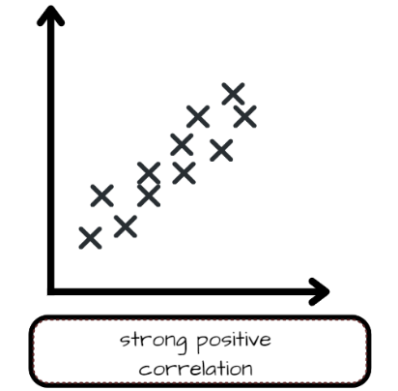

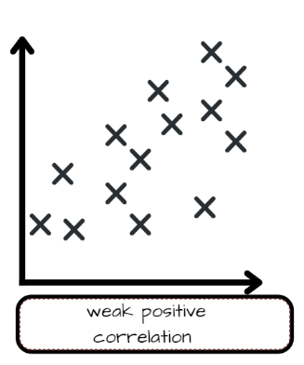

Relationships between the variables can be weak. One variable can still influence the other but the data points are more spread out. For example; This might apply to the number of advertisements that customers have seen and number of purchases.

If one variable increases then the other slightly increases.

Interpretation of scatter graphs continued

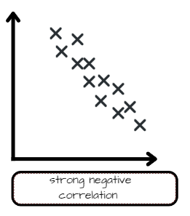

In a strong negative correlation, the data points are clustered in a line that points downwards on the graph. If one variable increases the other decreases. For example temperature and sale of thick winter coats. This would help a fashion retailer to decide what products to put for sale in which season.

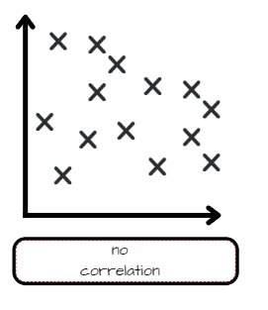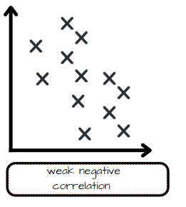

Where there is no correlation we would say there is no relationship between the variables. All the data points are spread out and it would be impossible to put a line of best fit onto the scatter graph. For example height of customers and number of movies streamed on Netflix. There is no link between these two variables.

In a weak negative correlation, the trend is still downwards but the data points are more spread out. There is still a relationship but it is a weak one. For example, if Nike starts a marketing campaign the sales of Adidas may slightly decrease. So this could be Nike advertising spend and the subsequent impact on Adidas sales.

Interpretation of line of best fit

A line of best fit might be used by a finance department of a business to explore the relationship between the two variables on a scatter graph. For example to look at the link between investment in a business and share price.

By looking at the line of best fit the finance department can predict the future by extrapolating that line out. This means the line is extended beyond what is already known into a forecast (or preduction) of what is most likley to happen.

As you know shocks such as the pandemic can change this, so their application is limited. They are still useful as an analysis tool to give the business a guide as to sales levels, so that resources can be allocated.

Example line of best fit

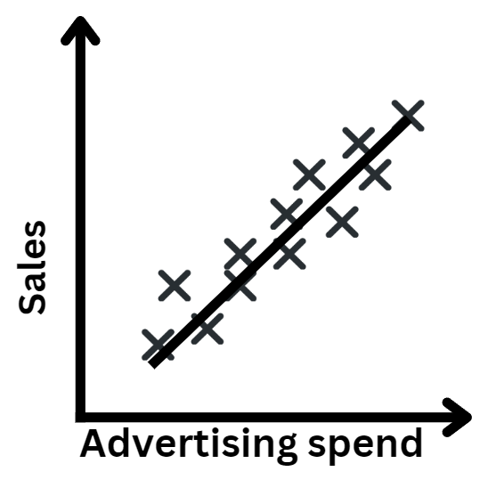This example shows:

A strong correctlation between advertising spend and sales. You can conclude that the advertising is a success and has increased the sales. The business should continue to advertise this product or service.

The line of best fit indicates where the sales are (notice it is right in the middle of all the data).

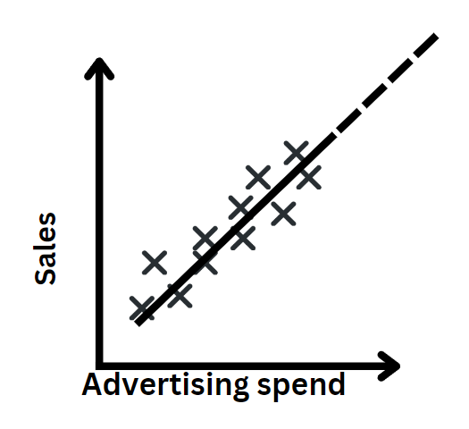 This example shows:

The line of best fit has been extrapolated (extended) using dashed lines to indicate where the sales are most likley to be in the future.

This is a forecast based on the data. As there is a strong positive correclation between advertising spend and sales we can be reasonably confident that sales will continue to increase in this way.

Uses and limitations of Quantitiative Sales Forecasting

# Uses of quantitative sales forecasting

* To predict the sales and therefore revenue levels of the business
* To manage resources in the business
* Simple, quick, cheap and can be completed on limited data
* Can be used as an effective decision making tool for business
* Can smooth out fluctuations in demand – particularly important in the post-pandemic sales phase, QSF could be used to smooth out peaks and troughs in demand so more accurate sales forecasts can be achieved

# Limitations of quantitative sales forecasting

* Data could be out-of-date, so the prediction is only as good as the data it is based on
* Human error in calculations can cause a business to invest in resources or areas that are not needed
* In new companies with little historical data, most forecasting would just be ‘best guess’

There are no past paper line of best fit or scatter graph questions to use as examples. So just learn what they mean and be able to apply what you have learn to a suitable business.

# Practice question 1

Noah has opened a restaurant called THE ARK serving a range of British cuisine in Dottingham. He specialises in roast dinners, fish and chips and jam sponge with custard. He opened in late April and can serve 95 diners in one day. The figures in the table are number of diners served per month. In June, he had a good review in the local paper and consequently has been busier serving more diners.

Calculate the 3 period moving average for the number of restaurant diners for the period May to December. State the difference between the May-July and Oct-Dec figures.

Your answer should be to two decimal places and show your working.

|  |  |
| --- | --- |
| Month | Number of monthly diners |
| May | 140 |
| June | 200 |
| July | 280 |
| Aug | 280 |
| Sept | 290 |
| Oct | 350 |
| Nov | 368 |
| Dec | 380 |

# Practice question 2

Jakub has started an Airbnb business in a house he used to rent out, in Kegthope, which is by the seaside. The Airbnb has a lovely view and Jakub normally has it available to rent 52 weeks of the year. Some months are busier than others due to the school holidays.

Calculate the 3 period moving average for the % occupants for the period May to December.

Your answer should be to two decimal places and show your working.

|  |  |  |
| --- | --- | --- |
| Month | % occupancy | 3 period moving average |
| May | 23 |  |
| June | 32 |  |
| July | 56 |  |
| Aug | 100 |  |
| Sept | 43 |  |
| Oct | 78 |  |
| Nov | 21 |  |
| Dec | 90 |  |

# Practice question 3

Alaysha runs a night bus to help students get back from Dottingham town centre to halls safely. She is subsidised by the university so charges just 50p per journey for her passengers. Alaysha has a team of 3 volunteer drivers who drive one day a week each from 10pm to 4am. The bus runs on a Thursday, Friday and Saturday. In the holidays the bus does not run at all. The night bus can take 16 passengers at a time and makes 7 trips a night. Figures in the table are number of passengers per month.

Calculate the 3 period moving average for the number of night bus passengers for the period Jan-December. Then calculate the variation.

Your answer should be to two decimal places and show your working.

|  |  |  |  |
| --- | --- | --- | --- |
| Month | Number of passengers | 3 period moving average | Variation |
| Jan | 1235 |  |  |
| Feb | 1050 |  |  |
| March | 985 |  |  |
| May | 965 |  |  |
| June | 998 |  |  |
| Oct | 1320 |  |  |
| Nov | 1020 |  |  |
| Dec | 1344 |  |  |

# Practice question 4

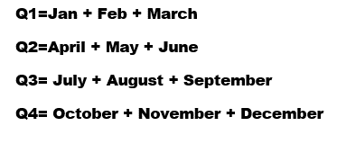Every year there is a UK kit car show in June where retailers show off fantastic designs of cars that customers can build themselves. The show runs for three days and attracts 25,000 visitors over that weekend.

The Rapid is a company in Dottingham that sells kit cars at the show. Kits retail for an average of £7,000 each. They have independent dealers all over the country and they collect their sales data in quarters.

Calculate the values of A B C and D and interpret your findings.

|  |  |  |  |  |  |
| --- | --- | --- | --- | --- | --- |
| **Year and Quarter** | **Sales**  **£000** | **4 Quarter Total** | **8 Period Total** | **4 Quarter moving average (Trend)** | **Variation** |
| **2020 Q1** | **28** |  |  |  |  |
|  |  |  |  |  |  |
| **2020 Q2** | **49** |  |  |  |  |
|  |  | **168** |  |  |  |
| **2020 Q3** | **56** |  | **343** | **42.88** | **13.12** |
|  |  | **175** |  |  |  |
| **2020 Q4** | **35** |  | **357** | **44.62** | **-9.62** |
|  |  | **182** |  |  |  |
| **2021 Q1** | **35** |  | **371** | **46.38** | **-11.38** |
|  |  | **189** |  |  |  |
| **2021 Q2** | **56** |  | **385** | **48.13** | **7.87** |
|  |  | **196** |  |  |  |
| **2021 Q3** | **63** |  | **399** | **49.88** | **13.12** |
|  |  | **203** |  |  |  |
| **2021 Q4** | **42** |  | **413** | **A** | **B** |
|  |  | **210** |  |  |  |
| **2022 Q1** | **42** |  | **427** | **C** | **D** |
|  |  | **217** |  |  |  |
| **2022 Q2** | **63** |  | **441** | **55.13** | **7.87** |
|  |  | **224** |  |  |  |
| **2022 Q3** | **70** |  |  |  |  |
|  |  |  |  |  |  |
| **2022 Q4** | **49** |  |  |  |  |

# Practice question 4 continued

Interpretations of findings from completed table on page 15

# Practice question 5

Discuss the possible limitations of quantitative sales forecasting for future sales. Make sure you include some counterbalance in your discussion.