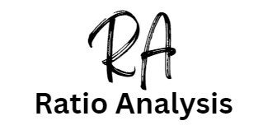

Introduction

Ratios are a set of calculations that can be carried out on the financial accounts of a business to find out what is going on. If you went to the doctor they would take your temperature and this would give them numerical information to find out what was happening with your health. It is the same with business and we use ratios to help us do this.

The accounting ratios you need to know for Edexcel A level business are:

1. Statement of comprehensive income, this shows the profit and loss of the business. From it we can calculate:
2. Gross Profit Margin (GPM)
3. Operating Profit Margin (OPM)
4. Net Profit Margin (NPM)
5. Statement of financial position, this shows what the business owns and what it owes. It is also called the balance sheet and is a picture of just one day in the business showing all the assets and labilities of the company on that day. From it we can calculate:
   1. Current ratio
   2. Acid Test ratio (also called the Liquid Capital ratio)
   3. Gearing ratio
   4. Return on Capital Employed (ROCE)

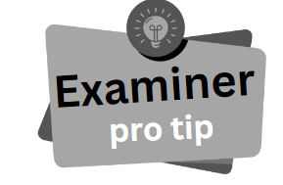

Like shoes, you need two accounting ratios for comparison, it helps to find out if the financial health of the business is improving or getting worse. This allows investors to work out if they should risk their capital (money) in the business. Usually it is from one year to another. E.g. The Gearing ratio has increased from 27% to 67% over the last year.

Types of Ratios

In an exam question you may be just asked to calculate profitability ratios based on a table of figures. Ratios are grouped into three types and you will need to work out in a question which ones to use:

Profitability ratios

* 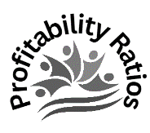Return on Capital Employed ROCE
* Gross Profit Margin GPM
* Operating Profit Margin OPM
* Net Profit Margin NPM

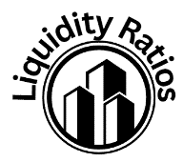Liquidity Ratios

* Current ratio
* Acid Test ratio (also called the Liquid Capital ratio)

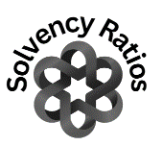Solvency ratios

* Gearing ratio



In the exam you may be given financial data which is a mixture of information taken from the Statement of Comprehensive Income and the Statement of Financial Position. You just need to focus on applying the formulas that you have learnt.

Gross Profit Margin (GPM) explained

Gross Profit Margin is a profitability ratio

The Gross Profit Margin (GPM) shows a business how many pence (p) in every £1 of sales is gross profit. As there are 100 pence in a £ this is quite simple. So a GPM of 30% would mean 30p in every £ made is profit. Increasing GPM would mean that the business has reduced its direct costs or raised its prices, possibly due to an increase in demand for the product. Decreasing GPM would mean that the business has lowered the selling price or that raw materials have become more expensive.

Let’s look at an example:

ABC Ltd makes chocolate products. If the GPM of chocolate products decreases then this may show that the price of cocoa has increased.

GPM does not allow for overheads such as advertising. You also need to consider the industry, food carries very low gross profit margins, but in comparison the gross profit margins in the jewellery industry can be very high.

You are looking for the highest figure possible, and like shoes, there needs to be two for comparison. This could be two years figures for the same company.

# Example: GPM of ABC Chocolate Ltd rises from 30% to 40%

If the GPM is rising over the two years, you could conclude that the business is doing well and managers are working hard to keep costs down. Profitability has increased.

# Example: GPM of ABC Chocolate Ltd falls from 40% to 30%

If the GPM is falling over the two years then this may be a management issue and you could conclude that the business needs to urgently look at cutting direct costs, for example raw materials. Profitability has decreased.

Gross Profit Margin (GPM) calculations

This is the formula we use to calculate the Gross Profit Margin (GPM):

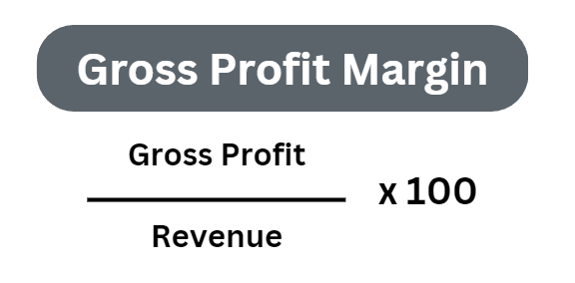

Remember to express your answers as a %

# Example GPM calculation 1

|  |  |  |
| --- | --- | --- |
|  | 2022 | 2023 |
| Gross Profit | £40,213 | £46,321 |
| Sales Revenue | £73,314 | £85,760 |
| Gross Profit Margin |  |  |

# Example GPM calculation 2

|  |  |  |
| --- | --- | --- |
|  | 2022 | 2023 |
| Gross Profit | £1.1m | £1.2m |
| Sales Revenue | £3.6m | £3.4m |
| Gross Profit Margin |  |  |

# Example GPM calculation 3

|  |  |  |
| --- | --- | --- |
|  | 2022 | 2023 |
| Gross Profit | £124,000 | £134,000 |
| Sales Revenue | £325,000 | £415,000 |
| Gross Profit Margin |  |  |

Operating Profit Margin explained

Operating Profit Margin is a Profitability Ratio

Operating Profit is Gross Profit minus expenses. Examples of expenses include:

* Overheads and all indirect costs
* Administration costs
* Rental costs
* Utilities (gas, water, electric)
* Payroll costs
* Insurance
* Advertising

The Operating Profit Margin (OPM) ratio gives the investor a better idea of how well the management are controlling indirect costs. For example some companies show a healthy gross profit of £2billion but the operating profit is just £3million. This means that the overheads and expenses are out of control.

Investors would be looking for a high Operating Profit Margin (OPM). This means the business is in control of indirect costs, and investing in the business would be less risky than a company with a lower Operating Profit Margin (OPM).

Let’s look at an example

ABC Ltd is a technology company specialising in AI and online games. Their Operating Profit Margin has fallen from 22% to just 12% since the launch of their latest AI console. You could conclude that management have lost control of indirect costs or conclude that ABC Ltd might have high R&D costs plus costs of advertising the launch of the new AI console may have contributed to high indirect costs which had a negative impact on the OPM ratio.

Always take the industry context into account and bring in other theories such as product lifecycle and Ansoff’s Matrix where possible.

Operating Profit Margin (OPM) calculations

This is the formula we use to calculate the Operating Profit Margin (OPM):

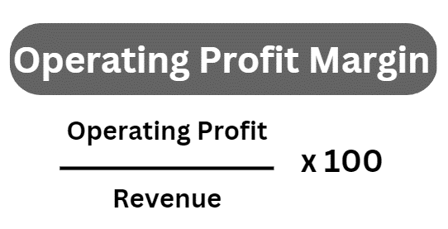

Remember to express your answers as a %

# Example OPM calculation 1

|  |  |  |
| --- | --- | --- |
|  | 2022 | 2023 |
| Operating Profit | £36,521 | £38,789 |
| Sales Revenue | £73,314 | £85,760 |
| Operating Profit Margin |  |  |

# Example OPM calculation 2

|  |  |  |
| --- | --- | --- |
|  | 2022 | 2023 |
| Operating Profit | £0.7m | £0.8m |
| Sales Revenue | £3.6m | £3.4m |
| Operating Profit Margin |  |  |

# Example OPM calculation 3

|  |  |  |
| --- | --- | --- |
|  | 2022 | 2023 |
| Operating Profit | £111,000 | £99,000 |
| Sales Revenue | £325,000 | £415,000 |
| Operating Profit Margin |  |  |

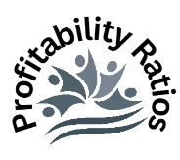Net Profit Margin explained

Net Profit Margin is a Profitability Ratio

Net Profit figure is obtained by taking the Operating Profit figure and then subtracting all interest on debt and taxes. These are kept separate because they are out of the control of the management of the business.

Having three types of profit margins helps the investors to understand the health of the business and how well the managers control the costs:

# Gross Profit Margin (GPM)

GP / SR x100

This just calculates the profit made from just the Sales Revenue and the cost of the goods (COGS) that have been sold. No other costs are taken into account. It is useful for shareholders to know if goods make a sound profit. Removing all direct costs helps investors to see how hard the management of the business works to make products or services that customers will demand, and make a healthy profit.

# Operating Profit Margin (OPM)

OP / SR x100

This takes the gross profit figure and removes the indirect costs of making the sales, for example advertising costs. This is the most useful profit margin ratio as it removes all costs and gives investors a good idea of how well indirect costs are managed.

# Net Profit Margin (NPM)

NP / SR x 100

This takes the Operating Profit figure and removes all the interest on debt, for example interest that must be paid back to the bank for loans. It also takes off all taxes. Interest and taxes are not able to be controlled by the management so is the least useful of the three profit margins.

Net Profit Margin (NPM) calculations

This is the formula we use to calculate the Net Profit Margin (NPM):

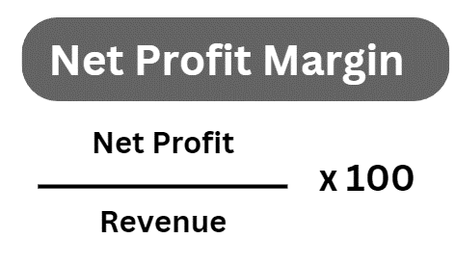

Remember to express your answers as a %

# Example NPM calculation 1

|  |  |  |
| --- | --- | --- |
|  | 2022 | 2023 |
| Net Profit | £31,501 | £32,719 |
| Sales Revenue | £73,314 | £85,760 |
| Net Profit Margin |  |  |

# Example NPM calculation 2

|  |  |  |
| --- | --- | --- |
|  | 2022 | 2023 |
| Net Profit | £0.5m | £0.6m |
| Sales Revenue | £3.6m | £3.4m |
| Net Profit Margin |  |  |

# Example NPM calculation 3

|  |  |  |
| --- | --- | --- |
|  | 2022 | 2023 |
| Net Profit | £101,000 | £93,000 |
| Sales Revenue | £325,000 | £415,000 |
| Net Profit Margin |  |  |

Current Ratio explained

The current ratio is a liquidity ratio

Just think for a moment about all the possessions that you have. Which item that you own do you think would sell the fastest? Your phone, bike, Xbox games at Cash converters or on eBay perhaps? This is the most liquid of your possessions, the one which can be converted quickest into cash.

Potential investors would be interested in knowing if the business can meet its short-term debts from its short term assets, and so it looks at items that it owns which are liquid, that means they can be turned into cash very quickly.

The short-term financial health of the business is important, without cash to pay suppliers they may be refused credit and so run low on stock. This ratio shows the ability of a business to pay its short-term (less than one year) debts.

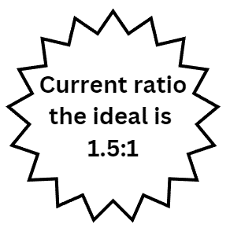Let’s look at an example

If a business has a current ratio of 4:1 this would mean that for every £1 of debt the business has £4 available to pay it.

The ideal current ratio is 1.5:1. For every £1 of debt there is £1.50 to pay for it. Higher than this then the money in the business is unproductive and could be working harder elsewhere. Lower than this and the business does not have enough cash to meet its short-term debts.

Having a current ratio less that one e.g. 0.75:1 is not always a concern, it depends on the business and the average liquidity ratio for it. Supermarkets often run at lower than 1:1 liquidity levels.

Current Ratio calculations

This is the formula we use to calculate the Current Ratio:

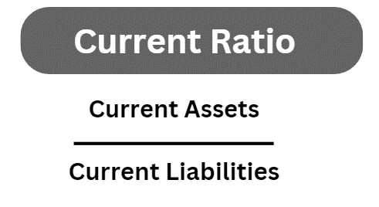

Remember to express your answers as a ratio :1

# Example Current Ratio calculation 1

|  |  |  |
| --- | --- | --- |
|  | 2022 | 2023 |
| Current Assets | 279.6 | 295.9 |
| Current Liabilities | 226.0 | 232.5 |
| Current ratio |  |  |

# Example Current Ratio calculation 2

|  |  |  |
| --- | --- | --- |
|  | 2022 | 2023 |
| Current Assets | 206.1 | 213.1 |
| Current Liabilities | 207.7 | 276.9 |
| Current ratio |  |  |

# Example Current Ratio calculation 3

|  |  |  |
| --- | --- | --- |
|  | 2022 | 2023 |
| Current Assets | 251.9 | 189.0 |
| Current Liabilities | 147.2 | 249.4 |
| Current ratio |  |  |

Acid Test Ratio explained

The Acid Test is a liquidity ratio

The Acid Test ratio is also known as the quick test. Stock can take a long time to sell and turn into cash, it may be obsolete or out-of-date making it unsellable. So the Acid Test was introduced to enable a business to check their ability to pay their short-term debts without selling having to sell off stock.

In the accounts the stock figure may also be called inventory or inventories.

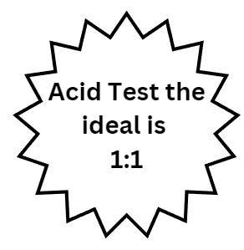

# Let’s look at an example:

A ratio of 1:1 would indicate a business which for every £1 of short-term debt had £1 to pay the debts off. Below this, 0.7:1 for example and the business may have trouble paying those short term debts as they only have 70p for every £1.00 of debt.

In this example they still have the stock, but for some reason is it unsellable, so it is not counted in the ratio. For this reason, the ideal is considered to be 1:1

# Reasons why stock might be unsellable:

* Stock has gone out-of-date e.g. yoghurts
* Stock has become obsolete e.g. video tapes
* Stock has gone out of fashion e.g. leg warmers
* Stock is no longer demanded by customers e.g. fidget spinners

Acid Test Ratio calculations

This is the formula we use to calculate the Acid Test Ratio:

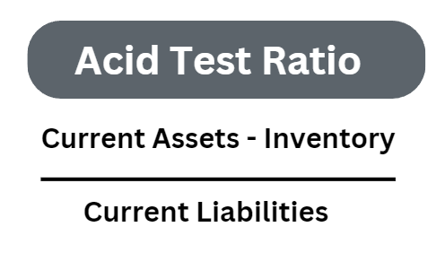

Remember to express your answers as a ratio :1

# Example Acid Test calculation 1

|  |  |  |
| --- | --- | --- |
|  | 2022 | 2023 |
| Current Assets | 279.6 | 295.9 |
| Current Liabilities | 226.0 | 232.5 |
| Inventory | 76 | 70 |
| Acid Test Ratio |  |  |

# Example Acid Test calculation 2

|  |  |  |
| --- | --- | --- |
|  | 2022 | 2023 |
| Current Assets | 206.1 | 213.1 |
| Current Liabilities | 207.7 | 276.9 |
| Inventory | 45 | 49 |
| Acid Test Ratio |  |  |

# Example Acid Test calculation 3

|  |  |  |
| --- | --- | --- |
|  | 2022 | 2023 |
| Current Assets | 251.9 | 189.0 |
| Current Liabilities | 147.2 | 249.4 |
| Inventory | 101 | 99 |
| Acid Test Ratio |  |  |

Gearing Ratio explained

 The gearing ratio is a solvency ratio

The gearing ratio looks at the long term stability of the business and its ability to pay its loans and debts. It also shows how reliant the business is on borrowed money.

If the gearing ratio is above 50% then you can conclude that the business is highly geared. Any interest on loans needs to be paid before dividends to shareholders can be paid out. This makes a highly geared company a high risk. They are also less likely to be approved for further borrowing from the banks, because of the risk.

Let’s look at an example:

Sometimes a business needs to have a higher gearing ratio in order to make the most of opportunities. For example, a business may miss out on being able to buy another business and grow because of its reluctance to increase borrowing.

A highly geared business is an investment risk, if interest rates rise or there is a recession they will have to pay back higher amounts. If the business experiences hard times they will still need to pay their loans.

Loan payments and interest payments can eat away at the profits of a business. This means you are looking for low gearing ratios, the lower the better. It depends what the business has been doing, perhaps they have been merging or acquiring other businesses for which they needed to borrow heavily. This would be fine as the investors who would be pleased that the business is growing.

Gearing Ratio calculations

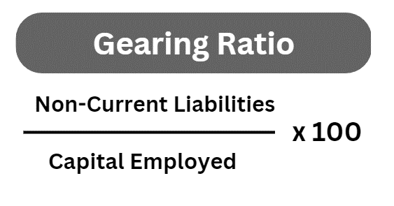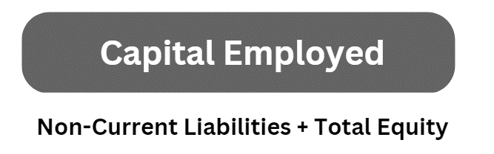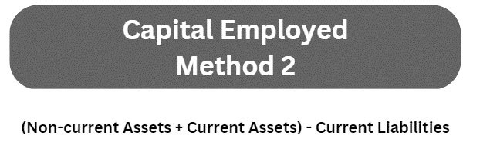You need two formulae to calculate gearing, the gearing ratio formula and one to help you calculate the Capital Employed. There are two alternative capital employed formulae depending on what information you are given in the question.

Gearing Ratio example calculations

# Example calculation 1 (using method 1)

Use both formulae to help you complete the table



|  |  |  |
| --- | --- | --- |
|  | 2022 | 2023 |
| Non-current Liabilities | £2748m | £2654m |
| Total Equity | £1899m | £1765m |
| Capital Employed |  |  |
| Gearing Ratio |  |  |

# Example calculation 2 (using method 2)

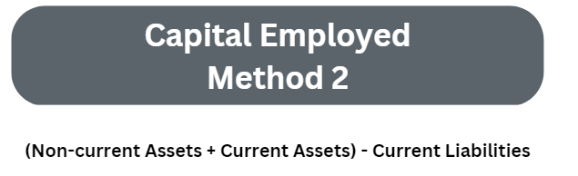Use both formulae to help you complete the table

|  |  |  |
| --- | --- | --- |
|  | 2022 | 2023 |
| Non-current Liabilities | £121.5m | £76.6m |
| Non-current Assets | £505.0m | £470.2m |
| Current Assets | £271.2m | £234.7m |
| Current Liabilities | £247.2m | £222.9m |
| Capital Employed |  |  |
| Gearing Ratio |  |  |

Return on Capital Employed (ROCE) explained

ROCE is a profitability ratio

Return on Capital Employed (ROCE) means how hard money invested in a business will work for the investor. A return is what the investor can expect to get back as a reward for keeping their money invested in the business.

Let’s look at a simple example:

Santander Bank offer 2% interest on a savings account (ROCE). With £100,000 invested at 2% you could expect to get £2,000 return on your investment. This is very nice indeed, but could your money work a little harder for you? Have a look at the alternative below:



Example: XYZ Ltd have a track record of getting 15% ROCE, shown in their financial accounts.

This is amazing, but carries huge risks, if the business makes a loss invetors get nothing. So as an investor you are really interested to see if the business will continue to yield 15% in the next 5 years.

An investment of £100,000 with a ROCE of 15% would be a return of £15,000 which could be invested in another project and continue to make more money.

Generally you are looking for a ROCE of around 20% or more to be a good investment. If you get a question and the ROCE is higher than 20% you would conclude that the business would be a good investment as long as it could sustain those levels of profit.

If the ROCE is well below 20% then you could conclude that the investor would be better off putting their money into a savings account where there is no risk of losing their investment.

Return on Capital Employed (ROCE) calculations

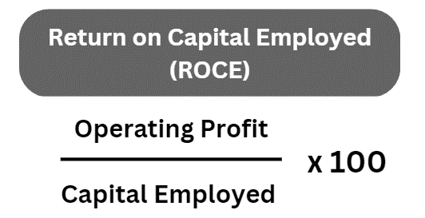You need both formulae to calculate ROCE. There are two alternative capital employed formulae depending on what information you are given in the question.



ROCE example calculations

# Example ROCE calculation 1 (using method 1)

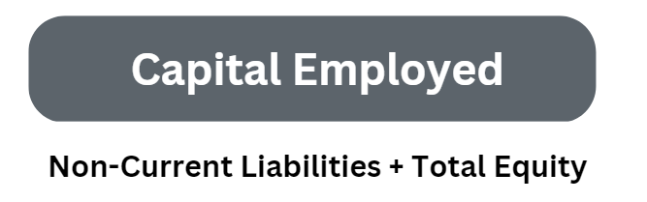

|  |  |  |
| --- | --- | --- |
|  | 2022 | 2023 |
| Non-current Liabilities | £2748m | £2654m |
| Total Equity | £1899m | £1765m |
| Operating Profit | £42m | £49m |
| Capital Employed |  |  |
| ROCE |  |  |

# Example ROCE calculation 2 (using method 2)



|  |  |  |
| --- | --- | --- |
|  | 2022 | 2023 |
| Operating Profit | £76m | £103m |
| Non-current Assets | £505.0m | £470.2m |
| Current Assets | £271.2m | £234.7m |
| Current Liabilities | £247.2m | £222.9m |
| Capital Employed |  |  |
| ROCE |  |  |

Example exam question using ratios

Extract A

# Information from JKL Ltd’s Statement of Comprehensive Income

|  |  |  |
| --- | --- | --- |
|  | 31 December 2022 (£’000) | 31st December 2021 (£’000) |
| Revenue | 33495 | 59730 |
| Cost of Sales | (3688) | (1652) |
| Gross Profit | 29807 | 58078 |
| Admin Expenses | 31485 | 57260 |
| Operating Profit or Loss | 1678 | 818 |

Extract B

# Information from JKL Ltd’s Statement of Financial Position

|  |  |  |
| --- | --- | --- |
|  | 31 December 2022 (£’000) | 31st December 2021 (£’000) |
| Non-current assets | 263801 | 315228 |
| Current assets | 4215 | 5855 |
| Current Liabilities | 16582 | 12389 |
| Non-current liabilities | 5520 | 2799 |
| Equity, Shareholder funds | 153945 | 267807 |

*Using the information in Extract A and B calculate appropriate accounting ratios for JKL Ltd.*

There is space for your answer on the next page. Show all of your workings, express to two decimal placed and round up as appropriate.

*Using the information in Extract A and B calculate appropriate accounting ratios for JKL Ltd.*

|  |  |  |
| --- | --- | --- |
|  | 2022 | 2021 |
| Gross Profit Margin |  |  |
| Operating Profit Margin |  |  |
| ROCE |  |  |
| Gearing |  |  |
| Current Ratio |  |  |

Summary of Ratio Analysis Formulae



