

Answers

## Answer to Supply and Demand (Price) practice question A on page 5

Draw the demand curve if the price falls

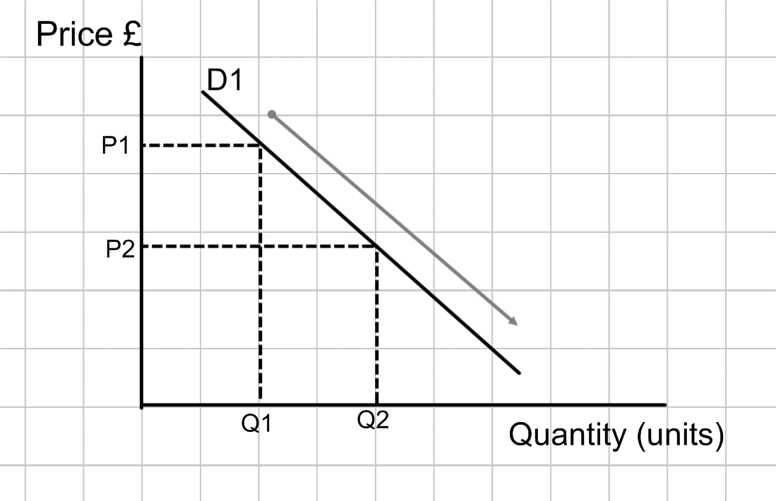

## Answer to Supply and Demand (Price) practice question B on page 5

Draw the supply curve if the price rises

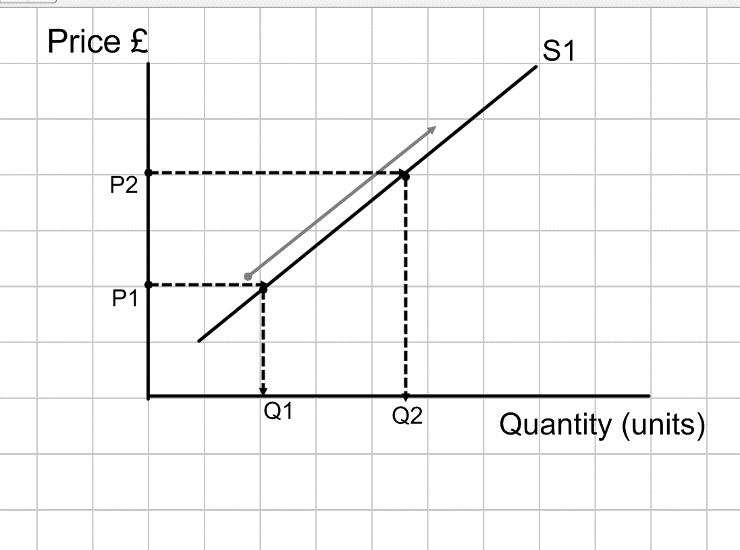



## Supply and Demand (Price) practice question C on page 6

Draw the demand curve if the price rises

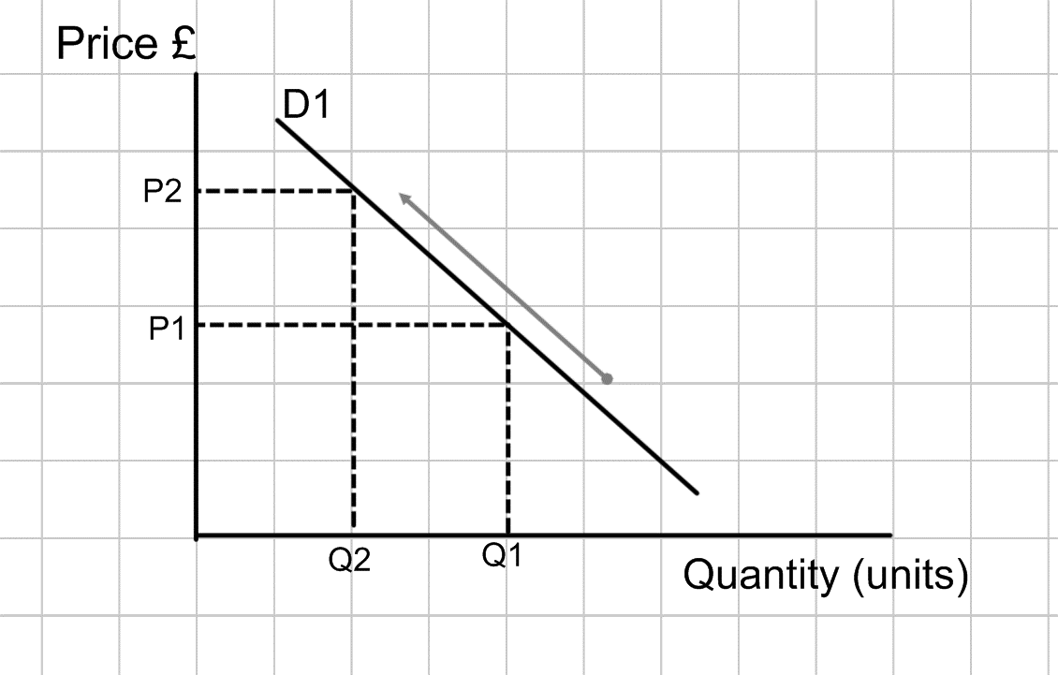

## Supply and Demand (Price) practice question D on page 6

Draw the supply curve if the price falls

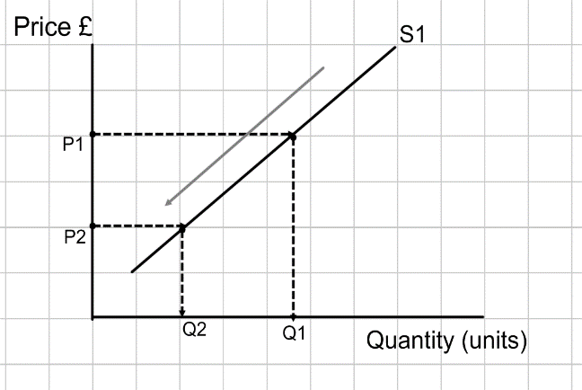

## Answer to example question 1 on page 10

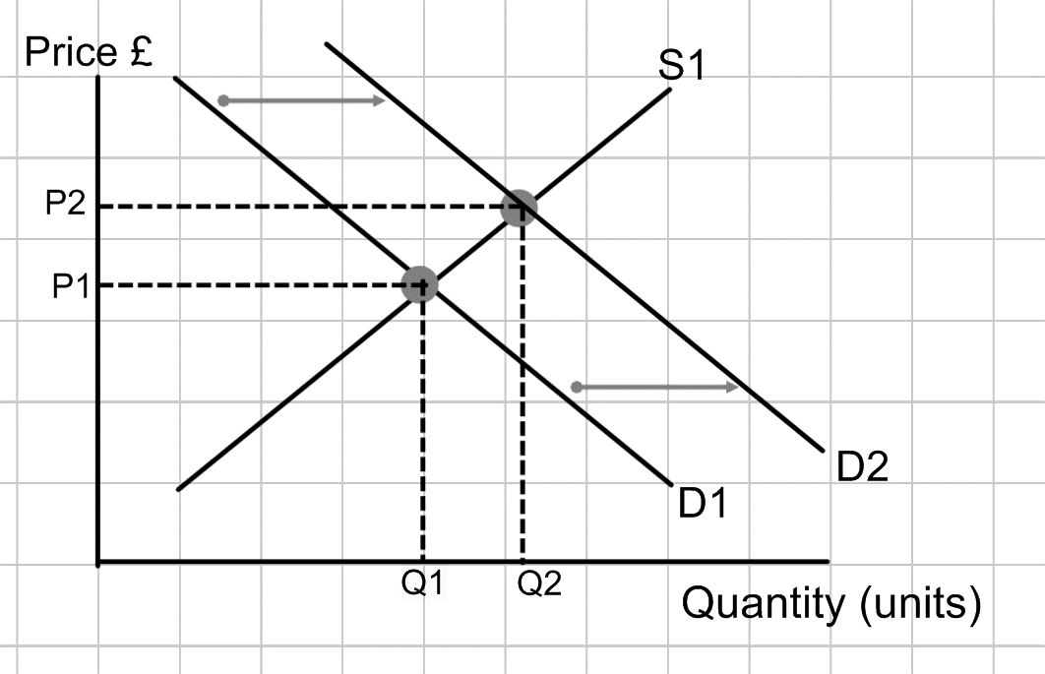

## Answer to example question 2 on page 11



## Answer to example question 3 on page 12

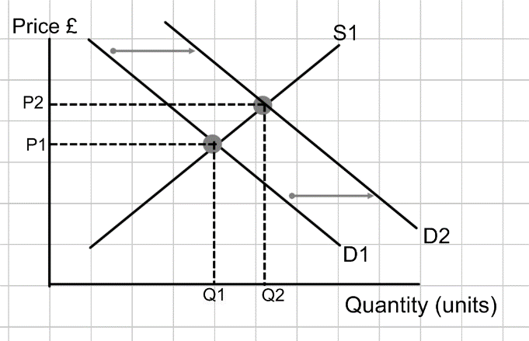

## Answer to example question 4 on page 13

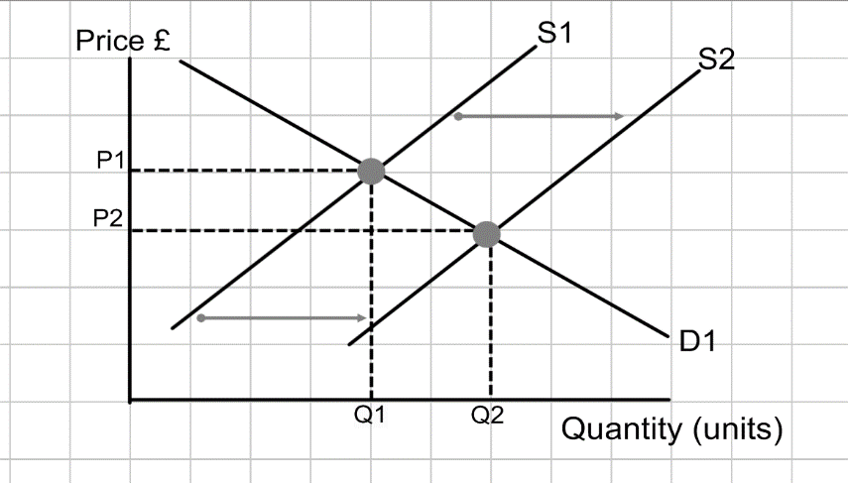



## Answer to example question 5 on page 14

