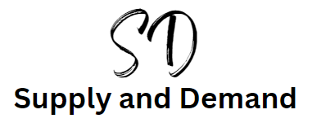

Introduction

Supply and demand is in Theme 1 but could be a question on paper 1 and paper 3. It usually comes up on the exam papers and so is worth knowing. There are 8 graphs to learn but there are some tips to help you learn them.

Drawing a supply and demand curve

P

All 8 of the supply and demand curves start with the same axes, price (P) on the vertical and quantity (Q) on the horizontal.

Q

D

S

Demand line is down for demand You can label this as D or D1

Supply line is supply to the sky. You can label this as S or S1

P

Q

P

Q

Supply and demand (Price) explained

 Supply – always consider this from the perspective of the business suppling the products. If the price of the product rises then the business will want to supply more because they will make more profit. If the price of the product falls then the business will want to supply less, as less profit could be made.

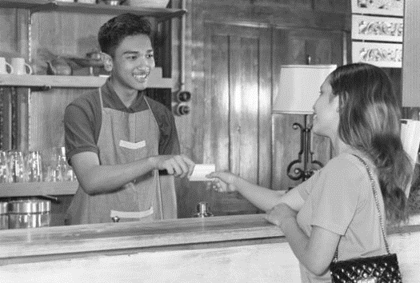

Demand – always consider this from the perspective of the consumer buying the products. If the price rises the consumers will buy less and if the price falls they will buy more. Customers like a bargain so this makes logical sense.



When drawing the supply and demand curve (which is actually a straight line so we will call them lines) as it is PRICE, which is one word then just draw ONE line. This will help you to work out which of the 8 diagrams you will need to draw in the exam question.

Supply (Price) curves

**Supply and price rise**

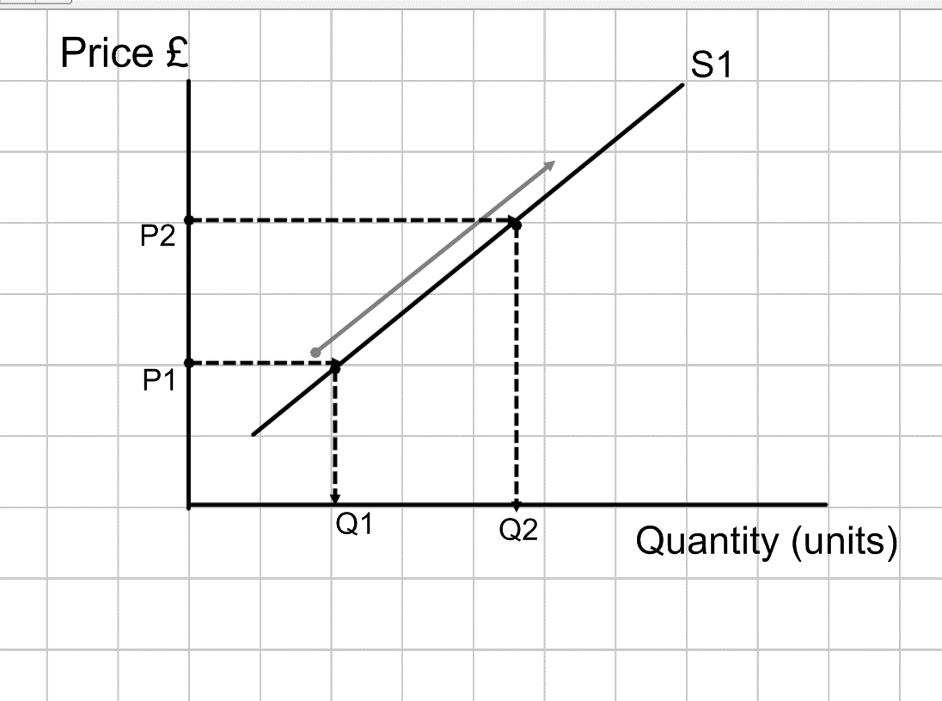As prices for goods rise, price moves from P1 up to P2, the business will want to supply more goods for more profit and quantity will move from Q1 to Q2.

Price is one word so there is one line the Supply line (S1).

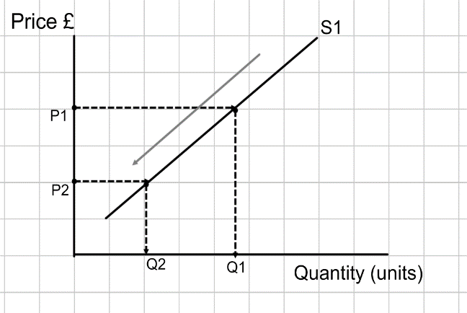Supply and price fall

As prices of goods fall the suppliers will wish to supply less goods at that price and so there will be a downward movement along the supply curve. As price moves down from P1 to P2 the quantity supplied moves L left (L for lower) and from Q1 to Q2

Demand (Price) curves

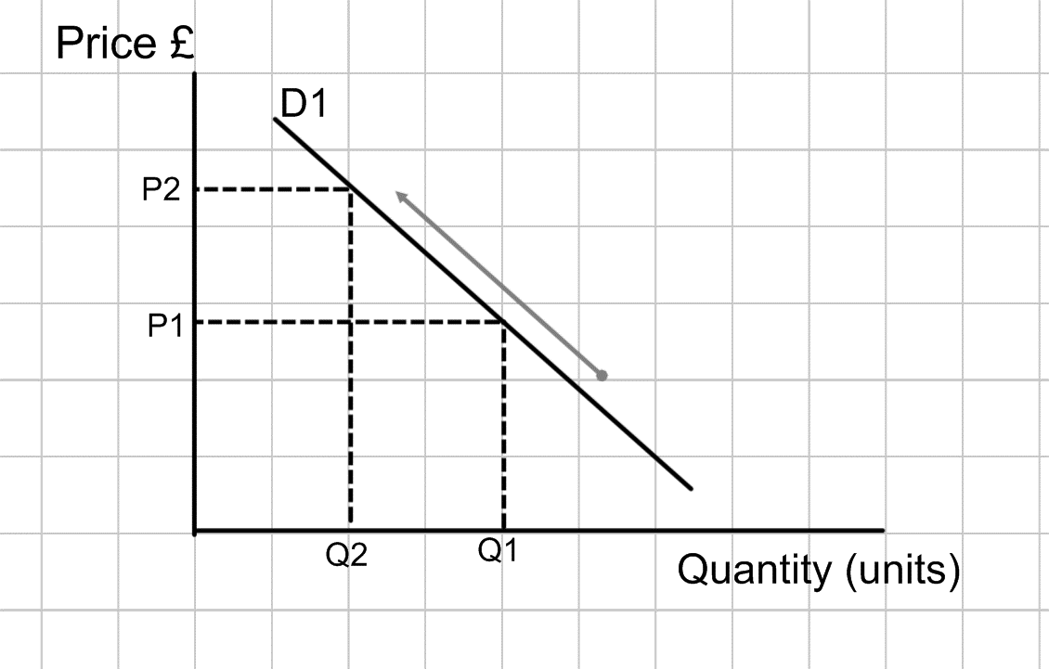Demand and price rise

As the price of the product rises from P1 to P2 the quantity demanded will fall from Q1 to Q2

This is because customers will demand less when prices rise.

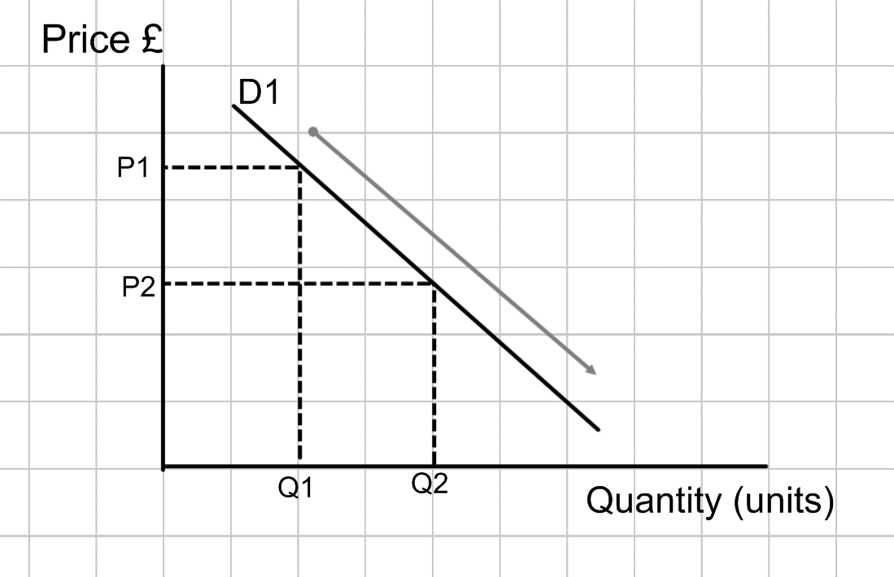Demand and price fall

As prices fall from P1 to P2 the quantity demanded will rise from Q1 to Q2

This because when prices fall customers will want to buy more products so demand increases.

Supply and Demand (price) practice

Complete the following 4 diagrams:

A: Draw the demand curve if the price falls

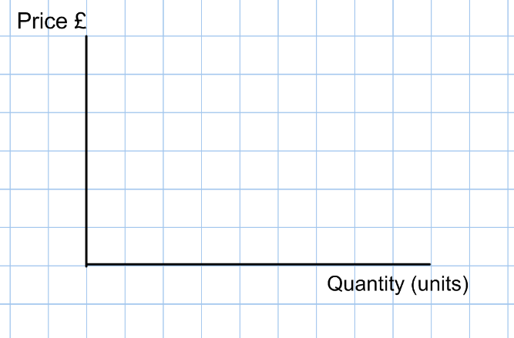

B: Draw the supply curve if the price rises



C: Draw the demand curve if the price rises



D: Draw the supply curve if the price falls



Supply and demand (Non Price) explained

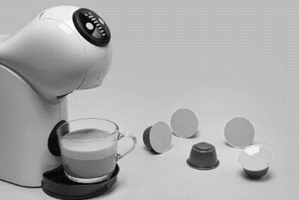Sometimes the quantity demanded can change but the price of the item has remained the same. You need to learn these factors and be able to spot them in exam questions. For example if the price of a coffee machine remains constant but the coffee pods have gone down then this is NOT a price factor. It is a non-price factor, the price of the complementary good has gone down.

Figure 1Coffee machine - the pods are complementary goods

Non-price factors which may affect demand

1. Price of substitutes e.g. train instead of flying
2. Alternative brands e.g. Nike instead of Adidas
3. Price of complementary goods (examiner favourite) e.g. Printer / printer ink
4. Changes in consumer income e.g. higher incomes demand different products
5. Trends in fashion and tastes e.g. trend towards electric cars
6. Advertising and branding e.g. social media campaign stimulating demand
7. Population structure / demographics
8. Time of year e.g. pumpkins on 31st October
9. Weather and climate e.g. ice creams on a hot day
10. External shocks e.g. facemasks in a pandemic

Non-price factors that may affect supply

1. Cost of production e.g automation in a factory makes the average cost per unit lower, which makes it more attractive to a business to supply more
2. Introduction of new technology e.g. new computer system to speed up customer service makes it possible to serve more customers per hour
3. Indirect taxes e.g. VAT
4. Government subsidies e.g. on milk and dairy products makes it more attractive for farmers to produce those products
5. External shocks e.g. An unexpected event that changes the amount supplied, like a flood



When drawing the supply and demand curve for NON PRICE FACTORS, this is two words so draw two demand lines or two supply lines (as appropriate). Most popular exam options are complimentary goods.

Supply (Non Price) curves

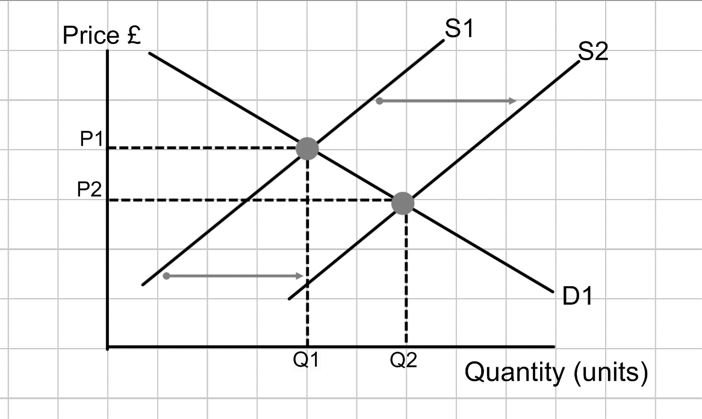Rise in Supply and non-price factors

A rise in supply due to non-price factors will cause a SHIFT in the supply curve to the right.

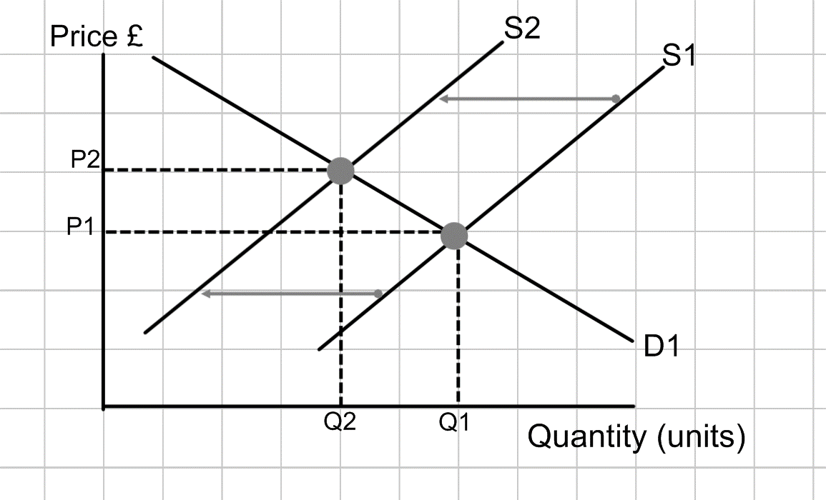Fall in Supply and non-price factors

A fall in supply due to non-price factors will cause a SHIFT in the supply curve to the left. The quantity that they want to supply goes from Q1 down to Q2.



Rise in supply to the right. Fall to the Left. Non price is two words so use two supply lines. See it from the perspective of a supplier. If they introduce technology this is nothing to do with price, but they will want to supply more.

Demand (Non Price) curves

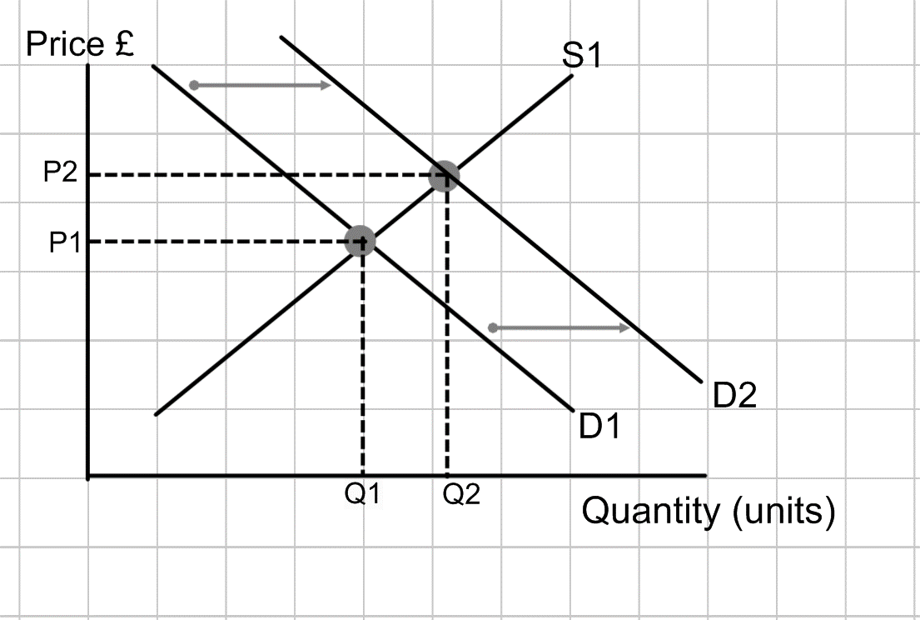Rise in demand due to non-price factors

As demand rises due to non-price factors this SHIFTS the demand curve to the right. Rise to the right. The quantity demanded moves up from Q1 to Q2.

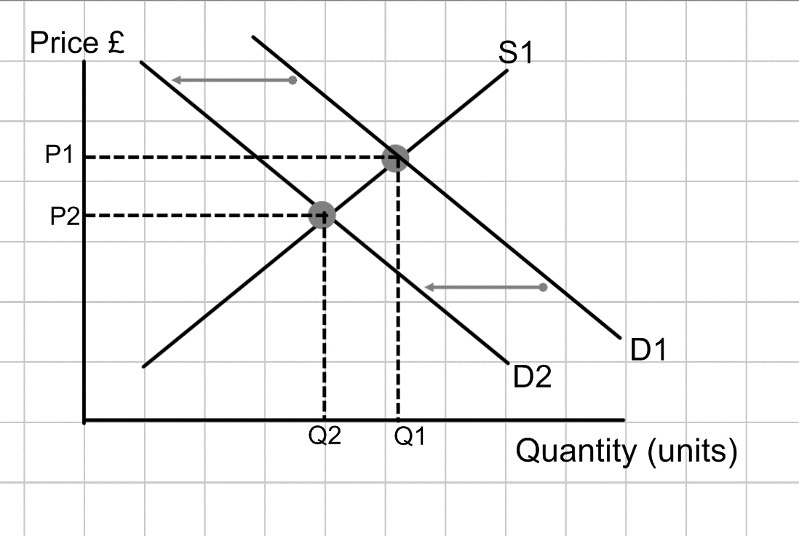

Fall in demand due to non-price factors

As demand falls due to non-price factors this shifts the demand curve to the left. The quantity demanded falls from Q1 down to Q2

Example questions

## Example question 1

Draw a supply and demand diagram to illustrate the fall in price of a complementary good.

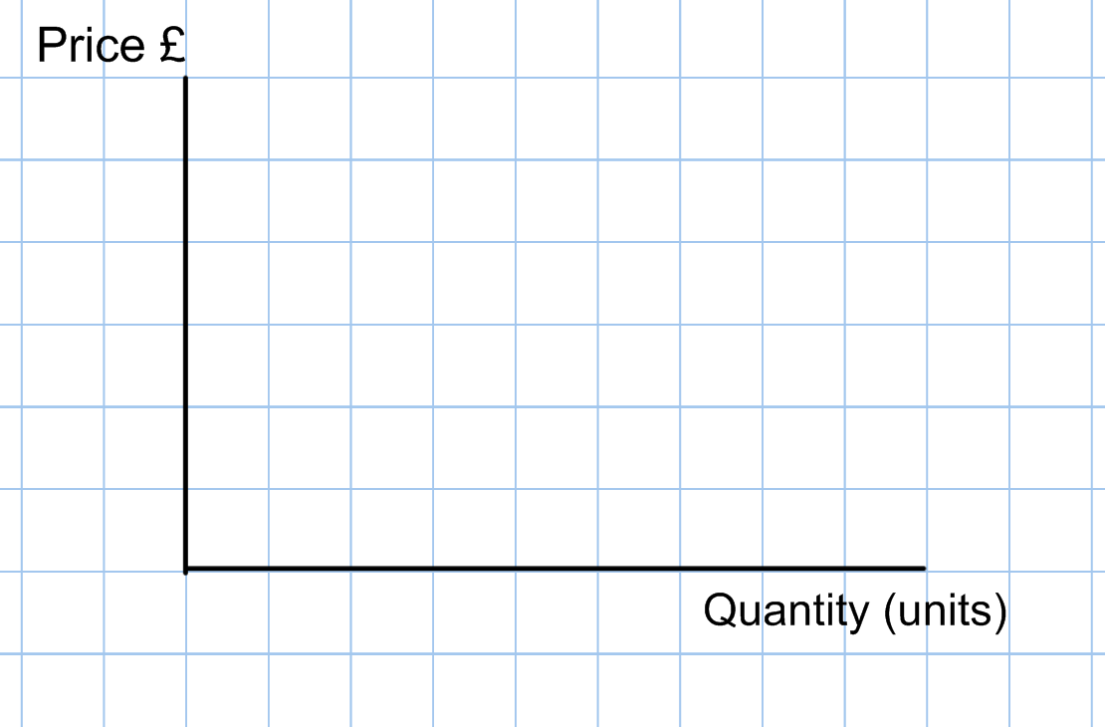

## Example question 2

Draw a diagram to show the impact on the motorcycle industry of more people taking up motorcycling



## Example question 3

Draw a diagram to show the impact on the gym market of more people working out at a gym into retirement



## Example question 4

There has been a global shortage of almonds – which means that the price of almond milk has risen. Draw a supply and demand diagram to illustrate this point.



## Example question 5

Shop rental prices have fallen due to a decrease in demand for high street retailers because customers are all shopping online.

