

Introduction

Break-even is a business analysis tool that helps managers to make decisions. It helps with pricing decisions and production quantity decisions, so it is very useful. It shows the point where the business makes neither a profit nor a loss; all of the business costs have been covered. We then say that the business has ‘broken even’.

* Break-even is the point where Total Revenue (TR) equals Total Costs (TC)
* Break-even is therefore TR=TC

## Four parts to master:

1. Contribution calculation
2. Break-even calculation
3. Break-even chart
4. Calculation of the margin of safety

## Uses of break-even

* Helps the owner to find out at what point they will make a profit
* Break-even can be used to work out the volume of resources and raw materials or stock that need to be bought to make a profit
* Can be used to analyse the impact of various pricing strategies, so the business will know if they can comfortably put products on sale and still cover all their costs

## Limitations of break-even

* Difficult to forecast future sales due to possibleshocks e.g. pandemic
* Assumes everything made is also sold
* Oversimplifies business situations
* Does not take into account changes in market conditions

Contribution method explained

Contribution is how much each product (unit) sold contributes to paying towards the fixed costs of a business. Once all the fixed costs have been covered by the products (units) produced, then the business is at the break-even point.

This is a two step process using two formulae.

# STEP 1: CALCULATE CONTRIBUTION

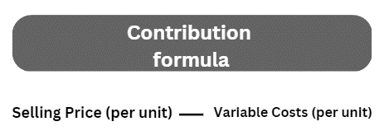

Contribution calculations - try these examples:

|  |  |  |  |
| --- | --- | --- | --- |
|  | Selling price per unit | Variable cost per unit | Contribution per unit (£) |
| A | £4.50 | 79p |  |
| B | £36.00 | £4.99 |  |
| C | £199.00 | £64.99 |  |

# STEP 2: CALCULATE BREAK-EVEN USING CONTRIBUTION

Now we need to put your calculated contribution values into the break-even formula:

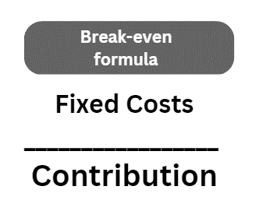

**Break-even calculations - try these examples:**

|  |  |  |  |
| --- | --- | --- | --- |
|  | Contribution | Fixed costs | Break-even  (in units) |
| A | £18.50 | £1,000 |  |
| B | £99 | £2,500 |  |
| C | £3,000 | £250,000 |  |

Break-even calculation walkthrough

You have raised £5,000 to start a business and you decide to print wellbeing phrases on t-shirts. You have called the business H-shirts. You know how much each H-shirt will cost to print and you know where to sell them. You need to find out how many H-shirts you need to order to break-even or not make a loss.

If you buy in bulk online, you can get H-shirts printed with your wellbeing phrases for £3.00 a shirt. You would like to sell the shirts at festivals, and you need to cover the cost of the stall, which is a total of £1,000 for a 3-day festival, so you are looking to set a retail price of £18 per H-shirt. At this point, you still don’t know how many to order which is where break-even comes in

Summary: Your business has Fixed Costs (FC) of £1,000 for the stall. Each H-shirt costs £3.00 to make which is your Variable Cost (VC) per unit and you expect to sell the shirts for £18.00 each, which is your selling price per unit.

If you were to have 400 H-shirts printed, calculate the break-even point using the contribution method. To do this follow the three steps below:

# Step 1: always start with the Contribution (C) calculation first:

* Contribution = Selling Price – Variable Cost
* C= £18.00 - £3.00
* C= £15.00

# Step 2: Now put your contribution into the break-even formula

* Break-even = Fixed Costs / Contribution
* B-E = £1,000 / £15.00
* B-E = 66.666
* B-E = 67 as we cannot sell half an H-shirt round up to the nearest unit.

# Step 3: Conclusion

You need to sell 67 H-shirts in order to break-even or NOT make a loss. You had 400 printed so it looks like you will have enough to sell to make a good profit.

Break-even practice calculation questions

### Break-even practice question 1

You now decide to put up your prices to £20 per H-shirt, calculate your new break-even amount if all the other costs remain the same. How many H-shirts do you now need to sell at the festival at this new price? Your fixed costs are still £1,000, and the variable costs are still £3.00 per shirt. Show your workings.

### Break-even practice question 2

Your supplier has gone bust, so you look for an alternative supplier for your printed H-shirt business. As it is short notice, they are going to charge you £7 per H-shirt. If your selling price is £20 and the cost of the stall is still £1,000, calculate the break-even point. Show your workings.

### Break-even practice question 3

The festival is sold out and the band Hotplay is headlining. This means that the festival organisers have decided to put up the cost of the stall and it is now £1,250. The selling price is now £20 and the cost of printing each H-shirt is still £7 per shirt. Calculate the new break-even point showing your workings. Show your workings.

Break-even chart explained

You may get a question where you need to interpret (read) a chart, so it will be helpful to know the parts of the break-even chart and what they mean.

In this example; You are selling the H-shirts for £8 and they are costing you £5 to have printed and the stall cost is £1,000.

|  |  |
| --- | --- |
| Fixed costs | £1,000 |
| Variable costs | £5 per H-shirt |
| Selling Price | £8 per H-shirt |

# Step 1: Plot the Fixed Costs (FC) line

We know fixed costs do not vary with output. If you sell no H-shirts at the festival, (it rains non-stop) you will still have to pay the cost of the stall even though you did not make any sales. The cost of the stall is £1,000. If you sell 800 H-shirts (the weather is good which has boosted demand) you will still have to pay the same stall cost of £1,000. This is your fixed cost and as it never changes, it is shown as a straight line on your break-even chart.

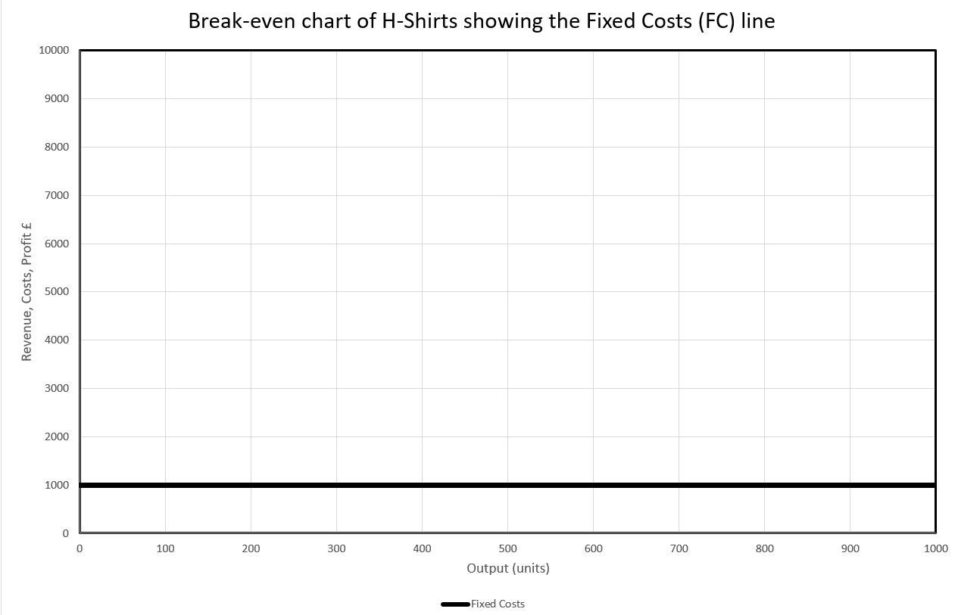

# Step 2: Plot the Total Costs (TC) line

**This is the Total Costs (TC) formula:**

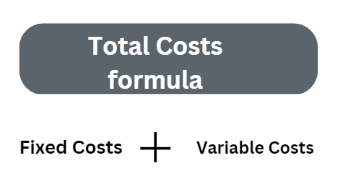

* Fixed Costs (FC) in this example is £1,000
* Variable Costs (VC) in this example is £5 per unit

We now plot the total costs line using this data:

|  |  |  |  |
| --- | --- | --- | --- |
|  | Fixed costs | Variable costs | Total costs |
| 0 units | £1,000 | £0 |  |
| 500 units | £1,000 | £2,500 |  |
| 1000 units | £1,000 | £5,000 |  |

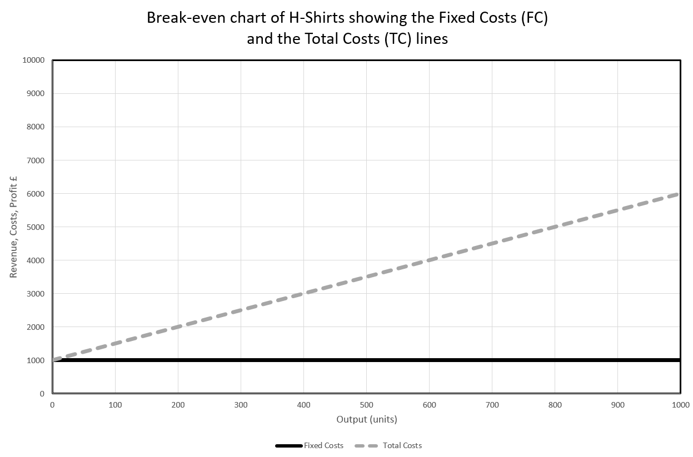



Did you notice that we don’t draw the Variable Costs (VC) line onto the chart? This is because it will make it easier to read.

Also, did you notice that the Total Costs (TC) line does not start at zero? This is because you ALWAYS have to pay the fixed costs even at zero sales.

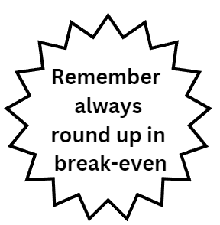

# Step 3: Plot the Total Revenue (TR) line

Now plot the Total Revenue (TR) line on the same break-even chart. At zero output you would make £0 revenue and at an output of 1,000 units you would make £8,000 revenue (£8 selling price x 1,000 H-shirts sold). Remember revenue is not the same as profit.

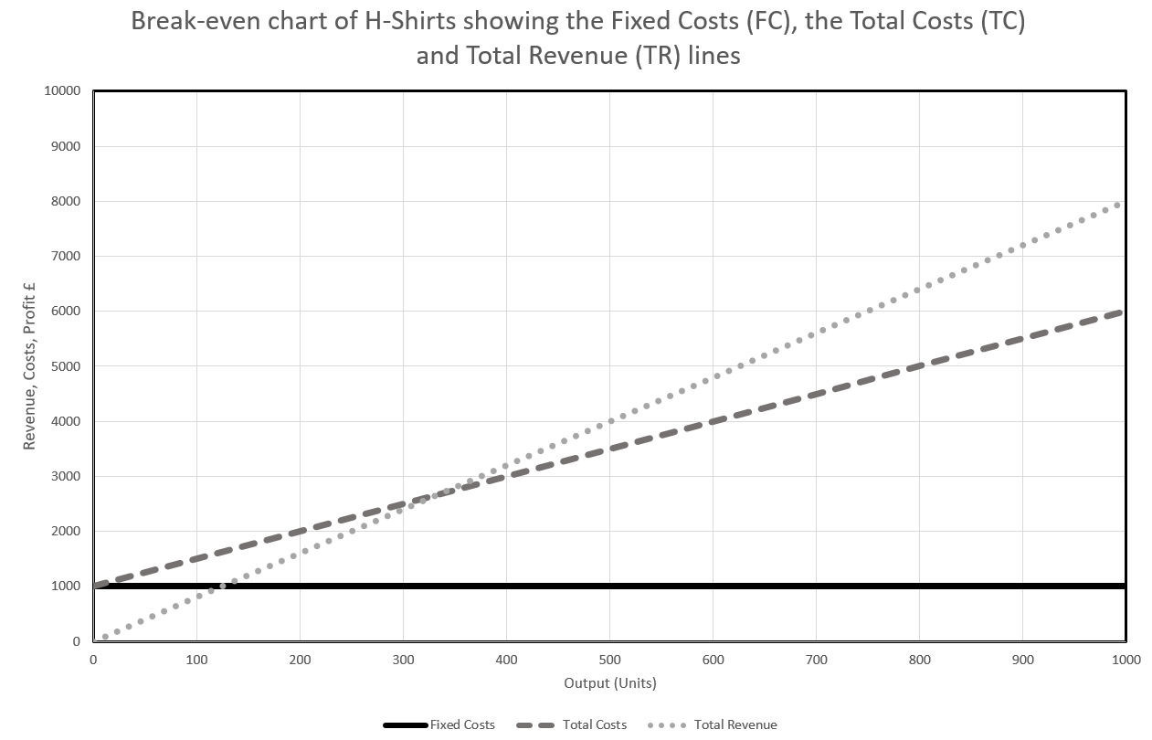

# Step 4: Find the break-even point

Draw on the break-even line, this is usually a dotted line. This is where the TC and TR lines cross. The break-even point is the exact point where the two lines cross. The break-even point should be indicated with an X.

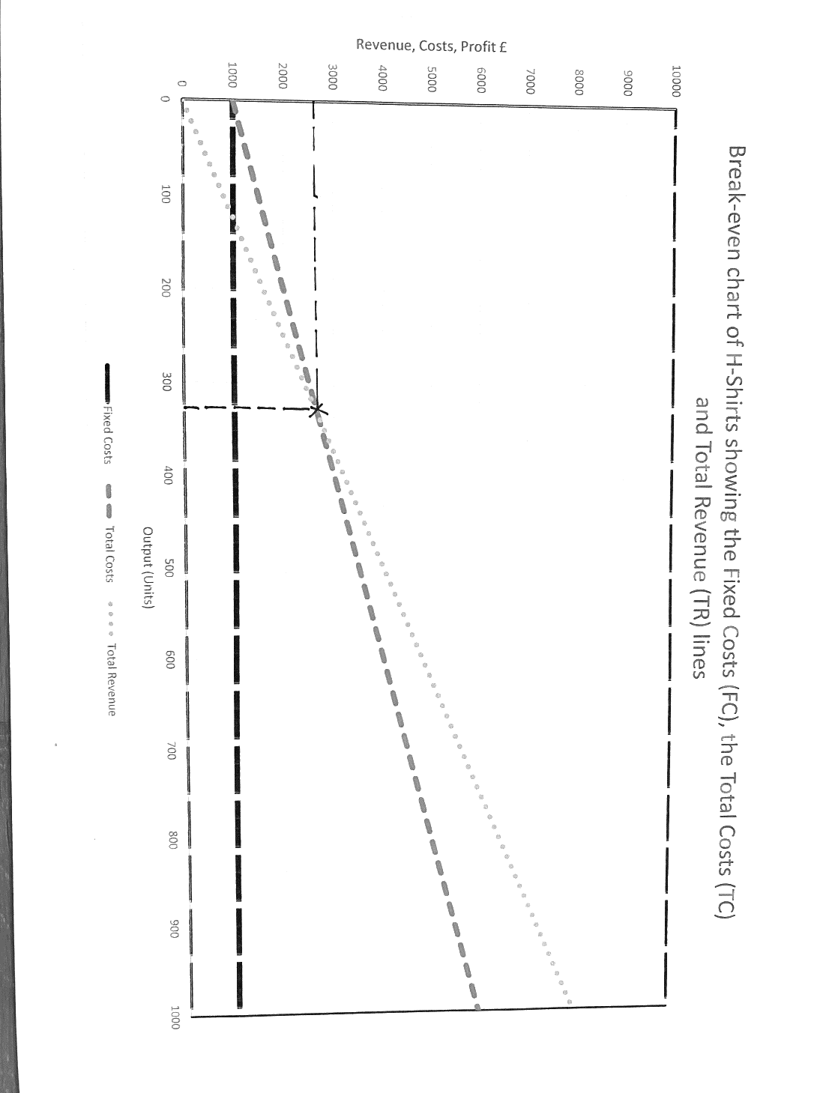

# Step 5: Find the profit area

Now shade the profit area on the chart (see the large shaded triangle).

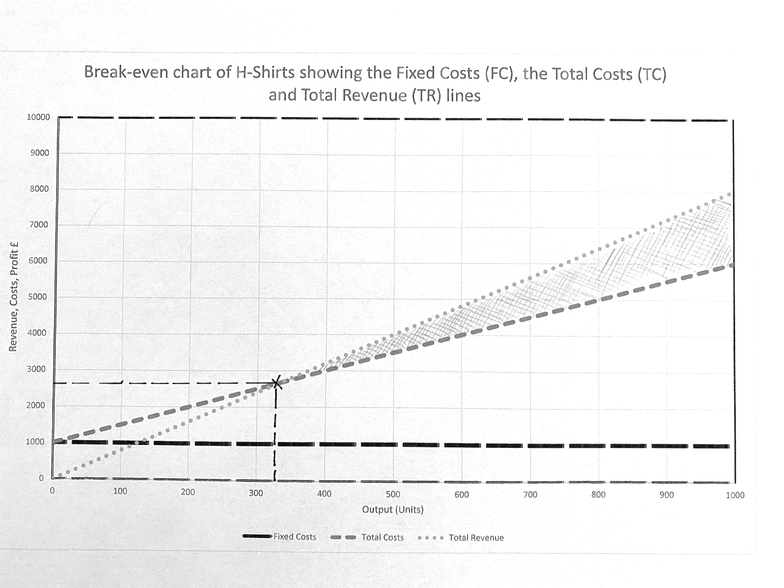

What would the area to the left of the break-even point (X) indicate, if the area to the right is profit? __________________________

### Break-even chart practice question

1. Add an X at the break-even point
2. identify the break-even point in units. _________________________
3. Shade the area of the chart which indicates profit

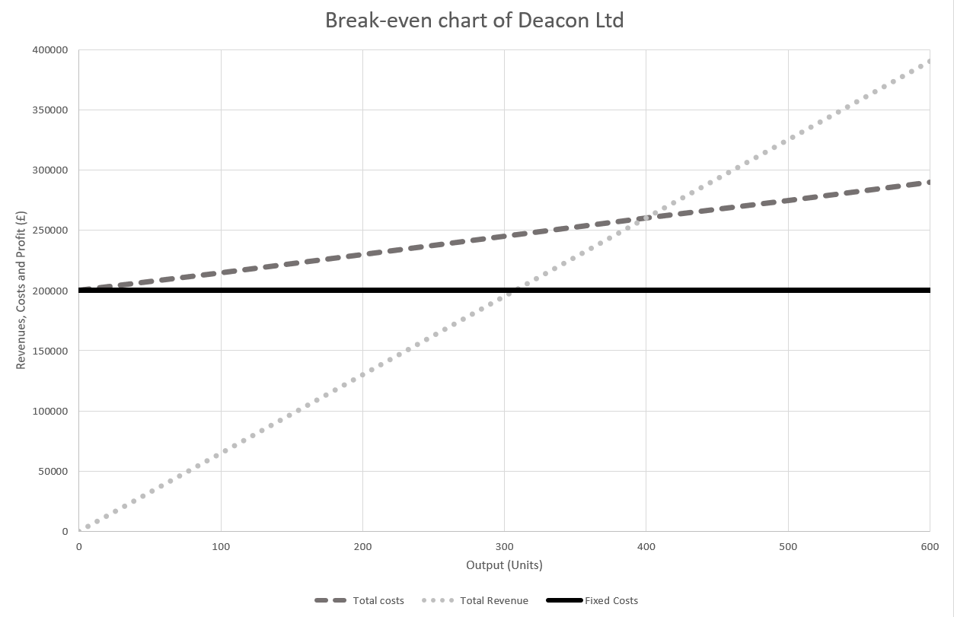

Margin of safety explained

It would be a poor business decision to just make the break-even amount, this strategy would yield no profit and if the prices of raw materials suddenly increased the business would find the costs would rise and the break-even amount would also increase.

Better business sense would be to include a margin of safety when deciding how many units to produce or to sell.

The margin of safety is the difference between the actual level of output and the break-even output. This helps the business to reduce the risks in getting the number of goods produced right.

The margin of safety will show the amount that demand can fall by before the business makes a loss.

We use this formula to calculate the margin of safety:

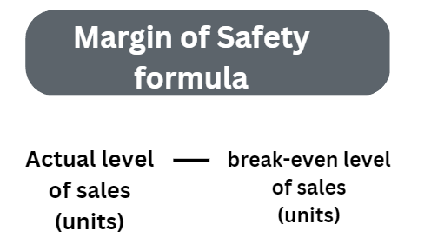

For example, if actual sales were 1,000 units and the break-even amount was 800 units then the margin of safety would be 200 units.

Margin of safety walkthrough example

Example question 1

Mailika makes wedding cakes. Her break-even amount per month is 10 wedding cakes. Most months she makes and average of 13 cakes. Calculate her margin of safety.

Answer

13 (actual output) minus 10 (break-even output) = margin of safety is 3 cakes.

**Example question 2**

**Train Ltd has an output of 400 units. Calculate the margin of safety using the information in the chart.** 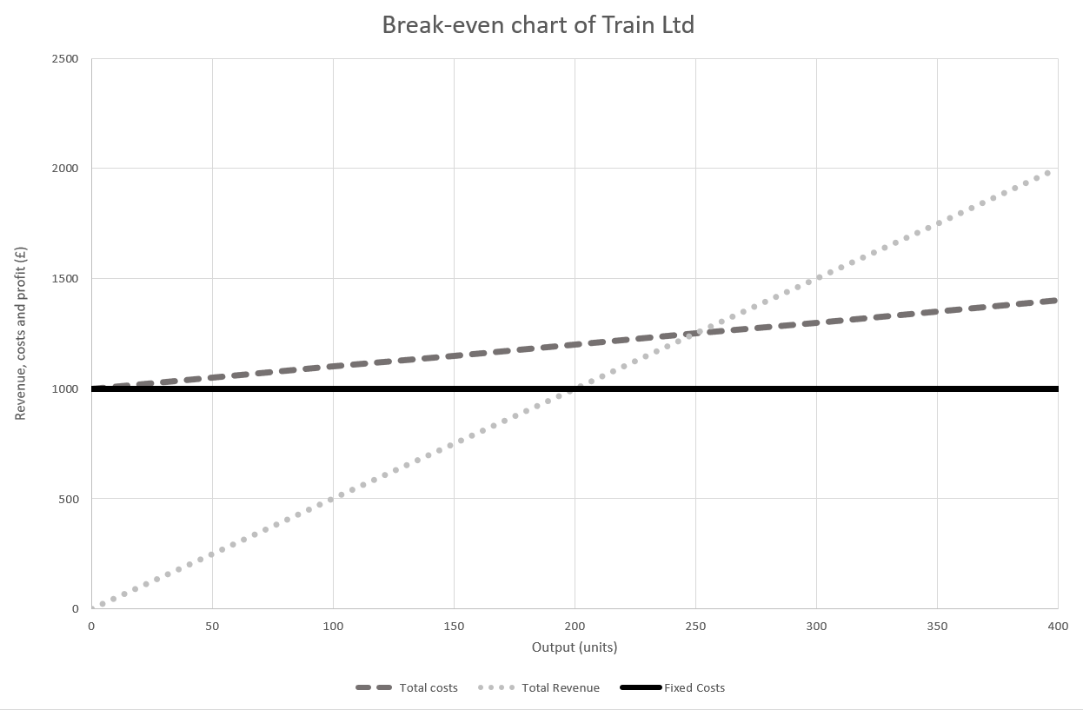

**Answer**

* **MOS = Actual – B/E**
* **MOS = 400-250**
* **MOS = 150 units**

### Margin of safety practice question 1

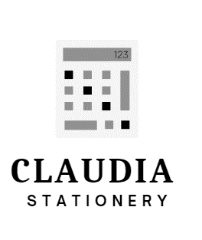Claudia runs a medium sized company that produces stationary items for schools. This month they are focussing on calculators and looking at their production levels. They currently have a break-even on 25,000 calculators a year. They sell around 46,000 worldwide. Claudia is concerned as the costs of raw materials are increasing so the break-even will change to 29,000 calculators. Calculate the difference between the two margins of safety.

### Margin of safety practice question 2



Billy owns a small business called Cleaner Homes Ltd, among other services they wash windows. In a month his team can wash the windows of 60 houses, charging customers just £18 a wash. His Fixed Costs (FC) costs are low at just £90. His Variable Costs (VC) are £1 per wash.

1. Calculate the Total Revenue (TR)
2. Calculate the break-even point
3. Calculate the margin of safety

Extra practice questions

## Extra practice question 1

Chrissy sells Smart TVs in her family’s small technology company called Vision One. The average selling price of a Smart TV is £1,000 each. The business buys the TVs for £800 each from their supplier. The Fixed Costs (FC) for the company are £12,000 per year. Calculate how many Smart TVs Chrissy needs to sell a year to break even. Show your workings.

## Extra practice question 2

Elle sells jewellery that she makes herself through an online shopping platform. The average selling price for her jewellery items is £12.50, and the cost of the silver is about £2.25 per item and her fixed costs are £2,000. She sells 350 items a year. Show your workings

1. Calculate how many items of jewellery Elle needs to sell to break-even.
2. Calculate the margin of safety for the jewellery business

Summary of Break-even Formulae

