

### Introduction

It is important for a business of any size to have data about their employees. This will help the business to make important decisions and monitor their efficiency, and make changes where necessary. For example, if lots of employees keep leaving then it may be that the management needs to change.

# The three main calculations that you will need to make are:

1. Labour productivity – measures how productive the employees are

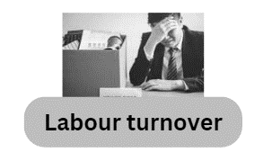

1. Labour turnover – measures the rate at which employees leave their job and need to be replaced

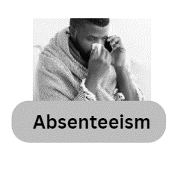

1. Absenteeism – measures the number of days lost by employees not being at work

Using the motivation theories

Conclusions for the HRM calculations need to go hand-in-hand with the four main motivation theories, these are just a quick reminder, you may need to do some full revision on these topics to be able to talk about them with confidence in an exam.

|  |  |
| --- | --- |
| Mayo  Elton Mayo.jpeg | Human Relations theory  Mayo stated that employees are motivated far more by relational factors such as attention and teamwork than by financial rewards or environmental factors such as lighting, temperature, etc. |
| F W Taylor  Frederick Winslow Taylor (1).JPG | Scientific Management Theory  Taylor stated that all workers were motivated by pay, so he promoted the idea of "a fair day's pay for a fair day's work." In other words, if one employee was not very productive they did not deserve to be paid as much as another worker who was highly productive. |
| Herzberg | Motivator – Hygiene Theory  Herzberg stated that some parts of a job will satisfy a worker and some will dissatisfy (hygiene factors). It is two-stage process to motivate people. Firstly, you need to eliminate the dissatisfaction that they are experiencing and, secondly, you need to help them find satisfaction. E.g. Ensure wages are competitive and recognise the hard work that employees put into the business. |
| Maslow  Abraham Maslow.jpg | Hierarchy of needs theory  Maslow stated that workers are motivated to achieve certain needs and that some needs take priority over others. The most basic need of employees is for physical survival, and this will be the first thing that motivates their behaviour. Once that level is fulfilled the next level up is what motivates employees, and so on. He argued that employees were unlikely to want to self-actualize (or improve themselves with training) if they had not fulfilled other needs lower down the hierarchy. |

### Labour productivity explained

The definition of labour productivity is the output per person per time period. This means how many units an employee can produce in an hour, a day or even a week. It measures the efficiency of the workforce.

A business will seek to increase productivity to reduce the average cost per unit to produce. On some products and services the margin for profit will be very small, so a cost saving could make a big impact on profitability and keep the business trading.

Labour productivity could be improved through kaizen, TQM or lean production but be careful to make sure this would be right for the context. Kaizen could work in a small company on a very small scale, but it is normally applied to giant MNCs and manufacturing companies such as Nissan, Coca Cola, Nike etc.

We use this formula to calculate labour productivity:

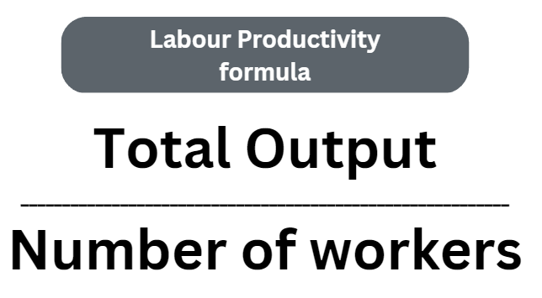

Remember to express the answer as the output per employee per time period e.g. 30 units per hour.

### Labour Productivity calculation walkthrough

# Example Productivity calculations:

Calculate the productivity of the staff at Artisans Bakery in Dottingham.

* Year 1: 13 staff produced 3,200 cupcakes a day
* Year 2: 15 staff produced 1,560 cupcakes a day
* Year 3: 17 staff produced 1,250 cupcakes a day

Make some conclusions about your calculations. Show your workings out.

Answer to example Productivity calculations:

Year 1 Productivity was 3200 ÷ 13 = 247 (rounded up because you can’t have half a cupcake)

Year 2 productivity was 1560 ÷ 15 = 104 cupcakes

Year 3 productivity was 2250 ÷ 17 = 133 cupcakes

## Example Productivity conclusions:

* In this example the labour productivity has been on a sharp decline since Year 1 and the management should be concerned. If a possible productivity level is 247 cupcakes per worker per day (your calculation from Year 1) then to fall to just 133 indicates that there may be a problem.
* Be prepared to discuss the possibility to any other factors – try and stay in context – a shortage of flour (supply and demand) leading to lower production numbers. Higher quality control due to a large number of customer complaints at the 247 output, logical to assume that fast production does not always lead to quality especially if the process is labour intensive such as making cupcakes could be in a small bakery. Don’t always assume automation.
* The business may have switched to making more elaborate cupcakes, such as ones with extra toppings or a caramel inside – which all takes time and slows down the rate of production. The important point to make is that the figures should not be viewed in isolation, to look at the whole picture of what is happening in the case study.

### Labour Turnover explained

The definition of labour turnover is the rate at which employees leave their jobs and need to be replaced.

High labour turnover may be due to poor recruitment, weak induction, lack of challenge in the job and low pay rates. This would almost certainly be true in a minimum wage job as there is little or no skill involved. This may in itself cause the high labour turnover rather than management failure.

Managers could improve rates by more employee involvement in the business (Mayo) rather than just treating staff as economic workers who are only there for the wages (Taylor).

Why do employees stop working or quit their jobs?

Often there are reasons unrelated to the job:

* Starting a family
* Moving area
* Retiring
* Changing career

Some reasons are related to the job:

* There is a mismatch between the job and the employee
* There is too little training
* There are too few promotion prospects
* Employees feel stress from overwork and have a work/life imbalance
* The employee loses trust and confidence in the manager

## Labour Turnover is calculated using the formula:

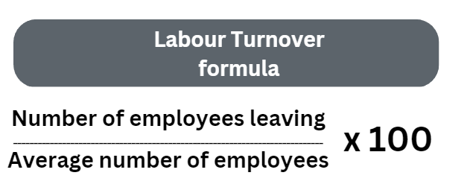

Remember to express the answer as a percentage %

### Labour Turnover walkthrough calculation

# Example Labour Turnover calculations

Leonard runs a comic book themed café on a university campus in Sussex. He employs lots of part time staff and many of his employees are university students earning some extra cash on the weekends and the evenings. Leonard has had problems with high labour turnover and has asked you to take a look at his figures for the last 3 years and offer him feedback.

* Year 1: The number of staff employed was an average of 18 and the number of staff that left during the year was 20
* Year 2: The average number of staff employed was 26 and the number of staff leaving was 5
* Year 3: The average number of staff employed was 25 and the number of staff leaving was 4

## Answer to example labour turnover calculation:

Year 1: 20 ÷ 18 x 100 = 111.11%

Year 2: 5 ÷ 26 x 100 = 19.23%

Year 3: 4 ÷ 25 x 100 = 16.00%

## Example Labour Turnover conclusions:

* Labour turnover calculation is a measure of performance, and it’s clear to see from the calculations above that the performance of the comic book café is improving.
* Some businesses may naturally have a high turnover so context is important. We know that Leonard uses a lot of university students and they may naturally leave at the end of their course to move elsewhere with their first job after graduation. There may be some leaving due to stress of exams, so 16% is probably about as low as Leonard can expect it to go.
* Labour turnover is falling and you could conclude that this may be due to more staff being hired as there are only 18 staff in year 1 and this rises to 26 staff in year 2.

### Absenteeism explained

Absenteeism is defined as a measurement of the deliberate workforce absences.

Some absenteeism is expected as employees can sometimes be sick or have family matters to attend to, but too much absence and it could cost the business in terms of lost orders and poor customer relations. Industry research tells us that 4% is about average so higher than this may indicate that there are problems in the workplace.

Absenteeism can be improved through non-financial motivation methods such as; job enlargement, job rotation, and job enrichment and more giving employees more responsibility (Herzberg).

For really good results you would need to compare % absenteeism with frequency of sickness, but as this data is not available you could conclude that these are just simple figures and a more detailed analysis of the factors behind the data would need to be carried out.

## Absenteeism can be calculated using the formula:

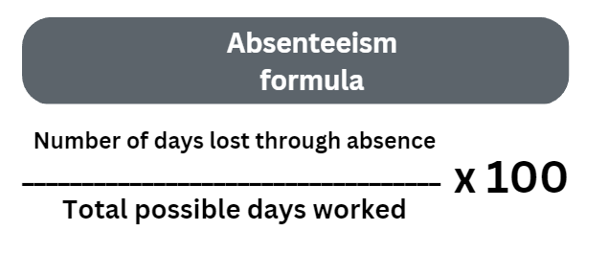

Remember to express the answer as a percentage %

### Absenteeism walkthrough calculation

# Example Absenteeism calculations

Sheldon Ltd makes novelty toys with a science twist, they are based in Dottingham. The business has been having some problems recently with too many staff calling in sick. The HRM department have been analysing the data to see what the problems might be. Sheldon Ltd employs the same number of employees in each age group.

* In employees over 30 and under 50 there were 50 days absent
* In employees over 50 there were 12 days absent
* In employees under 30 there were 66 days absent

Calculate the % of absenteeism for all 3 employee groups. Assume a working year of 232 days, which accounts for weekends, bank holidays and annual leave entitlement. Make some conclusions from your calculations.

## Answer to example absenteeism calculations:

* In employees over 30 and under 50 there were 50 days absent
* 50 ÷ 232 x 100 = 21.55%
* In employees over 50 there were 12 days absent
* 12 ÷ 232 x 100 = 5.17%
* In employees under 30 there were 66 days absent
* 66 ÷ 232 x 100 = 28.45%

## Example Absenteeism conclusions:

* The results of absenteeism calculations can show if there is low staff morale or job satisfaction, in the above example it is clear to see from the data that the highest percentage of absenteeism is in the under 30 age group. This could be down to the management or working conditions of that age group. Further data would be needed to make a full set of conclusions.
* The results could can be caused by; poor management, stress at work through role overload or underload, lack of recognition or poor working conditions (Herzberg). Making novelty toys may involve the use of melted plastics which could be smelly and quite unpleasant working conditions.

### HRM calculations practice questions

## Practice question 1

XYZ Water Ltd manufactures plastic reusable water bottles, which they sell in the UK.

Using the table below calculate the percentage change in productivity of the employees at XYZ Water Ltd between year 1 and year 3.

|  |  |  |
| --- | --- | --- |
| Year | Average number of employees | Amount of water bottles produced a year  (units) |
| Year 1 | 400 | 3,000 |
| Year 2 | 390 | 3,500 |
| Year 3 | 480 | 3,040 |

You will need to use both of these formulae for this question:



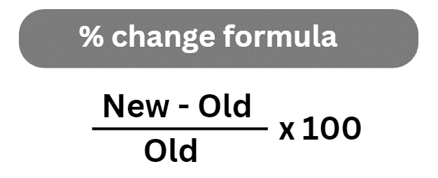

# Practice question 2

In December last year the S&J Ltd clothes shop in Dottingham had 14 instances of staff absence. The clothes shop closed on Christmas day, Boxing day and Christmas Eve. This left a total of 28 possible working days for December.

Calculate the absenteeism rate for S&J Ltd for December last year.

Answer box

## Practice question 3

Gurpal runs a small leisure club and gym business in Dottingham. The annual labour turnover at the gym is 23% which is below the industry average of 30%.

Explain one way in which the labour turnover calculation measures his competiveness.

Answer box:

## Practice question 4

FlavourFresh is a chain of supermarkets in the UK. This table shows the labour turnover figures for the last few years.

|  |  |
| --- | --- |
| Date | Labour turnover |
| Year 1 | 29% |
| Year 2 | 24% |
| Year 3 | 21% |

FlavourFresh supermarkets offer their employees; a social club which organises regular days out and events, good pay rates above minimum wage, staff discount, profit share scheme, paid holidays and a structured training scheme.

FlavourFresh are looking to expand the number of supermarkets across the North of England by opening eight new stores.

Give some possible reasons why the labour turnover figures for FlavourFresh supermarkets have improved over the last few years.

Answer box

# Practice question 5

Leo is considering investing in a business. He has narrowed his choice down to five companies and now thinks that the business with most productive employees would be his first choice.

Calculate the labour turnover of these businesses and recommend to Leo which business he should invest in. All figures are per month.

|  |  |  |  |
| --- | --- | --- | --- |
| Name of company | Total Output | Number of workers | Labour productivity |
| A | 1,500 | 275 |  |
| B | 4,921 | 320 |  |
| C | 13,961 | 125 |  |
| D | 103,945 | 621 |  |
| E | 99,701 | 665 |  |

## Practice question 6

Daisy and Lily have created a chain of shops selling pet accessories. They need to shut one of the branches and are using the labour turnover data to help them decide which store to close. All of the data in the table is taken over a year.

Calculate the labour turnover data of their store locations and recommend which one they should close.

|  |  |  |  |
| --- | --- | --- | --- |
| Location of store | Number of workers leaving | Average number of workers | Labour turnover % |
| North East | 1 | 9 |  |
| Wales | 2 | 6 |  |
| Scotland | 4 | 8 |  |
| South East | 3 | 11 |  |
| Midlands | 1 | 8 |  |

# Practice question 7

Sajida works in the HRM department of the large food MNC, GlobalCorp Plc.

She has been asked to look into the absenteeism rates of each of GlobalCorps Regional Managers and to report back on which one needs the most improvement. Sajida suspects that absenteeism may be linked to poor working conditions.

Calculate the absenteeism rates of each of the Regional Manager and recommend which one needs improvement. All the data in the table is taken over the last year.

|  |  |  |  |
| --- | --- | --- | --- |
| Name of Regional Manager | Number of days lost through absence | Total possible days worked | Absenteeism % |
| Declan | 14 | 232 |  |
| Oscar | 3 | 232 |  |
| Nadia | 17 | 232 |  |
| Robert | 25 | 232 |  |
| Mo | 6 | 232 |  |

### Summary of HRM formulae

