

Introduction

Price elasticity of demand or PED calculations are all about finding out if customers will switch to alternative products if the price rises.

For example, you are shopping for jeans in town. You spot a pair that you like and they are £30, which is quite a good price. They fit well and your mates approve of the look and the brand. However, you don’t have £30 on you today so you leave the shop without buying the jeans. Next week you go back to the shop and the price has gone up to £40. These are still just jeans and there are many shops selling similar jeans, so you leave without buying them. This is price elasticity in action.

As the price rises – generally the demand for products falls. There are some exceptions to this rule. You drive into a petrol station having run out of petrol. You cannot shop around, as the car won’t go without petrol, so you pay whatever the petrol station is charging. In this example the petrol is ‘price inelastic’ which means that demand levels don’t change if the prices go up or down.

The opposite is also true as the price of goods fall then demand (usually) goes up. We all love a bargain. If the price of those jeans goes down to £15 in the sale, and all your mates might buy a pair.

PED explained – elastic products

Most products have lots of available substitutes, for example if your local newsagents have increased the cost of Diet Coke cans you can probably buy Pepsi Max, a chocolate milkshake, orange juice or water instead in the same shop. Having elastic demand means that the consumer is sensitive to a change in price.

Elastic products – if the price of the products rises too high then customers will move and shop around. Just like elastic stretches and moves.

PED explained – inelastic products

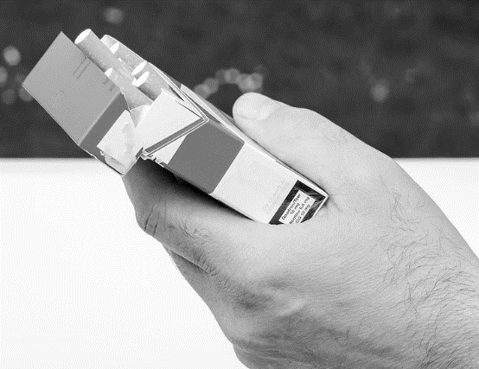Products which have inelastic demand, tend to be ones that have few substitutes like petrol and insulin. Customers are more likely to buy products regardless of the price is this is a necessity.

Inelastic products – if the price rises, customers may still buy the product. This is often true of addictive products such as cigarettes.

PED identifies if goods are elastic or inelastic

1. Bread 5. Train ticket 9. New games console
2. Petrol 6. Shampoo 10. Latest Nike trainers
3. Medicine 7. Coffee 11. Football team kit
4. Cola 8. New iPhone 12. Sunglasses

Sort the products into the correct column

|  |  |
| --- | --- |
| Elastic goods  Customers are very sensitive to price and will choose a substitute if prices rise | Inelastic goods  Customers will pay even if the prices rises, few substitutes |
|  |  |



You are required to know this about PED for the exams:

1. Calculation of price elasticity of demand
2. Interpretation of numerical values of price elasticity of demand
3. The factors influencing price elasticity of demand
4. The significance of price elasticity of demand to businesses in terms of implications for pricing
5. Calculation and interpretation of the relationship between price elasticity of demand and total revenue

Factors influencing PED

There are some factors that will influence the PED values of products and services:

1. The number of competitors e.g. lots of shops on the high street selling jeans
2. The strength of the brand e.g. Skoda or Mercedes?
3. The amount of income that consumers need to have to buy that brand e.g. Think what kind of income you need to buy a Rolex watch
4. If the product is luxury or essential e.g. is it a bag of sugar or is it a holiday?
5. The level of differentiation from competitors e.g. How different is an iPhone from a Samsung?
6. Availability of substitute products e.g. Can you easily go to a different shop or buy another product?
7. Frequency of purchase or how often the product is bought e.g. Toothpaste or a moped
8. Time e.g. Are you in a rush, or do you have time to shop around?

The significance of PED to a business

A business might use PED values to help when pricing products. If they price too high demand and sales will fall, so getting the price right can be critical to making a healthy profit.

A quick word about PED results, to get maximum marks always round to two decimal places.

All PED values will be minus figures as price and demand are linked. As the price increases so demand will decrease and the opposite is also true.

PED formulae (you need both)

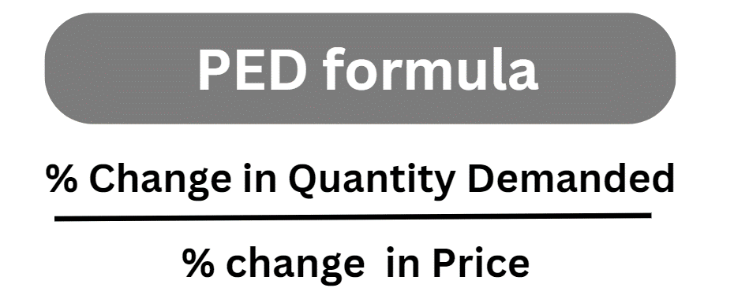

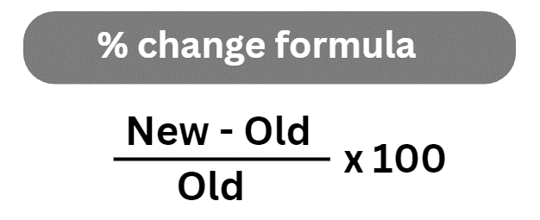

When you have calculated your PED values, you will then need to be able to interpret the results and draw some conclusions. Therefore, you will also need the table below.

|  |  |
| --- | --- |
| Elastic  >1 | A result greater than one means the product has elastic demand and customers are sensitive to a change in price. If the price goes up demand will go down and if the price goes down, as we all love a bargain, the demand goes up.  ELASTIC |
| Inelastic  <1 | A result less than one means the product has inelastic demand; customers will still buy it if the price goes up, so demand remains the same. INELASTIC |

PED calculation Walkthrough

Buddies is shop which sells wireless earbuds and USB charging cases. They want to hold a sale to clear out old stock to make way for some new designs. If they decrease their prices by 10% on all types of earbuds they can expect demand to increase from 120 to 150 pairs sold a week.

### Step 1: Calculate the % change in Quantity Demanded



In this example the new amount would be 150 pairs and the old was 120

* New 150 – Old 120 = 30 pairs of sunglasses
* 30 ÷ 120 x 100
* The change in quantity demanded is 25%

### Step 2: Calculate PED using the PED formula

* The percentage change in quantity demanded is 25% (from the calculation in step 1)
* The percentage change in price is a decrease of -10% (given in the question)
* Now use the PED formula 25% ÷ -10%
* PED value of the sunglasses is -2.5

### Step 3: Identify if the products have elastic or inelastic demand

PED is greater than 1 so price elastic (we ignore the minus sign). There are lots of different sellers and substitutes for earbuds. This means they need to be careful with any price increase as it will impact demand.

PED example calculations

Complete the table the first two have been done for you.

|  |  |  |  |
| --- | --- | --- | --- |
| % Change in Quantity Demanded | % Change in Price | PED | Comment  (Ignore the minus sign) |
| 45 | -25 | -1.8 | This is greater than 1 so the demand for the product is price elastic |
| 3 | -9 | -0.33 | This is less than 1 so the demand for the product is price inelastic |
| 10 | -5 |  |  |
| 45 | -12 |  |  |
| 17.5 | -90 |  |  |
| -8 | 11 |  |  |
| -16.24 | 25.97 |  |  |



Rearranging the PED formula,

What to do if the PED value is given in the question.

Case study

Darney Runners is a sportswear shop. They know that the PED of their products is -0.6 and the owners want to know what will happen if they increase their prices by 3% across the store. They want to know how this increase will affect demand. Give your answer to two decimal places and show your working.

To answer the question rearrange the PED formula:

* % CHANGE IN PRICE X PED VALUE
* 3 X (-0.6) = (-1.8%)

Answer: The sales at Darney Runners will decrease by 1.8% but lower prices will also mean lower sales revenue, and this will have a negative impact on profit.



Note if you got 2.4 as a result your calculator has given a false result, try NOT using the minus sign on your calculator.

PED practice questions

## Practice question 1:

Amin sells luggage, bags and suitcases in his online e-commerce business called Travel Bag. His most popular case the Kelsey has a PED value of -0.7. Amin wants to know if he puts his prices up by 25% what impact this will have on his sales revenue. Show your workings.

## Practice question 2:

Melissa runs a small shop in Dottingham called Allsorts, which among other items, sells cans of energy drinks to students. They have estimated that a 40% increase in price of energy drinks will only decrease demand by 10%. Calculate the PED of demand for energy drinks. Show your workings and comment on your results.

## Practice question 3:

Harley owns a business which manufactures tuna flavour popcorn and the product is called Fishcorn. They have increased their prices and the sales have decreased. Using the table below of data can you calculate the PED of the Fishcorn product and comment on your results.

|  |  |  |  |
| --- | --- | --- | --- |
| Jan | | Feb | |
| Price £ | Quantity sold | Price £ | Quantity sold |
| 20.60 | 900 | 21.63 | 891 |

## Practice question 4:

Jason sells computers and computer equipment in his business called Nosaj. He normally sells monitors at £150 each. This month he is having a promotion and has reduced the price of monitors down to £120 each. Jason notices that demand for the monitors has now increased from 60 to 75 units a week. Calculate the PED value of the monitors. Show your workings.

## Practice question 5:

If a product’s sales have decreased by 21% after a price rise from £3.00 to £3.50 per unit. Calculate the price elasticity for the demand of the product. Show your workings and comment on whether the product has elastic or inelastic demand.

## Practice question 6:

A business does not just sell one item it sells a whole range of products. This is the brand portfolio of the business. Suggest how a business might use PED information to help them manage their brand portfolio.

## Practice question 7:

Gurjivan sells a range of phone accessories from his shop called MobileShop in Dottingham. He knows that the PED of his best selling phone case has a value of -0.4 He wants to know what will happen to his sales revenue if he puts his prices up by 11%. He imports the cases from China and his suppliers have put their prices up.

Summary of PED Formulae

