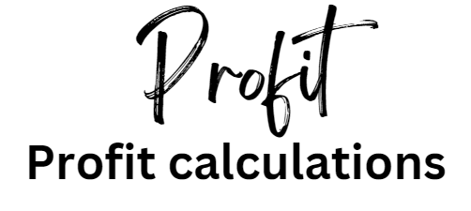

Introduction

Understanding profit starts with a simple equation:



Where TR = Total Revenue and TC = Total Costs

However, profit can be complex as there are three types. Each profit calculation is different and gives the stakeholders of a business information about how it is preforming.

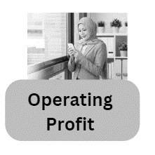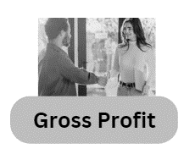The three main types of profit are:



You will need to know what these profits all are, and which stakeholder is interested in which profit type.

There are also other profit margin calculations to know:

1. Gross Profit Margin % (GPM%)
2. Operating Profit Margin % (OPM%)
3. Net Profit Margin % (NPM%)

These are covered in the ratio analysis worksheet in this Tricky Topics pack, where there are plenty of calculations to practice with.

Profit key terms

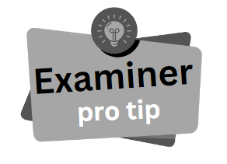

If you want to fully understand the concept of profit in A Level Business you will need to know some key terms, and make the right calculations.

If you get the calculation wrong, you can still comment on it and your examiner will award you marks if your conclusions from your own calculations are correct. This is called the OFR or own figure rule.

## Key terms to learn

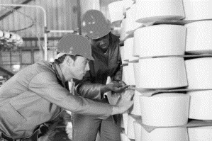Direct Costs (DC)

Direct Costs (DC) are those that can be directly allocated to a trading activity. For example; inputs used in factory production.

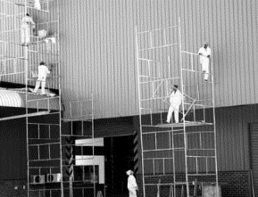Indirect Costs (IC)

Indirect Costs (IC) are those that cannot be allocated to a trading activity. For example; painting the inside of the factory.

Overhead Costs (OC)

These are also known as the expenses of the business. These are costs which help the business to run but are not about the normal trading of the business. For example; advertising, electricity, water and the business phone bill.

Fixed Costs (FC)

Fixed costs are those that do not vary with output, bills that must be paid no matter what output level the business has. For example; rent which must be paid even if the business makes or sells nothing.

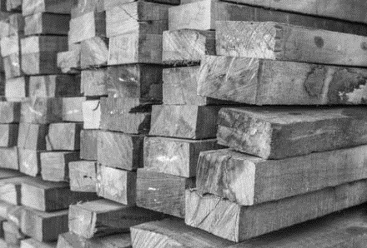Variable Costs (VC)

Variable costs are those that do vary with output. For example; raw materials, as production increases so does the amount of raw materials needed.

Total Costs (TC) explained

Total costs are the sum of fixed and variable costs of a business. Total Costs (TC) are used in break-even analysis to help plot a graph. Total Costs are also useful for calculating profit.

This is the formula used to calculate total costs:

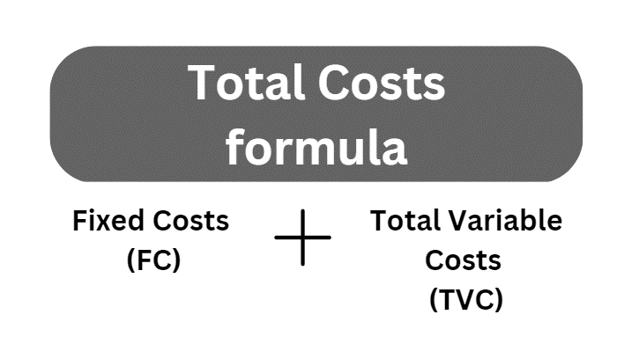

## Total cost example:

Total costs are at a certain level of output. For example, at 500 units the fixed costs are £3,000 and the variable costs are £1.25 per unit. 500 x £1.25 = £625. Total cost would add £3,000 to £625 which equals £3065.

## Example Total Costs calculations

Complete the table using the Total Costs (TC) formula. Total Variable Costs (TVC) figure found by multiplying the number of units by the Variable Cost per unit e.g. 11415 x £1.25 = £14268.75. Remember to express your answers as £.

|  |  |  |  |  |
| --- | --- | --- | --- | --- |
| Fixed Costs (FC) | Number of units | Variable Cost per unit (VC) | Total Variable Cost (TVC) | Total Cost (TC) |
| £3,000 | 11415 units | £1.25 |  |  |
| £259 | 7201 units | £6.06 |  |  |
| £80,000 | 19 units | £11,212 |  |  |

Total Revenue (TR) explained

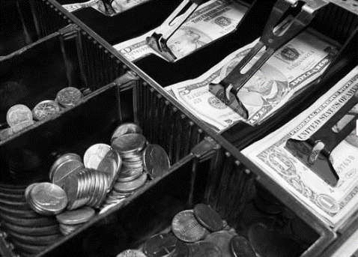Sales Revenue (SR)

Sales revenue is money coming into a business from normal trading of goods and services. At this point, no costs have been deducted. Sales Revenue (SR) is also known as Total Revenue (TR) turnover or just revenue.

Total Revenue (TR) is calculated using the following formula:

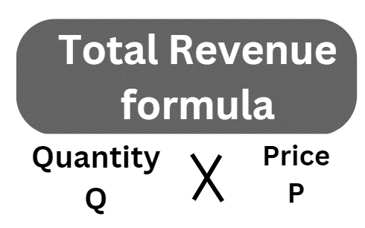

## Example Total Revenue calculations

Remember to express your answer in £.

|  |  |  |
| --- | --- | --- |
| Quantity sold | Price sold at | Total revenue |
| 11415 | £3.99 |  |
| 7201 | £11.25 |  |
| 19 | £39,000 |  |

## Average revenue (AR)

For example, £2,000 total revenue / 400 units = £5 average revenue per unit.

.

Using the basic profit formula

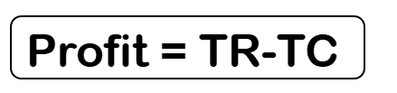If you are not sure about which formula to use – try this one.

## Example basic profit calculations

Use your Total Costs (TC) figures that you calculated on Page 3

|  |  |  |
| --- | --- | --- |
| Total Revenue (TR) | Total Costs (TC) | Profit |
| £45,545.85 |  |  |
| £81,011.25 |  |  |
| £741,000 |  |  |



Often the calculations in A Level Business exams will require you to use more than one formula. It is worth learning them all so you can use them in a variety of questions. Profit is a very important concept in business so there may be questions on all three papers.

Gross Profit (GP) explained

The formula for gross profit is Sales Revenue minus the Cost of Sales (COS) which is the total cost of goods bought to be sold on for a profit, or the cost of goods that have been manufactured in the business to be sold on.

## Gross Profit and stakeholders

Gross Profit (GP) shows the business how much profit is made from goods and services without deducting all the costs. This will help the owners and the managers to see which products and services are the most profitable. It can be used to compare products and see which should be continued to be sold. Once other costs and tax are deducted profit becomes more complex. This simple Gross Profit (GP) calculation is therefore the best way to work out what stock range to have in a shop for example.

This is the formula we use to calculate Gross Profit (GP):

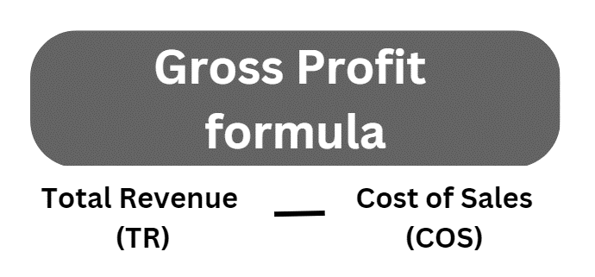

## Example Gross Profit (GP) calculations

Remember to express your answers as £

|  |  |  |
| --- | --- | --- |
| Total Revenue (TR) | Cost of Sales (COS) | Gross Profit (GP) |
| £45,545.85 | £13,995 |  |
| £81,011.25 | £41,250 |  |
| £741,000 | £270,132 |  |

Operating Profit explained

We use the Gross Profit figure to help calculate Operating Profit, and Operating profit to calculate Net profit so you need to know them all. This is profit which a business has earned from normal trading activity minus expenses associated with trading. For example; printer ink, advertising and administration.

## Operating Profit and stakeholders

Business owners use the Operating Profit figure as a more accurate indicator of how the business is performing. All associated expenses have been removed. This will indicate how efficient the managers are as it includes everything that is within the control of the business. The Net Profit figure removes tax and interest payments on debt, so a business owner may choose to discuss their Operating Profit figure if they have a lot of debt. It will make the business appear to be in better financial health.

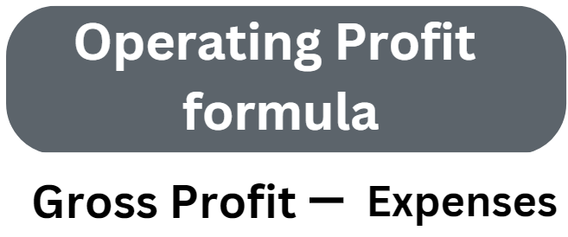This is the formula we use to calculate Operating Profit (OP)

## Example Operating Profit (OP) calculations

Use your Gross Profit figures from page 6

|  |  |  |
| --- | --- | --- |
| Gross Profit (GP) | Expenses | Operating Profit (OP) |
|  | £2016 |  |
|  | £4995 |  |
|  | £15,260 |  |

Net Profit explained

This is a profit which a business has earned from normal trading activity minus all the costs which are not associated with trading, for example interest payments on loans and taxes. Taxes might include VAT, corporation tax depending on the size of the business.

## Net Profit and stakeholders

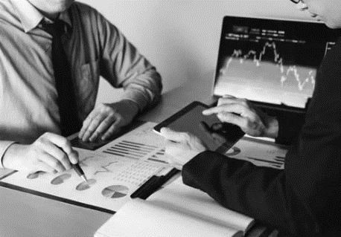Tax and interest payments are outside of the control of the business. Tax rates are set by the Government and Interest payments are set by the lenders (e.g. bank). This is the final profit figure and will indicate how much is available for the owners or for the shareholders to take as dividends. Often profit is retained in a business to be used for projects for the following years. A low Net Profit figure would not be very attractive to investors as this would mean a low return on their investment.

This is the formula we use to calculate Net Profit (NP)

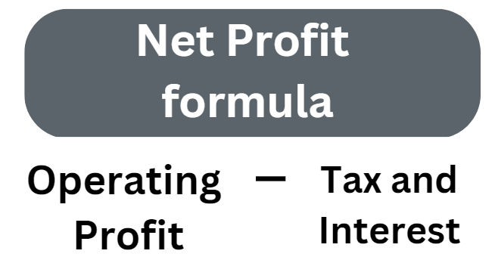

## Example Net Profit (NP) calculations

Use your Operating Profit figures from page 7

|  |  |  |
| --- | --- | --- |
| Operating Profit (OP) | Tax and interest | Net Profit (NP) |
|  | £5,800 |  |
|  | £6,953 |  |
|  | £91,216 |  |

Practice questions

## Practice question 1

Chokkies are a small company that make chocolate brownie boxes. They sell on TikTok lives and throughout social media. Last year they sold 12,000 brownies at £4.99 each. Each bar costs £2.25 to make. The fixed costs of the business are £6,000 a year, which covers the rental of an industrial unit. Calculate the profit of Chokkies for last year.

|  |  |  |
| --- | --- | --- |
| Sales  Quantity  units | Selling Price | Sales Revenue |
|  |  |  |

|  |  |  |
| --- | --- | --- |
| Sales Quantity  units | Variable Cost per brownie | Total Variable Cost |
|  |  |  |

|  |  |  |
| --- | --- | --- |
| Fixed Costs | Total Variable Costs | Total Costs |
|  |  |  |

|  |  |  |
| --- | --- | --- |
| Sales Revenue | Total Costs | Profit |
|  |  |  |

## Practice question 2



Trekkies Ltd make a variety of equipment for walkers, for example walking poles, water bottles and walking shoes. They sell them in their shop in Dottingham.

Using the data in the table below calculate Trekkies Ltd’s expected Operating Profit (OP) and Net Profit (NP) for 2024 and 2025 based on an average of 7,300 customers per year. Show your workings.

|  |  |  |
| --- | --- | --- |
|  | 2024 | 2025 |
| Gross Profit (GP) | £576,700 | £642,400 |
| Expenses | £5613 | £9,118 |
| Tax and interest | £228,434 | £253,312 |
| Operating Profit (OP) |  |  |
| Net Profit (NP) |  |  |

## Practice question 3

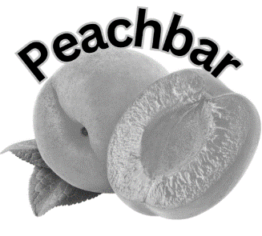

Peachbar is a new upmarket bistro cafe which has opened in Dottingham. Based on the data given, calculate the profit that Peachbar made in the six weeks of summer last year. Calculate profit for the total 6 week summer period. Show your workings.

|  |  |
| --- | --- |
| Summer finance figures | |
| Fixed Costs per week | £1,800 |
| Variable cost per customer | £10.00 |
| Average number of customers per week | 120 |
| Average spend per customer | £54 |

Peachbar also want to calculate the profit figures for the six weeks of winter last year for comparison. Make the calculations and comment on your findings. Calculate profit for the total 6 week winter period. Show your workings.

|  |  |
| --- | --- |
| Winter finance figures | |
| Fixed costs per week | £1,800 |
| Variable cost per customer | £8.00 |
| Average number of customers a week | 85 |
| Average spend per customer | £51 |

## Practice question 4

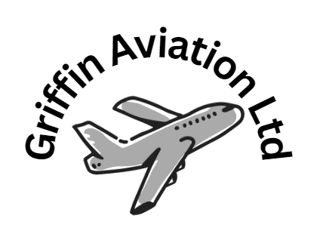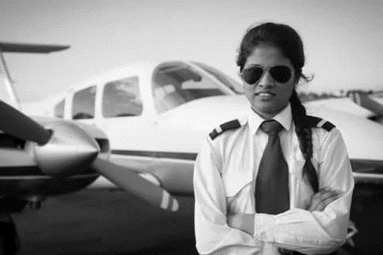

1. Griffin Aviation Ltd sells flying lessons at a small airfield in Dottingham. The business made a sales revenue of £10.4m and the finance manager has calculated the cost of sales to be £2.2m. Calculate the gross profit figure for last year. Show your workings.
2. The finance manager of Griffin Aviation Ltd estimates that the expenses for last year were £350,000. Calculate the operating profit figure for last year. Show your workings.
3. The tax and interest costs for Griffin Aviation Ltd amounted to £4.4m for last year. Calculate the net profit figure for last year. Show your workings.

## Practice question 5

Rollers PLC is a chain of take-away outlets that sells sausage rolls, pizza slices and a range of cakes and fizzy drinks. Below is a table of finance from the Rollers PLC annual financial accounts. Comment on the data in the table.

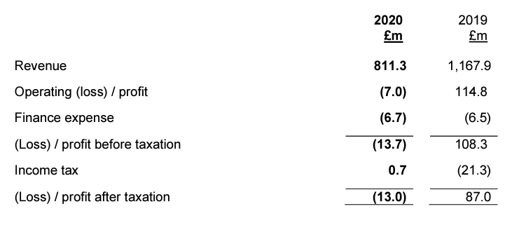

Answer Box

## Practice question 6

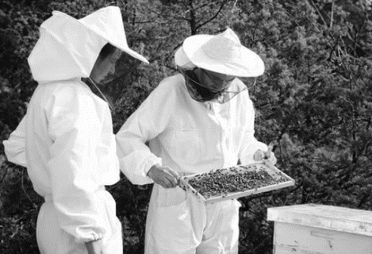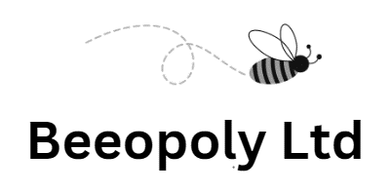

Beeopoly Ltd make beehives for urban gardens. Each beehive sells for £750 and Beeoply sold 80 beehives last year. The fixed costs were £8,000 for the year, and each beehive costs £250 to make.

1. Calculate the sales revenue figure for Beeopoly Ltd for last year
2. Calculate the total costs figure for Beeopoly Ltd for last year
3. Calculate the profit figure for Beeopoly Ltd for last year

## Practice question 7

Banshee Media PLC make and distribute vampire films, they publish their accounts every year. Calculate their Gross Profit for all 4 quarters from the data given in the table below. Show your workings.

|  |  |  |  |  |
| --- | --- | --- | --- | --- |
|  | Q1 | Q2 | Q3 | Q4 |
| Total Revenue (TR) | £1,000,000 | £1,250,000 | £1,500,000 | £1,750,000 |
| Cost of Sales (COS) | £400,000 | £600,000 | £750,000 | £825,000 |
| Gross Profit  (GP) |  |  |  |  |

## Practice question 8

Purple People Ltd is a UK recruitment business; they specialise in finding temporary staff for factories. Their sales revenue was £120,000, the cost of sales was £30,000 and operating expenses were £50,000.

Purple People Ltd

Purple People Ltd have published their accounts, using the available data calculate their gross profit and operating profit for last year. Show your workings.

Answer Box



Summary of Profit Formulae



