

Introduction

YED stands for Income Elasticity of Demand, the word income is indicated with a Y because the letter I is reserved for Investments.

To understand YED you first need to know that there are three types of goods:

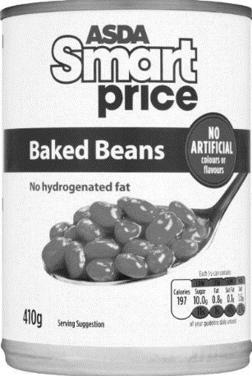

1. INFERIOR GOODS

These are basic goods, and as the income of the consumer rises, the demand for these goods fall. So if an individual gets a better job or a pay rise, they will buy less basic items. Products in this category include Supermarket own label goods and canned goods. They are the cheapest version available.

1. 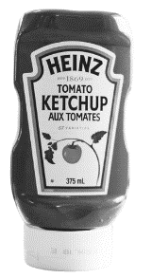NORMAL GOODS

These are products that as the income of the consumer rises they demand slightly more of these goods. They are normal because they are standard products with lots of substitutes. Products in this category might included branded goods such as Heinz Ketchup or Kellogg’s cornflakes.

1. 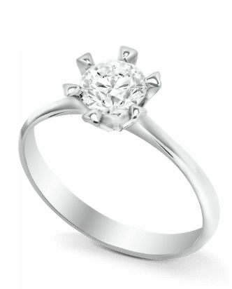LUXURY GOODS

These are goods, that as the income of the consumer rises, the demand increases larger than is proportional to the rise. So, the goods become a greater amount of overall spending of that consumer. Products in this category include designer clothes, high-end watches and jewellery.

YED explained

YED is the effect on demand of a change in consumers’ income. Imagine you have left school, university or college and got a job. You get promoted and you also get a pay rise, so your income has risen. You are now in a position to buy different products.

Three things happen:

1. Your demand for normal goods increases slightly

You can now afford more of the day-to-day goods than you could before. Therefore, you might buy more chocolate or multipacks of your favourite items.

1. Your demand for luxury goods increases sharply

You can now afford a holiday, a better car and some nicer clothes. In a recession your demand for these goods would fall sharply too.

1. Your demand for inferior goods decreases

Now that you have had your pay rise you no longer want to buy ASDA smart-price beans or ready meals. Instead, you might choose to eat out or have a take-away delivered.



You are required to know this about YED for the exams:

a) How to calculate income elasticity of demand (YED)

b) Interpretation of numerical values of income elasticity of demand (YED)

c) The factors influencing income elasticity of demand (YED)

d) The significance of income elasticity of demand (YED) to businesses

Factors influencing YED

There are some factors which will influence the YED values of products and services.

1. The type of product

Some products have a high YED value like luxury cars, as consumers we just don’t buy them unless we have incomes high enough. Customers would not be able to take out the finance to buy a car without enough income for a deposit and a salary to afford the monthly payments.

1. Time factor

Some goods take time to gain popularity or the trust of the consumers. Products that are in the introductory phase of their product lifecycles will not be demanded as much as those products that are in the growth or maturity phases.

1. Expectations of income

In times of economic recession consumers will expect their incomes to drop and so may demand inferior goods ahead of that time. It is logical to think that if a recession is announced by the Bank of England that customers will save their money instead of spending just in case their wages fall or they lose their job.

The significance of YED to a business

A business might use YED values to estimate how demand will change given changes in consumer income levels. This will help the business to forecast what goods to produce. For example; when incomes rise we all demand less inferior goods (e.g. Sainsbury’s basics), so producers or sellers of those goods may start to diversify into normal goods. E.g. Sainsbury’s taste the difference range.

YED identify normal, inferior and luxury goods

*Put these products into the correct part of the table, answers are at the end of the worksheet*

1. Sainsbury’s Own Brand Cola

11.China plates

12.Microwave pizza

13.Domino’s pizza

14.Cheap cuts of meat

15.Steak

16.Bus tickets

17.Taxi fare

1. Coca Cola
2. Sports car
3. Holiday
4. Diamond ring
5. Rolex watch
6. Pot noodle
7. Galaxy chocolate bar
8. ASDA Smart price chocolate bar
9. Paper plates

|  |  |  |
| --- | --- | --- |
| Image result for bread in wrapper |  |  |
| Normal goods:  As incomes rise the demand for these goods rises slightly  Positive YED <1 | Luxury goods:  As incomes rise the demand for these goods rises sharply  Positive YED >1 | Inferior goods:  As incomes rise the demand for these goods falls  Negative YED |
|  |  |  |
|  |  |  |
|  |  |  |
|  |  |  |
|  |  |  |
|  |  |  |
|  |  |  |

YED formulae (you need both)

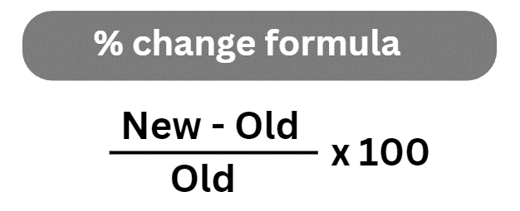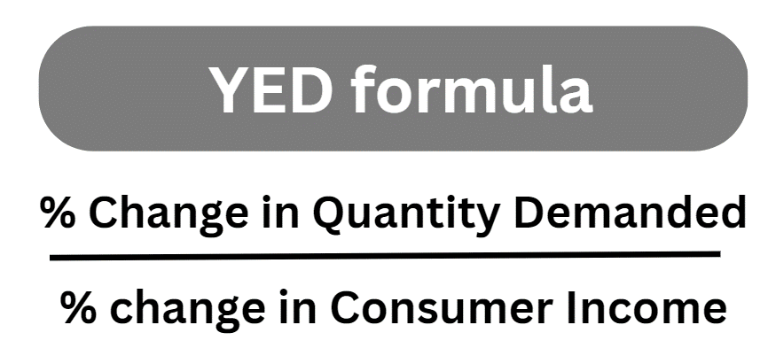

|  |  |
| --- | --- |
| Inferior | Negative YED value |
| Normal | YED value is Between 0 and 1 e.g. 0.56 |
| Luxury | YED value is larger than 1 e.g. 7.8 |

When you have calculated your YED values you will then need to be able to interpret the results and draw some conclusions. So you will also need the table below.

YED calculation Walkthrough

There is a recession in the UK and customers are experiencing a 3% reduction in their incomes. This has caused sales to fall from 52,500 down to 50,000 units. Calculate the YED value and comment on what type of good this might be e.g. inferior, luxury or normal.

### Step 1 calculate the % change in quantity demand – use the formula below



Use the formula to calculate the percentage change in quantity demanded

* New = 50,000
* Old = 52,500
* 50,000 – 52,500 ÷ 52,500 = 0.0476
* Multiply this figure by 100 to get a percentage change = 4.76%
* % change in quantity demanded = -4.76%

### Step 2 calculate YED using the YED formula:

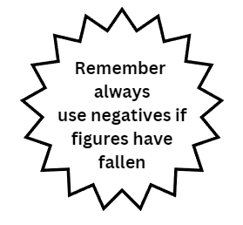

* Use the YED formula:
* % change in quantity demanded -4.76%
* % change in consumer income (given in the question) -3%
* -4.76% ÷ -3% = 1.59 (round up to two decimal places) Note dividing one minus number by another will always give a positive.
* YED is therefore 1.59

### Step 3 identify what type of good it might be:

|  |  |
| --- | --- |
| Inferior | Negative YED value |
| Normal | YED value is Between 0 and 1 e.g. 0.56 |
| Luxury | YED value is larger than 1 e.g. 7.8 |

If YED is 1.59 then the goods are luxury.

YED example calculations

|  |  |  |  |
| --- | --- | --- | --- |
| %Change in Quantity demanded | % Change in income | YED calculation | Inferior, normal or luxury goods? |
| +40% | -6% |  |  |
| -25% | +7% |  |  |
| +35% | -4% |  |  |
| -80% | -2% |  |  |
| +3% | +15% |  |  |
| +13% | +3% |  |  |
| +22% | +24% |  |  |
| +21% | +7% |  |  |
| -30% | 4% |  |  |

YED practice questions

## Practice question 1:

The manager of the Dottingham branch of Bob’s pizza estimates that a 10% reduction in consumer incomes will mean a 15% increase in sales of their “cheap and cheesy” range of pizzas. Calculate the YED value and comment on the results.

## Practice question 2:

A government report says that UK consumer incomes have risen by 1.6% for the year. Gamasnore is a bed company based in Dottingham. Gamasnore produces memory foam mattresses and pillows and has seen their demand increase by 1.2% over the past year. Calculate their YED.

## Practice question 3:

Amin buys a meal deal only a Friday from his local supermarket, Bubblemall, for £3.75. The rest of the week he makes his own sandwiches. He has been promoted in his part-time job as a gardener and now his income has risen by 8.5%. The quantity of meal deals that he wants to buy have risen by 4%. Calculate the YED of the meal deals.

## Practice question 4:

The BBC has run a news story explaining that UK incomes have risen by 2.2%. This is possibly good news for Veronica who runs a pet shop called Cutelines. She has noticed that the sales of dog beds went from 700 units sold to 800 over the past year. Calculate the income elasticity of demand for the dog beds. You are advised to show your working.

# Summary of YED formulae



