Recording sheet 7A: Beach profile measurements

Work in groups of three. Two of you will measure the profile of the beach from the low-tide mark upwards and the third person will record the measurements using the table provided. You will need: Ranging poles, a 20m tape measure, a clinometer, a map and recording sheet.

Identify three sampling sites across the width of the beach to measure your beach profiles and mark them clearly on your map.

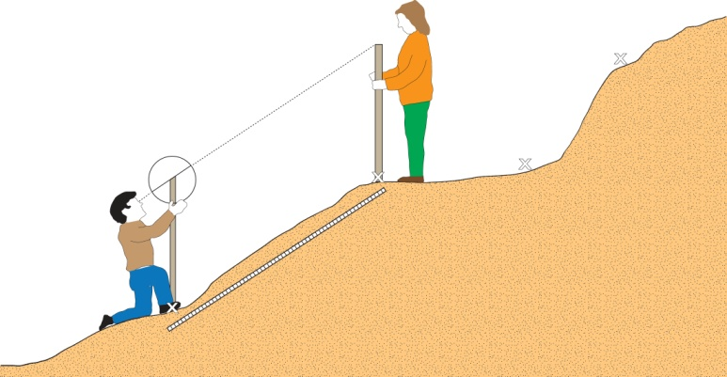
At the first site, look for key points where the angle of the beach seems to change (break of slope) and use these to divide your profile into manageable sections – mark them as points A, B, C and so on up the beach, on your map. (If the slope is uniform, look for changes in sediment or pebble size and use these points instead.)

One group member stands at point A - as close to the low-tide mark as it is safe to do so – with a ranging pole and one end of the tape measure.
The second group member takes the other end of the measuring tape and a ranging pole and walks up to point B.
The third group member records the distance in metres between point A and point B.

Measure the slope angle between point A and B using a clinometer:
Stand next to the nearest ranging pole, line up the arm of the clinometer with the bottom/top of a red or white band on the pole (hold on to the trigger).
Look along the sight to the distant pole and angle the clinometer so the sight notch at the end is in line with the corresponding band on the far pole.
Let go of the trigger so that the clinometer swings, keep your hand steady.
Once it has stopped swinging, press the trigger again and record the angle
Repeat this process for each section up the beach.

Group members: ____________________________________________________________
Date: ____________________Latitude /Longitude of start point (if known): _____________
Location: _________________________________________ Site number : ______________

 | Angle of slope (degrees) | Distance (metres)
A-B
B-C
….
F-G
Recording sheet 7B: Wave analysis

To understand the impact of wave energy, you will observe and measure wave frequency, wind speed and wind direction at five sites (A─E) on the beach. At no time during this process should you enter the sea. You should not need to stand closer than 2m to the zone where the waves are breaking to take your measurements. If your feet risk getting wet, you are too close.

Count waves for three 1 minute intervals then work out an average for each site. Alternatively or in addition use a stopwatch to record the time between the wave crests breaking. Look at the shape and sketch it and estimate the height of the waves. Observe any wave refraction that occurs as the wave approaches the beach, mark this on your map.
Record your observations in the table, then calculate whether the waves are likely to be destructive or constructive (see panel below) and note the prevailing wind direction and the wind speed.

Group members: ____________________________________________________________
Date: ____________________
Location: _________________________________________

Site | Wave count 1 | Wave count 2 | Wave count 3 | Average number of waves per minute | Time between waves breaking | Dominant wave type | Wave height  (estimate in cm) | Wind speed | Wind direction
1
2
3

Wave types

Destructive waves cause the most erosion along coasts. They are tall, have a strong backwash and higher wave frequency (13 waves per minute or more) than constructive waves.

Constructive waves tend to deposit material on the beach, they are shorter in height than destructive waves, have a strong swash and much lower frequencies (well under 13 waves per minute).

If you can, record at least one short video of the wave patterns at each site ─ these can be analysed back at school.

