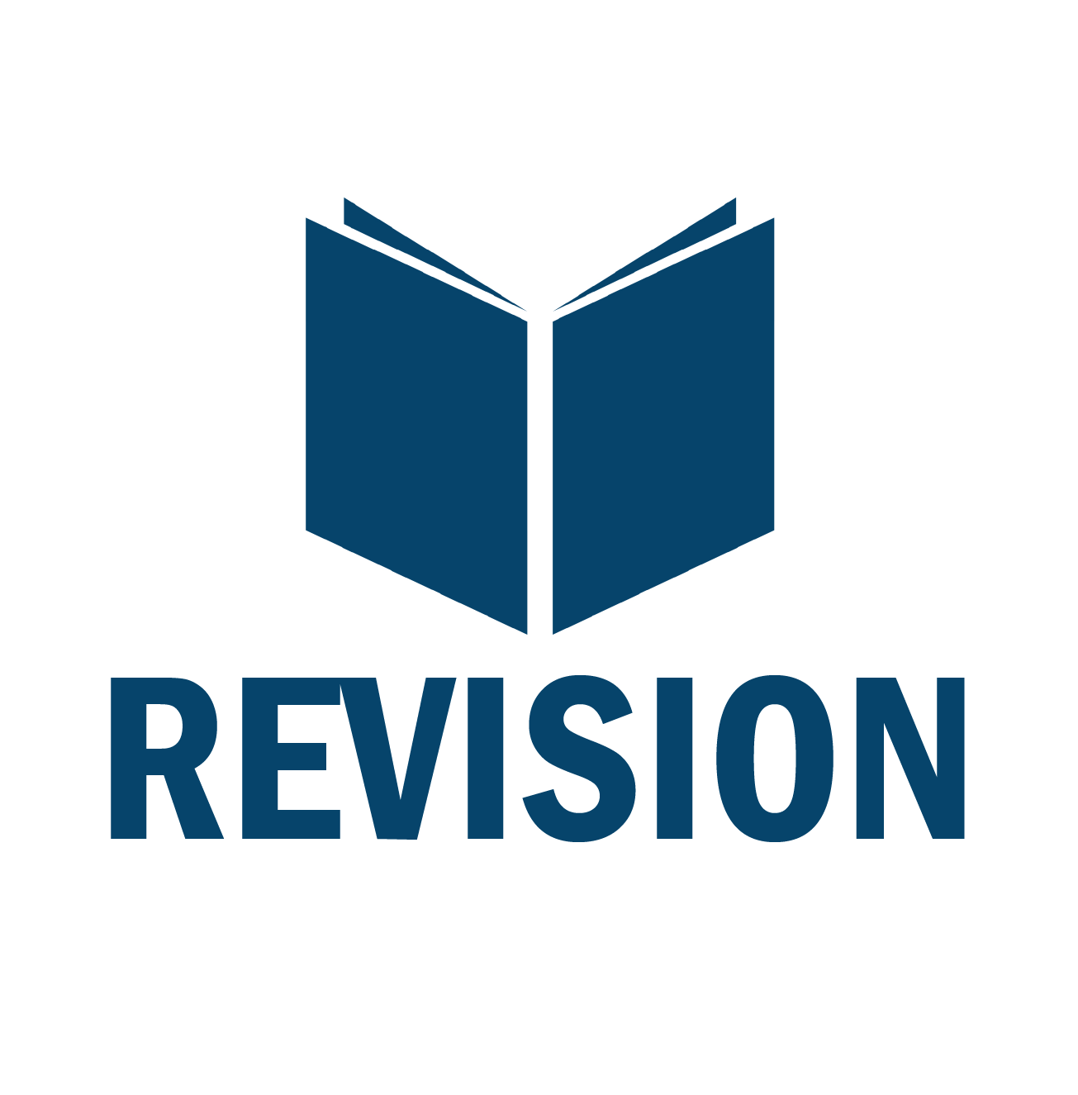**Effective Revision in Ancient history**

**How to use past questions**

Regular practice of past exam questions is a vital part of revision in Ancient History; it trains you to answer in the time given, reinforces the technique you will need to use, and is the best way to consolidate content – by actually using it.

Being faced with pages of past questions can, however, be challenging. The ideas below will give you some help in approaching past questions, and some suggestions about how best to use them as part of your weekly consolidation and final revision.

***When to use past questions***

* **Following feedback on an assessed question in class** – an excellent time to attempt a past question is straight after you have received feedback on a question you have done as a class. If, for example, you write a 30 mark essay in timed conditions in class, once you received feedback on this essay, select a further 30 mark essay to write independently. Focus on applying the feedback you were given to this new question and then bring the finished answer to the weekly workshop to get it marked.
* **When consolidating a topic or a difficult bit of work** – weekly consolidation (going over sources, adding detail to your answers, updating source summaries and glossaries) should be a central part of your 50/50 time in Ancient History each week. When you get to the end of a topic or you come across a complex or challenging bit of content, find a past questions that covers this area to plan in detail or write. Again, bring this to the weekly workshop for feedback. You know where your knowledge is weakest so use past questions to plug these gaps.
* **As part of structured revision** – this is the obvious one but often something students get wrong. Attempting questions at random reduces their impact and misuses your time. Instead, get into this habit:

This approach uses past questions in a routine way that helps you to check how much you really know about a topic. It also spaces them out so that you can attempt more over time.

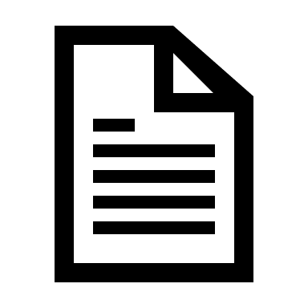***How to use past questions***

The first step is to get hold of Ancient History past questions, which are available in the exams and revision sections of Godalming Online and your Teams page. The questions are also arranged depending on how you want to use them. There is a **‘Question by Topic’** set, which lists all of the different types of question topic-by-topic for each of the four areas of the course. This would be ideal to use alongside structured revision; when you complete a topic’s content and source revision, choose a past question on this topic to attempt.

There are also **‘Question by Type’** sets, one for each question-type: 20 mark interpretation question, 30 mark essay, 12 mark source utility questions, and 36 mark essays. These would be helpful when you want to practice specific question technique or want to do a follow-up question to one you have done in class.

Lastly, you can also access the past and example **exam papers** in Ancient History through the revision sections of Godalming Online an Teams. This would be good if you want to attempt part of a mock paper (or one in full), or see how the questions connect and how you will need to organise your time through the 2.5 hour exam. Each also comes with a mark scheme which includes indicative content.

Once you have the past questions you need, there are lots of different things you can do with them to help you consolidate and revise your understanding.

1. **Attempt questions in full, in timed conditions** – there is no substitute for practicing under timed conditions and it should be a key part of your revision. Make sure you know how long you should spend on each question type and then sit down in one continuous block to write your answer. Make sure you check feedback from earlier questions before doing this and then self-assess your work or bring it to the lunchtime workshop.
2. **Self-Assessed questions –** when you attempt a past question in full you can bring it to the lunchtime workshop to get it marked by your teacher. At the same time, however, you should also be practising self-assessing your work. Use the feedback sheets you are given, or, if taking a question from a past exam, the mark schemes from OCR, to assess the level of your work. Focus on placing it in a level for each of the assessment objectives (1,2,3 or 4) and then from this give it an overall mark. A good idea is to do this before you submit he work to be marked so you can compare your perspective to that of your teacher.
3. **Detailed plan –** if you want to use a past question to help revise content, then producing a detailed plan can be the best way to do this. This works best for essay questions and you should plan the introduction, conclusion and each paragraph in depth. Make sure you also plan the sources into your answer. What will you use and how will you evaluate them?
4. **Produce a 15 minute ’Quick Plan’** – see the revision areas for this template. Once you have chosen you question, quickly summarise the sections of your answer and the key sources you want to use. Then write one paragraph in full. This technique is an excellent way to look at lots of different questions quickly, whilst also practicing how to write a developed paragraph in timed conditions. You could take one of these plans to then write up in full.
5. **Quick Plan a list of questions** – using the ‘Questions by Type’ lists, find the 30 or 36 mark essay lists. Then spend 5 minutes on each question quickly planning what arguments you would make in the essay and which sources you would use. This quick-fire style of planning is perfect for practising how to plan questions in the exam and also familiarising yourself with the wording of questions.
6. 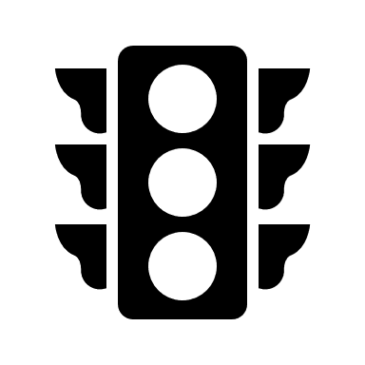 **Traffic light questions** – using the ‘Question by Type’ lists, go through each qestion and colour-code: **Green** = *I am confident about this question and could write it now*; **Amber** = *with some content and source revision I could write this answer*; **Red** = *I don’t know how to approach this question and need to revise it carefully and/or get some help*. This is a great technique when you are starting your revision as it highlights the areas you need to prioritise. Repeating this again at points in your revision is also a good idea to see how your knowledge is improving.
7. **Devise your own** – this works brilliantly if you are revising as a group or with someone else. Practice composing essay titles in the style of OCR, or, writing example interpretation paragraphs for the 20 mark question. Once you have done this, share your questions with your partner to plan. One step further is to also write the indicative content to go with this question.