**Timeline of the Julio-Claudian Dynasty**

**40 BC**

**AD 60**

**30 BC**

**10 BC**

**0**

**AD 10 BC**

**AD 20**

**AD 30**

**AD 40**

**AD 50**

**20 BC**

**Timeline of ROMAN BRITAIN**

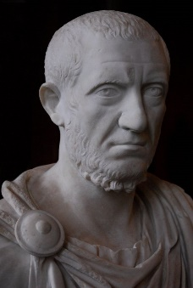

**TACITUS**

***Can you remember any other key sources or types of sources you used in the breadth topic?***

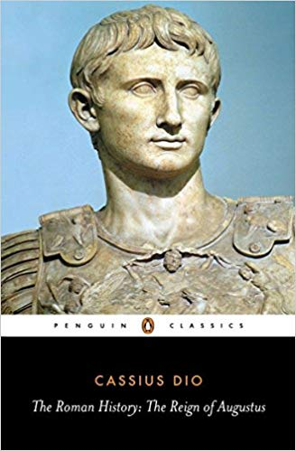

**DIO**

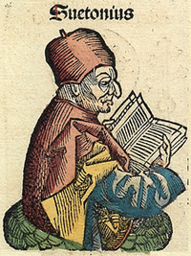

**SUETONIUS**