# Homework 5 Problem solving

# 1. Before a problem can be solved, it must be clearly defined. Suggest three aspects of the analysis that should be carried out in order to provide definition of the problem. [3]

# 2. An iterative or agile model is commonly used for project development.

# (a) Complete the development diagram below using the following headings. [6]

**Quick design**

**Refine prototype**

**Requirement gathering**

**Build prototype**

**Create final system**

**Customer evaluation**

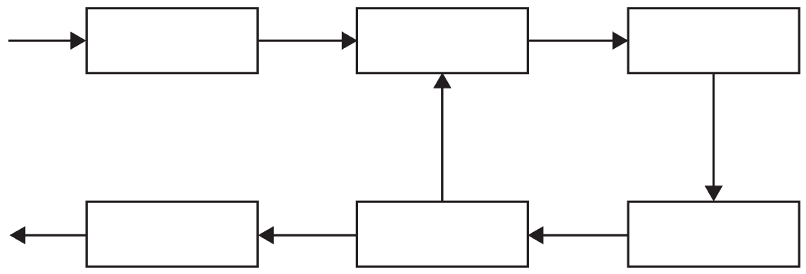

# (b) Suggest how this model may be applied to the creation and development of a new backing track for a music single. The track would involve the balance of percussion or rhythym, vocals and keyboard. [6]

Total 15 marks