# Worksheet 5 Problem solving

# 1. A simple, but addictive mobile game application is to be developed and launched. Users can post high-scores with their initials which are recorded for other users to see.

# What might the data requirements of the system be?

# How could the development of this application be divided into smaller, more manageable procedures?

# What potential future developments could be added to the application, and how could these ideas be future-proofed in order to save development time and cost at a later date?

# What problems might you have encountered with other, similar games or systems that this system could address?

2. The agile, iterative model below used for designing computer systems can be applied to various problems.

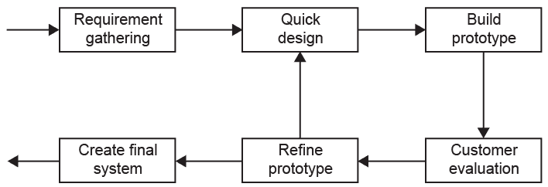

# Explain how each stage of the model might be applied by a chef and his or her team in the development of a new recipe.

# Describe the steps that might be involved in evaluating a new recipe.

# How would acceptance testing apply in this context?

# How might these principles apply to a computer system for a restaurant booking system?