# Artefacts

The references to AOs are from the marking criteria.

The elements the Exam Board need are:

PPF  
PAL  
Background Essay

Artefact

Evaluation

Presentation

## AO1 – Managing the project

This is much the same as for a dissertation or any other route.

**\*\*\*You MUST have a design brief that you refer back to as you develop your artefact.\*\*\***

Just like everyone else, you have a Project Proposal Form and a Project Log. Your mentor also notes how well you are keeping up to date.

To score well you need to have sensible timescales attached to producing each of the parts the Exam Board expects you to show evidence of. It is also important to refer back to your time plan and to say whether it is working or not. If it doesn’t work like you thought it would, you simply keep the original one and make a new time plan.

## AO2 -Research

For an artefact this is s different from a dissertation. There are **two** strands to the research.

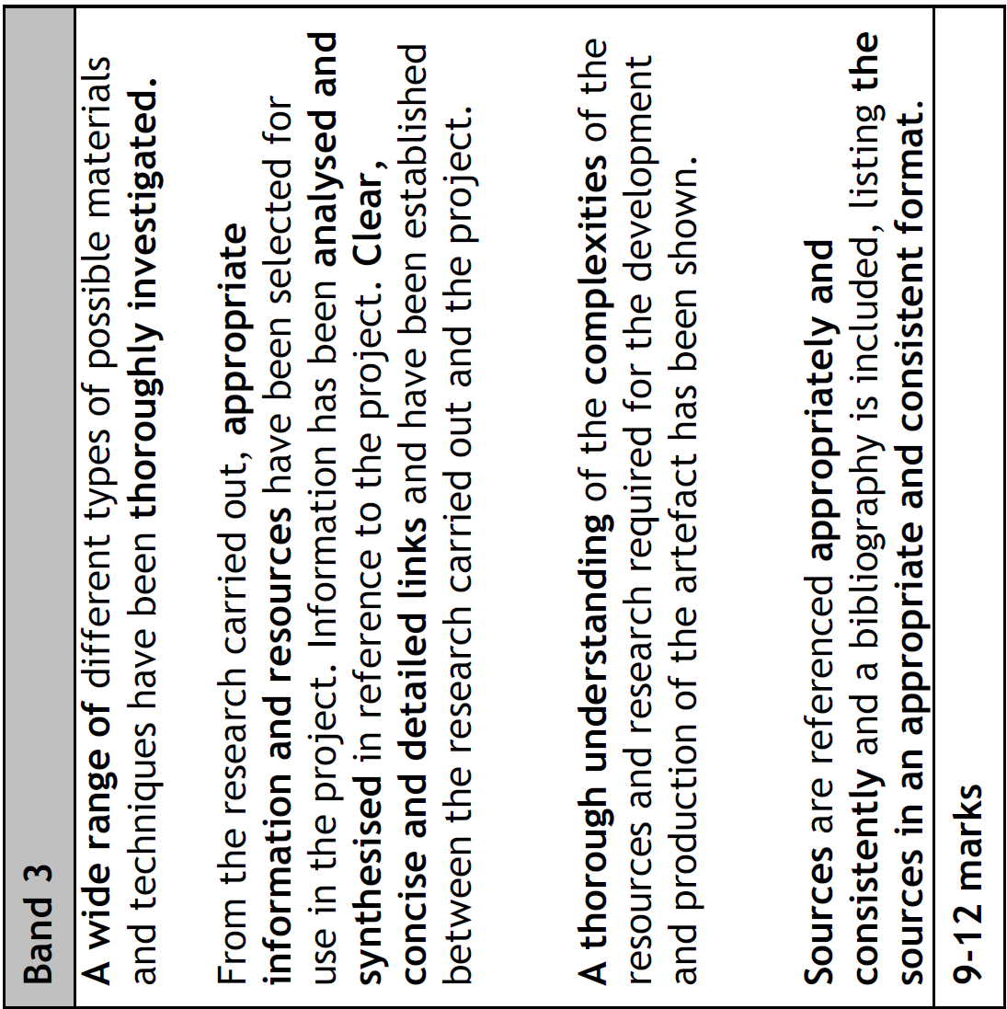

### **Written**

These are the things you read/watch that relate to the background essay. This background essay explores the influences behind the object you wish to make (e.g. guides on how to make short films, artists whose work you trying to incorporate elements of etc.). These should be in the Research Table. The essay you produce is much shorter than for a dissertation, but it must be referenced and have a bibliography.

#### E.g. Film

What have you watched and will take inspiration from for ways of filming/structure?

Whose work has elements you are going to try to incorporate and why?

#### E.g, Piece of artwork or similar

Which artists have work that will be relevant to what you want to make. What techniques did they employ that are relevant to your piece?

#### E.g, IT based project

Which pieces of software/programming languages could you use? Are there any examples of something similar – websites, Apps, security systems? Evaluate each of them and discuss how they are relevant to your project.

#### E.g, short story

What short stories/authors are going to influence what you write? Are there stylistic and linguistic conventions a short story should follow?

### **Practical**

The second much larger element is your exploration of the themes/techniques. There should be evidence that you have played with the ideas you are trying to put together. Your log should contain everything you have done and reflection on what is and is not working.

#### E.g. Film

What ideas have you considered using and do they really fit the brief you have?

What ideas have you tried out in practice – did they work?

#### E.g, Piece of artwork or similar

Sketchbook evidence of playing around with images/ techniques. Evaluation of each of the ideas you try out and how you are putting things together.

#### E.g, IT based project

Every step in creating the finished item should be documented, take screenshots for example – not just the final version. There should be evidence that you have played with the ideas you are trying to put together. Your log should contain everything you have done and reflection on what is and is not working.

#### E.g, short story

Every step in creating the finished item should be documented. A short story develops, it does not simply appear as a final version. Keep every draft you make. Annotate earlier versions. Explain what you are changing and why.

“**wide range**”

means looking at a lot of different material that could be relevant

“**thoroughly investigated**”

means that you have thought about how relevant each of the possible sources is both for your essay and for the possible filming methods and techniques you are considering using. You can record this information in both your log and in the essay.

“**appropriate information and resources**”

you need to show that you have selected things that fit with what you are trying to do and that you have identified the resources you need to have to create the artefact.

“**analysed and synthesised**”

means you’ve analysed sources for the elements you are going to use, recorded this somewhere, and that you have combined them into your piece.

“**clear, concise and detailed links**”

means that for every design decision you make you have gone back to the brief and discussed how the research relates to it.

“**thorough understanding**” of “**the complexities**”

means you show that you really understand how much research is required to underpin what you are doing and the resources needed to create the artefact and that you can do this at a complex level

“**sources** are referenced **appropriately and consistently**”

means you have credited any images you use, every time and referenced any information from written sources using an accredited system in your essay (see the referencing section in the EPQ Booklet)

“bibliography listing **the sources in an** **appropriate and consistent format”**

this is easiest to achieve if you use the Source Manager function in the Desktop version of Word. There is a guide to this on GOL. It is the same format as is needed for a dissertation.

## AO3 – Develop and Realise

For this part it should not only lead to an artefact that successfully fits the brief, but there must be evidence that you have thought about what you are doing and show that you have refined the piece from trying out techniques to a rough first draft to the final piece. It should also be very clear how you have used the elements you researched - particularly how you have synthesised and put them together.

**ALL the development** from start to finish should be there. A final piece on its own will not get you good marks. The journey from first design ideas e.g. sketches/first script draft etc. to the final piece must be visible.

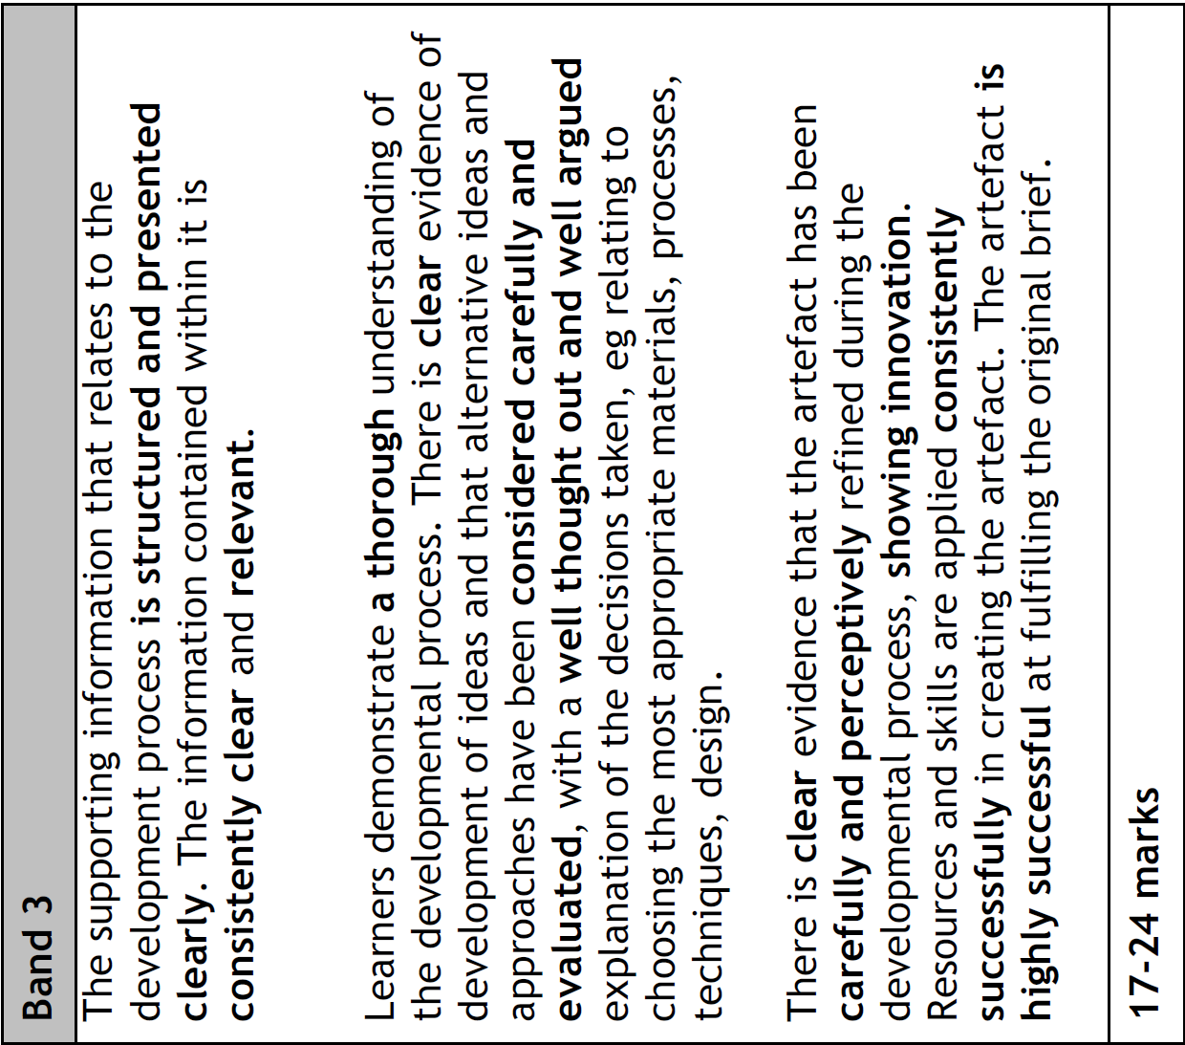

### E.g. Film

Create a storyboard for what you intend to film

If necessary, create a script – ensure you keep first drafts and later drafts, not just the final one. Ensure you explain what you are changing and why in your log. Annotate early script versions to indicate what you are changing and why.

Create a character sheet – what will each person be wearing and why, what kind of person are they?

Have a shoot schedule written down

Have location notes about where you intend to film

When you shoot the film

Very important - keep the bits you film as they were initially. You will need them for the final submission.

Create a first version of the final piece and keep it. This should be submitted.

Create further version(s) and ensure you explain what you are changing and why in your log. A final version will also be needed for the final submission.

### E.g. Piece of Artwork

Evidence that you have brought the different elements you tried out together in the piece you create.

Clear evidence that you have a succession of initial ideas in a sketchbook or similar, then bring them together in a final piece. There should be more than one version of that to show the refinement of the final piece.

### E.g, IT based project

Evidence that you have brought the ideas you researched together. Do not forget to document everything you do for it. The evidence should be clearly presented in a logical manner. Keep a development log. Ensure you relate all the decisions you make back to the design brief.

### E.g, short story

The development of the final piece is clearly documented. The ideas/influences can be clearly seen to have been integrated into the story and decisions clearly related to the design brief.

“**structured and presented clearly**”

your work showing how you developed your artefact should be in a logical sensible order and easily followed. This may be in a ‘sketchbook’ or a document and may also be in your log. The marker must be able to see what you did as you created the final artefact.

“**consistently clear and relevant**”

it is always obvious what you are doing and why, and always relates to the brief

“**thorough** understanding”

show that you really know how to develop your piece

“**clear** evidence”

every step in the development of your artefact has been recorded and shows careful thought.

“alternative ideas and approaches have been **considered carefully and evaluated**, with a **well-thought out and well-argued** explanation of the decisions taken, e.g. relating to choosing the most appropriate materials, processes, techniques, design”.

Each step has been assessed and evaluated – you’ve recorded what did/didn’t work and why you are choosing to do something a particular way. Also, don’t forget to make it clear how your choices relate to the design brief at every step.

“**carefully and perceptively**”, ”**showing innovation**”

it should be obvious that you have not just copied what you used to inspire you and lumped it together but have put it together in your own way in a careful manner showing you’ve been observant and understood how the elements fit together.

“The artefact is **highly successful** at fulfilling the original brief.”

It is clear how the finished piece relates to the original brief you had and how well it meets the criteria in the brief.

# AO4 - Review

This is the same for all the routes.

The **Evaluation** is your assessment of how well you coped with each of the aspects involved in producing all the parts of the EPQ.

There is a help for this on GOL in the form of questions you can answer to help you write it.

The **Presentation** is where you talk about your EPQ to an audience and answer questions. The assessment for this is all about your ability to communicate and to show your knowledge of the subject.

There is sample material for this on GOL.