**Geography Department**

**YEAR 2 - 3.2.1 Global Systems and Global Governance Summer Work**

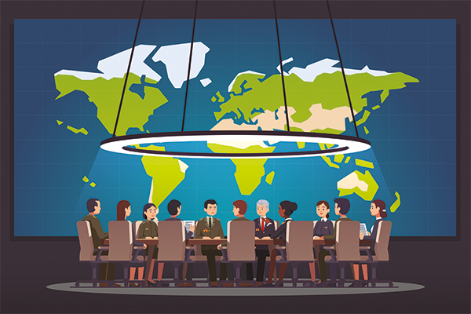

# 1. Introduction

This section of our specification focuses on **globalisation** – the economic, political and social changes associated with technological and other driving forces which have been a key feature of global economy and society in recent decades.

**Increased interdependence** and transformed relationships between peoples, states and environments have prompted successful attempts at a global level to manage and govern some aspects of human affairs.

# 2. Globalisation - What you need to know:

As part of this first section on Globalisation, you will be working towards the following learning outcomes:

1. To have a clear understanding of globalisation and its **interconnected** elements and **scales** of the global economy.
2. To appreciate that **globalisation has accelerated within your own lifetime**, driven by companies based in countries all over the world. It’s not just an assumed outcome of improved technology.
3. You will be able to discuss the **advantages and disadvantages of globalisation**.

## TASK 1: Globalisation is….

To understand the term globalisation and consider its impact on your lives – complete the following:

1. Where are your belongings are from?
2. Where was your recent or next planned holiday?
3. What music do you like and where is it from?
4. What is your favourite meal? Where does the food originate?
5. Are there any patterns?
6. Watch the clip on ‘Where do our clothes come from’: <https://timeforgeography.co.uk/videos-list/resource-management/where-do-our-clothes-come-from/>

How might the labels of where products are made be misleading?

## TASK 2: Produce a mind map poster (use the back page or a word document) detailing the global life/journey of a particular product - MUSIC

1. **Create an image** (include pictures /maps on your minds map) showing your connections to the rest of the world based on the music you listen to, using the following questions:

* What’s the origin of the most recent song or piece of music that you listened to? (Identify the nationality of the creator of the music as well as the tradition to which it belongs.)
* What technology do you most commonly use to listen to music?
* Where is the technology made? Where is the company that owns the technology based?
* How have you obtained music – online purchases or physically bought from retail outlets?

1. **Collect** some additional data from your family in relation to the music they listen to. Underneath your mind map make generalisations about any patterns in the data by answering the following two questions:
   * Do certain countries predominate in terms of musical choices and/or owning or making technology?
   * Which types of technology are most used? Is online or physical shopping more popular?
2. **Use** your mind map to discuss the following in your first lesson back: What is globalisation?

## TASK 3: News Headlines

**Think** of a current event featuring in headlines around the world. (Hint: politics, music, sport, film, celebrity culture, or disaster. Twitter might provide some ideas).

**Write** 500 words, in the **space** **below**, about the event using some of the following prompts: national identity, language, design, place of manufacture, origin of natural resources, cultural traditions, use of technology, history etc.

# 

# 3. Your Local Town

**Example: Godalming Town Centre: how local?**

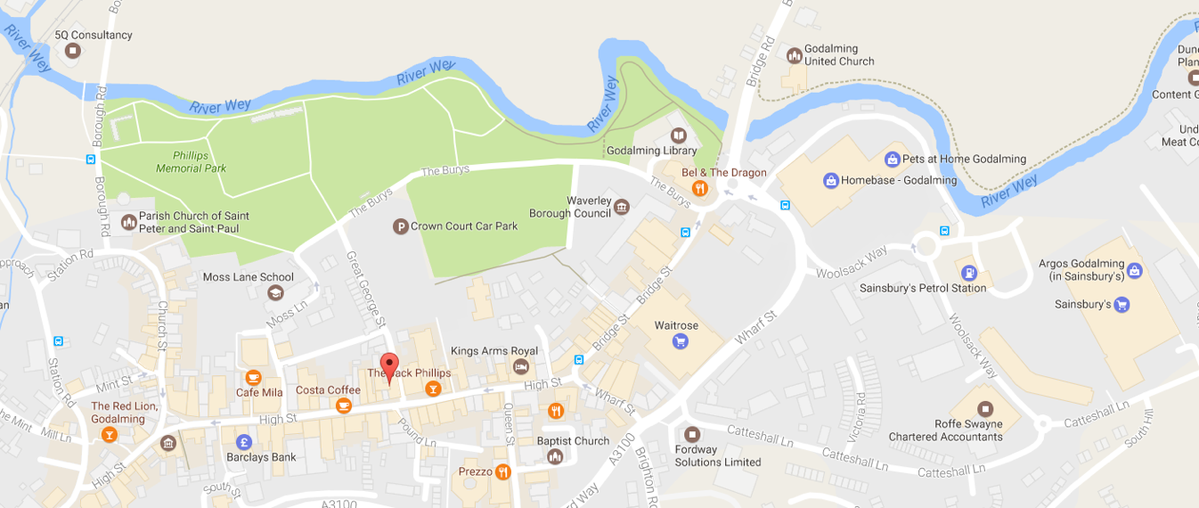

Source: <https://www.google.co.uk/maps/@51.1876812,-0.6089951,17z?hl=en>

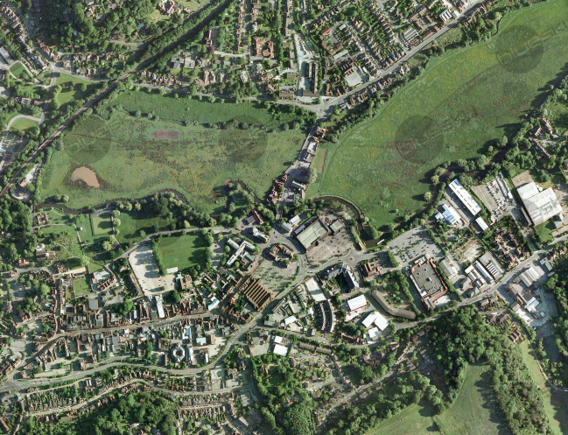

Image by Imagery ©2014 Infoterra Ltd & Bluesky, Map data ©2016 GoogleSource: <https://www.blueskymapshop.com/viewer/aerial-photography/aerial-photo-standard?x=497359&y=144089&z=2&w=500&h=500&f=&p=>[

## TASK 4: Research the extent of globalisation in your local area

You can ask geographical questions about globalisation….

**Fieldwork**: Take a walk or ‘virtual’ walk down Godalming or your local high street (you could use your clone town surveys from Changing Places fieldwork). Does it have chain stores, independent shops, are there signs of different cultures and languages? What are the immediate signs of globalisation in the local area? Are there any connections between your local area and the world (do some internet research or ask family and friends)? Record this and write a summary about your local area by answering the following question:

**To what extent is Godalming OR your local area truly local?**

## TASK 2: Space for Mind Map – MUSIC