**3.1 Biological Molecules: Proteins**

**Learning Objectives**

* Specification reference 3.1.4
* Know that amino acids are the monomers from which proteins are made, composed of an amine group, a carboxyl group and an R group bonded to a central carbon atom.
* Know that dipeptides are formed by the condensation of two amino acids, and polypeptides by the condensation of many amino acids, joined by peptide bonds.
* Know that a functional protein may contain one or more polypeptides.
* Understand that the 20 amino acids, common to all organisms, differ only in their R group.
* Recall the role of H bonds, ionic bonds and disulphide bridges in the structure of proteins.
* Understand the relationship between primary, secondary, tertiary and quaternary structure and protein function.
* Be able to relate the structure of proteins to the properties of proteins **named throughout the specification.**
* Recall the Biuret test for proteins.
* Understand how to use chromatography to identify amino acids in a mixture.

**What you should know from GCSE**

* Proteins are made of chains of amino acids which fold to produce a specific shape.
* The roles of proteins include enzymes, antibodies, hormones and as a structural component of muscle tissue.
* Chromatography can be used to separate mixtures and identify molecules within a mixture.

**Introduction**

Proteins are usually very large molecules. The types of carbohydrates and lipids in all organisms are relatively few and they are very similar. However each organism has numerous proteins that differ from species to species. The shape of one type of protein molecule differs from that of all other types of protein molecules. The word protein, a greek word, means ‘of first importance’ and proteins are extremely important in all living organisms, having a multitude of functions.

Start by watching the following video:

**Proteins, by Bozeman Science**

<https://www.youtube.com/watch?v=2Jgb_DpaQhM>

**What are proteins made of?**

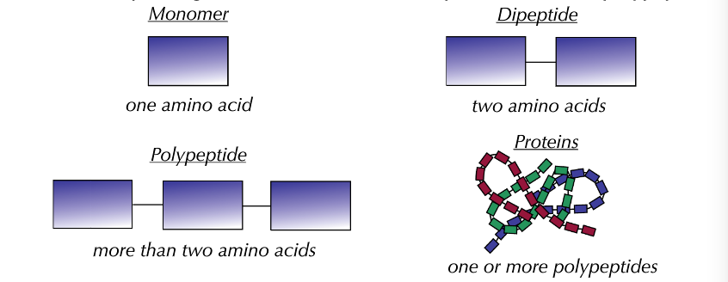

What elements are proteins made up of? ————————————————————

**Amino Acid Structure**

Draw the structure of an amino acid below and label the amine group, the carboxyl group and the R group.

How many different R groups are

there? -----------------------

How many different amino acids are there?

———————————

As polypeptides have many (usually hundreds) of the twenty naturally occurring amino acids joined in a different sequence, it follows that there is almost limitless number of possible combinations and therefore types of protein.

**Peptide Bonds**

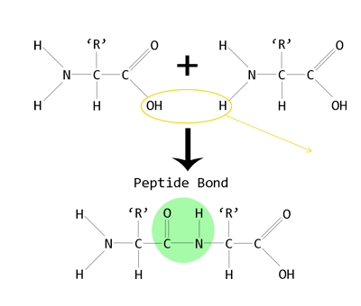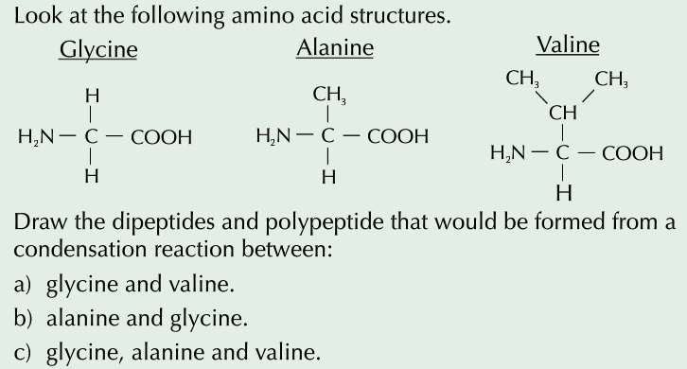

Formed between which groups?

--------------------------------------------

What type of reaction?

-----------------------------------------------

Between which two atoms does the peptide bond form?

-----------------------------------------------

What type of molecule is produced?

--------------------------------------------------

What is released through the reaction?

-------------------------------------------------

**Protein Structure**

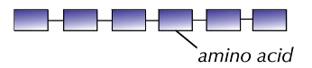

There are four levels of structure.

**Primary Structure**

The ——————————————-of amino acids in a polypeptide chain forms the **primary** structure. It is the primary structure of a protein that determines its ultimate shape and hence its function. A change in a single amino acid in the sequence can lead to a change in shape and may stop it from carrying out its function.

A functional protein may consist of a single polypeptide chain but more commonly a protein will consist of more than one polypeptide chain.

Do all proteins have secondary

structure? -----------------------------

Can proteins have both alpha helices and beta sheets in their structure?

--------------------------------------------

Which is the most common secondary structure?

--------------------------------------------

Label the Hydrogen bonds in the diagrams.

**Secondary Structure**

The linked amino acids that make up a polypeptide possess both amine and carboxyl groups on either side of the peptide bond. The H of the NH2 group has an overall positive charge while the O of the C=O group has an overall negative charge.

What bonds can form between these two groups? ————————————————

This causes the long polypeptide chain to be twisted into a 3D shape forming either an

——————————————————- or a ——————————————————

——————————————————————————————————————-.



**Tertiary Structure**

The alpha helices of the secondary protein structure can be further folded to give the complex and often specific 3D structure of each protein. This structure is maintained by a number of different bonds. These bonds include:

1.

2.

3.

Between which groups do the bonds form? ——————————————

Which is the strongest of the bonds? —————————————————

Which bonds are easily broken? ——————————————————-

Which bonds are extremely vulnerable to changes in pH? ——————————-

It is the 3D shape resulting from the tertiary structure that is important when it comes to how it functions. It makes each protein distinctive and allows it to recognise and be recognised by other molecules. The diagram below shows a hypothetical protein with different levels of protein structure. Label a part that shows an **alpha helix**, a part that shows a **beta pleated sheet**, a part that shows **primary structure** and parts that represent the **peptide bond;** **hydrogen bond of secondary structure; hydrogen bond of tertiary structure; ionic bond; and disulphide bridge** (bond). Label the C-terminus and the N-terminus of this hypothetical protein.

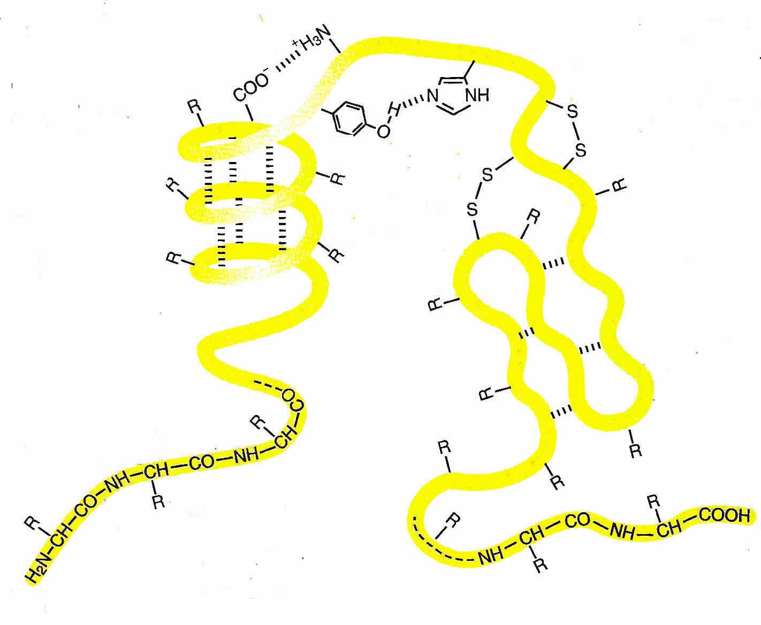

**Quaternary Structure of Proteins**

Some proteins are made up of several different polypeptide chains held together by bonds that are similar to those found in the tertiary structure. Proteins that are made from **more than one** polypeptide chain are said to have quaternary structure.

Haemoglobin has quaternary structure and is described as a **globular** protein. How would you describe its shape?

—————————————————————

How many polypeptide chains does it have?

————————————————————-

It also has a non protein group associated with it (**prosthetic group**). What is it called and what element does it contain?

—————————————————————

What is the function of haemoglobin?

—————————————————————-

—————————————————————-

—————————————————————-



**Protein Shape and Function**

Proteins have many different roles in living organisms. Their role depends upon their molecular shape, which can be of two different types.

1. **Fibrous** proteins, such as **collagen**, have **structural** functions.
2. **Globular** proteins such as **enzymes** and **haemoglobin** carry out **metabolic** functions.

The diagram to the left shows the structure of the collagen molecule. Collagen is the most abundant protein in the human body. It is regarded as the substance that holds the whole body together and can be found in the bones, muscles, skin and tendons. Tendons join muscles to bones. When a muscle contracts the bone is pulled in the direction of the contraction.

**Research the structure of collagen and on the next page write short notes on how the structure of collagen and its shape is related to its function. Why is it described as a fibrous protein?**



Notes on Collagen (Include information on primary, secondary, tertiary and quaternary structure using drawings to help you and check you have met the brief)

Now choose a **named globular protein**, **other than haemoglobin or an enzyme**, and research it and write short notes below on how its structure is related to its function.

**The Biuret Test for Proteins**

