**3.1.4.2 Many proteins are Enzymes**

**Learning Objectives**

* Appreciate that enzymes catalyse a wide range of intracellular and extracellular reactions that determine structures and functions from cellular to whole organism level.
* Know that each enzyme lowers the activation energy of the reaction it catalyses.
* Appreciate how models of enzyme action have changed over time.
* Recall the induced-fit model of enzyme action.
* Understand the specificity of enzymes.
* Know how the properties of an enzyme relate to the tertiary structure of its active site and its ability to combine with complementary substrate (s) to form an enzyme-substrate complex.

**What you should know from GCSE**

* The kinetic theory of states of matter.
* Temperature is a measure of the average kinetic energy that particles within a system are moving/vibrating with.
* The shape of an enzyme is vital to its function in speeding up chemical reactions. Enzymes are affected by temperature and pH.
* The use of enzymes in the body during digestion, protein synthesis and respiration.
* The use of enzymes industrially and within the home, including the advantages and disadvantages of using enzymes.
* The calculation of rate and the factors that affect the rate of chemical reactions.
* Evaluation of the use of catalysts in industrial processes.

**Preparatory Work**

1. Watch the video on BBC Bitesize on enzymes to recap your GCSE knowledge

<http://www.bbc.co.uk/bitesize/standard/biology/revision_videos/enzymes/video/>

2. Read the article entitled **Enzymes Fast and Furious by Dianne Gull,** originally published in Biological Sciences Review, Vol 6, No.2 pp 26-29.

Answer the questions that follow.

3. Define the following terms

| **Term** | **Definition** |
| --- | --- |
| Metabolism |  |
| Anabolic Reaction |  |
| Catabolic Reaction |  |
| Catalyst |  |
| Activation Energy |  |
| Enzyme |  |
| Substrate |  |
| Active site |  |
| Intra/extracellular |  |
| Metabolic Pathway |  |
| Denatured |  |

**Naming Enzymes**

Recommended Names:

Systematic Names:

What type of proteins are enzymes?

--------------------------------------------

What level of structure do they have?

----------------------------------------------

Why are enzymes specific for one reaction only?

------------------------------------------------

How is the substrate held onto the enzyme?

--------------------------------------------------

**The structure of enzymes**

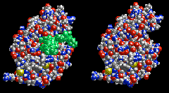

**Chemical reactions**

For a chemical reaction to take place there are three conditions that must be satisfied:

1. The reactant molecules must —————-with sufficient energy to alter the arrangement of their atoms to form products.

<http://www.kscience.co.uk/animations/anim_2.htm>

1. The energy of the products must be lower than that of the reactants.
2. ——————————— - ——————————— must be supplied, often in the form of heat.

**Enzymes act by lowering the activation energy of chemical reactions**

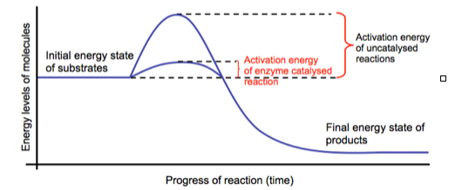How do enzymes lower the activation energy of a reaction?

1. —————————————————————————————————————

————————————————————————————————————-

2. ————————————————————————————————————

—————————————————————————————————————

* Alternatively the enzyme can make the local conditions inside the active site quite different from those outside (pH, water concentration, charge, for example) so that the reaction is more likely to happen.

Why is it important in living organisms that the activation energy is lowered?

———————————————————————————————————————

* The rate of reaction is a measure of how fast the reaction is occurring. It can be considered as the number of reactions per second.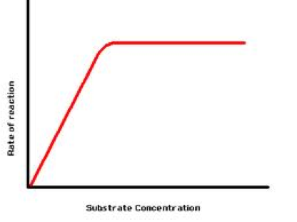

Enzymes have an optimum rate for a given set of conditions.

Why does the rate of reaction increase as the substrate concentration increases?

————————————————————

————————————————————

Reaction Mechanism

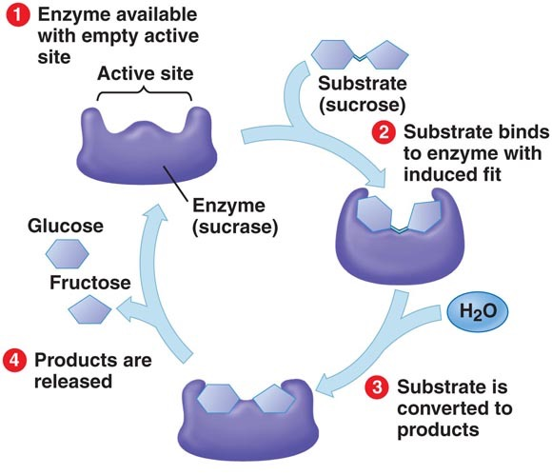







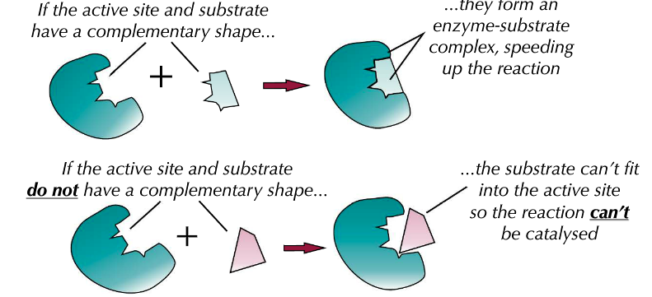

* Enzymes lower the activation energy by forming enzyme-substrate complexes.
* The enzyme substrate complex can be formed because the shape of the active site and the substrate are complementary to each other.

**Models of enzyme action**

**The Lock and Key model**

One earlier model of enzyme action proposed that enzymes work in the same way as a key operates in a lock - each key has a specific shape that fits and operates only a single lock. In a similar way, a substrate will only fit the active site of one particular enzyme.

The limitation of this model is that the enzyme, like the lock, is considered to be a rigid structure. However scientists had observed that other molecules can bind to enzymes at sites other than the active site. In doing so they altered the activity of the enzyme. This suggested that the enzyme’s shape was being altered by the binding molecule. In other words, its structure was not rigid but flexible.

**The Induced Fit Model**

How does this model differ to the lock and key model?

————————————————————————————————————————

————————————————————————————————————————

————————————————————————————————————————

Hexokinase

Go to the following site:

<http://molvisual.chem.ucsb.edu/ABLE/induced_fit/index.html>

Hexokinase is an enzyme that catalyses the ATP dependent phosphorylation of glucose to glucose -6-phosphate. This is one of the reactions that take place during the process of respiration.

Write the word equation for the reaction below:

Watch the induced fit movie in figure 2 and figure 5. It shows how hexokinase changes its conformation in response to the substrate entering the active site to activate it.

What is the name of the substrate? ——————————————————-

What is the name of the second molecule involved in the reaction that will be used to phosphorylate glucose?

——————————————————————-

* The induced fit model helps to explain why enzymes are so specific and only bond to one particular substrate. The substrate doesn’t only have to fit the active site, it has to make the active site change in the right way as well.

**Measuring Enzyme activity**

We can measure the rate of reaction in two ways:

1) the appearance of product over time

2) the disappearance of reactants over time

**A chemical reaction proceeds when molecules with sufficient kinetic energy,**

**collide**, and react. Initially, product is formed at a high rate as there are plenty of **substrate** molecules to fit the **active sites. The amount of substrate decreases as it is broken down, resulting in an increase in product.**

As substrate molecules become scarce, the rate of product formation slows down. It becomes more and more difficult for substrate molecules to come into contact with enzyme molecules and also product molecules get in the way of substrate molecules and prevent them for reaching an active site. Eventually product formation levels out when all of the substrate has been converted to **product. Note that at this point all of the enzyme molecules are still available for re use.**

**Estimating the initial rate of a reaction**

You can use a tangent to estimate the initial rate of reaction from a graph. The initial rate of reaction is the rate of reaction right at the start of the reaction where time is zero. To work out the initial rate of reaction carry out the following steps:

1. Draw a tangent to the curve at time zero, using a ruler.
2. Calculate the gradient of the tangent.
3. Work out the units for rate (divide the units of the y axis by the x axis)

Worked example

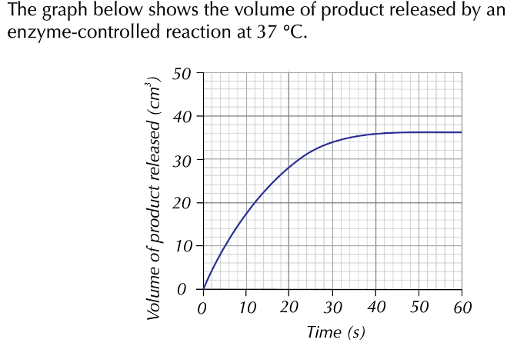

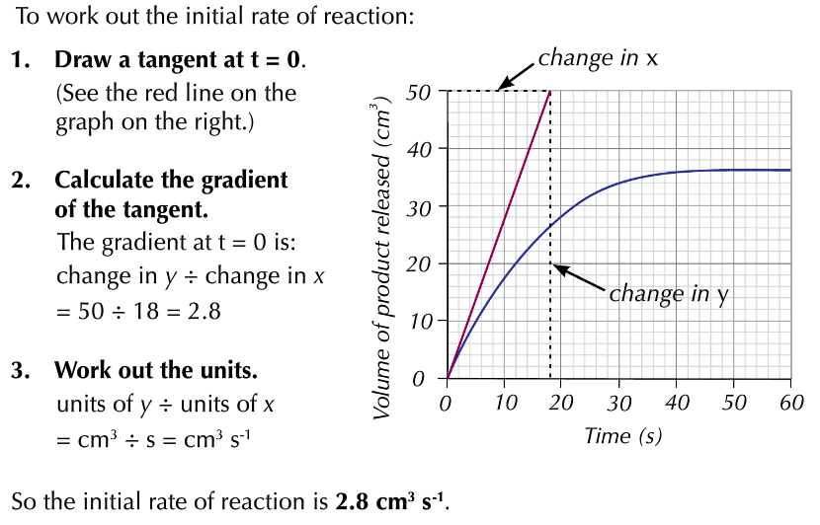

Question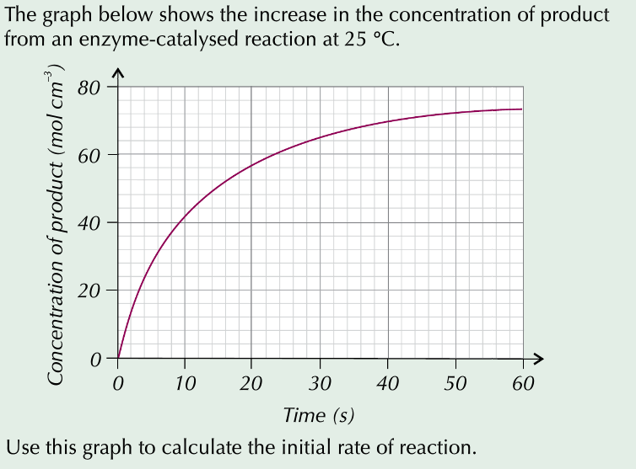

**Factors affecting Enzyme action**

Temperature

y

Temperature at which enzyme works best (optimum)

**Temperature/ 0C**

Increased kinetic energy increases collisions

**A**

**B**

Enzyme is denaturing due to vibration

**Rate of Reaction**

0

40

50

30

20

10

60

|  |  |
| --- | --- |
| **Region A on the Graph** | **Region B on the Graph** |
| **Description:**  As the temperature increases from 0 oC to 40 oC, the rate of reaction increases. At 40 oC, it reaches its maximum rate of reaction (y) | **Description:**  As the temperature increases above 40 oC, the rate of reaction decreases until at 57 oC the rate of reaction is zero. |
| **Explanation:**   * Increasing the temperature provides   more heat energy   * This gives both the enzyme and the   substrate more kinetic energy.   * Both enzyme and substrate move faster. * This results in more collisions * More enzyme-substrate complexes are   Formed   * The rate of reaction is increased. | **Explanation:**   * High temperatures result in more kinetic   energy being given to the enzyme and  substrate.   * The enzyme molecules vibrate more as   the kinetic energy increases.   * The bonds holding the tertiary structure   of the protein break.   * This changes the shape of the enzyme * The active site changes shape * The substrate can no longer fit * There is less / no reaction occurring * We say the enzyme has been denatured. |

pH



|  |  |
| --- | --- |
| **Region A on the Graph** | **Region B on the Graph** |
| Description:  At pH of 7.0, there is a maximum rate of reaction (y); pH 7.0 is optimum FOR THIS ENZYME | Description:  As the pH moves away from the optimum, the rate of reaction decreases. Below pH5.7 and above pH 8.3 there is no reaction |
| Explanation:   * A solution of the optimum pH has a   a number of hydrogen ions in it which  does not disrupt the ionic bonding of  this enzyme.   * No change in the shape of the enzyme * No change in the shape of the active site * Substrate can fit * Enzyme-substrate complexes are formed * Rate of reaction is maximum | Explanation:   * Change in pH has disrupted the ionic   Bonding in the tertiary structure by  altering the charges on the amino acids that make up the active site.   * This changes the tertiary shape of the   protein   * The shape of the active site is changed * The substrate cannot fit * Enzyme substrate complexes not formed * Reaction rate is reduced / none |



pH 7 pH > 7 pH > 7

**Rate of Reaction**

y

pH at which the enzyme functions best (optimum)

5

6

7

8

9

10

**A**

**B**

**B**

Enzyme is denaturing

Enzyme is denaturing

**pH**

Substate Concentration

V max – maximum rate of reaction

x

**Reaction rate**

y

**Substrate concentration**

**B**

Substrate concn. is

limiting

Enzyme concentration is limiting

**A**

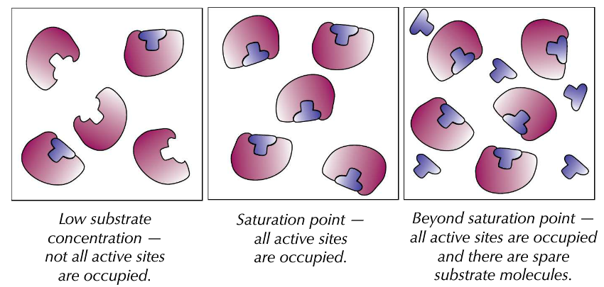

|  |  |
| --- | --- |
| **Region A on the Graph** | **Region B on the Graph** |
| **Description:**  Rate of reaction increases as the substrate concentration increases until substrate concentration X. At substrate concentration X there is a maximum rate of reaction y. | **Description:**  As the substrate concentration increases above X, the rate of reaction remains constant at its maximum y. |
| **Explanation:**   * The more substrate molecules present,   the greater the chance of collision with  the enzyme   * More collisions so more enzyme –   substrate complexes formed.   * Increased rate of reaction * Substrate concentration is limiting | **Explanation:**   * Increasing substrate concentration has   no effect on reaction rate.   * All the enzyme’s active sites are occupied * Enzymes are working at maximum   turnover rate   * Enzyme concentration is limiting |

Enzyme Concentration

**Reaction rate**

y

**Enzyme concentration**

x

**Normally** there is excess substrate so the rate continues to rise as enzyme concentration is increased

Substrate is limiting, rate levels off.

Enzyme is limiting

**B**

**A**

|  |  |
| --- | --- |
| **Region A on the Graph** | **Region B on the Graph** |
| **Description:**  Rate of reaction increases with increased enzyme concentration | **Description:**  Rate of reaction levels of as enzyme concentration increases beyond concentration x |
| **Explanation:**   * More enzymes so more active sites * More enzyme-substrate complexes   formed   * More products formed * Rate of reaction increased * Limiting factor is enzyme concentration | **Explanation:**   * All substrate molecules have formed   enzyme-substrate complexes   * Limiting factor is substrate concentration |

**Enzyme inhibition**

Enzyme inhibitors are substances that directly or indirectly interfere with the functioning of the active site of an enzyme and so reduce its activity.

There are two key types shown in the diagram below:

1. Competitive inhibitors that bind to the active site of the enzyme.
2. Non competitive inhibitors that bind to the enzyme at a position other than the active site.

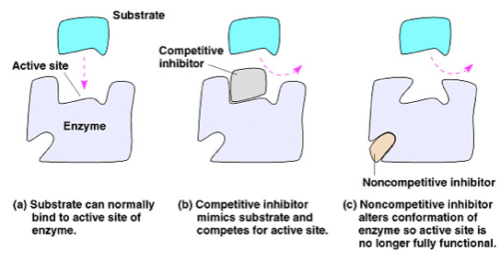

Competitive inhibitors

* Have a molecular shape that is ————————- to that of the ———————-
* Compete with the substrate for available active sites.
* Effect on enzyme activity depends on the ——————————- of the inhibitor and substrate.
* The inhibitor does not —————— to the active site and so when it leaves another molecule can take its place.

Non Competitive Inhibitors

* Attach themselves to the enzyme at the ——————————— site.
* Upon attaching to the enzyme they change the —————— of the active site so that further substrate molecules cannot enter and form —————— ————————— complexes.
* As the substrate and inhibitor are not —————————— for the active site, an increase in substrate concentration does not decrease the effect of the inhibitor.

**Choose from the following words to fill the gaps: competing, shape, bind, enzyme-substrate, similar, allosteric, concentration, substrate.**

You should be able to draw and interpret graphs showing the effect of inhibitors on enzyme activity.



Comparison of Inhibitors

| **Differences** | **Competitive** | **Non Competitive** |
| --- | --- | --- |
| Shape of molecule |  |  |
| Site on enzyme |  |  |
| Effect of increasing inhibitor conc. |  |  |
| Effect of increasing substrate conc. |  |  |

**Control of metabolic Pathways**

A metabolic pathway is a series of reactions in which each step is catalysed by an enzyme. Cells have evolved to use the products of their own reactions for feedback inhibition of enzyme activity. Feedback inhibition involves the use of a reaction product to regulate its own further production



In the example below, describe the events shown in the diagram using the following key words: substrate, enzyme, collision, active site, complementary shape, enzyme substrate complex, product, allosteric site, non competitive inhibition.

————————————————————————————————————————

————————————————————————————————————————

————————————————————————————————————————

————————————————————————————————————————

————————————————————————————————————————

————————————————————————————————————————

————————————————————————————————————————

————————————————————————————————————————

**Understanding how enzymes work and how they can be regulated is a key principle behind the development of many of the pharmaceutical drugs.**

Statins

The end product of a metabolic pathway known as the mevalonate pathway, produces cholesterol. Statins are medicines used to treat high cholesterol levels.

Explain below how they work to reduce cholesterol (you will need to do some independent research to help you).

————————————————————————————————————————

————————————————————————————————————————

————————————————————————————————————————

————————————————————————————————————————

————————————————————————————————————————

————————————————————————————————————————

————————————————————————————————————————

————————————————————————————————————————

**Exam Tip**

