**3.1.5 Nucleic Acids are important information carrying molecules**

**3.1.5.1 Structure of DNA and RNA**

**Learning Objectives**

* Understand that Deoxyribonucleic acid (DNA) and Ribonucleic acid (RNA) are important information carrying molecules. In all living cells, DNA holds genetic information and RNA transfers genetic information from DNA to the ribosomes,
* Know that ribosomes are formed from RNA and proteins.
* Know that both DNA and RNA are polymers of nucleotides.
* Know that a condensation reaction between two nucleotides forms a phosphodiester bond.
* Recall that the DNA molecule is a double helix with two polynucleotide chains held together by hydrogen bonds between specific complementary base pairs.
* Know that an RNA molecules is a relatively short polynucleotide chain.
* Appreciate that the relative simplicity of DNA led many scientists to doubt that it carried the genetic code.

**What you should know from GCSE**

* DNA holds the genetic information for our features and characteristics.
* Chromosomes are made of DNA which has a double helix structure.
* DNA is contained within the nucleus of cells.

**Preparatory Work**

1. Watch the following **Ted Talk by James Watson; How we discovered DNA (2005)**

<http://www.ted.com/talks/james_watson_on_how_he_discovered_dna/transcript?language=en>

Biography of James Watson extracted from the TED website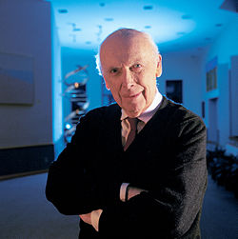

* James Watson has led a long, remarkable life, starting at age 12, when he was one of radio's high-IQ Quiz Kids. By age 15, he had enrolled in the University of Chicago, and by 25, working with Francis Crick (and drawing, controversially, on the research of Maurice Wilkins and Rosalind Franklin), he had made the discovery that would eventually win the three men the Nobel Prize.
* Watson and Crick's 1953 discovery of DNA's double-helix structure paved the way for the astounding breakthroughs in genetics and medicine that marked the second half of the 20th century. And Watson's classic 1968 memoir of the discovery, The Double Helix, changed the way the public perceives scientists, thanks to its candid account of the personality conflicts on the project.
* More than 50 years later he continues to investigate Biology’s deepest secrets.

2. Now watch **The DNA double Helix Discovery - HHMI Biointeractive video**: <https://www.youtube.com/watch?v=1vm3od_UmFg> and answer the Quiz questions that follow on the next page.

3. Finally, use the text book **Advanced Biology for You,** pages 100-102 and 107 to make your own notes on nucleic acids.You should include the following:

Nucleic Acids

* The name of the two types of nucleic acid.
* The name of the monomer and polymer for nucleic acids.
* A labelled diagram of a nucleotide.
* Purines and Pyramidines (structure, names of bases).
* The type of reactions that form polynucleotide chains.
* Diagram of a polynucleotide chain (page 100).

DNA

* Diagram of DNA (page 101, left hand side of page).
* Double helical structure.
* Hydrogen Bonding.
* Chargaff rule of complementary base pairing.
* Anti parallel nature of the molecule.

RNA

* The different types.
* The roles of the different types.

Use your notes to complete the table below

|  | DNA | RNA |
| --- | --- | --- |
| Number of strands |  |  |
| Name of pentose sugar |  |  |
| Names of nitrogenous bases |  |  |
| Number of different types |  |  |
| Location in cell |  |  |
| Relative length |  |  |
| Lifespan |  |  |
| Function |  |  |

**3.1.5.2 DNA Replication**

**Learning Objectives**

* Understand that the semi-conservative replication of DNA ensures genetic continuity between generations of cells.
* Understand the process of semiconservative replication (unwinding of the double helix, breakage of H bonds, role of DNA helicase, attraction of new nucleotides to exposed bases, role of DNA polymerase in the condensation reaction that joins adjacent nucleotides.
* Be able to evaluate the work of scientists in validating the Watson-Crick model of DNA replication

**Introduction**

The cells that make up organisms are always derived from existing cells by the process of cell division. Cell division occurs in two main stages:

* Nuclear Division is the process by which the nucleus divides.
* Cytokinesis follows nuclear division and is the process by which the whole cell divides.

Before a nucleus divides its DNA must be replicated (copied). This is to ensure that all of the daughter cells have the genetic information to produce enzymes and the other proteins they need.

The process of DNA replication is very precise to ensure that daughter cells are identical to parent cells.

**Semi-Conservative replication**

For semi-conservative replication to take pace there are four requirements:

1. The four types of —————————-, each with their bases of adenine, guanine, cytosine or thymine must be present.
2. Both strands of DNA act as a —————————
3. The enzymes DNA ———————- and DNA —————————————— must be present.
4. A source of —————————————— is required to drive the process.

**The process is shown in the diagrams on the next page. Spend some time looking at the process and then see if you can draw and annotate the series of diagrams yourself.**

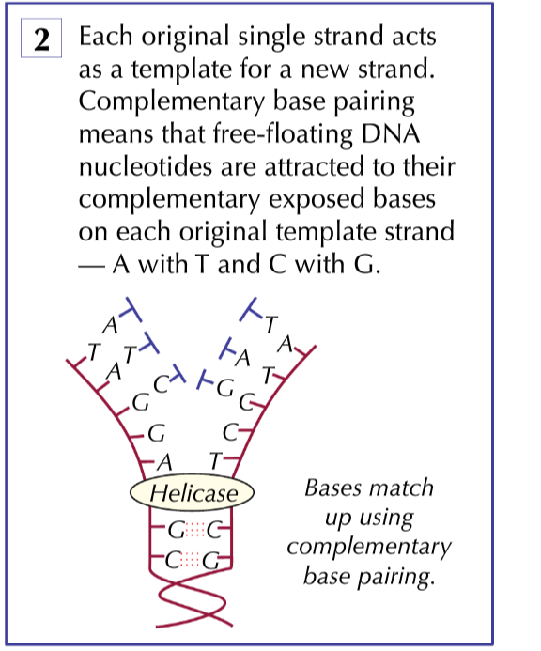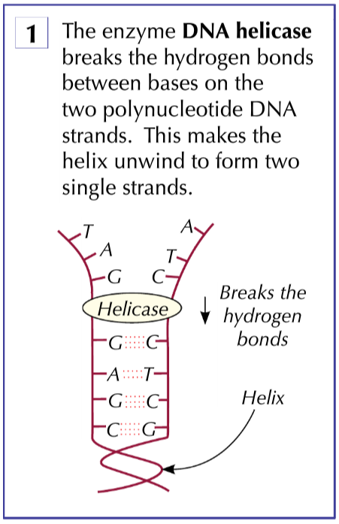

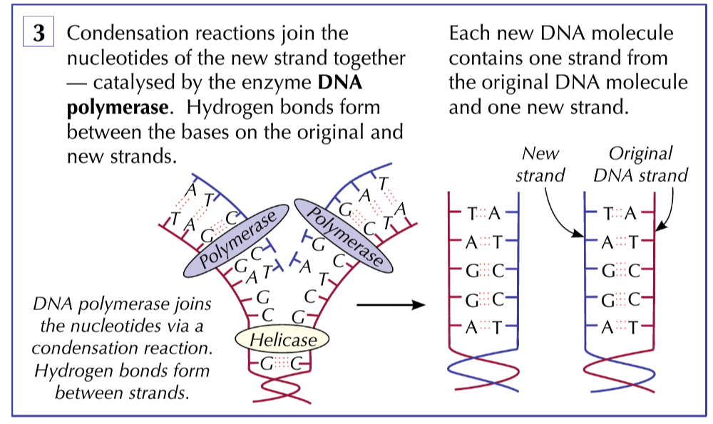

**The Action of DNA polymerase**

Recall the antiparallel nature of DNA. One end is called the 3’ end and the other end is called the 5’ end.

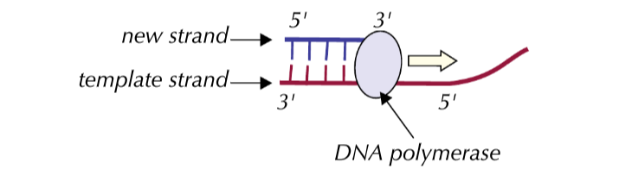

During replication the active site of DNA polymerase is only complementary to the 3’ end of the newly forming DNA strand, so it can only add nucleotides to the new strand at the 3’ end. This means the enzyme can only add nucleotides to the new strand at the 3’ end. Thus the new strand is made in the 3-5 direction.

Because both strands in DNA are antiparallel, the DNA polymerase works in different directions on each strand.

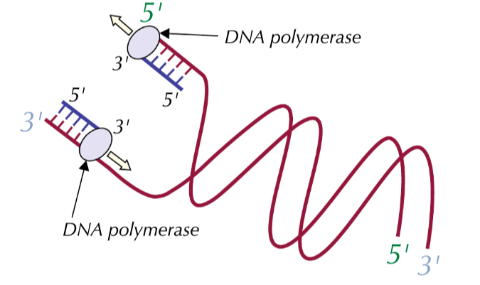

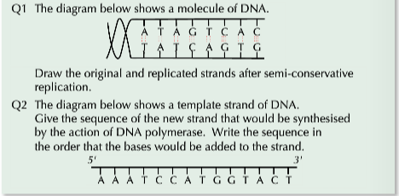

**Consolidation videos**

1. Crash Course: <https://www.youtube.com/watch?v=8kK2zwjRV0M> for structure of DNA and replication DNA
2. Wiley:http://[www.wiley.com/college/pratt/0471393878/instructor/animations/dna_replication/index.html](http://www.wiley.com/college/pratt/0471393878/instructor/animations/dna_replication/index.html)for DNA replication
3. <http://www.sumanasinc.com/webcontent/animations/content/meselson.html>

for Meselson - stahl

4. Build a DNA molecule at Learn Genetics Utah website.