**3.1.6 ATP**

**Learning Objectives**

* Understand that a single molecule of adenosine triphosphate (ATP) is a nucleotide derivative and is formed from a molecule of ribose, a molecule of adenine and three phosphate groups.
* Know that hydrolysis of ATP to adenosine diphosphate and an inorganic phosphate group, is catalysed by the enzyme ATP hydrolase.
* Understand that the hydrolysis of ATP can be coupled to energy requiring reactions within cells.
* Know that the inorganic phosphate released during the hydrolysis of ATP can be used to phosphorylate other compounds often making them more reactive.
* Know that ATP is re synthesised by the condensation of ADP and Pi.
* Understand that this reaction is catalysed by the enzyme ATP synthase during photosynthesis or during respiration.

**What you should know from GCSE**

* Respiration releases energy
* Energy from respiration is used for for movement, protein synthesis, synthesis of amino acids in plants and maintenance of body temperature.

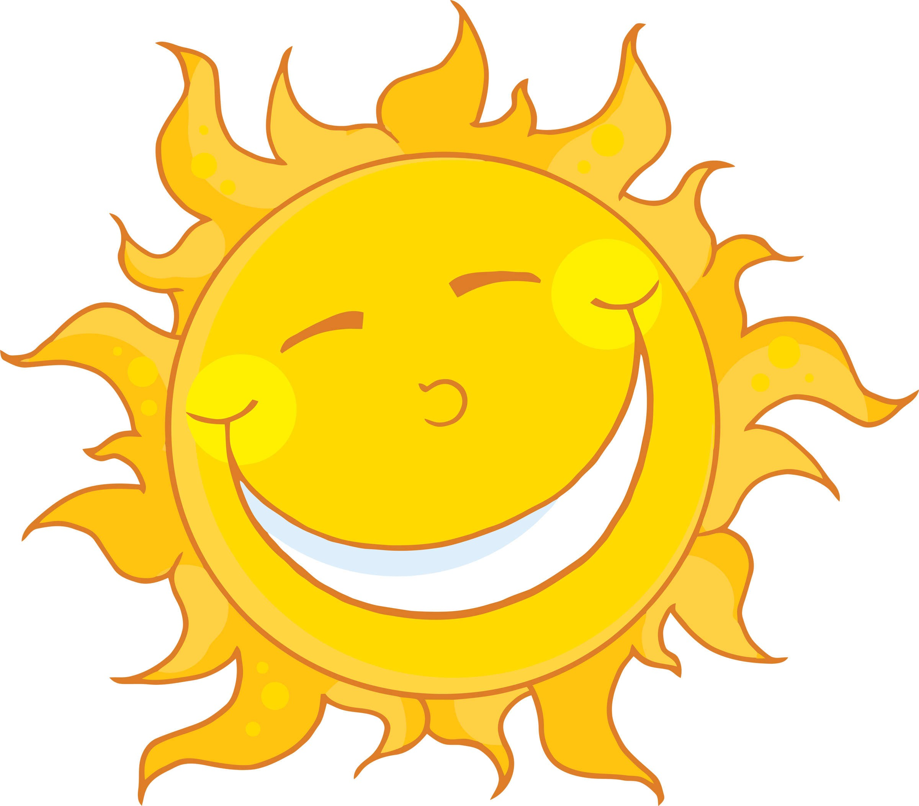

**Introduction**

All living organisms require energy in order to remain alive. This energy comes initially from the sun. Plants use solar energy to combine water and carbon dioxide into complex organic molecules through photosynthesis.

Write the chemical equation for photosynthesis below.

———————————————————————————————————————

Living things store energy mainly in the form of chemical bonds.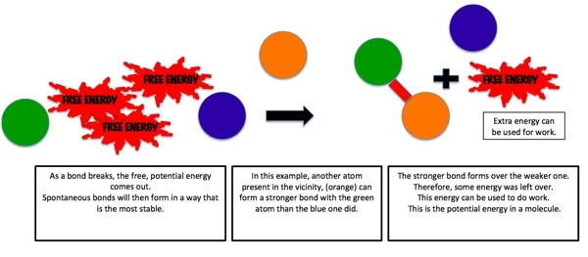

Within your cells, energy is constantly moved around from one large molecule to another. The energy from the food you eat is released in a process called respiration. Write the chemical equation for respiration below.

———————————————————————————————————————-

How does the energy get converted from a food molecule to a muscle molecule? The answer is ATP. Write the full name of ATP below.

——————————————————————————————————————-

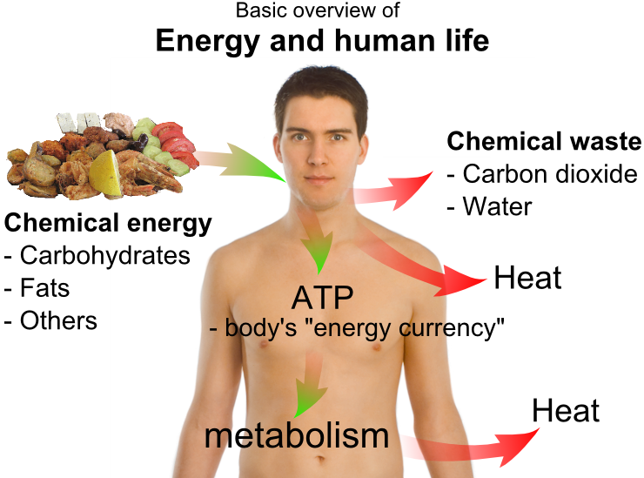

ATP is often described as the universal energy currency for organisms. Explain why.

———————————————

———————————————-

———————————————

———————————————-

———————————————-

———————————————-

**Structure of ATP**

Watch the following video from Bozeman on ATP and use it to fill in the next page of the booklet.

<https://www.youtube.com/watch?v=5GMLIMIVUvo>

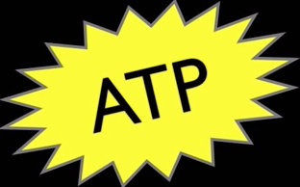

Why is ATP often shown with a yellow star shape around it?

——————————————————————

——————————————————————

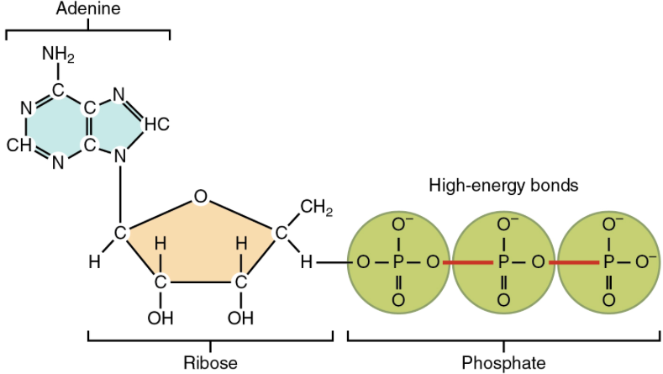

The ATP molecule is composed of adenine, ribose and three phosphate groups.

What type of molecule is adenine?

—————————————————————

What type of molecule is ribose?

—————————————————————

Together, what are adenine and ribose referred as?

—————————————————————

What does the structure of ATP remind you of?

————————————————————-

What two elements are the phosphate group

composed of? ————————————-.

Pi should remind you that phosphate contains both phosphorous and oxygen.

Draw a simplified diagram of ATP below.

Using the diagram of ATP to help you, write the names of the two molecules below.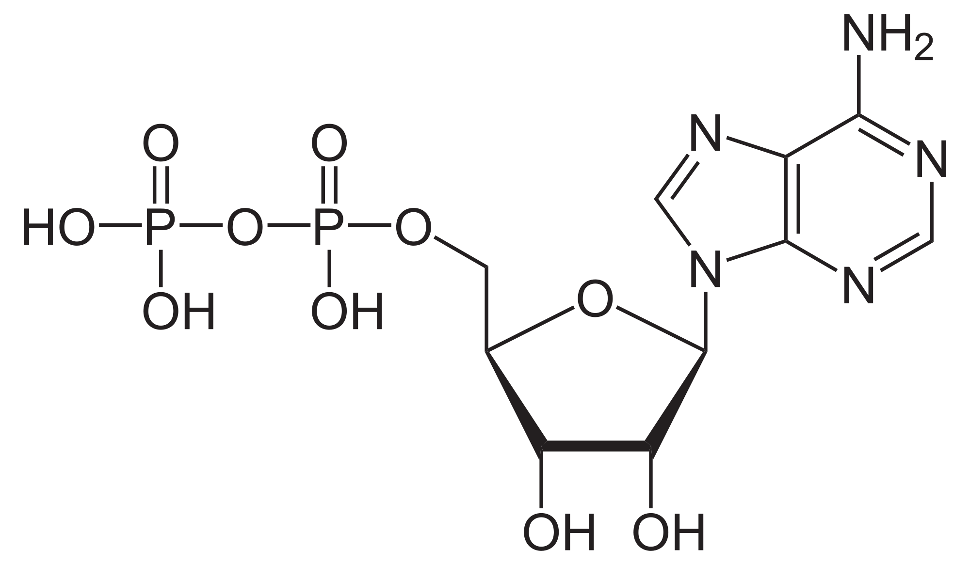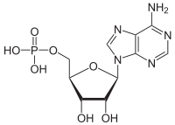

——————————————— ————————————————

Bozeman refers to ATP as being similar to a charged battery. Look at the animation at the following website; Dr Saul’s Biology in motion:

<http://www.biologyinmotion.com/atp/>

Dr Saul describes ATP as a rechargeable battery.

Describe what the diagrams show.

————————————————————

———————————————————-

———————————————————-

———————————————————

———————————————————-

———————————————————-

———————————————————-

———————————————————-

————————————————————

———————————————————-

———————————————————-

———————————————————

———————————————————-

———————————————————-

———————————————————-

———————————————————-

———————————————————-

————————————————————

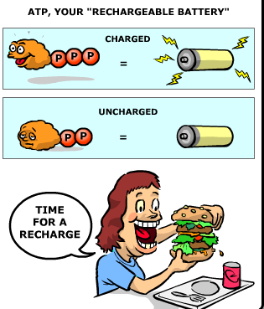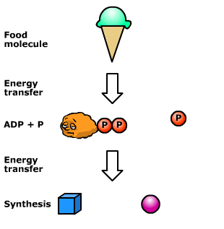

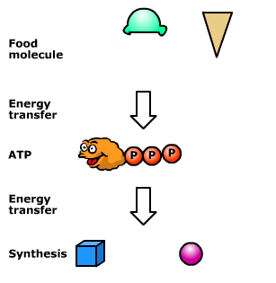

Describe what the diagrams show.

————————————————————

———————————————————-

———————————————————-

———————————————————

———————————————————-

———————————————————-

———————————————————-

———————————————————-

————————————————————

———————————————————-

———————————————————-

———————————————————

———————————————————-

———————————————————-

———————————————————-

———————————————————-

———————————————————-

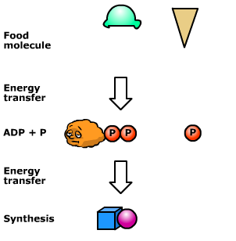

What type of reaction breaks down ATP into ADP?

—————————————————————

What is the name of the enzyme that catalyses this reaction?

—————————————————————-

What type of reaction synthesises ATP from ADP?

—————————————————————-

What enzyme catalyses the reaction?

——————————————————————

Where is ATP synthesised within the cell?

——————————————————————

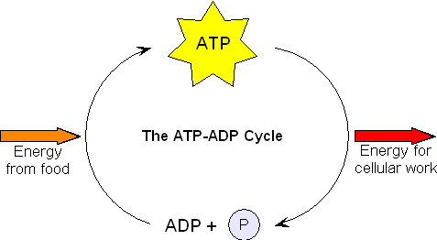

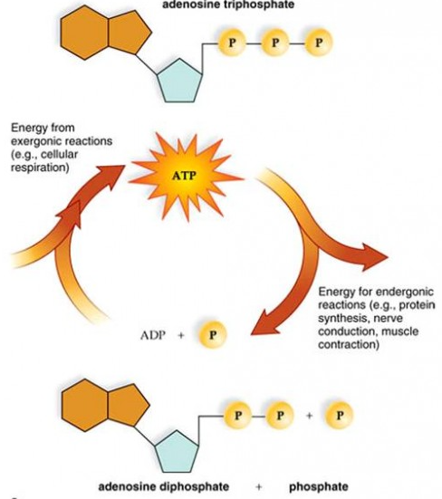

This is known as the ADP -ATP cycle, allowing energy to be stored and released as it is needed.

The bonds that link the phosphates in ATP can be thought of as coiled springs. Due to these spring like bonds, the end phosphate is straining to break away from its nearest partner. Any small addition of energy and the end phosphate springs away, releasing all the energy that is stored in the spring (the bond).

**Why use ATP?**

ATP is the immediate energy source for cells. As a result cells do not store large quantities of energy, but rather just a few seconds supply. This is not a problem as ATP is rapidly reformed form ADP and Pi and so a little goes a long way.

Why isn’t glucose used as the energy release molecule? What happens when food is burnt in a bunsen flame? What impact would this have on the cell?

——————————————————————————————————————

**Roles of ATP**

ATP is required for various processes such as synthesising macromolecules from their basic units, muscle contraction, active transport, and secretion. These topics will be covered later in the A level course. The inorganic phosphate released during the hydrolysis of ATP can be used to phosphorylate other compounds in order to make them more reactive, thus lowering the activation energy of the reaction. You will learn about this in the topic of respiration.