**Induction Work 2015: The Biological Importance of Water**

**Learning Objectives**

* Develop independent research skills
* Describe the structure of the water molecule
* State the properties of the water molecule
* Explain the importance of the water molecule to living organisms
* Specification reference: 3.1.7

**What you should know from GCSE**

* Heat can be transferred by **evaporation**
* Water has a high **specific heat capacity**
* Water reacts with many **elements** and **compounds** and is a **solvent** in which many chemicals can dissolve
* Water is a **covalent** **compound**

Start by defining the words written in **bold** above, the web site BBC GCSE bitesize can help you or you could use your old GCSE notes or revision books.

**Evaporation**

————————————————————————————————————————

————————————————————————————————————————

————————————————————————————————————————

**Specific Heat capacity**

————————————————————————————————————————

————————————————————————————————————————

————————————————————————————————————————

**Element**

———————————————————————————————————————————

———————————————————————————————————————————

———————————————————————————————————————————

**Compound**

———————————————————————————————————————————

———————————————————————————————————————————

———————————————————————————————————————————

**Solvent**

————————————————————————————————————————

————————————————————————————————————————

————————————————————————————————————————

**Covalent compound**

————————————————————————————————————————

————————————————————————————————————————

————————————————————————————————————————

**Show how water is covalently bonded using a dot and cross diagram in the space below.**

Dot and cross diagrams show how a pair of electrons form a covalent bond. Notice that in the diagram below only the electrons in the outer shell of each atom are shown. There is a hyperlink to follow if you require further explanation.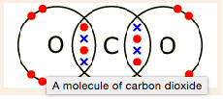

<http://www.bbc.co.uk/schools/gcsebitesize/science/add_ocr_gateway/periodic_table/covalentbondingrev7.shtml>

**Independent Research**

It’s important that you build **research** skills whilst at College.

* As part of the assessment of practical competency in A level Biology you must demonstrate that you can **research** and **reference**. AQA requires you to **cite** sources of information, demonstrating that research has taken place. The purpose of citing is to let readers know that a specific piece of information you're providing has a source, other than your own observation or reasoning. In many cases, the strength and credibility of your work depends on the validity of your sources, as well as your ability to represent those sources clearly without plagiarising.
* Whatever you choose to do following A levels, research is a vital part of life. If you should choose to go to University then you will be expected to work **independently**, carrying out research to support your learning. When you enter the workplace your employer will expect you to research information and communicate your findings.

It is for this reason that we will set many independent work activities this year, often requiring your own research. By the end of the course you will be well prepared for life beyond sixth form.

**Independent Research Activity on Water**

**Water is a major component of cells. The majority of the contents of cells are water and the environment around cells is mainly water. All living things take in water and many living things live in water. There is no life as we know it without water.**

You are going to carry out research in preparation to write the following essay:

***“Describe the properties of water, explain the properties of water linked to the polar nature of the molecule and explain the significance of these properties to living organisms and processes.”***

Sources of Information

Listed below are suggested sources of information that you can choose to use. Many of these are sources that you will use to help consolidate your learning this year and so it’s a good idea to get to know them. Look at all of them plus any other sources that you stumble across and decide which sources you like best.

Podcasts

* Craig Savage - why is water important to biology?
* Bozeman - water - a polar molecule
* Bozeman - water and life
* Crash Course Biology - water, liquid awesome

Text Books in the library

* AQA Biology, Glenn Toole and Susan Toole, Oxford University Press (2015 edition)
* AQA A level year 1 and AS, CGP (2015 edition)
* Advanced Biology for You, Gareth Williams, Nelson Thornes
* WJEC Biology AS student book, Gareth Rowlands, Iluminate Publishing

Websites

* [biologymad.com](http://biologymad.com) chapter 3, water
* [www.biology.arizona.edu](http://www.biology.arizona.edu) biochemistry tutorial on water
* [www.rsc.org](http://www.rsc.org) chemistry for biologists, water and living organisms
* Fast [bleep.com](http://bleep.com) - properties of water
* A level [notes.com](http://notes.com) - water
* [s-cool.co.uk](http://s-cool.co.uk) - water
* [mrothery.co.uk](http://mrothery.co.uk) biochemistry of water

You must use at least **5 sources** to write **research notes** to bring to your first lesson. Your teacher will check that you have written full notes (using the 5 **named** sources), in your own words and that you have clearly stated where the information has come from. **You will be graded on your effort.** Make a note of anything that you think may be important but that you have not properly understood.

**The information will be shared with other members of your class and so it is important that you take this preparatory work seriously. You will write the essay following the first lesson.**

**The research notes (and diagrams where relevant) should be written using the following titles to guide you:**

1. Chemical structure of the water molecule including bonding and polarity
2. Hydrogen bonding between water molecules
3. The different states of water and the density of water at different temperatures
4. Cohesion and Adhesion
5. Surface tension
6. High Specific heat Capacity and buffering changes in temperature
7. Large Latent heat of vaporisation and cooling through evaporation
8. Water as a solvent
9. Water in metabolism (start by defining metabolism)

**Exam Question For Consolidation**

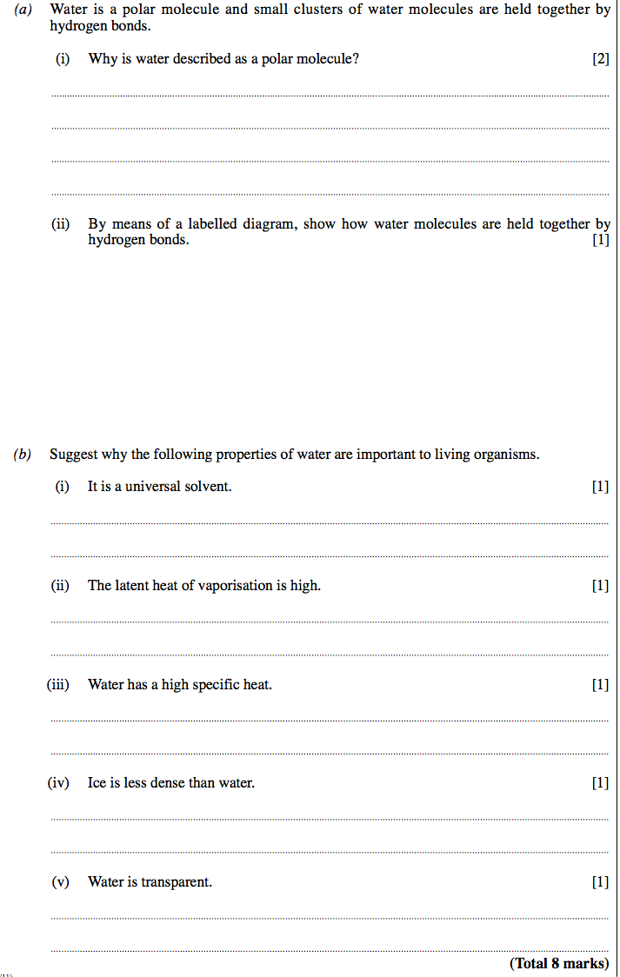

**Mark Scheme for Exam Question**

