**3.1.8 Inorganic Ions**

**Learning Objectives**

* Know that inorganic ions occur in solution in the cytoplasm and body fluids of organisms, some in high concentrations and others in very low concentrations.
* Understand that each type of ion has a specific role, depending on its properties.
* Be able to recognise the role of ions in the following topics: iron as a component of haemoglobin, hydrogen ions and pH, sodium ions in the co transport of glucose and amino acids, phosphate ions as components of DNA and ATP.

**What you should know from GCSE**

* Metals lose electrons to form positive ions, whereas non metals gain electrons to form negative ions.
* Mineral ions and vitamins are needed in small amounts for healthy functioning of the body.
* Internal conditions that are controlled include the ion content of the body - ions are lost via the skin when we sweat and excess ions are lost via the kidneys in the urine.
* When atoms form chemical bonds by transferring electrons, they form ions. Atoms that lose electrons become positively charged ions. Atoms that gain electrons become negatively charged ions. Ions have the electronic structure of a noble gas.
* Hydrogen ions make solutions acidic.

**Chemical Elements**

[www.rsc.org/Education/Teachers/Resources/cfb/basicchemistry.htm](http://www.rsc.org/Education/Teachers/Resources/cfb/basicchemistry.htm).

What are the most common elements that are found in living organisms?

————————————————————————————————————————

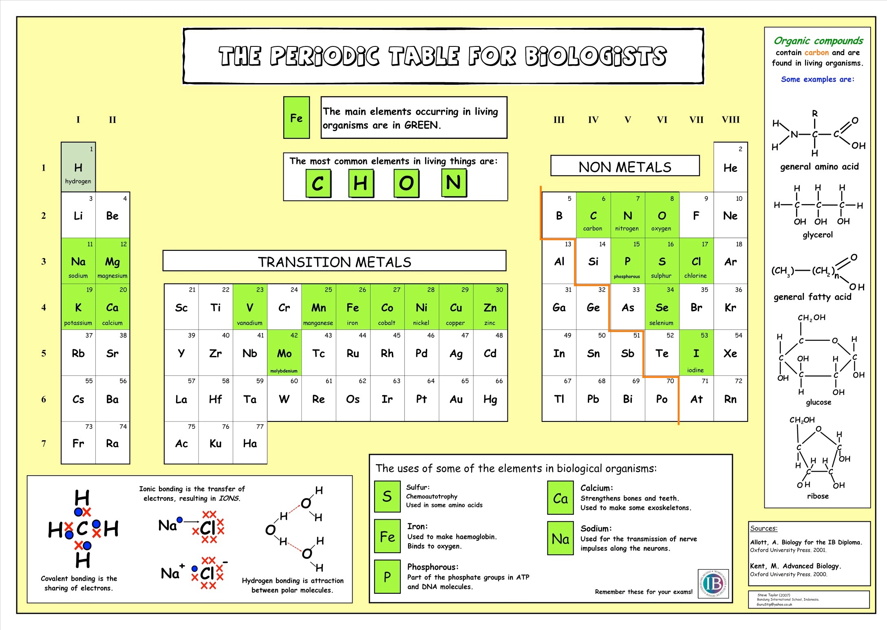

**Ions**

If you have forgotten what ions are then watch the following video:

**What’s an ion by Tyler DeWitt (7 mins):** <https://www.youtube.com/watch?v=WWc3k2723IM>

And then watch **polyatomic ions**: <https://www.youtube.com/watch?v=MJZeZvDxcx8>

Tyler has produced a number of videos that revise GCSE chemistry.

**Answer the following to recap your knowledge (the videos contain all of the answers)**

What is an ion? ————————————————————————————————-

What is a cation ————————————————————————————————

What is an anion? ———————————————————————————————-

Write the formula for the following ions:

* Sodium ——————-
* Calcium ——————-
* Chloride ——————-
* Iron ———————
* Hydrogen ———————

What is a polyatomic ion? ————————————————————————————

Write the formula for the following polyatomic ions

* Ammonium —————————-
* Carbonate —————————
* Hydroxide —————————-
* Nitrate ——————————
* Nitrite ——————————-
* Phosphate ——————————-

**Inorganic Ions**

An inorganic ion is one that usually doesn’t contain —————————- and if it does contain carbon then it is found in small proportions. There are inorganic ions in solution, in the cytoplasm of cells and in the body fluids of organisms.

**Macronutrients and Micronutrients**

* These are inorganic ions that play important roles in cell metabolism. An ion’s role determines whether it is found in high or low concentrations.
* Macronutrients are needed in SMALL amounts e.g.

Mg2+, Fe2+, PO43-, Ca2+, K+, Na+, Cl- , SO4 2-

* Micronutrients are needed in TINY (trace) amounts e.g. Cu2+ , Zn 2+
* Cations
* Calcium ions, Ca 2+, are the most abundant cations (positive ions) in the body, making up about 1.5% of total body weight. About 99% is found in bones and teeth, largely in combination. They combine with phosphate ions to form calcium phosphate which increases the rigidity and hardness of bones and the enamel in teeth. Calcium ions are also involved in blood clotting, normal muscle contraction and nerve activity.
* Sodium ions, Na+, are the main cations in extracellular fluids. They affect the transport of water through cell membranes by osmosis. They are also part of the hydrogen carbonate buffer system.
* Potassium ions, K+, are the main cations in intracellular fluids. They contribute to the transmission of nerve impulses and muscle contraction.
* Magnesium ions, Mg2+, are important because of their role in the normal functioning of muscle and nerve tissue, bone formation and as a component of many coenzymes.

A normal diet provides sufficient quantities of calcium, sodium, potassium and magnesium ions.

* Anions
* Chloride ions, Cl-, are important in the acid-base balance of blood and the water balance of the body, and in the formation of hydrochloric acid in the stomach. They are found in intracellular and extracellular fluids.
* Phosphate ions, PO43-, have more roles than any other inorganic ions in mammals. They are important for the formation of bones and teeth, as a buffer in blood, their role in muscle contraction and nerve impulses, as a component of many coenzymes, for their role in transfer and storage of energy in ATP, and as a component of DNA and RNA.

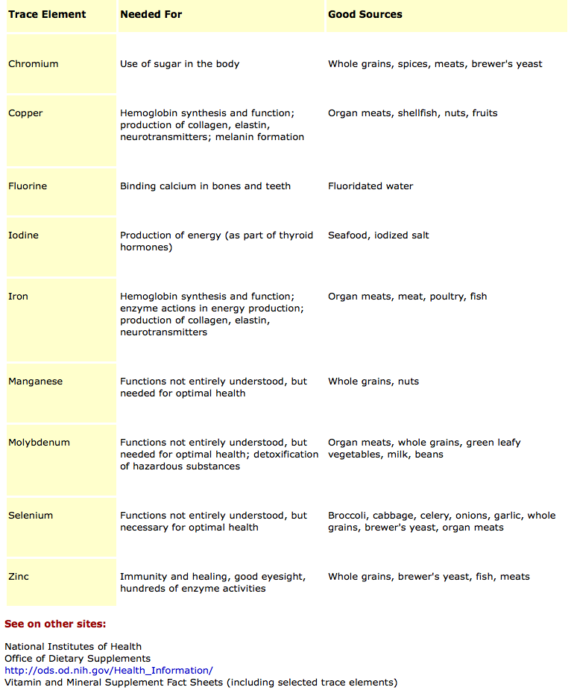

**Ions in the specification**

| Inorganic Ion | Role |
| --- | --- |
| Iron |  |
| Phosphate |  |
| Hydrogen |  |
| Sodium |  |

You will learn more about these ions as you move through the A level course.

**Exam Questions**

