**Young's double slits experiment - Laser**

### Theory

For a double source interference pattern, the distance between adjacent bright fringes is w, given by:

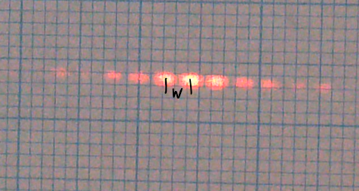

where   
λ is the wavelength of the light used

D is the distance to the eyepiece / screen

s is the slit separation

### Apparatus

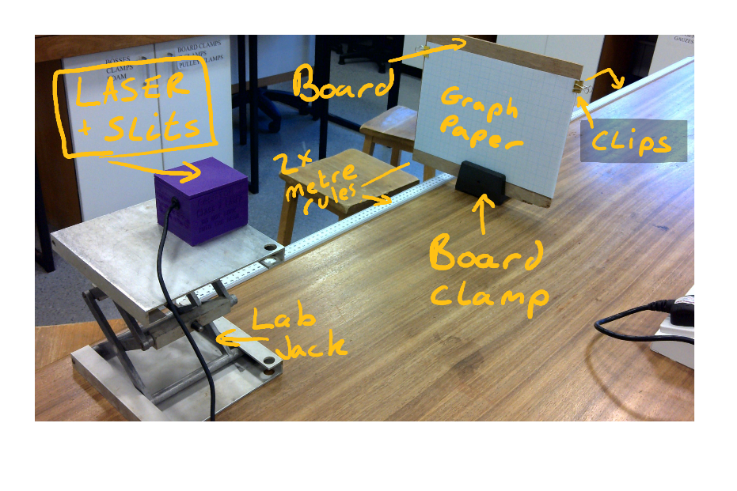

LASER + Slit box

Lab Jack

Board + Board clamp

2x Metre Rules

Bulldog clips

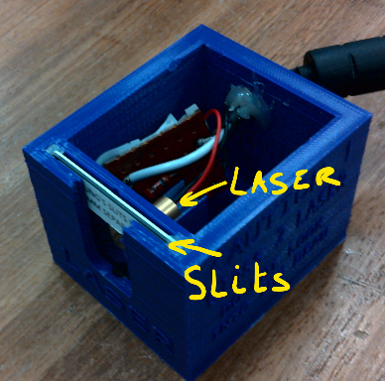

**NEVER LOOK INTO THE LASER BEAM   
OR DIRECT IT AT ANOTHER PERSON!**

### Method

**Write a risk assessment and check with your teacher.**

Set-up the equipment as shown. Use blue-tac to secure the rules and laser box.

The Laser box should be aligned with the front of the lab jack, and the lab jack aligned with zero on the first rule. Ideally the pattern is in line with the horizontal rules of the graph paper.

You will start with an initial distance D of 40.0cm and take readings every 20cm up to 2m.

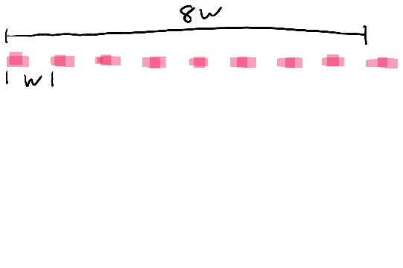

For each value of D measure across 8 fringe widths. You can choose to measure from centre to centre or left edge to left edge. BUT ensure you include 8 lots of bright and dark fringes. E.g.

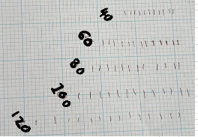Mark clearly on the graph paper each bright fringe location

Start at the top of the graph paper and lower the lab jack for each value of D, ensure this sheet is kept and stuck in your lab book.

Once 8w for all values of D have been taken turn the LASER off and remove the graph paper from the board.

Use a ruler to measure the value of 8w and tabulate against D, calculate w and add to the table.

|  |  |  |  |
| --- | --- | --- | --- |
| D / m | 8w / mm | w/ mm | w/ m |
|  |  |  |  |

### Analysis

Plot a graph of w against D and measure the gradient of the best fit line.

From the equation given in the theory, the gradient of this line is equal to λ / s, from which the wavelength can be calculated if the slit separation is known.

The slit separation s is as 0.1 mm. Convert this value to SI units and use it with your gradient to calculate a value for λ.

### Uncertainties and error

**Ensure all the workings for uncertainties including for D are clearly shown in your lab book.**

The absolute uncertainty of a **metre rule** is +/-0.5mm, as we apply this to the zero and the measurement of D we use 1mm (0.001m)to calculate %UD . To calculate %UD we use the median value of D ( 1.00m)

Now calculate the % Uncertainty for your value of 8w using the same method.

NOTE the %Uw is the same as 8w

We are going to assume there is no uncertainty in the value for s

The total %U = %UD + %Uw.

Why did we measure w for several value for D rather than just 1?

Why did we measure the average fringe separation over eight fringes?

The Manufacturers quoted value for **wavelength of the LASER is 650nm.**

Calculate the % difference using:

### Discussion and Conclusion

Was the %Diff bigger that the %Uncertainty? If so what do you think is the most likely source of the unmeasured error? How close to the line of best fit were your data points?

You should state your measured value for the wavelength of the Laser light.