Godalming College Physics Department

Measurement of the acceleration due to gravity, g, using free fall
N.B. This sheet is for reference only – DO NOT remove it from the laboratory.

Apparatus

Ball bearing Clampstand
Release mechanism Boss
Trap door Metre rule
Scalar timer Wires

Diagram

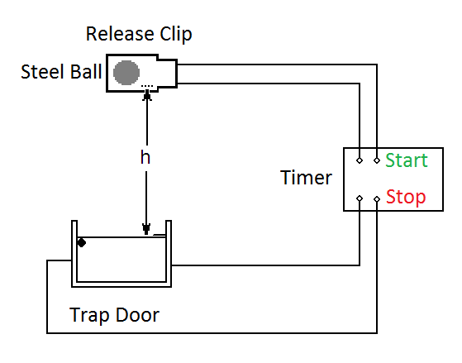

Theory
When the ball is released, it falls through the distance h, in time t. Assuming negligible air resistance, the following equation of motion can be used:
s = ut + ½ at²
u = 0, a =g, s = h,
h = ½ g t²

Method

Following the instructions on the timer, set up the apparatus as shown in the diagram, with h set at roughly 0.30 m. Make sure you measure the distance as accurately as you can to the bottom of the ball. Measure t three times and then repeat for increasing values of h. You should discard and repeat any clearly anomalous readings. Remember that you require at least eight points for a graph.

Results and Analysis
What are the Dependant, independent and control variables?

Use the following format for your results table:

h / m | t₁ / s | t₂ / s | t₃ / s | Average t / s | t ² / s²
The general equation for a straight line is y = mx + c
- Look at h = ½ gt².
- What is in the position of y and is therefore plotted on the y axis?
- What is in the position of x and is therefore plotted on the x axis?
- What will the gradient be?
If you used a false origin then calculate the intercept as follows:
c = y – mx
Select a point ON THE LINE NOT IN THE TABLE.
Substitute in the values of y, m and x in the equation.

- What should the intercept be?

Plot the graph.
- Is your graph the shape you expected?
- Is the intercept the expected value?
- If not can you suggest why?
- Is random error very evident in your table and on your graph?
- How did you attempt to reduce random errors in the experimental procedure?
- Is a systematic error evident in your graph?

Find the gradient of your graph.
- Calculate g from the gradient (IT IS NOT THE GRADIENT).
- Look up a data book value for g. Even though you ought to know the value, you should still reference the source!
- Find the % difference between your value and the data book value.

i.e. difference × 100 or 100 - your value ×100
true value true value

Is your result too low or too high?
- Can you suggest why?

Pick a middle row of your results table.
- State the uncertainty in the height (nearest cm, mm)
- Calculate this as a % of the value – this is the % uncertainty in the height.
- State the uncertainty in the times from the instrument
- Calculate the ½ range ((biggest – smallest)/2) in the times at that particular height.
- State which of these is the largest. The largest one is the uncertainty.
- Calculate the largest one as a % of the average value of the times at that height.

The gradient comes from h/t² so h appears once and t appears twice.

the overall % uncertainty = the % uncertainty for h + (2 × the uncertainty in t)

- Compare this to the % error.
- Your uncertainty tells you the smallest and biggest your value of g could be. If the % uncertainty is bigger than the error your value’s range overlaps the true value.
If it is smaller then you cannot account for the discrepancy and your value’s range does not overlap the true value.

Conclusion

State your value for the acceleration due to gravity with an appropriate unit.

