Godalming College Physics Department
Measurement of Young modulus

Theory

Young Modulus = Stress / Strain = $\frac{{\text{Force}}/{\text{Area}}}{{\text{Extension}}/{\text{length}}}$

Re-arranging the equation and using symbols we can write:

$E=\frac{\text{Fl}}{AΔl}$

In this particular experiment, the extension is small, and so the cross-sectional area of the wire remains constant. We can therefore arrange the equation in straight-line form as follows:
$F=\frac{\text{EA}}{l}×Δl$

A straight-line graph of F on the y-axis, against Δl on the x-axis should be plotted. From the gradient and the measured values of A and l, the Young modulus, E can be calculated.

Apparatus required

The following arrangement of Brass wires is suspended to the side of the whiteboard in 131.

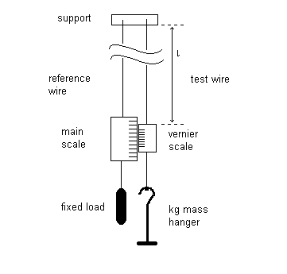
Also required:
kg and half kg masses
Micrometer screw gauge
Long overlapping rule
What is the main safety risk with this experiment and what precaution should you take? Write your answer below and check with your teacher before starting the experiment.

Method

Starting with just the mass hanger to keep the wire taut (this can be assumed to be a load of zero kg), measure the original length of the wire with the long ruler and the initial position on the vernier scale. If you have difficulty with the vernier, ask for help.

Now take a series of readings from the vernier on loading and unloading the wire and calculate the extension for each. You will also need to find an average value for the diameter of the wire
What will you use to measure the diameter and why?

Processing of results

Tabulate your results, and draw up values for the force (load x g) and the corresponding average extension. Plot a graph of F against Δl and measure the gradient. Use the theoretical expression for the gradient to calculate the Young modulus. The cross-sectional area of the wire can be calculated from the average value of the diameter. (A = π r² = π d² / 4)

Discussion

Why do you think two wires are used in the apparatus and measurements were taken on loading and unloading?

Why would you expect the graph to pass through the origin?

You should be able to find an accepted value for the Young modulus of Brass in either a data book, or a textbook. Make sure you reference the source of your value.

How do your results compare with those expected? Can the discrepancy be explained by experimental error? Consider the uncertainties in each of your experimental measurements.

Why is it acceptable to use a metre rule to measure the original length of the wire, whereas a sensitive vernier is needed for the extension?

Conclusion

Your conclusion should state the Young modulus of Brass.

