Godalming College Physics Department

I/V characteristics for various components

Theory.

The characteristic of a component is a graph showing how the current through the component varies with the voltage across it. Some components are Ohmic, i.e. the current is proportional to the voltage giving a straight line I-V ‘curve’ that passes through the origin. Other components are non-Ohmic. The resistance of a component at any voltage is given by that voltage divided by the current at that voltage.

Apparatus.

Continuously variable power supply Voltmeter Variable resistor
Ammeter 12V Filament lamp Silicon diode

Method.

You will be obtaining characteristic graphs for three different components.

a) Resistor

Set up the circuit shown. Use the full resistance of the variable resistor, by connecting it into the circuit at each end of the coil. Set up the current loop first and then connect the voltmeter in parallel with the resistor. For the resistor you need to select the 2A and 20 V ranges.

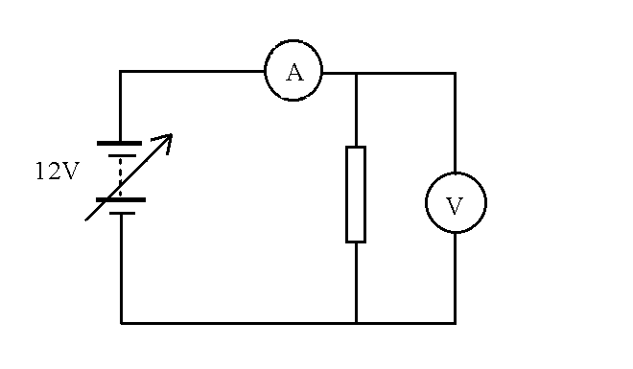

Have your circuit checked by the teacher before you switch on the power supply.

Use the power supply adjustment to vary the voltage across the resistor from 0V to 12V, taking readings at appropriate intervals. Note down the value written on the top of the resistor.

Warning: Ensure that the power supply adjustment is set to zero before you turn on the power supply and adjust the voltage carefully to ensure that the maximum values are not exceeded.

b) Filament lamp

Replace the resistor with a 12 V filament lamp. Repeat the above process taking care to adjust the voltage slowly to allow the temperature of the lamp to stabilise.

c) Diode

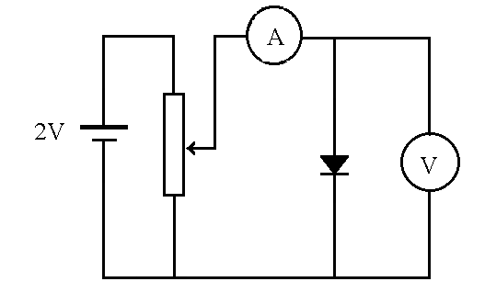

Replace the lamp with one of the heavy-duty diodes mounted in a grey box. Ensure that the diode is in forward bias. You will need to make very fine adjustments to the voltage across the diode. This can be achieved by setting the power supply to give roughly 2V and then building a potential divider using the variable resistor as shown in the circuit diagram. Reset the voltmeter to the 2V range and repeat the procedure.

Analysis and discussion.

Plot graphs of I/A on the y axis against V/V on the x axis for each of the components.

In your analysis consider the following points:

- Which of the components are Ohmic and which are non-Ohmic?

- Determine the value of the resistance of the resistor from the gradient of the graph of part a). Note that this is not simply the gradient of the graph as you have plotted current against voltage. If we rearrange the definition of resistance, we obtain the following equation for a constant resistance:

I = 1 x V
R

By comparing this with ‘y = m x + c’, you should be able to see what the gradient of the graph represents.

- Calculate the percentage difference between your value for the resistance and the value written on top of the variable resistor and consider likely sources of error.

- Explain the shapes of the I-V curves for the diode and the filament lamp.

