Refractive Index Problems

These problems all use the formula: sin θ₁ = n₂
sin θ₂ n₁
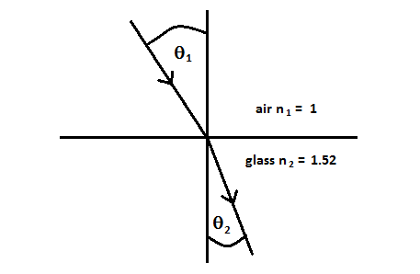
Worked example:

A ray of light is incident on a glass block of refractive index 1.52 at an angle of incidence of 30º to the normal as shown in the diagram. Calculate the angle of refraction.

sin θ₁ = n₂ sin 30º = 1.52 sin θ₂ = sin 30º
sin θ₂ n₁ sin θ₂ 1 1.52

sin θ₂ = 0.5 / 1.52 = 0.329 θ₂ = 19.2º

- Calculate the angle refraction for a ray of light incident on the same glass block at:
  - 50º
  - 70º

- Calculate the angle of incidence that will give an angle of refraction in the block of:
  - 15º
  - 25º

- The ray of light is now travelling in water of refractive index 1.33. Calculate the angle of refraction for the same block and the following angles of incidence:
  - 20º
  - 40º
  - 60º

- The ray of light is now incident within the glass block at an angle of 30º to the normal. Calculate the angle of emergence (refraction) into:
  - Air of refractive index 1
  - Water of refractive index 1.33
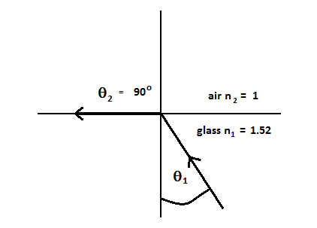
  - Oil of refractive index 1.28

Critical angle – Worked example

Calculate the critical angle for glass of refractive index 1.52

Although there is a special equation for critical angle, we will use the above general equation with glass as medium 1 and θ₂ as 90º, as shown in the diagram.

sin θ₁ = n₂ sin θ₁ = 1 sin θ₁ = 1 as sin 90º = 1
sin θ₂ n₁ sin 90º 1.52 1.52

sin θ₁ = 0.658 θ₁ = 41.1º

- Calculate the critical angle for water of refractive index 1.33

- Calculate the critical angle for diamond of refractive index 2.42

- Calculate the critical angle for light travelling in glass incident at a glass / water boundary (use 1.52 and 1.33 as the refractive index values).

- Calculate the critical angle for total internal reflection inside the core of an optical fibre of refractive index 1.48 when it strikes the cladding of refractive index 1.46.

Exam Question

