Handling Vectors

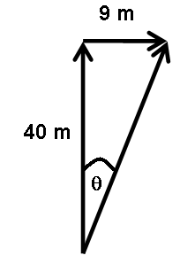
Vector Combination Problems

- A man walks 40 m due North and then turns and walks 9 m due East. Calculate his total displacement from the starting position and the angle of the resultant from due North.

- Calculate the resultant magnitude of the forces shown below and the angle of the resultant measured from the horizontal:

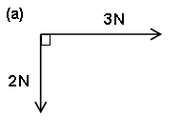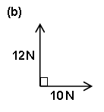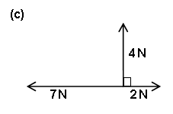

- A small boat has a maximum speed of 5 m s⁻¹. The owner wants to sail across a river to a landing stage which is immediately opposite his current position. At what angle will he need to point the boat if the river is flowing with a speed of 2 m s⁻¹?
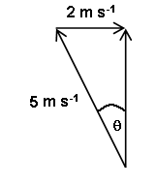

What is the ‘effective’ speed with which the boat crosses the river, and how long will it take to cross a river which is 100 m wide?

4. A crow flies 1 km in a direction 40⁰ east of due north and then lands on a rooftop.

How far north of its starting position is it when it stops?

How far East of its starting position is it when it stops?

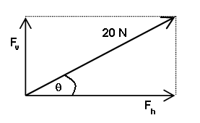
Resolving Vectors

5. A force of 20 N acts at an angle of 30º to the horizontal. Calculate the size of the vertical and horizontal components of this force.

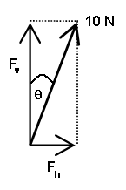
6. A force of 10 N pulls at an angle of 15º to the vertical. Calculate the size of the vertical and horizontal components of this force.

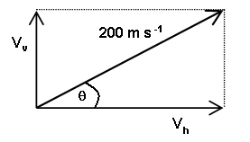
- A gun fires a shell at 20 m s⁻¹ at an angle of 40º to the horizontal. Calculate the resolved parts of the velocity in the horizontal and vertical directions.

8. A box of weight 50 N sits on a slope at an angle of 20º to the horizontal.
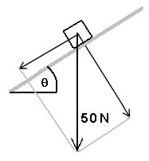

Calculate the components of the weight of the box along the slope and in the direction perpendicular to the line of the slope.

- A pendulum bob of weight 1.0 N is pulled to one side through an angle of 10º and then released.
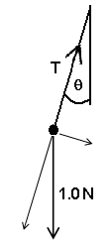

At the moment of its release, the tension in the string will be equal to the component of the weight along the line of the string. Calculate the value of this tension. Calculate also the component of the weight perpendicular to this direction.

10. A force of 10 N acts on an object at 27º to the vertical as shown in the diagram below. A horizontal force of 15 N to the right also acts at the same point. By first finding the vertical and horizontal components of the 10 N force, calculate the total resultant force acting on the object in magnitude and direction.

