# Worksheet 5 Logic Gates

**Task 1**

1. Write the following Boolean expressions using Boolean notation:

(a) (A AND B) OR NOT (D AND E)

(b) NOT A AND NOT (B OR C)

(c) (A AND B) OR (B AND (NOT C))

2. (a) Complete the truth table for the following logic circuit.

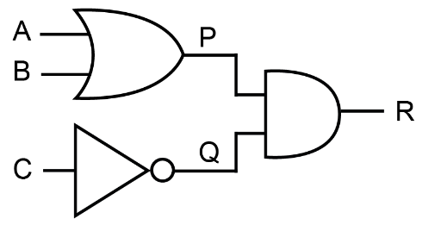

|  |  |  |  |  |  |
| --- | --- | --- | --- | --- | --- |
| **Input A** | **Input B** | **Input C** | **P = A OR B** | **Q = NOT C** | **Output R = (A OR B) AND (NOT C)** |
| 0 | 0 | 0 |  |  |  |
| 0 | 0 | 1 |  |  |  |
| 0 | 1 | 0 |  |  |  |
| 0 | 1 | 1 |  |  |  |
| 1 | 0 | 0 |  |  |  |
| 1 | 0 | 1 |  |  |  |
| 1 | 1 | 0 |  |  |  |
| 1 | 1 | 1 |  |  |  |

(b) Write a Boolean expression to represent this circuit, using Boolean notation.

3. Draw logic circuits to represent the following Boolean expressions, and in each case say what is output if A = 1, B = 0 and C = 1, showing the output from each gate.

(a) Q = NOT ((A OR B) AND C)

(b) Q = A  **•** (NOT (B + C))

**Task 2**

1. Draw the truth tables for the following logic circuits:

(a)

|  |  |  |
| --- | --- | --- |
| **Input A** | **Input B** | **Output Q** |
|  |  |  |
|  |  |  |
|  |  |  |
|  |  |  |

(b)

|  |  |  |  |  |  |
| --- | --- | --- | --- | --- | --- |
| **Input A** | **Input B** | **Input C** | **P = NOT (A AND B)** | **NOT C** | **Q = (NOT A AND B) OR NOT C** |
|  |  |  |  |  |  |
|  |  |  |  |  |  |
|  |  |  |  |  |  |
|  |  |  |  |  |  |
|  |  |  |  |  |  |
|  |  |  |  |  |  |
|  |  |  |  |  |  |
|  |  |  |  |  |  |

(c) Draw the logic circuit for the expression:

2. Draw truth tables for each of the following logic circuits to show that they are equivalent.

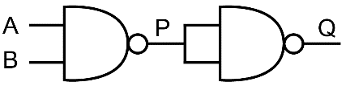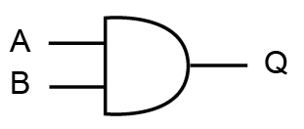

(i) (ii)

Truth table (i) Truth table (ii)

|  |  |  |
| --- | --- | --- |
| **Input A** | **Input B** | **Output Q** |
| 0 | 0 |  |
| 0 | 1 |  |
| 1 | 0 |  |
| 1 | 1 |  |

|  |  |  |  |
| --- | --- | --- | --- |
| **Input A** | **Input B** | **P =**  **NOT (A AND B)** | **Q =**  **NOT (P AND P)** |
|  |  |  |  |
|  |  |  |  |
|  |  |  |  |
|  |  |  |  |

3. (a) Write the following Boolean expression using Boolean notation:

(A XOR B) AND (NOT (C XOR D))

(b) Draw the logic diagram using only XOR, NAND and NOR gates, showing the output from each gate if the inputs for A, B, C and D are all 1.