# Homework 2 Bits, bytes and binary

Answer the following exam-style questions about number theory:

1. Computers make extensive use of the binary number system.
   1. In an 8-bit computer system, explain how to determine how many different decimal values can be represented. [2]
   2. When voltage changes in a circuit it often takes time to settle to a constant level as shown in the graph below:

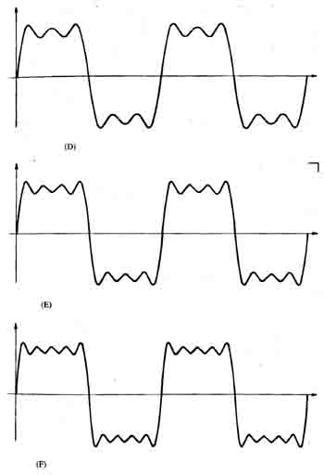

Explain why, in a computer system using binary, this effect is not an issue. [2]

1. A company runs a website where users can upload videos about sport. Users register from all over the world.
   1. The database storing the videos has grown to 2,407,117,015 Bytes.   
        
      What is this value expressed in GB rounded to 1 decimal place. [2]

* 1. The database is expected to grow to in the next year to 1030 GB. A new hard disk to store the database is required.  
       
     Show that a 1 TiB hard disk would be able to store a database of this size. [2]
  2. The database uses Unicode character encoding to store details about the videos.  
       
     Describe one reason for this choice. [1]

1. Messages are transmitted using **odd** parity error checking Which of the following messages have been received with an error in them? The parity bit has been marked in **bold**. [3]

|  |  |
| --- | --- |
| **Message** | **Received with error present?** |
| 1010101**1** |  |
| 1110100**0** |  |
| 1110101**0** |  |

1. Why can it not be assumed that all errors have been identified using this system? [2]
2. A majority voting system is used when sending a message across a network. The following table summarises what is sent:

|  |  |  |  |  |  |  |  |  |  |  |  |  |
| --- | --- | --- | --- | --- | --- | --- | --- | --- | --- | --- | --- | --- |
| **Bit position** | **1st** | | | **2nd** | | | **3rd** | | | **4th** | | |
| **Actual bit** | 1 | | | 1 | | | 0 | | | 0 | | |
| **Bits sent** | 1 | 1 | 1 | 1 | 0 | 0 | 0 | 0 | 1 | 0 | 0 | 0 |
| **Bit value voted** |  | | |  | | |  | | |  | | |
| **Incorrect vote?** |  | | |  | | |  | | |  | | |

1. State the Bit values voted and which votes are incorrect in the table above. [3]
2. How could this system be changed so that there is less chance of this error happening? [1]
3. Explain why this change might cause problems with traffic on the network? [2]

[Total 20 Marks]